Permit
The Environmental Permitting (England & Wales) Regulations 2016

Servmax Limited

Servmax Ltd
Lower House Farm
Coed Morgan
Llanvapley
Abergavenny
NP7 9UD

Permit number

EPR/BB3498CZ

Permit
The Environmental Permitting (England and Wales) Regulations 2016
Permit number

EPR/BB3498CZ

The Natural Resources Body for Wales (“Natural Resources Wales”) authorises, under regulation 13 of the Environmental Permitting (England and Wales) Regulations 2016

Servmax Limited (“the operator”),

whose registered office is

Suite 10 Equinox Centre,

Sankey Street,

Warrington,

England,

WA1 1NN

company registration number 12029885

to operate waste operations at

Servmax Ltd

Lower House Farm

Coed Morgan

Llanvapley

Abergavenny

NP7 9UD

to the extent authorised by and subject to the conditions of this permit.

Under regulation 27(2) of the Regulations, standard rules SR2008No3 are conditions of this permit.

Name | Date
Huw Davies | 05/12/2019

Authorised on behalf of Natural Resources Wales

Schedule 1 - Site plan

This is the plan referred to in the standard rules SR2008 No3

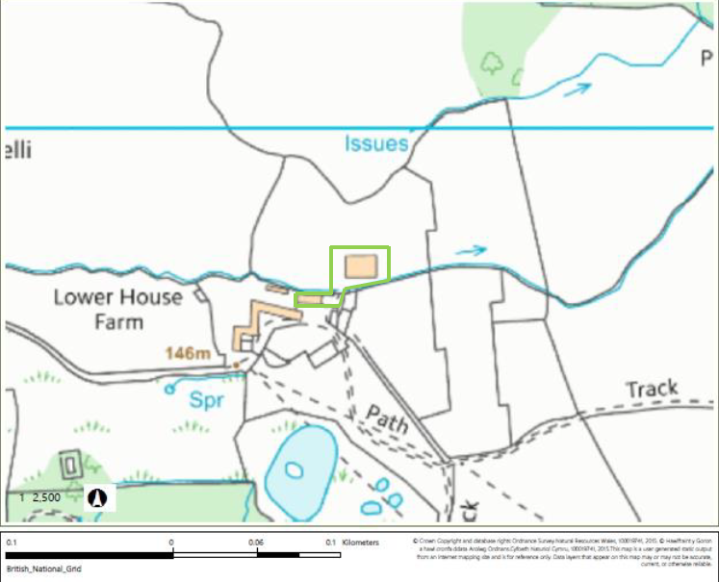

© Crown Copyright and database right 2019. Ordnance Survey licence number 100019741.

END OF PERMIT

