Permit Number: | PAN-007275
Applicant name: | Mr Clancy
Site Address: | Llwynbedw Farm, Cwmgiedid, Ystradgynlais, Swansea SA9 1LX
Discharge Point NGR: | SN 79064 11558 and SN 79065 11752
Respond by date: | 31st December 2019 (10 working days)
Permitting Officer: | Katrin Raynor-Evans

Brief Description of proposal:

A new application to dispose of diluted waste sheep twice a year. The applicant wishes to spread 5.8m3/day, twice a year via a vacuum tanker whish spreads at a rate of 2.8m3/ha. Given this low spreading rate, the applicant requires quite a large amount of land for the disposals. 2.76 ha per disposal requiring a total of 5.53 ha. I requested that the applicant submit a new site map showing additional fields to accommodate the spreading, which is available to view on DMS. Whilst there is enough land available, the L1 assessment does raise some concerns.
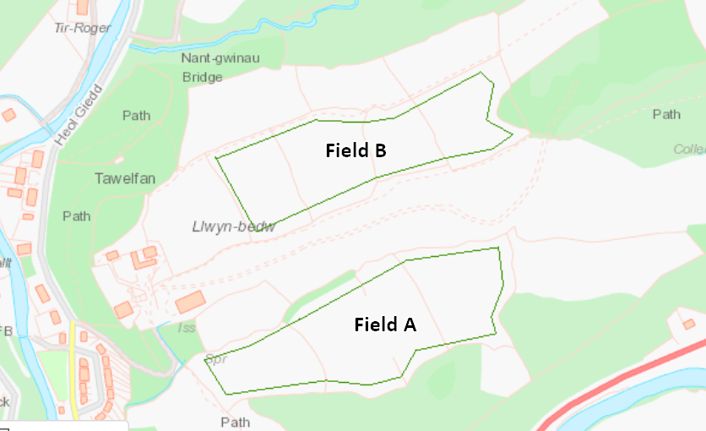

Habitats Screening Report – Designations or protected species/habitats:

SSSI – Rhos Hen-Glyn-Isaf approximately 900m to the North of the discharge areas
SINC – Three located to the South East of the site approximately 84 m away
Protected habitats and species – none to be considered within 30m

Risk Assessment Results (modelling or L1 Risk Assessment):
The Level 1 assessment suggests that the application should be refused. You will see that this is for numerous reasons concerning Field A (SN 79064 11558):
I have assumed worst case for the non-aquifer cover.
Field A is located in close proximity to a spring which has increased the scoring considerably. Given the amount of land that the applicant needs for one disposal, the spreading area within the field cannot be restricted to a different area. At a squeeze, the distance could be increased to 30m from the spring, but this still produces a high score.
Based on information from the application form, the leaching type is high which again has produced a high score.

Miscellaneous:

N/A

NRM Responses:

Environment Management comments:

Officers name:
Date:

Geoscience Response:

I have reviewed the level 1 risk assessment and made some minor changes. The assessment has been undertaken using reasonable worst case scenario inputs for unknown values. The revised score is 139 – potential refusal. Failure of the level 1 risk assessment is largely caused by the close proximity of receptors to field A. Field B is acceptable. Is there an alternative site to field A for disposal in a more favourable location?

Officers name: Alan Price
Date: 08/01/2019

External Consultations sent to: | Yes/No
National Parks | No
Water Company regarding Drinking Water Protected Zone / SPZ1 | No
Environmental Heath | No

Any Permitting Responses:

Date:

