PAN-007275
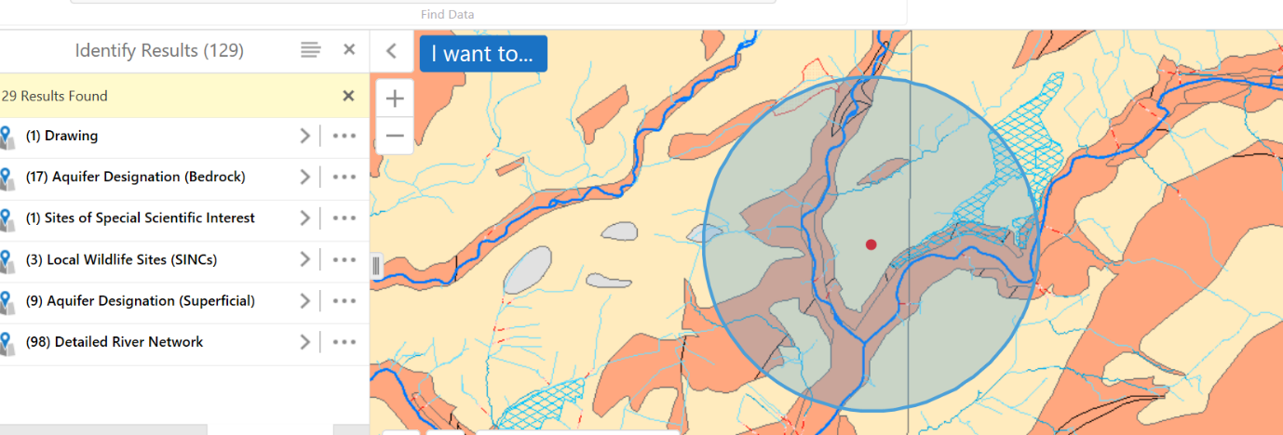
Please refer to internal consultation form for explanation.

