CRoW Appendix 4 (140_10_SD02)  CRoW Act 2000: Natural Resources Wales application for permission - Formal Notice |  | 
Natural Resources Wales Formal Notice.
Requirements of Section 28I of the Wildlife & Countryside Act 1981 as amended by the Countryside and Rights of Way Act (CRoW) 2000.
Duty in relation to granting any consent, licence or permit for activities likely to damage Sites of Special Scientific Interest (SSSI).
Guide to filling in this form for Natural Resources Wales staff:
To be completed by Permitting Officers for any applications for a permission which the Natural Resources Wales has considered under S28G duties to protect and enhance SSSIs. This applies to all proposed permissions within a SSSI, and to operations outside the SSSI boundary which are likely to damage its special features.
Refer to OI 140_10 ‘Applying the Countryside and Rights of Way (CRoW) Act 2000 to applications for permits with potential for impact on Sites of Special Scientific Interest (SSSI)’, including the flowchart in Appendix 2.
Pink italic text – drafting notes, to be deleted before completion/consultation.
Blue text – examples, to be replaced with permission-specific information.
Ensure you have completed all sections.
- Natural Resources Wales area/region/NPS hub: | North Wales
- Name of SSSI: | Malltraeth Marsh/Cors Ddyga SSSI
- Type of permission: | Bespoke Environmental Permit
- Date for Natural Resources Wales permit determination: | 13/12/2019
- Predicted 28 day date for response from NRW conservation/ecology (under S28 I(4)): | n/a saved for information only
- Natural Resources Wales reference no: | EPR/QP3294FQ/V004
- National grid reference: | SH 47579 71432
- Description of proposal: | Variation application to:  - Increase the permitted area;  - Add two materials to an activity in Table 1.1 Specified Waste Management Operation, under D9 Physico-chemical treatment - part iv to be amended to add wood and mixed municipal waste.  Environmental Setting  The facility is situated on an industrial estate near to the village of Gaerwen, Ynys Mon. Site of Special Scientific Interest, Malltreath Marsh is approximately 1.5km to the west of the facility. This SSSI is important for its biological interest. It is especially important for its breeding bird community of lowland damp grassland, as a threatened habitat of wet meadows and for its botanical interest of its ditches and watercourses.  Site Operations  The transfer buildings of the facility provide good containment for waste at the site along with the surrounding yard area which is mainly concreted. Further yard areas are hard cored.  It is proposed to extend the operation to include an existing modern building directly adjacent to the Permitted site. This building will be used solely for the transfer of municipal waste or similar commercial and industrial wastes.  Small quantities of demolition wastes and soils are processed and stored on the hard cored part of the site along with other materials which have been baled for recycling such as cardboard and plastics. The wastes which are to be accepted at the site are non-hazardous general household and commercial wastes, industrial wastes and wastes from the construction industry.  The majority of wastes, arising from municipal collections, will be transferred in the new main building. Simple treatment to remove objects considered as contaminants to an energy from waste process will take place.  Adhoc commercial wastes will be sorted to remove recyclables such as metal, paper, plastics, wood, cardboard and secondary aggregates. The wastes which are separated will vary depending upon the economic viability of the recycling markets. Processing of demolition wastes and soils will also take place to produce secondary aggregates and soils of various grades. There will also be the facility to segregate unauthorised waste should this situation arise.  The facility has been designed to minimise emissions to air, surface water and groundwater by means of containment within covered transfer buildings or by use of a concreted yard area and hard-core area for appropriate waste types. The buildings will provide containment for dust, litter and odours and will minimise the risk of contaminated run off being produced. Containment of any liquid run off from the waste is ensured by the site’s drainage system which discharges via silt traps and an oil/water interceptor. The management systems are in place to ensure that these containments systems are maintained and that all the operations at the site are conducted in a manner so as to prevent pollution of the environment, harm to human health and detriment to the amenity of the locality.  Dust  Site operation may result in dust being produced on the site. The most likely source of dust will be the crushing and screen plants used to produce secondary aggregates at the site and the shredding of green waste at the site. The dust could become airborne and if no action was taken to mitigate the impact the local houses or businesses would be the most sensitive receptors. The risk of dust becoming airborne from waste activities at the site can be reduced by damping down with water any materials which may produce dust in dry weather. In addition waste screening, shredding and crushing will not take place at the site during periods of windy weather unless these activities are taking place within a transfer building. These measures should reduce the potential dust impact from the site operations to a low level. Site management and monitoring of dust emissions should ensure that any dust problems are addressed quickly and adequately as described in section 5.1.1 of the Working Plan.  Management of municipal waste transfer within the new building is considered a low risk of producing dust. Should material be transferred out of the building it will be cleared by housekeeping measures and recorded in the daily checks and site diary.  Ecological Impact  There are no European Natura 2000 Sites, as defined by Regulation 10 of the Conservation (Natural Habitats etc.) Regulations 1994, within 2 km of the facility. However, there is one Sites of Special Scientific Interest within 2 km of the facility, Malltraeth Marsh which is approximately 1500m to the west of the facility. This SSSI is important for its biological interest. It is especially important for its breeding bird community of lowland damp grassland, as a threatened habitat of wet meadows and for its botanical interest of its ditches and watercourses.  In assessing the potential risk to the Malltraeth Marsh SSSI the possible effects on the site from the following hazards will be considered :  • Toxic contamination from toxic leachate landfill gas toxic wastes contaminated dusts  • Nutrient enrichment from nutrient rich leachate nutrient rich wastes  • Habitat loss from land encroachment explosive wastes landfill gas monitoring boreholes  • Siltation mud suspended solids  • Smothering dust/particles from vehicles dust from periphery dust from wastes  • Disturbance visual human presence noise/vibration  • Predation/displacement by other birds attracted to the site gulls/corvidores; rodents  Siltation  Siltation could potentially result from suspended solids being discharged from the Cymru Lan site to the receptor site or from mud being washed off site surfaces and discharging into receptor site. As the surface water management within the Cymru Lan site is contained this risk is considered to be insignificant.  Smothering  Smothering could potentially result from dust and particulates being generated at the Cymru Lan site and being deposited on the receptor sites by vehicle movements both within and outside the site boundary and from airborne particulates from the facility. Due to a combination of distance from the facility and prevailing wind direction it can be concluded that there is no risk posed to this receptor.  Disturbance  Due to the distance from the Cymru Lan site to the SSSI and the intervening features such as the rest of the industrial estate there will be no visual impact on the SSSI. Human presence from the site will again not affect the SSSI due to distance and noise and vibration will be controlled at source. It will also be insignificant compared to other noise sources between the SSSI and the Cymru Lan site.  Predation/Displacement  Birds should not be attracted to the Cymru Lan facility as there will be little food type wastes at the site. Rodents are not likely to be attracted to the facility especially in such rural location. If rodents are evident there are inspection and control measures in place to reduce the hazard at source.
- Is the proposed activity within (wholly or partially) the SSSI boundary? | NO  The Malltraeth Marsh SSSI which is approximately 1500m to the west of the facility.  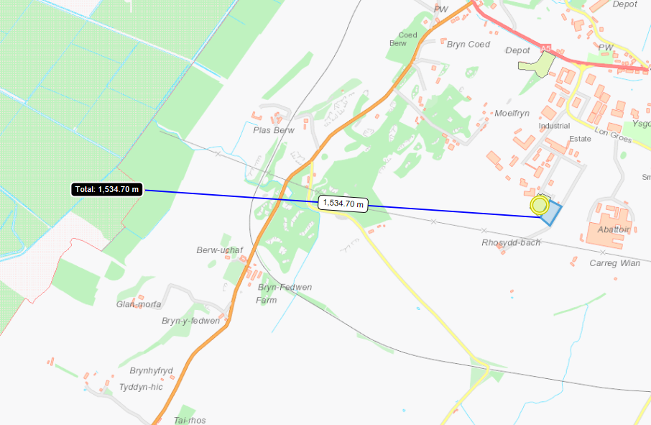
- Has there been any pre-application discussion or correspondence with NRW conservation/ecology | NO
- What aspect(s) of the proposed permission may damage the features which are of special interest for the SSSI?
None

- Decision
The proposed permission is not likely to damage any of the flora, fauna or geological or physiological features which are of special interest as there is no pathway for features to be affected. Natural Resources Wales is minded to issue the permission.

Natural Resources Wales is minded to:
Issue the permission

- Name and job title of Natural Resources Wales officer: | Rohini Sawant  Permitting Officer
- Date form sent to NRW conservation/ecology | N/A – Information only

