CRoW Appendix 4 (140_10_SD02)  CRoW Act 2000: Natural Resources Wales application for permission - Formal Notice |  | 
Natural Resources Wales Formal Notice.
Requirements of Section 28I of the Wildlife & Countryside Act 1981 as amended by the Countryside and Rights of Way Act (CRoW) 2000.
Duty in relation to granting any consent, licence or permit for activities likely to damage Sites of Special Scientific Interest (SSSI).
Guide to filling in this form for Natural Resources Wales staff:
To be completed by Permitting Officers for any applications for a permission which the Natural Resources Wales has considered under S28G duties to protect and enhance SSSIs. This applies to all proposed permissions within a SSSI, and to operations outside the SSSI boundary which are likely to damage its special features.
Refer to OI 140_10 ‘Applying the Countryside and Rights of Way (CRoW) Act 2000 to applications for permits with potential for impact on Sites of Special Scientific Interest (SSSI)’, including the flowchart in Appendix 2.
Pink italic text – drafting notes, to be deleted before completion/consultation.
Blue text – examples, to be replaced with permission-specific information.
Ensure you have completed all sections.
- Natural Resources Wales area/region/NPS hub: | North Powys
- Name of SSSI: | - Gweunydd Ger Fronhaul  - Cors Cefn Llwyd  - Coed Ty-Mawr  - Afon Banwy Ger Mathrafal  - Ffridd Mathrafal Track Section  - Coed Byrwydd  33 Ancient Woodlands - all within 5km of the site.
- Type of permission: | Environmental Permit
- Date for Natural Resources Wales permit determination: | 08/12/2019
- Predicted 28 day date for response from NRW conservation/ecology (under S28 I(4)):
- Natural Resources Wales reference no: | PAN-005672
- National grid reference: | SJ 12132 06222
- Description of proposal: | Installation of three new poultry houses to provide accommodation for up to 114,000 pullets.
- Is the proposed activity within (wholly or partially) the SSSI boundary? | No
- Has there been any pre-application discussion or correspondence with NRW conservation/ecology | No
- What aspect(s) of the proposed permission may damage the features which are of special interest for the SSSI?

Ammonia and Nitrogen Deposition

Computer modelling has been undertaken to assess the impact of ammonia emissions from the installation.

ADMS was run a total of twenty-eight times, once for each year in the meteorological record in the following six modes:
- In basic mode without calms, or terrain – GFS data.
- With calms and without terrain – GFS data.
- Without calms and with terrain – GFS data.
- Without calms and with terrain – GFS data with a fixed deposition at 0.003 m/s.
- In basic mode without calms, or terrain – Lake Vyrnwy data.
- In basic mode without calms, or terrain – Shawbury data.

For each mode, statistics for the maximum annual mean ammonia concentration at each receptor were compiled.
Details of the predicted annual mean ammonia concentrations at each receptor are provided in Table 5. In the Table, predicted ammonia concentrations, including those that would lead to a nitrogen deposition rate, that are in excess of the Natural Resources Wales upper threshold (8% of Critical Level or Load for a SSSI and 100% of a Critical Level or Load for an AW) are coloured red. Concentrations in the range between the Natural Resources Wales upper threshold and lower threshold (1% to 8% for a SSSI and 50%1 to 100% for an AW) are coloured blue. For convenience, cells referring to the AWs are shaded olive and cells referring to the SSSI are shaded green.
Where a Critical Level of 3.0 μg-NH3/m3 is assumed, the Critical Load for nitrogen deposition then provides the stricter test and the following equivalences may be useful in interpreting Table 6 (second table).

- Assuming a deposition velocity of 0.03 m/s, 1% of the Critical Load of 10.0 kg-N/ha/y is equivalent to an annual mean ammonia concentration of 0.0129 μg-NH3/m3.

The results indicated that the concentrations were only within the upper and lower thresholds for the 6 SSSI sites shown in the table below, though only 2 sites show this for the 6 modelling modes.
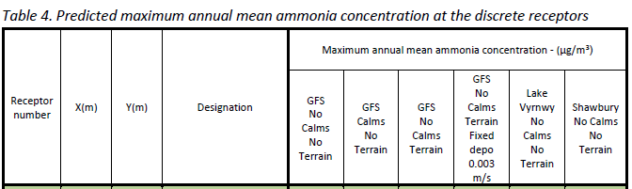
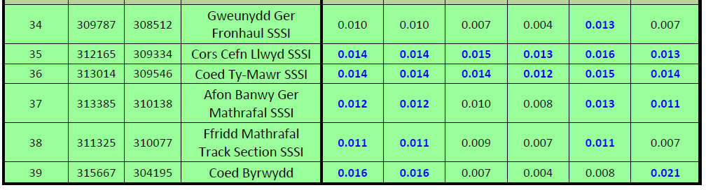

The detailed modelling, which includes ammonia deposition and the consequent plume depletion, was carried out over a restricted domain covering the proposed poultry houses, Cors Cefn Llwyd SSSI and Coed Ty-Mawr SSSI, the area where preliminary modelling (GFS terrain and fixed deposition run) indicated that annual mean ammonia concentrations or nitrogen deposition rates would potentially exceed 1% of the (precautionary) Critical Level of 1.0 μg-NH3/m3.

At the other wildlife sites considered, the preliminary modelling indicated that ammonia levels (and nitrogen deposition rates) would be below Natural Resources Wales relevant lower threshold percentage of Critical Level/Load for the designation of the site.

Terrain effects are likely to be significant at some receptors; therefore, the detailed deposition runs were made with terrain. Calms cannot be used with terrain or spatially varying deposition; therefore, calms have not been included in the detailed modelling; however, the results of the preliminary modelling indicate that the effects of calms are insignificant in this case.

The predicted maximum annual mean ground level ammonia concentrations and nitrogen deposition rates at the discrete receptors within the detailed modelling domain are shown in Table 6. In the Table, predicted ammonia concentrations or nitrogen deposition rates that are in excess of the Natural Resources Wales upper threshold (8% of Critical Level or Load for a SSSI) are coloured red. Concentrations in the range between the Natural Resources Wales upper threshold and lower threshold (1% to 8% for a SSSI) are coloured blue. (shown in the table below)

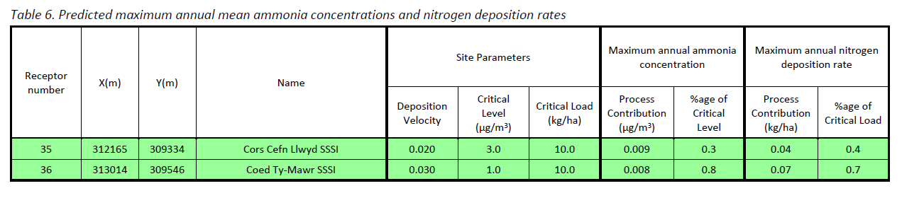

Contour plots of the predicted ground level maximum annual mean ammonia concentration and the maximum nitrogen deposition rate are shown in Figure 6a and 6b (below images).

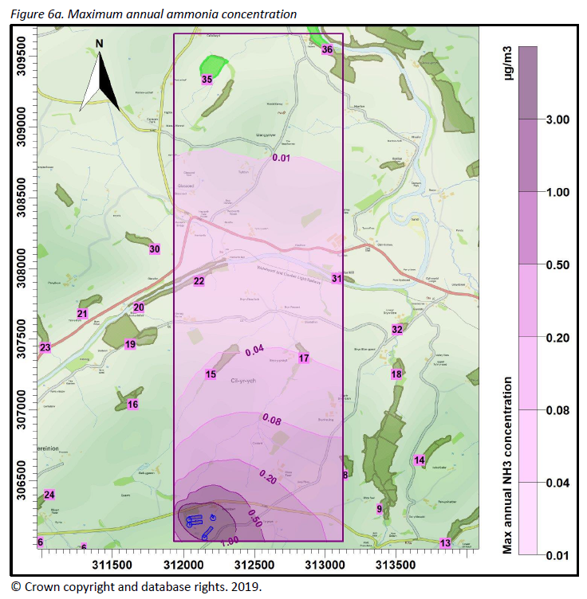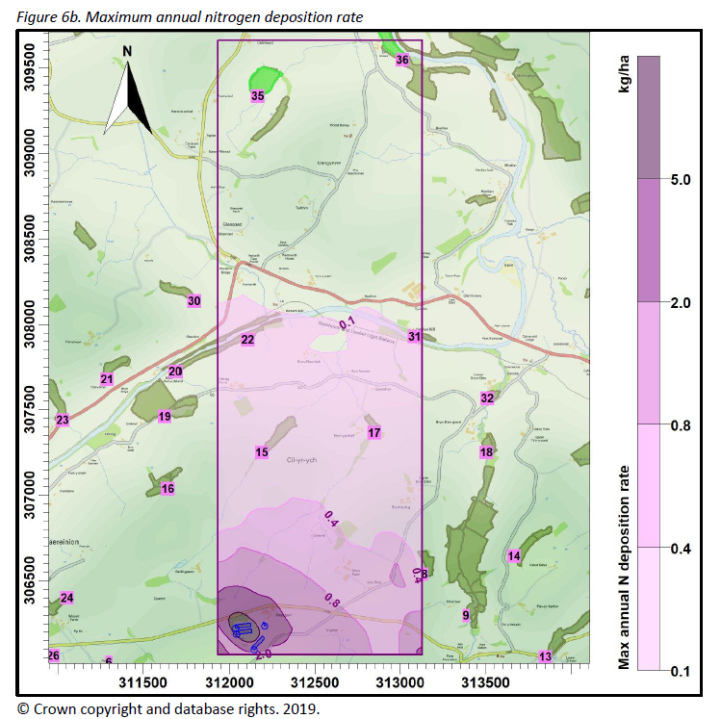

Summary
Ammonia emission rates from the proposed poultry houses have been assessed and quantified based upon the Environment Agency’s ammonia emission factors. The ammonia emission rates have then been used as inputs to an atmospheric dispersion and deposition model which calculates ammonia exposure levels and nitrogen deposition rates in the surrounding area.

At all sites considered, the modelling predicts that the process contribution to the annual ammonia concentration and the nitrogen deposition rate would be below the Natural Resources Wales lower threshold percentage of Critical Level or Critical Load for the site (1% for a SSSI and 100% for a non-statutory wildlife site).

- Decision
Natural Resources Wales is minded to:
Issue the permission

- Name and job title of Natural Resources Wales officer: | Jack Stevens  Permitting Consultant
- Date form sent to NRW conservation/ecology | 11/09/2019
For Natural Resources Wales use only, once NRW conservation/ecology response received
- NRW conservation/ecology comment on assessment: | Please delete as appropriate:  i) NRW conservation/ecology advise the operation can go ahead  ii) NRW conservation/ecology advise the operation can go ahead with conditions  iii) NRW conservation/ecology advise against permitting the operation  Please ensure that the NRW conservation/ecology response is attached to this Formal Notice.
- Name and job title of NRW conservation/ecology officer:
- Date of receipt of NRW conservation/ecology response:

