The comments within this document are based on the information we have received with regards to the lower bund in lower part of the site, but the comments are also relevant to information required for the upper bund and rest of the site.

Report | NRW comments
2.0  The visit was requested in order to assess the design and construction of a bund constructed as secondary containment for a recently constructed bio-digester tank. | The permit condition 3.2.3 states “All liquids in containers, whose emission to water or land could cause pollution, shall be provided with secondary containment, unless the operator has used other appropriate measures to prevent or where that is not practicable, to minimise leakage and spillage from the primary container.”  There are several containers on site that are part of the AD plant and are within the permitted boundary. The digester is located on the upper part of the site, and the digestate storage tank on the lower part. Only bund part of the secondary containment for the lower part of the site has been assessed in the report.
2.0  Natural Resources Wales (NRW), have raised some concerns about the construction of the bund and the potential for leakage of pollutants into the surrounding area. | The requirement set by NRW was to provide confirmation from an appropriately qualified person that the sites secondary containment meets with relevant standards/requirements.  Permit condition 3.2.3 requires “All liquids in containers, whose emission to water or land could cause pollution, shall be provided with secondary containment, unless the operator has used other appropriate measures to prevent or where that is not practicable, to minimise leakage and spillage from the primary container.”  Guidance: How to comply with your environmental permit and CIRIA-C736 Containment systems for the prevention of pollution.
2.0  The site inspection focuses on the quality and suitability of the construction and contains the authors considered opinion as to the viability of the containment area. | The report focuses on the lower bund only. See below for further comments.
3.0  There is a bio-digester tank constructed from pre-formed concrete sections enclosed within a walled area (2900 m²), the wall of which is also constructed from pre-formed concrete sections. Outside the secondary wall there is an embankment of shale mixed with clay (see Photographs in Appendix). | The walled area is stated to be 2900 m². We do not know how this was calculated. No plans have been provided for this. The only plans we have received is for the lower bund wall design.
3.0  Due to heavy rainfall in the preceding twenty-four hours the area within the bund contained a substantial quantity of rainwater. | We have received information that there is a pipe discharging water directly into the lower bund which is not acceptable. Condition 2.2.2 of the permit does not allow the permitted activities to be carried out within 10 metres of any watercourse. See Photo 1 below. What The source of the discharge is unknown.
3.0  The pumping system which had been installed in the site was in operation to remove the water. | We need further information with regards to the pumping of water, including but not limited to:  - At what level of water does the pumping start?  - Does it start manually or automatically?  - At what rate does the pump operate?  - Where is the water pumped to?  - If the pumping is automatic; if there was a waste spill in the bund would pumping be stopped?
3.0  Because of this it was not possible to inspect the ground surface between the wall and the tank however, PFL were able to supply photographs of the area taken during construction of the wall. The ground is of loose shale and clay and photographs of the trenches during construction clearly show bedrock close to the surface. | As the ground surface could not be visually assessed, then it cannot be confirmed that the secondary containment meets the guidance.
3.0  The concrete retaining wall appears to have been constructed to a high standard. Photographs taken by PFL at various stages of the construction process show the methodology employed and these support the initial observations of the finished wall. | We are unhappy with the phrasing of “appears”. We need confirmation that it has or hasn’t been built to the required specification.
3.0  The panels for the bund wall are in pre-stressed concrete and are 180 mm thick. They are manufactured by ACP (Concrete) Limited and installed by Lloyds Brothers Construction Limited. The joints of the concrete slabs utilize a tongue and groove system with SikaSwell S-2 (red), swellable sealant applied to the central tongue and groove and Fosroc Supercast SW (grey), sealant applied to the flat outer edges of the joint. | No comments from NRW.
3.0  Analysis of the design calculations have allowed an appraisal to be made of the structural adequacy of the wall | The results of the appraisal are not clear.
3.0  The concrete panel walls are three metres high, and with a freeboard allowance of 500 mm, the calculated volume of storage over the net area of 2,900 m² is 7,250 m³. | The volume of storage has been stated to be 7,250 m³. It is unknown how this was calculated. No plans have been provided to this. The only plans we have received is for the lower bund wall design.  The guidance states “Where a single bulk liquid tank is bunded, the recommended minimum bund capacity is 110% of the capacity of the tank. Where 2 of more tanks are installed within the same bund, the recommended capacity of the bund is the greater of:  - 110% of the capacity of the largest tank within the bund  - 25% of the total capacity of all the tanks within the bund, except where tanks are hydraulically linked in which case they should be treated as if they were the same tank.”  We do not have any information on the sizes of the tanks, and it does not appear that the whole site in contained in one single continuous bund, nor each area (upper and lower) within their own separate continuous bunds.  At present there is also a discharge of water directly into the bund. This will greatly reduce the bunds capacity and needs to be taken into account in the calculations.  We therefore cannot know if the bund(s) have the correct capacity and if they meet the guidance.
4.0  A noted in Section 3 the wall has been built to a high standard with all joints being uniform and even. Close inspection of the joints shows that the sealant has been applied uniformly and evenly. The photographic archive of the various stages of construction, in addition to the visual inspection, show that the work has been carried out to a high standard in accordance with CIRIA C736 guidelines. | It is unknown what parts of the CIRIA C736 guidelines have been complied with.
4.0  A check on the structural calculations produced by ACP suggested that the moment of resistance of the wall is 91.42 kN m and the applied moment for a depth of water of 3.4 m is 64.26 kN m. There is therefore a theoretical safety factor of 1.4% on failure which is considered satisfactory. | While calculations with regards to the required strength of the wall have been carried out and supplied (we have no assessed this formation at this time), information has not been provided to show compliance with CIRCA C736 guidance (section 6.3.1.) relating to the height of bund walls, proximity to primary storage and jetting (i.e. to ensure profiles are correct and would be sufficient to prevent overtopping in the event of a catastrophic tank failure).  It appears that containment relies on the gradient of the site and the containment walls to channel effluent to the lowest point within the secondary containment system (Lower Bund). However this has not been stated (as whole site containment has not been addressed) and we do not know if this has been modelled at all, or what assessments have been carried out to demonstrate this containment design would work.
4.0  The ground within the enclosed area of the bund is presently of loose shale and photographic evidence shows bedrock close to the surface. The composition of the mudstone in this area is such that it is prone to fracturing and the likelihood of this occurring on a construction site with heavy machinery movements is high. | The bedrock has been given as mudstone which is “prone to fracturing” this is concerning. See below.
4.0  The ground condition in its present state is likely to be permeable and would therefore be ineffective as a containment medium.  It is understood from PFL that there is a DPM membrane below the surface shale but conditions on the day of the site visit meant that it was not possible to confirm this.  PFL have also advised that the ground between the tank and the wall will be concreted as part of Phase 2 of the project. Re-surfacing of the yard area with concrete close to the site has already commenced and it is understood that the entire yard including the bund will be concreted in due course. | “The ground condition in its present state is likely to be permeable and would therefore be ineffective as a containment medium.” This is unacceptable.  It has not been confirmed that there is a DPM membrane below the surface shale.  It is unknown how was it decided that a damp proof membrane was the most appropriate method to seal the floor of the bund, how thick the damp proof membrane is, how it was installed, how the applicant can be sure it is intact, has not or will not be be punctured by the shale or the underlying bedrock especially when traversed by heavy machinery.  NRW has seen the damp proof membrane used which appears to be the type of plastic sheeting used when concreating the floor of a domestic property. We question its suitability for the purpose its been used for.
4.0  When the ground between the tank and the wall has been sealed with an adequate depth of concrete, the bund wall can then be regarded to be fully effective. | Until the ground of the bund has been concreted, the secondary containment can be deemed complaint with the guidance or the permit condition.
4.0  Until such time, the loose surface area cannot be considered an effective leak-proof barrier and it was recommended to PFL that an impermeable plug of soil be created along the outer face of the wall to a depth of 1m. A schematic drawing with a specification of the requirements passed to PFL has been included at the end of this section. This backfill will also increase the stability of the wall by counterbalancing the overturning effect should any leakage occur. | No comments from NRW.
4.0  It should be noted that at the time of the second visit to the site on Sunday the 10th of November 2019, the external backfilling had been satisfactorily completed and the bund adequately sealed. | The outside of the lower bund wall has been sealed, however the floor of the bund is still unsealed.
4.0  It is recommended that a further inspection be made of the site when the Internal base of the bund has been concreted. | It is after this point that this report should be submitted, taking into account the above comments and all of the relevant parts of the CIRCA C736 guidance

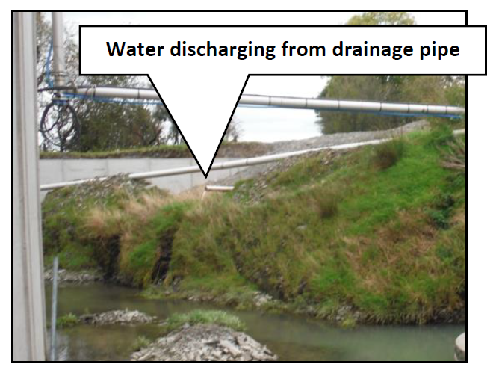
Photo 1

