Permit Number: | PAN-003874
Applicant name: | Mr Thomas Wyn Anwyl
Site Address: | Land at Maesmedrisiol, Pennant, Llanbrynmair, Powys, SY19 7BN
Discharge Point NGR: | SN 87709 94377
Respond by date: | 20/02/2019 (10 working days)
Permitting Officer: | Jason Copsey

Brief Description of proposal:

Application to discharge used Organophosphate sheep dip three times a year, once in July, August and September. Max volume of spreading activity in one day will be 2.1m³ used dip diluted to ratio of 3:1 with water or slurry totalling 8.4m³/d. Total area available for discharge is 8.79 ha. Min required per discharge is 0.42 ha.

Habitats Screening Report – Designations or protected species/habitats:

Ceunant Twymyn SSSI was found within a 1km screening distance of the proposed discharge.

An Appendix 4 assessment has been completed and Filed for Audit on the DMS here.

The screening report can be found on the DMS here.

Risk Assessment Results (modelling or L1 Risk Assessment):

The score on the L1 was 79. This is mainly as a result of high leaching soils, unknown saturated zone thickness and proximity to a GW receptor.

The L1 assessment can be found here on the DMS.

Miscellaneous:

NRM Responses:

Environment Management comments:

Officers name:
Date:

Biodiversity comments:

N/A

Officers name:
Date:

Fisheries comments:

N/A

Officers name:
Date:

Conservation/Ecology Comments:

Officers name:
Date:

Internal Consultation Responses from other NRW Teams:

Water Quality Planning:

N/A

Officers name:
Date:

Geoscience Response:

Geoscience have reviewed the level 1 assessment provided and the general site setting, and application information submitted. It is noted than an area of 0.42ha is required per discharge. Provided that the discharges are located within the flatter area of the field (as demonstrated in the below drawing), the discharge is likely to be acceptable and within a reasonable distance from identified receptors.

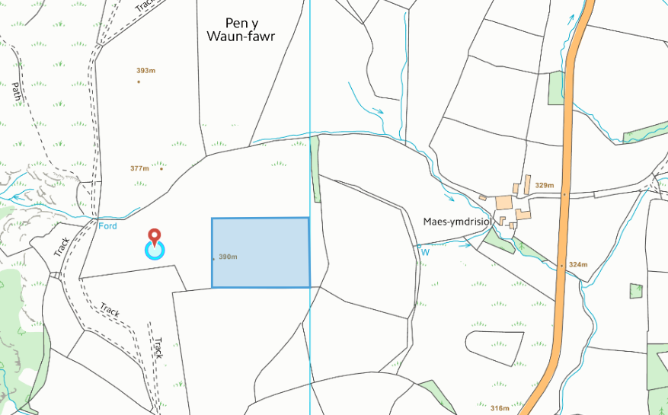

Officers name: Haf Peskett
Date: 22.02.19

Flood Risk Management:

N/A

Officers name:
Date:

External Consultations sent to: | Yes/No
National Parks | No
Water Company regarding Drinking Water Protected Zone / SPZ1 | No
Environmental Heath | No

Any Permitting Responses:

Date:

