Permit
The Environmental Permitting (England & Wales) Regulations 2016

SBS Salvage Limited

SBS Salvage
Unit 13A
Atlantic Trading Estate
Barry Docks
Barry
CF63 3RF

Permit number

EPR/BB3499ZN

Permit
The Environmental Permitting (England and Wales) Regulations 2016

Permit number

EPR/BB3499ZN

The Natural Resources Body for Wales (“Natural Resources Wales”) authorises, under regulation 13 of the Environmental Permitting (England and Wales) Regulations 2016

SBS Salvage Limited (“the operator”),

whose registered office is

Singleton Court Business Park

Wonastow Road Industrial Estate (West)

Monmouth

Monmouthshire

NP25 5JA

company registration number 07688221

to operate waste operations at

SBS Salvage

Unit 13A

Atlantic Trading Estate

Barry Docks

Barry

CF63 3RF

to the extent authorised by and subject to the conditions of this permit.

Under regulation 27(2) of the Regulations, standard rules SR2008No20 are conditions of this permit.

Name | Date
Huw Davies | 02/01/2020

Authorised on behalf of Natural Resources Wales

Schedule 1 - Site plan

This is the plan referred to in the standard rules SR2008No20.
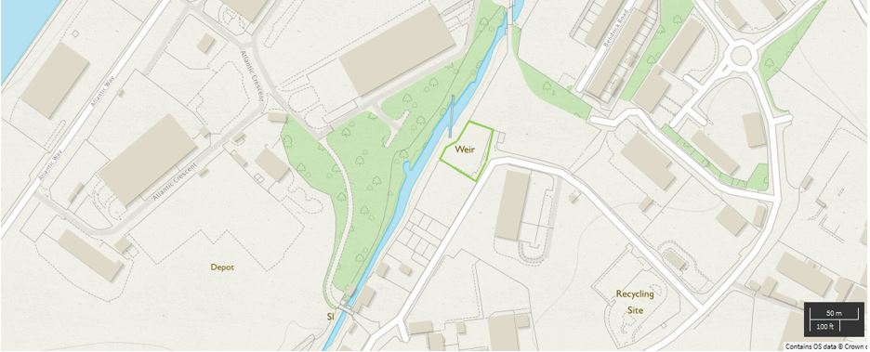

© Crown Copyright and database right 2019. Ordnance Survey licence number 100019741.

END OF PERMIT

