Notice of variation with introductory note
Environmental Permitting (England & Wales) Regulations 2016

Servmax Limited

Servmax Ltd
Lower House Farm
Coed Morgan
Abergavenny
NP7 9UD

Variation application number
EPR/BB3498CZ/V002

Permit number

EPR/BB3498CZ

Servmax Ltd

Permit number EPR/BB3498CZ

Introductory note

This introductory note does not form a part of the notice

The following notice gives notice of the variation of an environmental permit.

This is a regulator led variation to amend the site plan as the plan in the original permit was incorrect.

The schedules specify the changes made to the original permit.

The status log of a permit sets out the permitting history, including any changes to the permit reference number.

Status log of the permit
Description | Date | Comments
Permit determined  EPR/BB3498CZ | 05/12/19 | Original permit issued to Servmax Limited.
Application EPR/BB3498CZ/V002 | Duly made  12/12/19 | Application to amend site plan.
Variation determined EPR/BB3498CZ | 06/01/20 | Varied permit issued.

End of introductory note

Notice of variation
Environmental Permitting (England and Wales) Regulations 2016

The Natural Resources Body for Wales (“Natural Resources Wales”) in exercise of its powers under regulation 20 of the Environmental Permitting (England and Wales) Regulations 2016 varies

Permit number

EPR/BB3498CZ

issued to:

Servmax Limited (“the operator”)

whose registered office is

Suite 10 Equinox Centre

Sankey Street

Warrington

England

WA1 1NN

company registration number 12029885

to operate a regulated facility at

Servmax Ltd

Lower House Farm

Coed Morgan

Abergavenny

NP7 9UD

to the extent set out in the schedules.

The notice shall take effect from 06/01/2020

Name | Date
Huw Davies | 06/01/2020

Authorised on behalf of Natural Resources Wales

Schedule 1 – conditions to be deleted

None

Schedule 2 – conditions to be amended

None

Schedule 3 – conditions to be added

None

Schedule 4 – amended plan

Amended plan attached
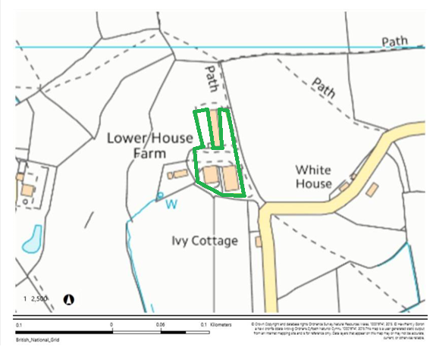

© Crown Copyright and database right 2019. Ordnance Survey licence number 100019741.

