EMERGENCY & INCIDENT RESPONSE PLAN

Address: | Tradebe Healthcare - Wrexham  Marlborough Road  Wrexham Ind Est  LL13 9RJ

Nature of Business: | Collection, Treatment and Disposal of Healthcare Waste

Date of Plan: | 10th December 2019 | Review Date: | 10th December 2022

Approved by: | Vince Norris | Date: | 10th December 2019

 | Copies to: |  | Date Sent:
Environment Regulator ……….. | EA – Matthew Kelk
Other ……………………………….. | North Wales Fire Brigade
Internal ……………………………..

CONTENTS
Page
2. | Emergency Contact Details
3. | General Procedure for Responding to an Incident
4. | Site Drainage Plan (including surface water isolation point)
5. | Site Utilities Isolation Points
6. | Site First Aid location & equipment
7.  8. | Fire Assembly point  Fire Alarm locations
9. | Site Inventory
10. | Index of Emergency Procedures

2. EMERGENCY CONTACT DETAILS:

Emergency Services: | 999
Local Police | 101
Local Hospital: | 01978 291100
Environmental Hotline: | 03000 653000
Environmental Regulator: | 03000 653844

IMPORTANT CONTACTS:
 | Office Hours |  | Out of Office
Local Authority: …………………………………..  (Wrexham City Council) | 01978 292000 |  | 01978 292000
Sewerage Provider: ………………………………  (Welsh Water) | 0303 313 0021 |  | 0303 313 0021
Water Supplier: …………………………………..  (Dee Valley) | 01978 833200 |  | 01978 833200
Gas Supplier: ………………………………………  (National Grid) | 0800 111 999 |  | 0800 111 999
Electricity Supplier: ………………………………  (Scottish Power) | 0800 0015400  Or 501 |  | 0800 0015400  Or 501
Waste Management Contractor: ………….  (Haulage, Browns) | 07483 300231
COMPANY CONTACTS:

Site Manager: | Vince Norris | 07918 912912
Plant Manager: | Paul Phillips | 07891 075859
SHEQ Manager: | Lorna Steel | 07879 473097
National Operations Manager | Paul Simpson | 07483 300231

3. General Procedure for Responding to an Incident
Incident Discovered
Incident Occurs

Is Emergency life threatening or dangerous to environment
No
Inform Supervisor/Manager
Yes

Can emergency be tackled at source safely?

No

Yes

Restrict Access and Wait for Manager
Implement Response Procedure Isolate and contain at source

Manager/LIC assesses situation. Can emergency be contained?
Implement Response Action
Yes

No
Is situation under control?
No
Evacuate Area/Building, Use fire Alarm

LIC contact/liaise with emergency services other Managers
Yes

Is Situation under control?
Inform Relevant Company & regulatory contacts investigate & complete incident report on QPulse
No Yes

4. SITE DRAINAGE PLAN
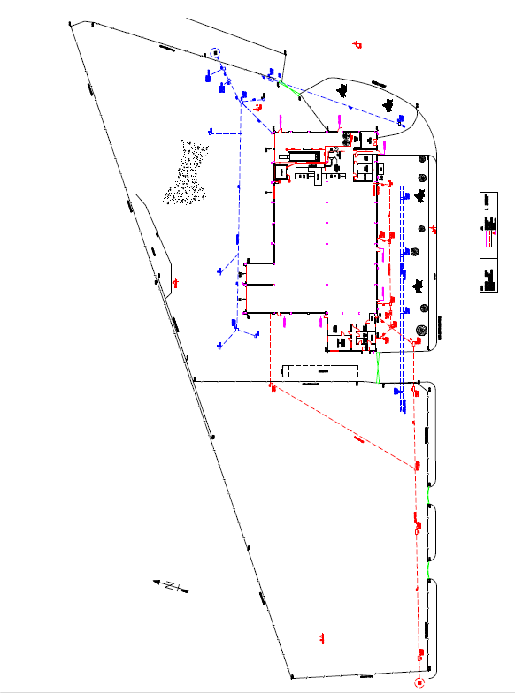
Penstock valve to isolate surface water drains situated behind porta cabin on perimeter fence.

**THE PENSTOCK VALVE IS KEPT CLOSED AT ALL TIMES UNDER NORMAL OPERATING CONDITIONS**

BLUE LINE INDICATES SURFACE WATER
RED LINE INDICATES FOUL SEWER

5. SITE UTILITIES ISOLATION POINTS
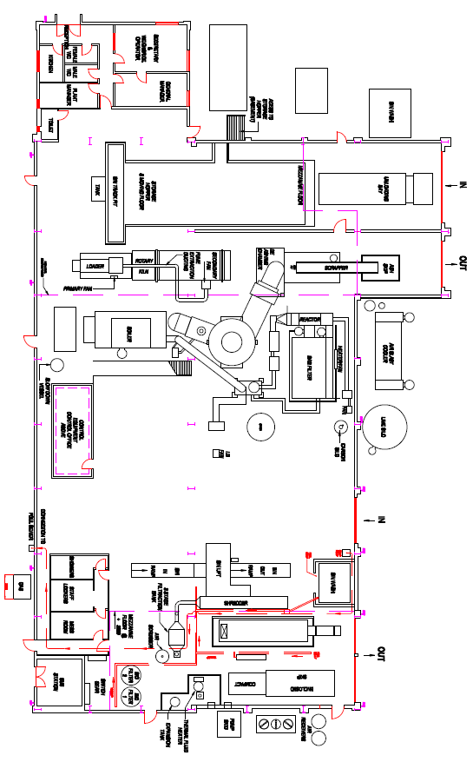
Internal electrical Isolator
Sub Station
Scottish Power
Main Gas Supply & isolation valve

6. FIRST AID LOCATIONS

First Aid locations:

Main reception (During office hours)
First Aid and utilities Room Next to mess room

On site Equipment:

Defibrillator – Control room
First aid kit –Control Room

7. FIRE ASSEMBLE POINT

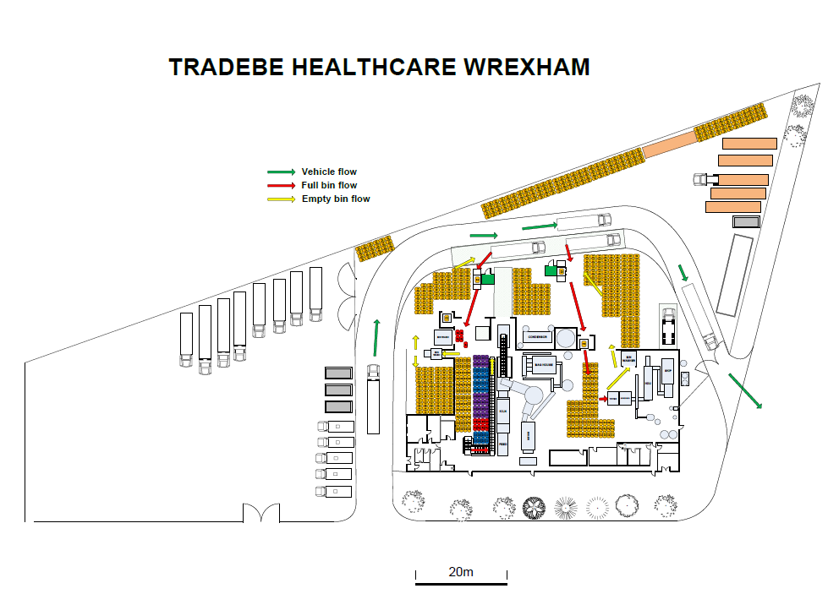
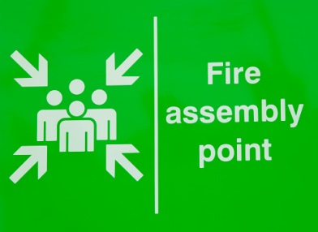
FIRE ASSEMBLE POINT CORNER OF THE LORRY PARK

Evacuation Procedure:
- Administrators to collect visitors signing in book, the waste booking in sheet and the shift rosta on route to the fire assembly point.
- Incident controller will check all personnel have evacuated and arrived at the assemble point, all names will be recorded on Evacuation form EVAC001

8. FIRE ALARM LOCATIONS

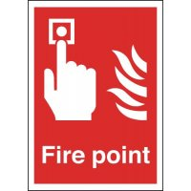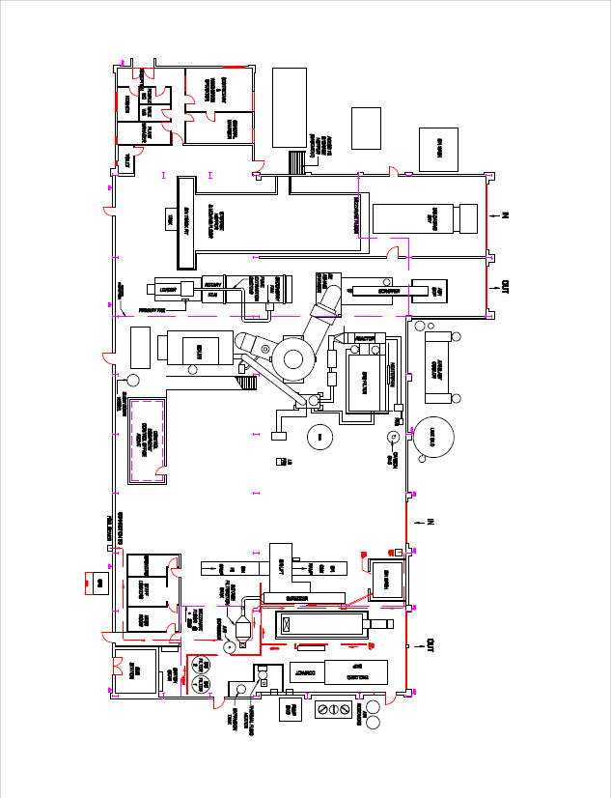
6

5

4

3
2
1
Fire Alarm system control panel

9. CHEMICAL, PRODUCT AND WASTE INVENTORY

Trade Name | Substance | Hazard | Solid / liquid / gas  or  powder | Container size | Maximum quantity  (Peak Times)
HYDRANSAFE 46 | Hydraulic oil | Low | LIQUID | 200LTR | 400ltr
KLEENKILL | DETERGENT | LOW | LIQUID | 25lt | 200lt
SORBACAL | HYDRATED  LIME | LOW | POWDER | LOOSE | 15 ton
DE-IONISED  WATER | WATER | LOW | LIQUID | 25lt | 50lt
CERGUN 1600 | REFRACTORY | LOW | POWDER | 25kg | 6 ton
DURAGUN  1600 | REFRACTORY | LOW | POWDER | 25kg | 6 ton
CARBOWOOL | INSULATION BLANKET | LOW | SOLID | 25kg | 50kg
LITHIUM  GREASE | GREASE | LOW | SOLID/LIQUID | 5kg | 100kg
CORRABAN 66 | BOILER CHEMICAL | MEDIUM | LIQUID | 25lt | 75lt
POLYTAN 4C | BOILER CHEMICAL | MEDIUM | LIQUID | 25lt | 75lt
POLYSHIELD 300 | BOILER CHEMICAL | MEDIUM | LIQUID | 25lt | 200lt
MUCSHIFTA | DEGREASER | HIGH | LIQUID | 205lt | 410lt
WGHF | HYRAULIC OIL | LOW | LIQUID | 205lt | 410lt
BOTTOM ASH | ASH | LOW | SOLID / LIQUID | 12 Yard Skip | 2 Skip
APC  RESIDUES | SORBENT | HIGH | POWDER | 1 ton IBC Bags | 20 IBC Bags
ACTIVATED  CARBON | CARBON | LOW | POWDER | 25kg | 3 Ton Pallet
DIESEL | OIL | HIGH | LIQUID | 1000ltr | 800ltrs
PALLETS | WOOD | MEDIUM | SOLID | 70Pallet | 70 Pallets
SPAN GASES | CEM GASES | MEDIUM | GAS | 10lt Bottles | 10 Bottles
FUEL GAS | Hydrogen & Helium GASES | HIGH | GAS | 50lt Bottles | 6 Bottles
IBC BAGS | PLASTIC | LOW | SOLID | 200 Bags | 2 Pallets
PAINTS | PAINT | MEDIUM | LIQUID | 5lt | 15 tins

10. INDEX OF EMERGENCY PROCEDURES
The following is a list of foreseeable emergency conditions that may be relevant depending on site circumstances. These will require initiation of the emergency procedure and possibly involvement of the emergency services.
Fatality  Fire  Explosion  Gas leaks  Flood  Major Spillage | Catastrophic plant failure  Electrical failure  Unsafe structure/subsidence  Vehicle accident | Bomb or other threat  ‘Discovery’ of hazardous /dangerous substances  Off-site incidents affecting the site  Industrial Action  Protest action

