Toxocara
Proposed solution to remove it from treated dogs trust effluent.
Toxocara canis (also known as dog roundworm) is a helminth parasite, which is present globally in dogs and other canids. Toxocara canis is also gonochoristic with adult worms measuring from 9 to 18 cm, being yellow-white in color and are found in the intestines of many Canids, the most common being dogs.
In adult dogs, the infection is usually asymptomatic. By contrast, massive infection with Toxocara canis can be fatal to puppies.
As a paratenic hosts, a number of various vertebrates (including humans) and some invertebrates can also become infected. Infection is caused, like other paratenic hosts, by ingestion of embryonated T. canis eggs. The disease (called Toxocariasis) caused by migrating T. canis larvae (toxocariasis) results in two syndromes: visceralis larva migrans and ocularis larva migrans.

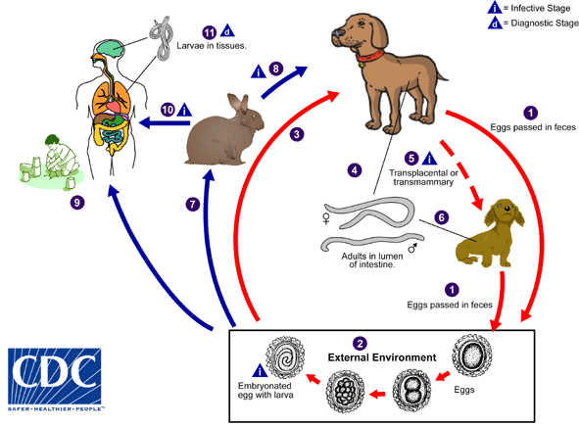

The Design Problem
Animal welfare centres around the UK require a means of disposal of sewage waste including dog faeces and in the past connection to the public sewer system has been an acceptable option. However, due to changes in regulations relating to the risk of Toxcara infection on site treatment has become the only cost effective alternative. In some situations it is not possible to obtain a discharge permit from the Environment Agency for discharge of a treated effluent into the environment and this has led to the investigation of methods of removal of Toxocara from waste that has been in contact with dog faeces.
The Toxocara worm is easily removed but eggs between 60 ad 78 micron diameter present a different challenge.
Toxocara eggs have a strong protective layer which makes the eggs able to survive in the environment for months or even years under the right conditions. Many common disinfectants are not effective against Toxocara eggs but extreme heat has been shown to kill the eggs. Prompt removal of animal faeces can help prevent infection since the eggs require 2 to 4 weeks to become infective once they are out of the animal.

The Solution
All foul waste, including dog faeces, from the site should be treated using a WPL HiPAF package Treatment Plant to achieve a treated effluent standard of 20 BOD:30 Suspended Solids:20 Ammoniacal Nitrogen. The treated effluent can then be passed through a WPL Drum Screen fitted with a 20 micron filter cloth. The Drum Screen will remove all parts of the Toxocara lifecycle and thus render the screened effluent suitable for discharge to sewer. The Drum Screen is an end of pipe solution which will filter out all material over 20 microns in size on a 100%ile basis.
Any particles removed by the filter will be delivered to a sludge digestion module along with primary settled solids and waste sludge will be removed from site by road tanker and taken to a works for approved disposal incorporating incineration of the final arisings.

Process description:
Water containing solid particles passes through the inlet pipe into the centre of the disc shaft, where impurities are retained on the inside of the filter cloth as filtered fluid flows out through the cloth. During this process the backwash system remains dormant. As the filter cloth slowly becomes obstructed with the increasing amount of filtered impurities, the flow resistance increases and the water level inside the disc cartridges rises.
The installed filter:
When the internal ‘high level’ set point is reached inside of the filter discs, via the water pressure probe, the drum drive and backwash pump is initiated. This in turn, with the use of the spray bar nozzles removes detritus from the screen, collecting it in the sludge collection trough in the centre of the unit. The ‘sludge’ debris is then carried, by gravity, in to the sludge collection chamber at the rear of the unit. The sludge collection chamber is also controlled by a pressure probe, such that when the pump set point is reached the sludge pump is initiated, conveying the sludge to the desired collection point. If the sludge is discharged by gravity flow, the sludge pump is not necessary. Thanks to backwash the filter cloth permeability is restored.

Note: sludge pumps are a standard size and as such it will be the responsibility of the site to ensure that the correct flowrate is achieved.

Following the backwashing of the filter elements the fluid level within the filter will drop deactivating the rotational drive, when the set point has been reached. The drum drive will remain dormant until the upper set point has been achieved again. Flow to the filter remains un-interrupted during filter operation with no additional requirement for sludge storage or backwash and therefor reducing the capital costs. The entire process is controlled by differential pressure probes, which are controlled by the programmable logic controller (PLC). Filtration efficiency increases as the base layer of suspended solids increases the, thus meaning the average water filtration capacity increases, enforcing the consent requirements.

Filter description:

General arrangement:
Discfilter general arrangement

Filtration Element:
The basic filtration element is a filter cassette circular in shape, coated with polyester. Cartridges are held in place by the lock rail and screw, putting tension on the cartridge base, and sealing it in position.
Filtration element configuration
The filtration modules can be changed individually; figure 5.3 shows the arrangement of the cartridges. Each cartridge can be replaced individually by loosening the tensioning bars and removing the cartridge. Each of the discs contains twelve separate cartridges. Each of the cartridge bodies is made from moulded ABS with the pre tensioned polyester screen bonded to it. The screens are available in 10, 20, 30 and 40µm.
Figure 5.3. Filter disc assembly
The inside of the discfilter shaft.
Water flows from the centre of the discfilter shaft and out in to the treated water reservoir; therefore particulate matter is deposited on the inside of the filter screen.

