Hydrometry & Telemetry SE Area
Flow Gauging report: Newport Dock Feeder
Measuring points:
- Point 1 – Dock Feeder @ Tredegar Park Gauge (056029; existing flow site)
  - ST 27951 86697
- Point 2 – Inflow into Tredegar Park Lake
  - ST 28518 85805
- Point 3 – Outflow from Tredegar Park Lake
  - ST 29096 85389
- Point 4 – Dock Feeder upstream of Pontycwcw reen offtake
  - ST 29248 85846
- Point 5 – Pontycwcw reen
  - ST 29431 85844
- Point 6 – Visual check to see if water is overtopping overflow weir
  - ST 29399 85861

Date: 17/10/2017
Time: 09:30 – 13:45 GMT
NRW Officers present: John Evans and Hayley Corless
Flow Q value: Q68
Comments:
A flow gauging survey, at the points listed above, was undertaken at the request of South Wales Hydrology team, to assist with determination of an abstraction licence. Weather conditions on the day were stable and dry. River flow conditions (from Rhiwderin) were falling slowly with stage decreasing from 0.385m to 0.380m over the survey period.

Maps & Photographs:
Point 1 – Dock Feeder @ Tredegar Park Gauge
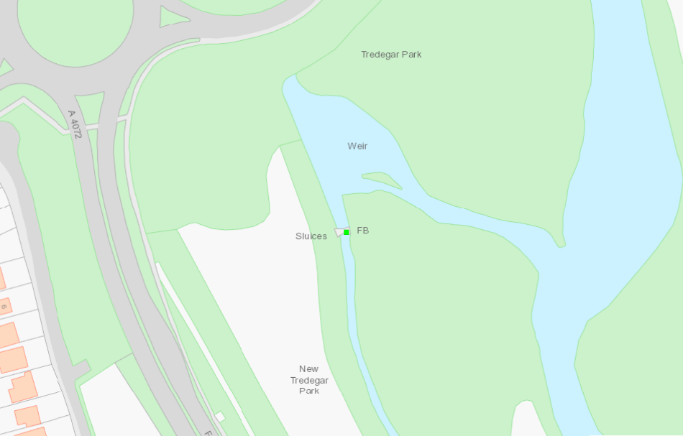
Point 1: Tredegar Park gauge
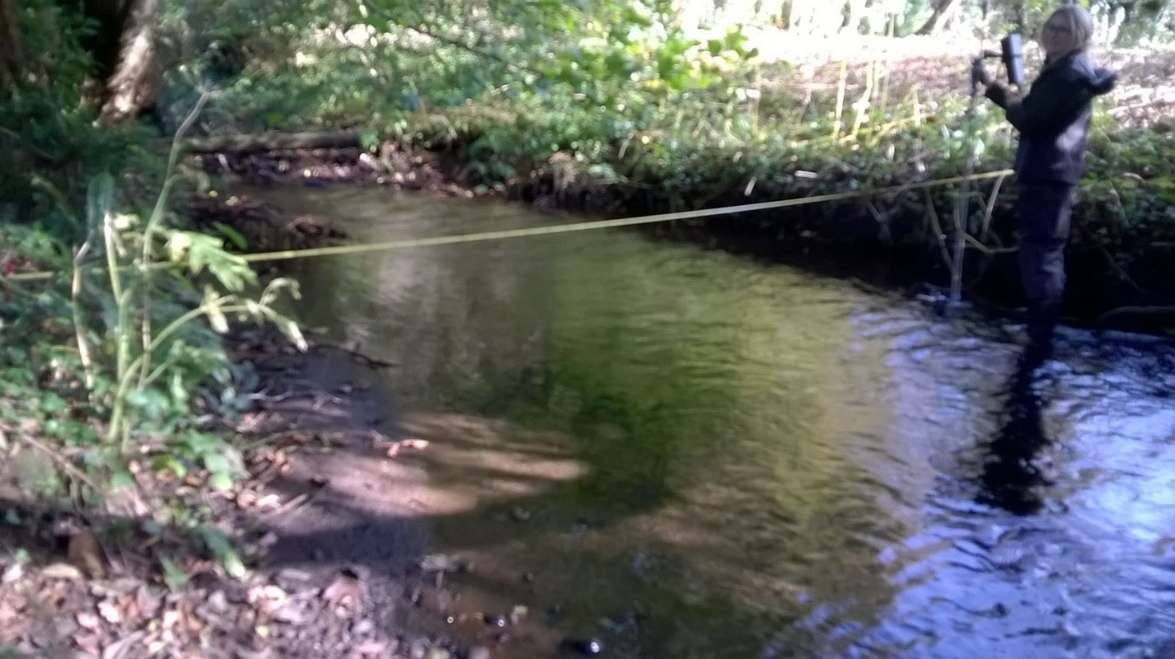
Point 1

Point 2 – Inflow into Tredegar Park Lake
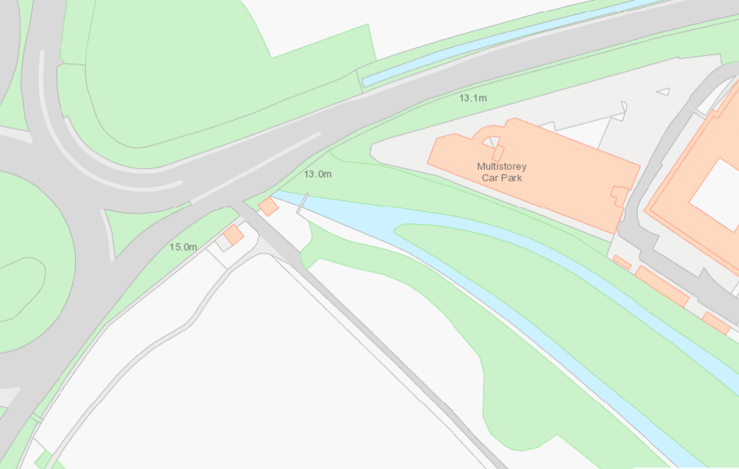
Point 2: Inflow into Tredegar Park Lake
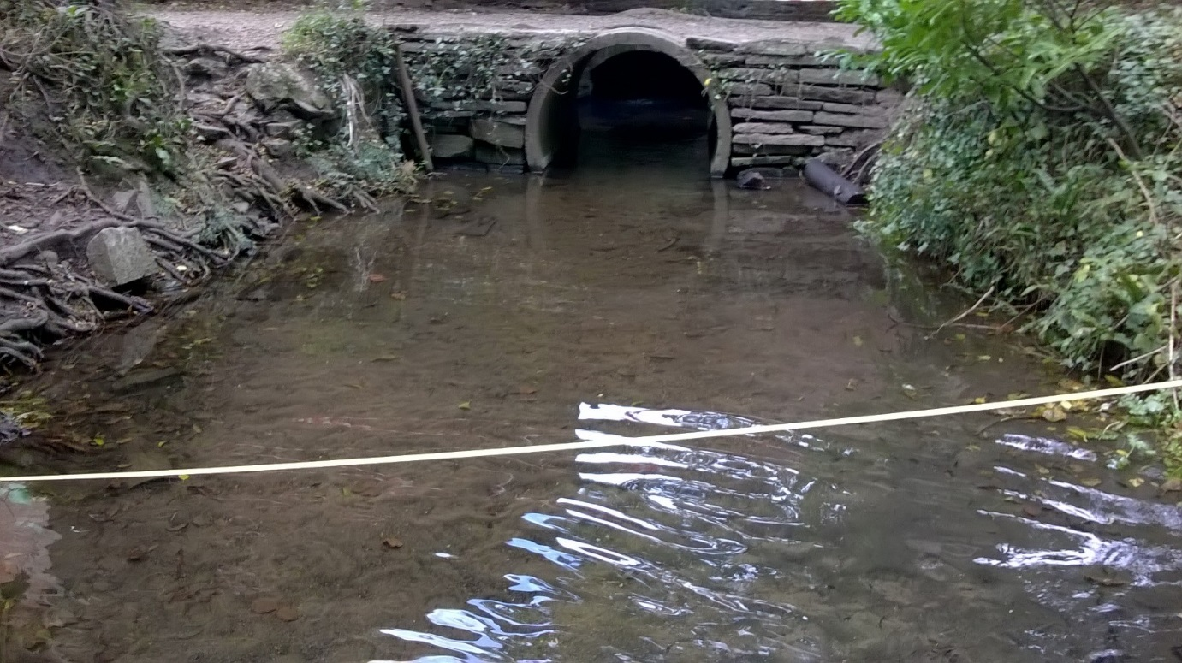
Point 2
Point 3 – Outflow from Tredegar Park Lake
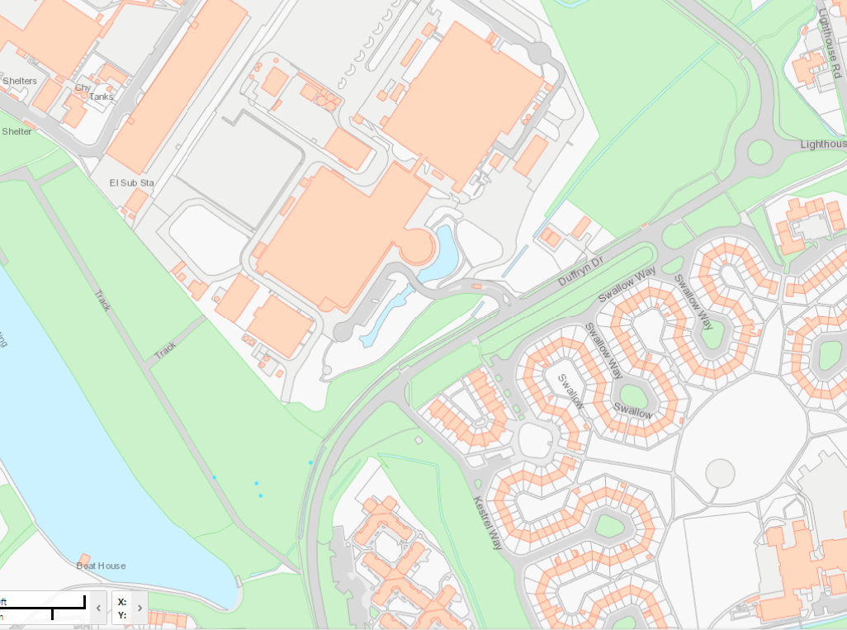
Point 3: Outflow from Tredegar Park Lake
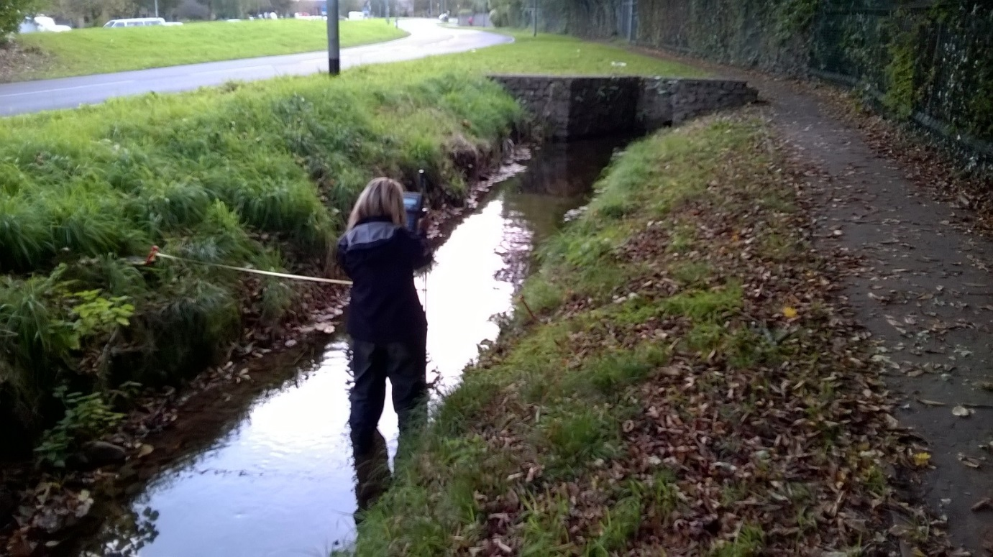
Point 3

Point 4 – Dock Feeder upstream of Pontycwcw reen offtake
Point 5 – Pontycwcw reen
Point 6 – Visual check to see if water is overtopping overflow weir
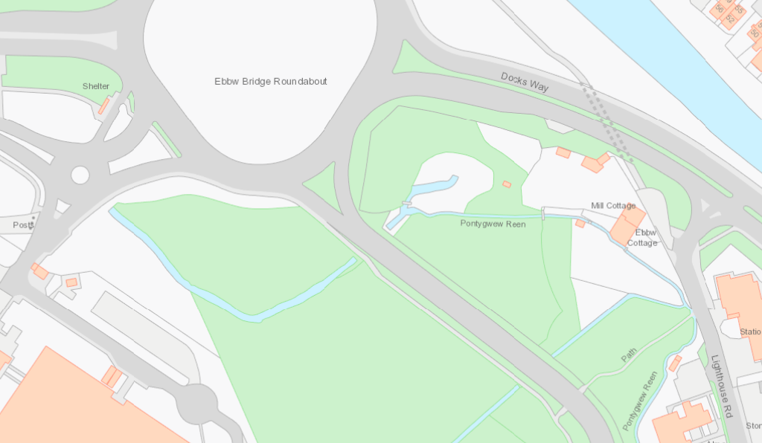
Point 5: Pont-y-cwcw reen

Point 6: Visual check to see if water is over-topping overflow weir (no gauging required)
Point 4: Dock Feeder u/s Pont-y-cwcw reen offtake

(There is an existing gauging location in WISKI: BASALEG06)

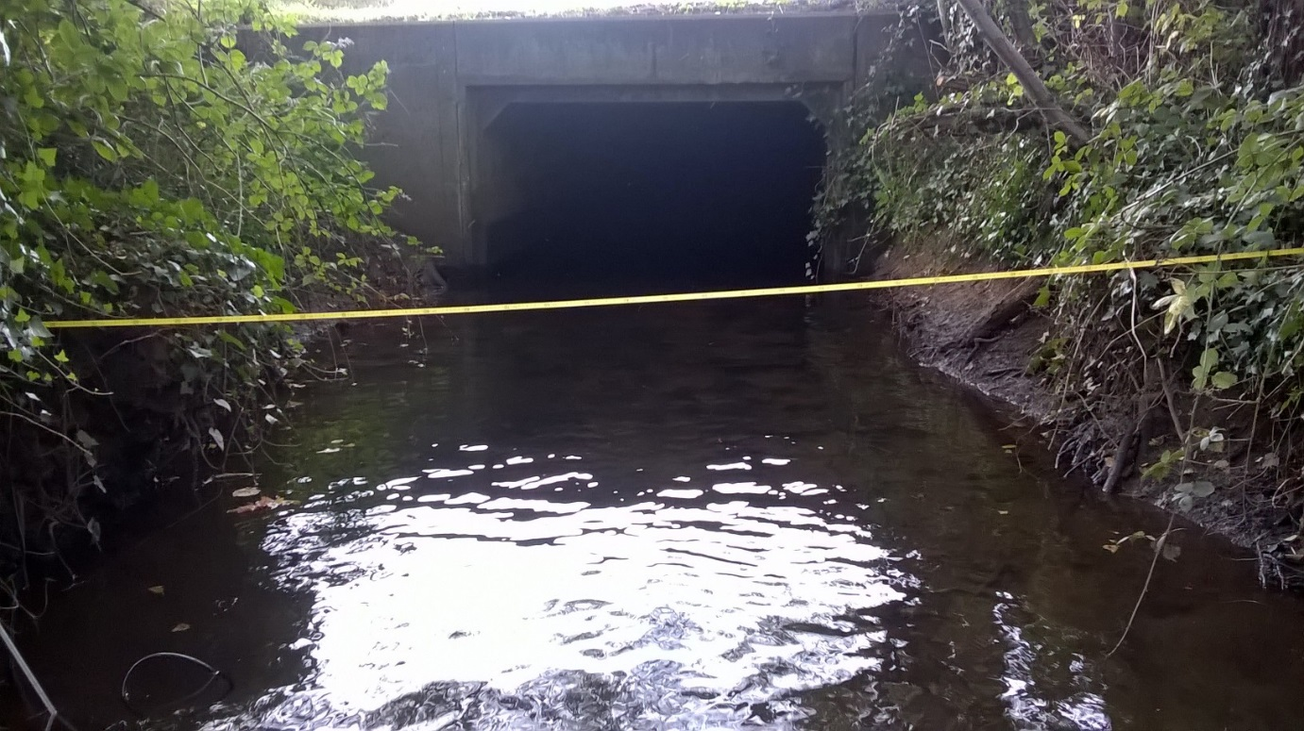
Point 4

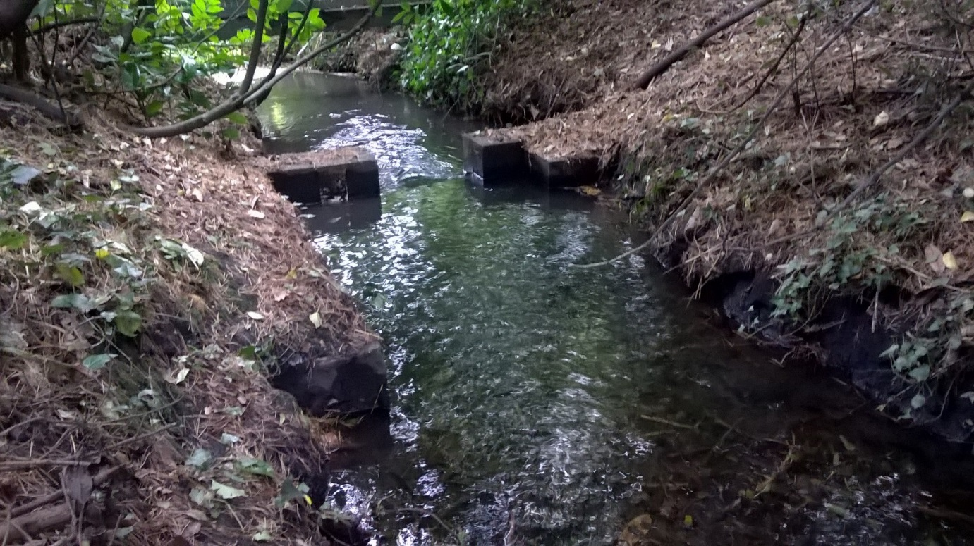
Point 5
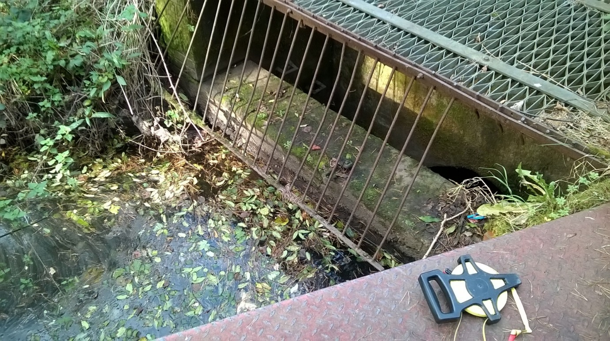
Point 6

Results:
Point 1 – Dock Feeder @ Tredegar Park Gauge (056029; existing flow site)
0.126 m³s⁻¹ Stage 0.457
Point 2 – Inflow into Tredegar Park Lake
0.034 m³s⁻¹ Stage 0.120m
Point 3 – Outflow from Tredegar Park Lake
0.038 m³s⁻¹ No SG present
Point 4 – Dock Feeder upstream of Pontycwcw reen offtake
0.068 m³s⁻¹ No SG present
Point 5 – Pontycwcw reen
0.022 m³s⁻¹ Stage 0.257
Point 6 – Visual check to see if water is overtopping overflow weir
Status – Weir NOT being overtopped

Flows were measured to ISO 748:2007 standard using a Flowtracker ADV current meter and QA’d under ISO 1088:2007 guidelines. The uncertainty in the measurements could be up to 15% due to site conditions.

