NRW Transitional Water Resources Licence Application for Gwent IDD
Newport Dock Feeder - Supporting info – schematic and photos

Abstraction from the Newport dock feeder to supply the IDD has been operated by Internal Drainage Board / NRW for 30+ years by John Southall (Operations Delivery / Water Levels Supervisor). The abstraction location from the dock feeder is not located within the IDD boundary, however, access to abstraction location has not been contested in this time. See Witness Statement dated 10/12/2019.

Schematic to show Flow Paths associated with the River Ebbw and the Newport Dock Feeder Channel

Key:
Open Channel

Culvert
BASSALEG WEIR
Direction of Flow

Bassaleg Weir

Overflow
Spillway

N R
E I
W V
P E
O R
R
T

D
O
C
Tredegar House Lake K E
B
B
W
F
E
E
D
E
R

C
H
A
N
N
E
L
Pont-y-cwcw Reen Overflow
(Caldicot and Wentlooge
Levels)
Sandy Lane Pumping Station

The Docks Usk / Severn Estuary

Notes from site visit 9th February 2016 – John Southall, Owain Sheppard, Martin Clarke

Sluice from the dock feeder into Pont-y-Cwcw reen:
- Actively managed by IDD staff.
- During the winter months (during winter penning levels) this is closed down with only a minimal amount of leekage through the sluice
- In the summer sluice gate is opened to supply flow to Caldicot and Wentlooge Levels (to maintain summer penning levels)
- V-notch weir a short distance downstream of sluice gate used by IDD staff to help operate sluice gate. Normally work on ½ inch from top of V to maintain sufficient flow into the levels.
- IDD estimate that approx. 10% of Dock Feeder flow is diverted into the Pont-y-Cwcw reen

Photos

Photos from site visit Aug 2000 – Newport Dock Feeder

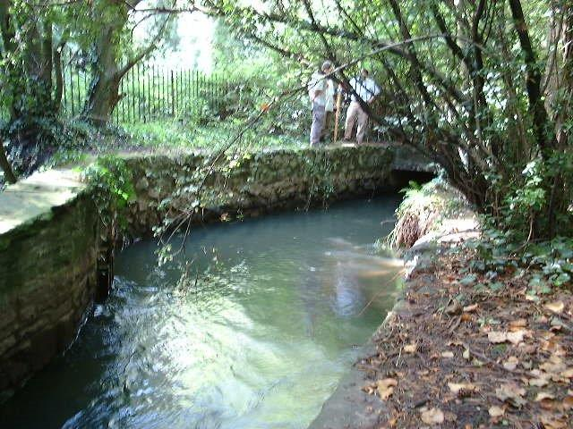
Newport Dock Feeder 1
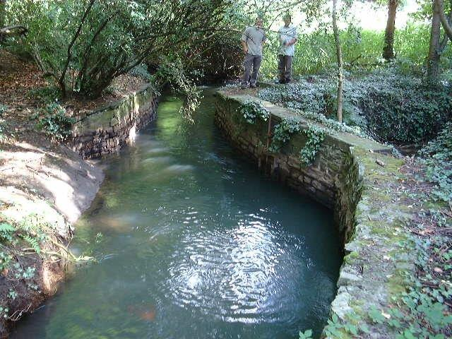
Newport Dock Feeder 2

Photos from site visit Aug 2000 - Offtake from Newport Dock Feeder to Pontycwcw Reen

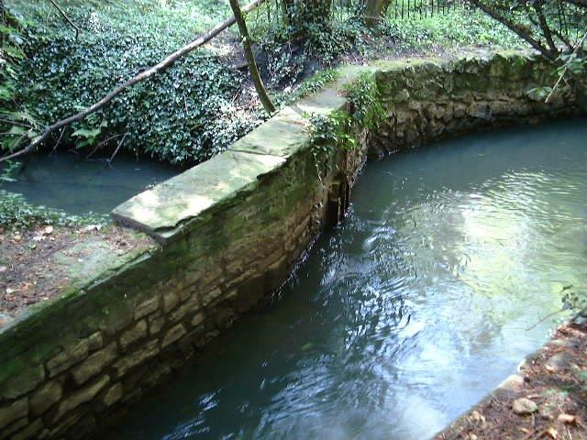
Newport Dock Feeder – sluice and reen

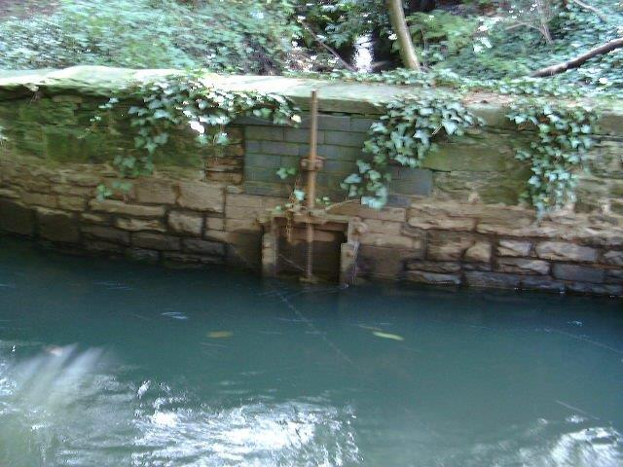
Reen intake Sluice

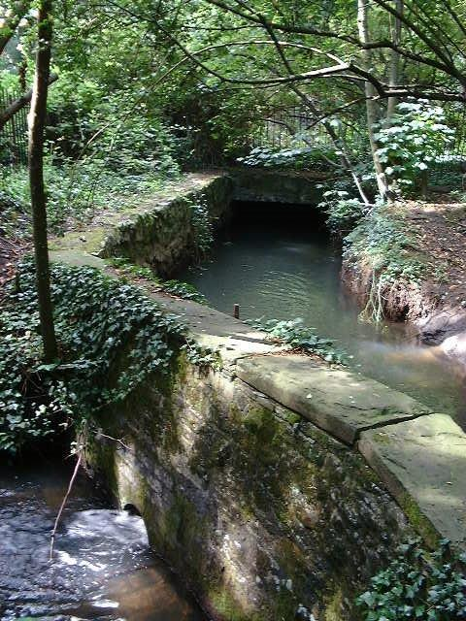
Reen just downstream of intake

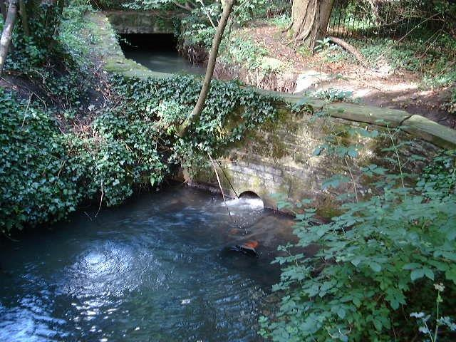
Feed from Newport Dock Feeder

Photos from site visit Aug 2000 - Offtake from Newport Dock Feeder to Tredegar Lakes

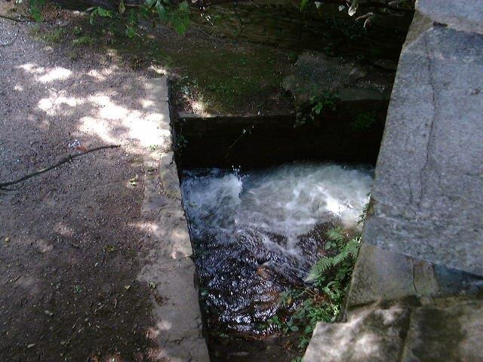
Inflow near A48

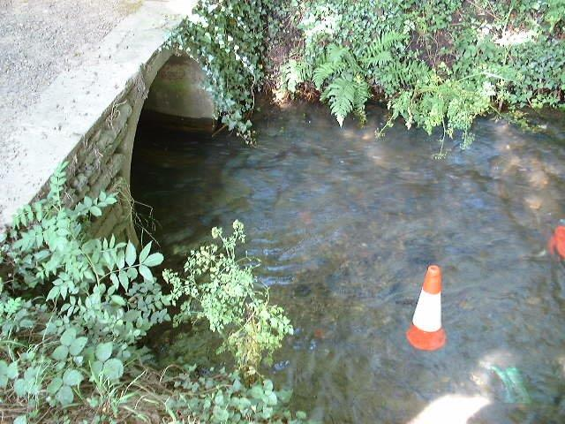
Downstream intake

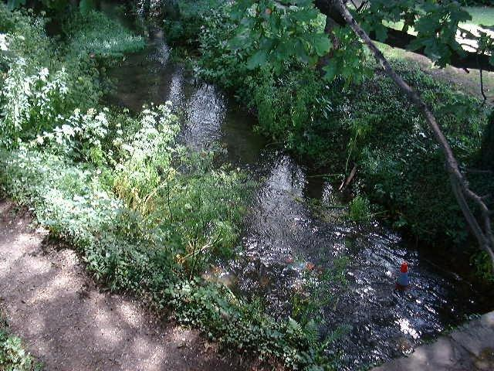
Just downstream intake

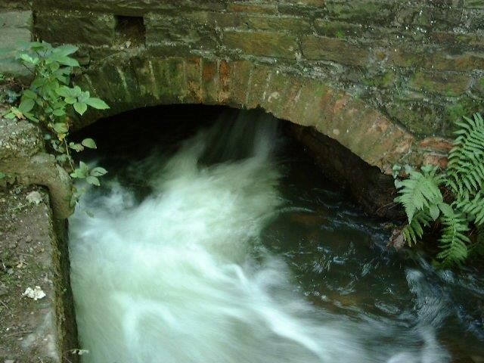
Intake 1

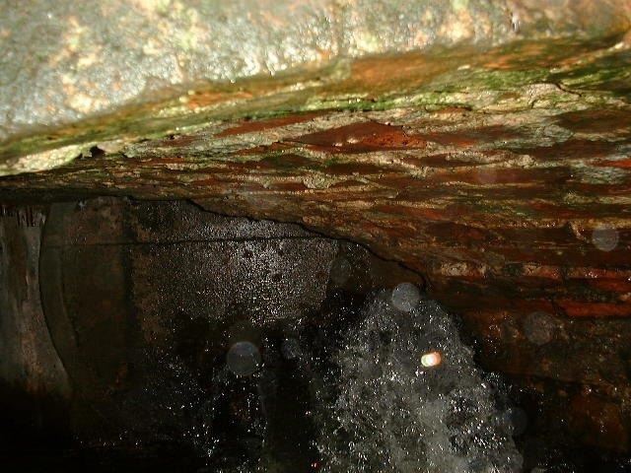
Intake 2

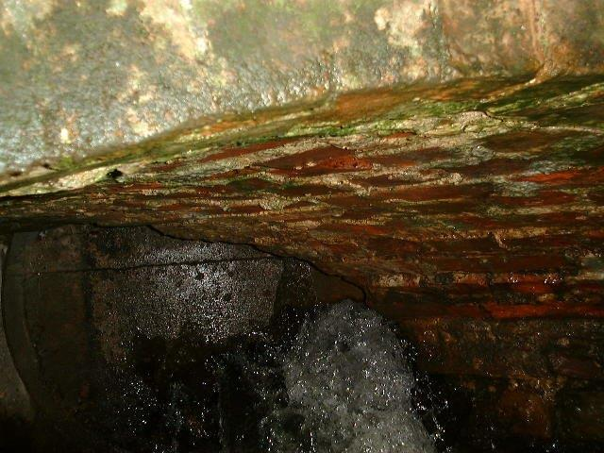
Intake 3

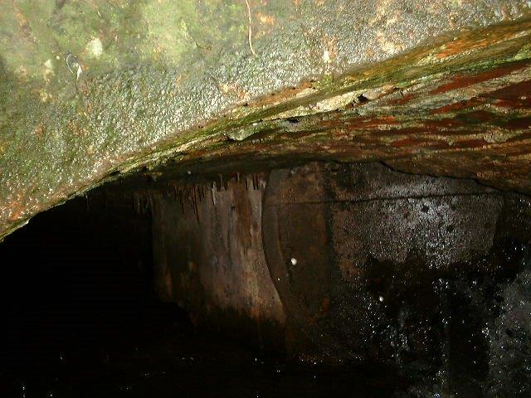
Intake 4

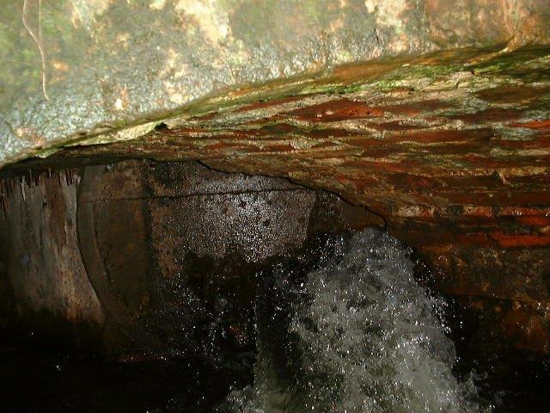
Intake 5

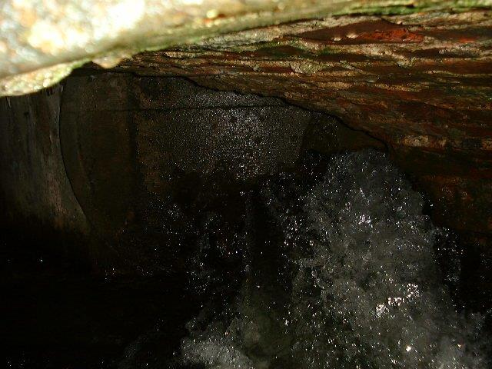
Intake 6

