Docks Feeder to Ponty Cwcw Wentlooge
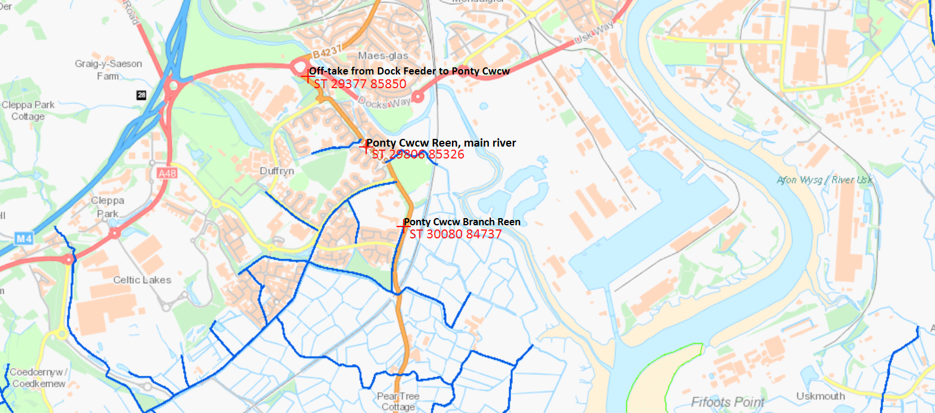
Figure 1. Map identifying take-off from Docks feeder to Ponty Cwcw NGR; ST 29379 85847.

Indicates IDD maintained watercourses.
Key;

