Sandy Lane Pumping Station Feed to Ponty Cwcw
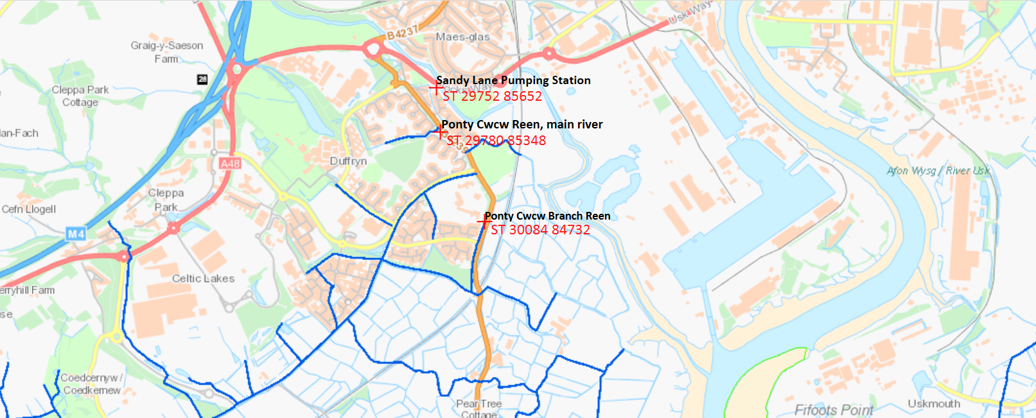
Figure 1. Map location of Sandy Lane Pumping Station to North, NGR; ST 29752 85652.
Indicates IDD maintained watercourses.
Key;

