NATURAL RESOURCES WALES
SANDY LANE PUMPING STATION

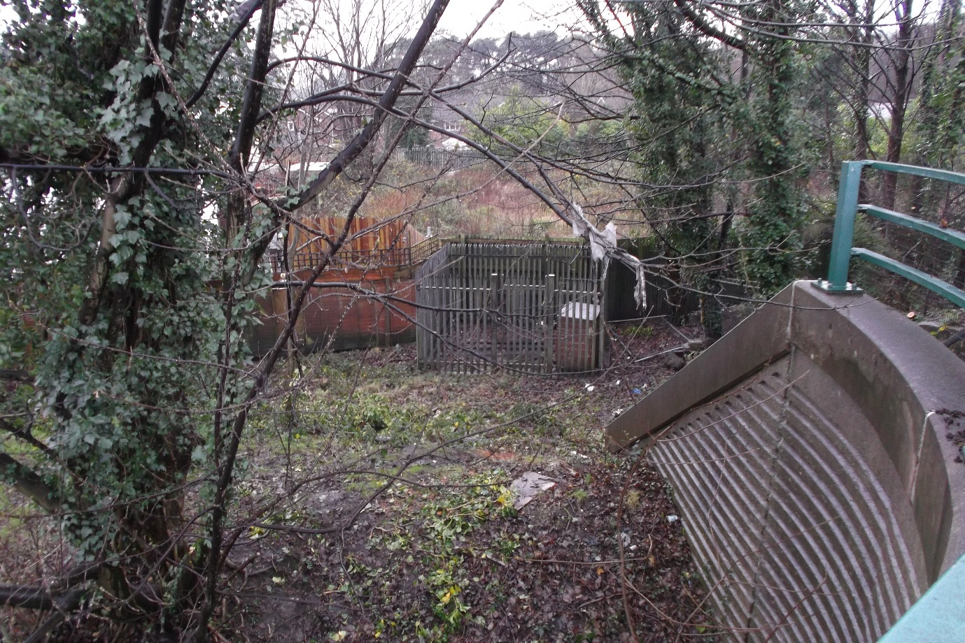

Introduction
Sandy Lane Pumping Station is located, in the Duffryn area of Newport in South East Wales and was built in 1988 by the Caldicot & Wentlooge Levels Drainage Board. The pumping station is an integral part of the Wentlooge Levels Drainage System that covers an area of 3400 hectares to the west of Newport.
In 2013 the pumping station underwent a major refurbished, with the installation of new pumps, control panel and valve spindle extension shafts that allow the valves in the confined space of the pump chamber to be operated from above ground level.
In 2015 the Caldicot & Wentlooge Levels Drainage Board became part of Natural Resources Wales.
Pumping Operation
During the summer months the pumping station operates to ensure water levels in the Wentlooge System are maintained by transferring water into the system from the River Ebbw. During the winter months the pumping station is normally switched off as water levels in the system are sufficiently high without the operation of the pumping station.

Pumping Station Equipment
The pumping station consists of:
- A locked gated / fenced compound. (non-standard locks fitted)
- Pump Control Panel contained within a breeze block shed with metal security door due to vandalism.
- Pump Chamber 2100mm Diameter and 4200mm Depth
- Pumps: Two 5.9 kw Flygt Submersible CP3127LT Pumps
- Level System: Float type.
- Inlet Valve 200mm Diameter HDL Valve
- Outlet Valve 200mm
Note: No telemetry on site.
Pump Configuration
The pumps operate in a direct on line, duty standby configuration with automatic changeover.
Maintenance
The pumping station is currently maintained as required by contractors on a one off ad-hoc basis.
Recommendations
- Sandy Lane Pumping Station’s engineering maintenance should be organised by the NRW Operations Delivery MEICA Team and carried out through the MEICA Term Contract.
- Engineering reactive and emergency works should also be carried out through the NRW Operations Delivery MEICA Team.
- The site should be added to the MEICA standby site list.
- Site Information and drawings should be placed on the MEICA files.
- Locks and keys for the site should be standardised.
- Telemetry could be provided at the pumping station however this is not essential.

Adrian Champion
(21/12/2015)

