CRoW Appendix 4 (140_10_SD02)  CRoW Act 2000: Natural Resources Wales application for permission - Formal Notice |  |  | 
Natural Resources Wales Formal Notice.
Requirements of Section 28I of the Wildlife & Countryside Act 1981 as amended by the Countryside and Rights of Way Act (CRoW) 2000.
Duty in relation to granting any consent, licence or permit for activities likely to damage Sites of Special Scientific Interest (SSSI).
Guide to filling in this form for Natural Resources Wales staff:
To be completed by Permitting Officers for any applications for a permission which the Natural Resources Wales has considered under S28G duties to protect and enhance SSSIs. This applies to all proposed permissions within a SSSI, and to operations outside the SSSI boundary which are likely to damage its special features.
Refer to OI 140_10 ‘Applying the Countryside and Rights of Way (CRoW) Act 2000 to applications for permits with potential for impact on Sites of Special Scientific Interest (SSSI)’, including the flowchart in Appendix 2.
Pink italic text – drafting notes, to be deleted before completion/consultation.
Blue text – examples, to be replaced with permission-specific information.
Ensure you have completed all sections.
- Natural Resources Wales area/region/NPS hub: |  | North
- Name of SSSI: |  | - Dee Estuary E3  - Inner Marsh Farm E1  - Shotton Lagoons + Reedbeds E2
- Type of permission: |  | Environmental Permit – MCP/SG
- Date for Natural Resources Wales permit determination: |  | 12/03/2020
- Predicted 28 day date for response from NRW conservation/ecology (under S28 I(4)): |  | Xx/12/2019
- Natural Resources Wales reference no: |  | PAN-005749
- National grid reference: | 331372, 371798  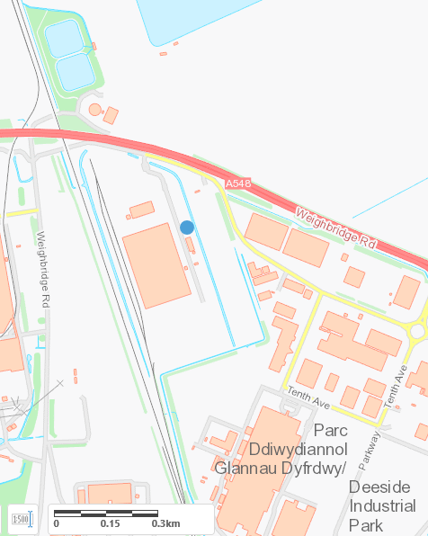
- Description of proposal: |  | The application site is located within the Deeside Industrial Park, off Weighbridge Road, Deeside, Flintshire, Wales. It is on the northern edge of the industrial park at grid reference 331372, 371798.  The plant’s aggregated thermal input capacity is 11.93MWth. Each engine will operate for up to 8,760 hours per annum.  The Proposed Development will comprise of two 2.5MWe Gas-Engine Generating-Sets (gen-sets) with 7m exhaust stacks, a gen-set including a ventilation/cooling equipment, a local distribution network substation and costumer substation buildings, and a gas kiosk. The gen-sets will be fired on natural gas and will export electricity for grid balancing purposes via the local 11kV HV network.  There are 3 SSSI’s within 2km:  - Dee Estuary (Wales & England)  - Inner Marsh Farm (Wales & England)  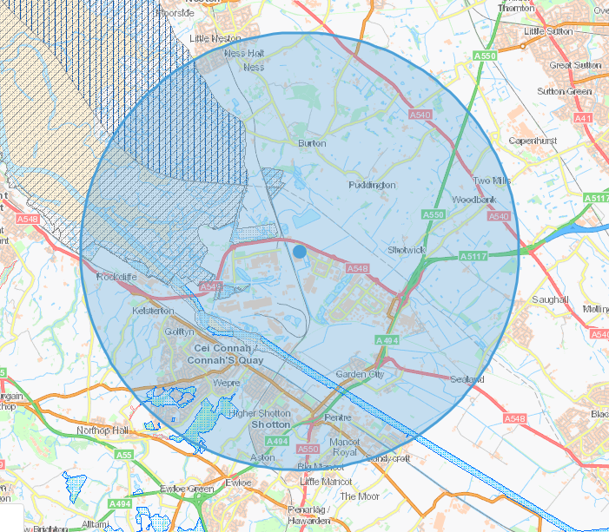  - Shotton Lagoons + Reedbeds (Wales)
- Is the proposed activity within (wholly or partially) the SSSI boundary? |  | NO  .
- Has there been any pre-application discussion or correspondence with NRW conservation/ecology |  | NO
- What aspect(s) of the proposed permission may damage the features which are of special interest for the SSSI?
The following ‘Operations Requiring Consent’ (or other activities associated with the permission) that may cause damage) are relevant to the proposed permission.

Air Quality – Oxides of Nitrogen:

Critical Level

The significance criteria provided by the Environment Agency states that for SSSI’s the air quality impact can be considered to be insignificant if the long-term process contribution is less than 1% of the Critical Level.

Detailed air quality impact assessment modelling shows predicted annual mean ground level concentrations [process contribution (PC)] from this installation, as a percentage of the critical level for each SSSI are as follows:

Dee Estuary = 2.6%PC PEC = 59.1%
Inner Marsh Farm = 1.1%PC PEC = 57.5%
Shotton Lagoons + Reedbeds = 0.5%PC

The PC from the site will exceed the 1% threshold at Dee Estuary SSSI and Inner Marsh Farm SSSI and will fall below the 1% threshold for Shotton Lagoons + Reedbeds.

If the PEC is less than 70% of the long-term environmental standard, the emissions are insignificant. For both Dee Estuary and Inner Marsh Farms the PEC is below 70%, therefore, the predicted impact of the operation of the installation on each of the SSSI’s is considered to be insignificant.

The modelling also shows predicted 24-hour maximum ground level concentrations (PC) from this installation, as a percentage of the critical level for each SSSI are as follows:

Dee Estuary = 10.7% PEC = 55.8%
Inner Marsh Farm = 2.6%
Shotton Lagoons + Reedbeds = 4.8%

The PC from the site will exceed the 10% threshold at Dee Estuary SSSI and will fall below the 10% threshold for Shotton Lagoons + Reedbeds and Inner Marsh Farms. If the PEC is less than 70% of the short-term environmental standard, the emissions are insignificant. For Dee Estuary the PEC is below 70%, therefore, the predicted impact of the operation of the installation on each of the SSSI’s is considered to be insignificant.

Critical Load

The maximum Critical Load (Clo) is 0.4% whixch occours at Dee Estuary SSSI. The maximum PC nutrient nitrogen deposition rates at both SSSI’s arising from the operation are low in comparison to the critical loads (1% or less). Therefore, it is considered that the impact is insignificant. At all of the sensitive habitat sites, the PC is also low in comparison to the existing acid deposition rates and critical loads. Therefore, it is considered that the impact of the operation of the installation on acid deposition is insignificant

- Decision
The proposed permission is not likely to damage any of the flora, fauna or geological or physiological features which are of special interest.

Natural Resources Wales is minded to: Issue the permission

- Name and job title of Natural Resources Wales officer: |  | Lewis Evans  Permitting Officer
- Date form sent to NRW conservation/ecology |  | Xx/11/2019
For Natural Resources Wales use only, once NRW conservation/ecology response received
- NRW conservation/ecology comment on assessment: |  | Please delete as appropriate:  i) NRW conservation/ecology advise the operation can go ahead  ii) NRW conservation/ecology advise the operation can go ahead with conditions  iii) NRW conservation/ecology advise against permitting the operation  Please ensure that the NRW conservation/ecology response is attached to this Formal Notice.
- Name and job title of NRW conservation/ecology officer:
- Date of receipt of NRW conservation/ecology response:

