AN0122301
(Gareth)

NRW OR Comment: Previous permit has weir setting of 121. Current submission has weir setting unknown. Please could DCWW check weir setting?

DCWW Response: Currently EO only permit. Should be storm and EO. I cant find a copy of the previous permit with the 121l/s> could you please send us a copy and we can then confirm the pff.

NRW Further comment: The latest permit is an EO only, it has 5 variations in total, previously with storm. Attached are documents requested: Page 5 of pdf has weir setting 272. Word document is part of 2008 application for variation

DCWW Further Comment: Thanks for sending the word document highlighting the sign off. Happy for the setting of 121l/s to be applied.

CG0329701
(Gareth)

NRW OR Comment: Previous permit has storage capacity of 850 m2. Could DCWW check if this is relevant to current variation? Name of asset amended to differentiate from CG0329702

DCWW Response: I cant find reference to 850m of storage. Can you forward a copy of the permit.

NRW Further comment: Documents attached

DCWW Further Comment: Thanks for the documents. Happy for the 850m to be used. We also need to keep the reference to the detail in in the existing condition 5 i.e. Flows between 3DWD (47l/s but not exceeding 10DWF 103l/s shall get at least 2 hrs storage.
BP0115001
(Will)

NRW OR Comment: SPS permit produced, please confirm if this is correct.

DCWW Response: It’s a CSO from a PS

NRW Further comment: DCWW confirmed this as SPS but the CSO was uploaded.
Redrafted permit as SPS (attached) – DCWW to confirm they are happy to issue.

DCWW further comment: Yes happy to issue
CM0062901
(Will)

NRW OR Comment: Flow 2 Permit: Address and point of discharge are changed; the provided address and NGR are for another permit CG0349301 located on the same WTW site. Is the flow 2 for CM0062901, CG0349301 or both?

DCWW Response: Flow 2 is for CG0349301

NRW Further comment: Permit number that had been originally submitted was CM0062901 but the site address, NGR and receiving waters were for CG0349301. We asked which permit they wanted to vary and the response was that they wanted flow 2 for CG0349301. AS such a new permit will have to be drafted up and sent off for operator review as the conditions of the two assets differ from each other. Does DCWW still want to issue CM0062901 or should we withdraw this application.

DCWW further Comment: Flow 2 is certainly for CG0349301, as per the NEP. There seems to have been an error/overlap with the information submitted. The sheet has been reattached with the amended details. Apologies for this error.

CM0192201
(Will)

NRW OR Comment: SPS but no EO in old permit. However, our database has this recorded as a pumping station, so it is likely that it was varied to be added at some point. Please could you confirm that it is definitely a PS and CSO and EO? Thanks.

DCWW Response: Yes this is storm and EO

NRW Further comment: DCWW confirmed this as SPS but the CSO was uploaded.
Redrafted permit as SPS (attached). – DCWW to confirm they are happy to issue.

DCWW further comment: happy to issue

CG0072703
(Will)

NRW OR Comment: Report of Llanberis in 2014 says that this asset had a bar screen. Please could you check and confirm?

DCWW Response: I cant find reference to the screen. Could you please send a copy of the report to us for review

NRW Further comment: Attached a report on Llanberis that mentions the screen on page 22.

DCWW further comment: Thanks for the document. Agreed.

AN0293901
(Will)

NRW OR Comment: This asset is linked to Nash WWTW and the Emergency overflow will occur when Nash WWTW fails. This has been reflected in table s1.1 (second row) in the permit. Please provide PSKPM.

DCWW Response: Need to attach a PSKPM

NRW Further comment: Awaiting PSKPM from DCWW

DCWW further comment: PSKPM now populated and returned.

CM0191701
(Will)

NRW OR Comment: EO was permitted under permit CM0035201 which was surrendered on 11/10/2017

DCWW Response: The new permit should be storm and EO as per the existing permit

NRW Further comment: DCWW confirmed this as SPS but the CSO was uploaded.
Redrafted permit as SPS (attached) – DCWW to confirm they are happy to issue.

DCWW further comment: happy to issue

CM0191101
(Sarah)

NRW OR Comment: Address details amended. Name of receiving waters amended to reflect the site map. Requirement to provide a screen added to Improvement Table (S1.3) - required by Environment Agency Report of Contravention (case ref: 3558) from 12/04/2010.

DCWW Response: Happy with the name change and receiving waters. I have not seen the report of contravention report. Could you please send us a copy for review.

NRW Further comment: Report attached

DCWW further comment: Happy with the name Change. RPJ confirmed no screen in place.

BP0298901
(Tom W)

NRW OR Comment: Weir setting and storage added. Old permit on database shows weir (8 l/s) and storage (125m3)

DCWW Response: can you please provide copy of this permit

NRW Further comment: I now realise I must have made a mistake, and the information they originally provided was correct. The re-drafted the permit containing the correct information has been attached – DCWW to confirm they are happy to issue.

DCWW further comment: Happy to issue

CM0188401
(Helen)

NRW OR Comment: Consent from 29/11/1989 states 4 hours at Dry Weather Flow storage and gives a weir setting of 8l/s. There should also be screening (10mm bar) and a dipping scum box. These have been added to the permit. Please could you check?

DCWW Response: I am happy 8l/s and 10mm bar screen but cannot find reference to 4 hrs at DWF.The 4 hrs seems to refer to the notification period.

NRW Further comment: Previous permit below: shows (v) notification within 4 hours but also (vi) storage capacity of 4 hours at DWF which applies to both CSO and EO.

DCWW further comment: Apologies I did not read that properly. Happy to add the 4hrs

BP0246001
(Sion)

NRW OR Comment: Drafted as a CSO because old permit suggests no EO. Please can DCWW confirm whether this is correct?

DCWW Response: It’s a CSO from a PS

NRW Further comment: There is already a SPS permit issued at this site under the permit number BW4102801
DCWW further comment: Apologies I did not read that properly. It is CSO

CG0145801
(Sion)

NRW OR Comment: Application is for EO and Storm sewage. Previous permit only consents "storm sewage (through 1 1/4 spaced screens)". Drafted as unknown screen. Please can DCWW confirm that there is a screen?

DCWW Response: We think it’s a a 12mm screen.

NRW Further comment: Is this a 12 mm mesh or bar screen?

DCWW further comment: Bar
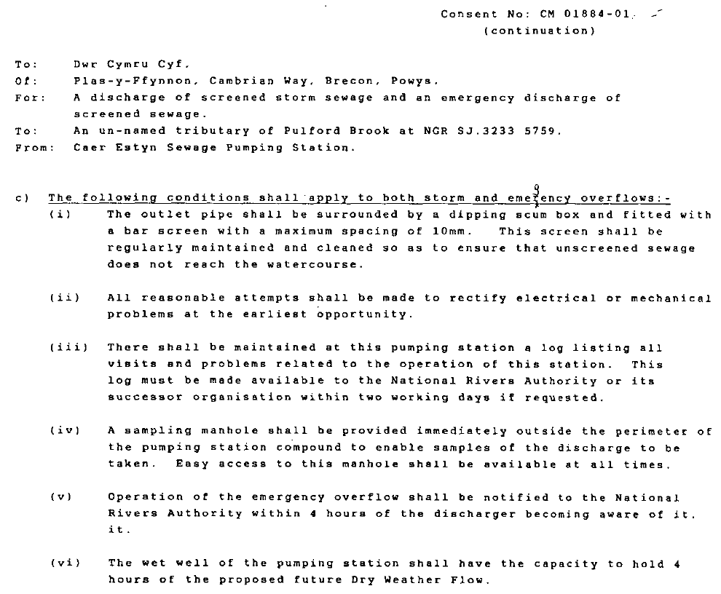

BH0053407
(Helen)

NRW OR Comment: Additional reporting conditions have been added to reflect their inclusion in the previous permit. 63m3 of storage added as it was included in most recent permit. Please check whether you agree.

DCWW Response: Can you confirm what additional reporting conditions? Is it the Shellfish reporting. The 63m of storage is part of the EO setting

NRW Further comment: Sorry, I meant additional notification conditions, not reporting. There was some controversy when the EO was added to the permit in 2009/10 and they were added to the permit as a result of this. The additional conditions are conditions 4.3.4 and 4.3.5.
Storage in table S3.3 and storage conditions removed. Corrected permit attached -D DCWW to confirm they are happy to issue.

DCWW further comment: Agreed. Its just transfer of the conditions from the existing permit.

