WASTE REVIEW AND PLAN
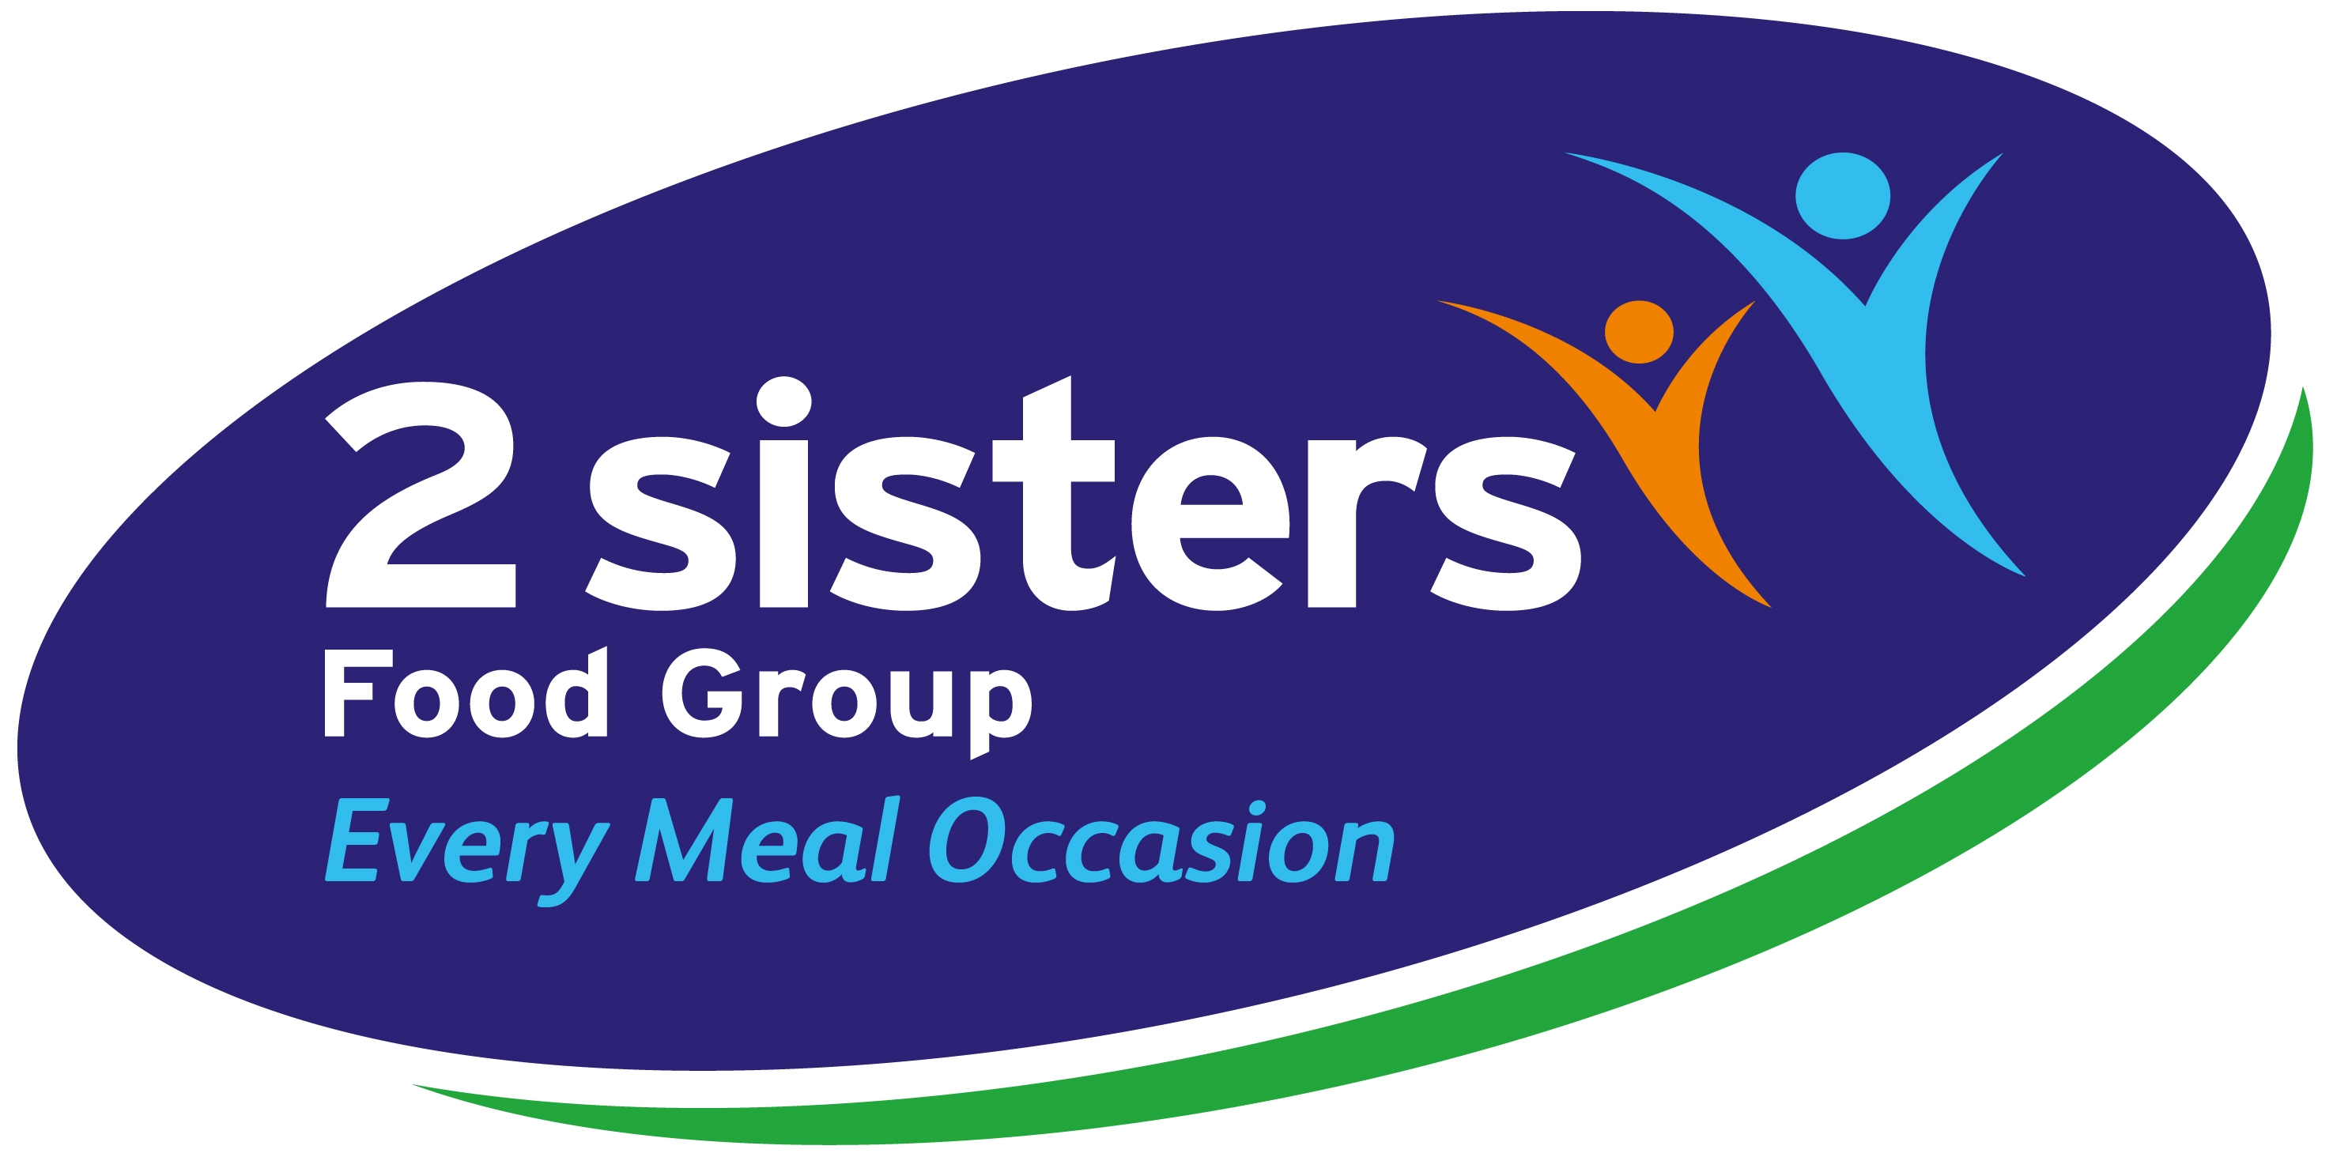

- Reviewed 10-10-19

2 Sisters Food Group Sandycroft aims to reduce waste generation by using the waste reduction hierarchy as the basis.
Waste Reduction Hierarchy
- Prevention and minimisation of waste production at the source
- Reuse of resources where possible
- Recycling of generated waste
- Energy recovery from non-recyclable wastes
- Disposal to landfill
Waste Profile
- 2 Sisters Food Group Sandycroft consists of a primary poultry processing factory taking in 1.5m live chickens for slaughter with additional chicken product brought in from other sites for cutting and packing. Majority of product produced by the site is fresh chicken cut and packed for retail.

- There are two additional “further processed production areas”. The RTC (ready to cook) producing chicken with further ingredients to supply a ready to cook meal. The other is the BBQ area that has been seasonal and has historically produced the larger volumes over the summer months will little or no production as the summer months end and into winter.
Waste generation
Waste is generated from a variety of areas across the site including:
- Primary Process
- Secondary production processes
- Further process production
- Engineering Maintenance
- Engineering Projects
- Hygiene
- Despatch
- ETP Processes
- Offices
- Canteen
- Amenity areas
- Stores.
- Occupational Health Function.
- Drain and Interceptors
- Odour abatement systems
- Agriculture Hooks/2 Sisters operating from site.

Waste types generated on site include:
- Animal By-products CAT2/3
- Chicken wastage from cutting processes
- Production ingredients for further process activities
- Sludge produced by ETP
- Waste water produced by ETP
- Plastics
- Cardboard
- Paper
- General Waste. Non-recyclable
- Chemical usage from hygiene activities
- Chemical usage from water treatment
- Chemical usage from odour abatement
- Chemical usage from ETP processes
- Waste oils from engineering maintenance
- Waste oils from canteen
- Food waste canteen
- Plastic, Cans and bottles from canteen
- Wood / Pallets
- Metal
- Lighting
- Electrical waste
- Batteries
- Sanitary waste
- Clinical waste
- Construction / Project waste
- PPE usage
- Hand towels
In addition to the above utility usage needs to be considered
- Electricity
- Water
- Fuel Oil
- LPG usage
Drivers for waste minimisation
Waste minimisation is sustainability by ensuring that our actions today do not limit the range of social, cultural, environmental and economic options open to future generations.
It also twofold in that it controls costs to the business keeping it competitive and sustainable for the future.
Target Setting
Target setting is an important part of progress toward minimising waste production and maximising recycling efforts. 2 Sisters Food Group at Sandycroft have set targets according to the SMARTER principle, specific, measurable, achievable, relevant, and time- targeted objectives which are evaluated and re-evaluated.
Annual waste reduction and recycling targets become more specific through quantification or enumeration, or by defining certain tasks that need to be completed. Target setting creates an official commitment to reduce waste and increase recycling and attracts the allocation of resources to achieve the agreed targets.
In the case of waste management, creating reductions in waste volumes and increasing recycling rates will result in immediate savings.
The major barrier for waste reduction is behaviour change from management and, to a lesser extent, staff. Most of the required infrastructure is already in place and it is a matter of educating and encouraging a cultural shift in waste management practices to create changes in procurement and disposal practices.
Targets will focus on a reduction in total waste volume (waste and recycling combined) with the key objective to reduce total waste volume and minimise usage of utilities and materials used through the production and maintenance of the site.

The baseline time frame for all targets from April 2018…
Short-term targets 0-6 months
- No net increase in total waste production (waste and recycling combined)
- Continuous improvement in recycling rates.
- Review of consumable items and management accountability for control - Measured
- Review of production wastage with accountability for control – Measured
- Plans set to implement reduction in utility usage.
- Training programme to implement controls
Longer- term reduction set targets 6-24 months
- 10% reduction in general waste production to landfill
- 5% reduction in water usage
- 5% reduction in electricity consumption / tonne product
- 10% reduction in chemical usage
- 10% reduction in packaging wastage
- 10% increase in recycling of plastics and cardboard

Ref | Waste Stream | Action | Who | When | Done
01 | Animal by-products CAT 2/3 | Meeting with Amber foods to review current waste handling processes to confirm best possible practices are being followed. | SVDK  N.H | 15-1-19 | Complete
02 | Waste Chicken from cutting processes. | Managers to be set targets to identify where product is being lost from issues such as floored product or dropped birds. Liaise with Engineering where mechanical processes need to be modified. Each manager to follow documented flow process for identification. Then follow hierarchy of reduction from elimination to reduction. This is reviewed weekly as SMT meetings | SD  MK  NH  RP | 23-2-19 | Complete
03 | Further process ingredients waste | Managers to be set targets to identify where there is product wastage. Liaise with Engineering where mechanical processes need to be modified. Each manager to follow documented flow process for identification. Then follow hierarchy of reduction from elimination to reduction. This is reviewed weekly as SMT meetings | RP | 20-3-19 | Completed
04 | ETP Sludge | Review current process for sludge generation on site. Review waste on site that goes into the water treatment process and whether this can be reduced and then lead on to sludge production. | MJ  SVDK  NH | 20-5-19 | Completed
05 | ETP Waste Water | Review of current water quality at discharge to reduce CODS and solids. This reducing cost and environmental impact for further waste water treatment. | MJ  SVDK | 20-5-19 | Completed
06 | Plastics | Review wastage of plastics in production used for tray packs and films. Eliminate wastage before looking at recycling. | SD  MK  GW | Reductions shown but ongoing | Ongoing
07 | Plastics | Confirm effective waste segregation from production ensuring what can be recycled is not put into general waste. | SD  MK  SVDK | Reductions shown but ongoing | Ongoing
08 | Plastics | In line with current concerns raised globally, reduction in the use of plastics as disposable items such as cups, stirrers and other items where there use can be eliminated. | JR  SVDK | 10-4-19 | Completed
09 | Cardboard | Review wastage of cardboard in production used for supply of. Eliminate wastage before looking at recycling. | DJ  GW | 10-5-19 | Completed
Ref | Waste Stream | Action | Who | When | Done
10 | Cardboard | Confirm effective waste segregation from production ensuring what can be recycled is not put into general waste. | SD  MK  SVDK | 10-4-19 | Completed
11 | Paper | Policy on paper usage. Do we need to print off or keep electronic records. Implement improved controls where needed. | JH  SVDK | Reductions shown but ongoing | Ongoing
12 | Paper | Policy for collecting and recycling paper to ensure it is not going to general waste. Implement improved controls | JH  SVDK | 10-6-19 | Completed

13 | General Waste | Review contents of general waste to confirm controls for segregation are effective. | DJ  SD  MK | Reductions shown but ongoing. Weekly | Ongoing
14 | Hygiene Chemicals | Review current cleaning processes to ensure dosing levels are correct and no excess use is present. Consult with Holchem on cleaning practices for efficiencies. We have reduced the amount of chemical used and types. | JB  AP | 28-5-19 | Complete
15 | ETP Chemicals | Review current process and confirm dosing systems are at optimum levels to reduce wastage. Dosing levels in line with water sampling and discharge consents. | MJ  SVK | 2-6-19 | Complete
16 | Odour Abatement Chemicals | Review current process and confirm dosing systems are at optimum levels to reduce wastage. Reviewed as part of NRW check to ensure di run out. Turning dosing off when not running. | MJ  SVK | 12-7-19 | Complete
17 | Waste Oils | Consult with Amber to confirm waste oils are being recycled where possible to reduce environmental impact. | JR  SVK | 28-5-19 | Complete
18 | Waste Oils Canteen | Consult with Amber to confirm waste oils are being recycled where possible to reduce environmental impact. | MJ  SVK | 28-5-19 | Complete
19 | Food waste | Canteen to conduct a survey on amount of waste that is produced and where this can be reduced. Implement plan for reduction. Good processes for minimizing waste and cost. | SVK  AW | 05-7-19 | Complete
20 | Cans, plastic bottles Canteen | Consult with Amber for the provision of segregated bins to reduce items going into general waste streams. | JR  SVK | TBC | TBC
21 | Wood, Pallets | Review current process for recycling wooded pallets to confirm recycled where possible. Confirmed with pallet company | KT | 5-4-19 | Complete
22 | Metal | Review current process for recycling metals to confirm recycled where possible. Also receiver processes. | MJ | 5-7-19 | Complete
23 | Light tubes | Continue with process to change out to LED which have a much longer life span. More efficient.  Confirm current light tube recycling process via Amber. | MJ | Large number changed out. Continue in 2019/2020 | In progress
24 | Electrical Components | Compliance with current disposal regulations. Confirm process of receivers via Amber | MJ | 5-4-19 | Complete
25 | Batteries | Confirm where possible batteries are not used and rechargeable items are sourced. Where batteries are collected confirm via Amber disposal processes. Many more rechargeable used | SVK | 12-3-19 | Complete
26 | Sanitary waste | Compliance with current disposal regulations. Confirm process of receivers via Amber. Licenses contractor incineration. | AP | 5-4-19 | Complete
27 | Hand towels | Review current hand washing process to see if use of hand towels can be reduced. Consider use of blow dryers where practicable. Main toilet’s being changed out Oct 2019 | AP | 10-2-20 | Complete

Ref | Waste Stream | Action | Who | When | Done
28 | Clinical Waste | Confirm controls over clinical waste and correct handling and disposal. Check with receiver their controls. | OH  SVDK | 5-4-19 | Complete
29 | Contractors and Project Waste | Produce policy for contractors compliance with ethical disposal of waste. Ensure this is included and checked in the pre works tendering. Included in pre tender stage and checked end of work. | MJ  SVDK | 20-2-19 | Complete
30 | PPE | Review current supply of PPE to confirm items being supplied are best possible to reduce wastage. Ensure issue controls are in place and managed. Now mainly controlled by group procurement for supply but issue is now monitored. | SD  MK  NH | 20-2-19 | Complete
31 | CO2 Stunning | Review current use of the CO2 Gas stunning equipment and process | MJ  NH  SVK | 30-03-19 | Planned
32 | Feather trailer | Review current feed to trailer to reduce the number of trailers needed. This is with Amber foods | MJ JA SVK | 30-11-19 | Planned

Ref | Issue | Action | Who | By when | Done
01 | Heat recovery Air compressors | Heat recovery. Resolve solenoid issue on air compressor | MJ | 15-1-19 | Completed
02 | Refrigeration | Ensure the higher water temperature only is returned. | MJ | 30-1-19 | Completed
03 | Refrigeration | Ensure the heat recovery is not pushing higher head pressures | MJ | 30-1-19 | Completed
04 | Electrical | Reduce air leaks down to lowest possible level. | MJ | 18-2-19 | Completed
05 | Electrical | Investigate inverters on the feather and offal pumps | MJ | 15-2-19 | Completed
06 | Electrical | Floating head pressure. Confirm with Brooktherm of viability of FHP. | MJ | 20-1-19 | Completed
07 | Electrical | Revisit the PFC for the overall site to ensure correct. | MJ | 30-3-19 | Completed
08 | Boiler efficiency | Review if possible to lag the rear of the boilers | MJ | 30-4-19 | Completed
09 | Boiler efficiency | Review the lagging of pipes and valves |  | 30-10-19 | Completed
10 | Electrical | Continue with the change out to LED lighting. Much has been done but keep up the progress. |  | 30-12-19 | In progress
Ref | Issue | Action | Who | By when | Done
11 | Change to gas boilers | Complete feasibility for gas supply to site to removed need to use the oil fired boilers. Capex approval required | MJ | TBC | TBC
12 | Change to gas boilers | Obtain prices for new gas burner boilers to replace the oil-fired boilers. Capex approval required | MJ | TBC | TBC
13 | Water | Review the trailer washing process to see if water usage can be reduced down. | NH MJ | 15-12-19 | Planned
14 | Water | Review if this process can be eliminated by improving primary wash. | NH  MJ | 15-12-19 | Planned
15 | Water | Review of the hose nozzle sizes to see if these are authorised to standard size | GC  MJ | 20-12-19 | Planned
16 | Electricity | Installation of sensor lights in the offices, plant rooms, corridors, canteen, roof voids | MJ | 30-3-20 | Planned

