Permit Number: | PAN-008996
Applicant name: | Mr William Locke
Site Address: | Glangwesyn, Abergwesyn, Llanwrtyd Wells, Powys, LD5 4TP
Discharge Point NGR: | SN 86268 53724
Respond by date: | 01/04/2020(10 working days)
Permitting Officer: | Steve Bickerton

Brief Description of proposal:
The application is for a new bespoke discharge of secondary treated sewage effluent; a maximum of 2.4 cubic metres per day, originating from 6 glamping units. The proposed treatment system consists of a package treatment plant that meets the British Standard BS 12566, the discharge will be made via pipe into the Nant Henfron leading to the Afon Gwesyn after approximately 95m.

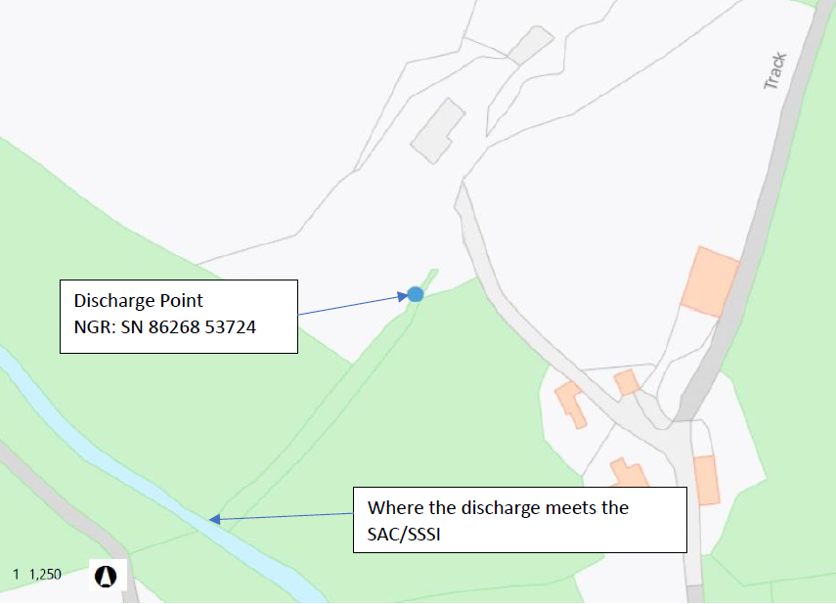

Habitats Screening Report – Designations or protected species/habitats:

Afon Gwy/River Wye is designated a SAC and the Afon Irfon a designated SSSI.

A copy of the Form 1 (HRA) can be found here

A copy of the Appendix 4 can be found here

The Elenydd Mallaen SPA and Elenydd SSSI are located approximately 470m west of the discharge point and approximately 40m higher. The Afon Gwesyn also forms a barrier between the discharge point and these special sites. The natural river flows are away from these special sites. No HRA or Appendix 4 has been completed for these sites as there is no conceivable pathway for any contamination.

Risk Assessment Results (modelling or L1 Risk Assessment):

The discharge is under 5m³/day therefore no river quality modelling has been conducted.

The proposed discharge would be within the designated WFD stretch GB109055041870 ‘Afon Gwesyn-conf Irfon’, which is currently classified as ‘High’ for all physio-chemical parameters relevant to this application. I have compared the SAC water quality targets to current concentrations in the Afon Gwensyn as found within the spreadsheet ‘Freshwater_Phys-Chem_2016-2018’ below:

As the organic pollution concentrations currently within the watercourse surpass the target levels found within the management plan for the SAC, the input of 2.4m³/day of secondary treated sewage effluent is not likely to damage SAC or the SSSI in meeting of these targets, especially when considering the dilution of the Nant Henfron and the Afon Gwesyn.

Due to the dilution that the proposed discharge would receive in the watercourse, the impacts from any traces of organic pollution found within the discharge would be negligible when it reaches the SSSI. The effluent will be treated by a package treatment plant built to British Standard BS 12566-3 providing low levels of suspended solids and good quality of effluent. The British Standard for domestic sewage treatment systems requires that effluent contains a maximum of 30mg/l suspended solids.

The dilution and dispersal within the receiving water course of the discharge, the Nant Henfron, will render it insignificant, reducing any potential for impact. Further dilution and attenuation potential of the Afon Gwesyn will only reduce the potential for risk to the water quality of the river or features within the Afon Irfon SSSI.

Miscellaneous:

No known pre-application advice given

NRM Responses:

Environment Management comments:

Officers name:
Date:

Biodiversity comments:

Officers name:
Date:

Conservation/Ecology Comments:

Officers name:
Date:

Internal Consultation Responses from other NRW Teams:

Water Quality Planning:

Officers name:
Date:

External Consultations sent to: | Yes/No
National Parks | No
Water Company regarding Drinking Water Protected Zone / SPZ1 | No
Environmental Heath | No

Any Permitting Responses:

Date:

