CRoW Appendix 4 (140_10_SD02)  CRoW Act 2000: Natural Resources Wales application for permission - Formal Notice |  | 
Natural Resources Wales Formal Notice.
Requirements of Section 28I of the Wildlife & Countryside Act 1981 as amended by the Countryside and Rights of Way Act (CRoW) 2000.
Duty in relation to granting any consent, licence or permit for activities likely to damage Sites of Special Scientific Interest (SSSI).
Guide to filling in this form for Natural Resources Wales staff:
To be completed by Permitting Officers for any applications for a permission which the Natural Resources Wales has considered under S28G duties to protect and enhance SSSIs. This applies to all proposed permissions within a SSSI, and to operations outside the SSSI boundary which are likely to damage its special features.
Refer to OI 140_10 ‘Applying the Countryside and Rights of Way (CRoW) Act 2000 to applications for permits with potential for impact on Sites of Special Scientific Interest (SSSI)’, including the flowchart in Appendix 2.
Pink italic text – drafting notes, to be deleted before completion/consultation.
Blue text – examples, to be replaced with permission-specific information.
Ensure you have completed all sections.
- Natural Resources Wales area/region/NPS hub: | Pembrokeshire/Ceredigion
- Name of SSSI: | 1.Caeau Crug bycan, Ty Gwyn a llwyn ysgaw  2. Aberarth – Carreg Wylan
- Type of permission: | Mobile plant waste deployment - land spreading
- Date for Natural Resources Wales permit determination: | 11/06/19
- Predicted 28 day date for response from NRW conservation/ecology (under S28 I(4)): | N/A
- Natural Resources Wales reference no: | ERP/AB3891CX  PAN-005436
- National grid reference: | Farm Location: SN 18094 50342  Nurse tank storage location: SN 18100 50729
- Description of proposal: | PAN-005436 SSSI Map  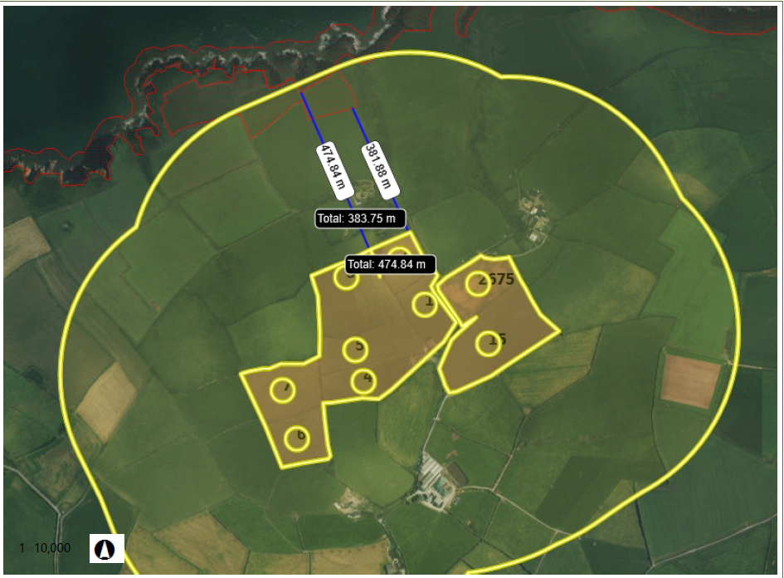  Application is for applying cheese sludge effluent (020502) in a liquid form. They are applying to grass silage fields by shallow soil injection. And fields 3A 4A 5A and 2301 (Land at Rhosygadair), are being treated using a dribble bar and soil incorporation due to ploughing, for maize and winter wheat crops. The total amount of waste to be spread over the course of the application is 3174 (50t/ha).  They are applying to-  Hafod Farm, Ferwig, Caradigan, Ceredigion, SA43 1PU  Nant Y Croi Farm, Ferwig, Cardigan, Ceredigion, SA43 1PU  Trefwtial Farm, Blaenannerch, Cardigan, SA43 2AG  Castell Malgwyn Farm, Llechryd, Cardigan, Pemborkeshire SA43 2QB.  The treatment will take place in Spring prior to crop planting for fields  3A, 4A, 5A, and 2301.  The treatment of the other fields will be treated when ground and weather conditions are suitable in early spring and following a silage cut.  NRW will be informed 48hrs before the spreading.
- Is the proposed activity within (wholly or partially) the SSSI boundary? | No the deployment take place within 386ms of SSSI  PAN-005436 SSSI Map
- Has there been any pre-application discussion or correspondence with NRW conservation/ecology | NO
- What aspect(s) of the proposed permission may damage the features which are of special interest for the SSSI?
The following ‘Operations Requiring Consent’ (or other activities associated with the permission) that may cause damage) are relevant to the proposed permission.

Caeau Crug bycan, Ty Gwyn a llwyn ysgaw
5. Application of manure, slurry, silage liquor, fertilisers and lime
7. dumping, spreading or discharging of any materials

Aberarth – Carreg Wylan
5. Application of manure, slurry, silage liquor, fertilisers and lime
7. dumping, spreading or discharging of any materials

The following SSSI features and mechanisms of impact have been considered to assess the likelihood of damage:
Caeau Crug bycan, Ty Gwyn a llwyn ysgaw

Contains a variety of Coastal and terrestrial plants, insects and birds of scientific and conservational interest.
Aberarth – Carreg Wylan

Contains a variety of intertidal, marine, fresh water and coastal plants, mammals, fish, shellfish and birds of scientific and conservation interest.
The area is also noted for its geological importance.
SSSI mechanisms/pathways for impact
Soil leaching is the mechanism which could cause impact the SSSIs, this will be avoided due to the methods of spreading.
All silage fields will be spread using shallow soil injection.
All other fields will be treat when the soil is freshly turned and then spread with a dribble bar allowing for a swift absorption.
no spreading will take place during poor weather conditions preventing transportation by rain flow or ground water leeching.
Soil leaching into the water course is the only method which could cause an impact on SSSI. This would affect water quality, flora and fauna, due to the wastes propensity for growing bacteria. However following standard spreading practise and using the declared methods of delivery should prevent this.
- Decision
i) The proposed permission is not likely to damage any of the flora, fauna or geological or physiological features which are of special interest.
Fields 2 and 3 of Hafod castell farm are the closest to the SSSIs they are within 381ms of Crug and 4, the closest area of spreading is 473m form Aberath.
A Risk assessment has been provided along with soil samples. These details cover water courses, slopes, ditches etc. No waste will be spread within 10m of any ditch, pond or surface water, within 50m of any spring, well, borehole, or reservoir that supplies water for human consumption or farm dairies. All spillages will be reported immediately to Natural Resources Wales as required by the SR2010No4 permit conditions.
Natural Resources Wales is minded to: Issue the permission

- Name and job title of Natural Resources Wales officer: | Environmental Waste Permitting Officer 2  Ethan Banfield
- Date form sent to NRW conservation/ecology | FOR INFORMATION ONLY

