CRoW Appendix 4 (140_10_SD02)  CRoW Act 2000: Natural Resources Wales application for permission - Formal Notice |  | 
Natural Resources Wales Formal Notice.
Requirements of Section 28I of the Wildlife & Countryside Act 1981 as amended by the Countryside and Rights of Way Act (CRoW) 2000.
Duty in relation to granting any consent, licence or permit for activities likely to damage Sites of Special Scientific Interest (SSSI).
Guide to filling in this form for Natural Resources Wales staff:
To be completed by Permitting Officers for any applications for a permission which the Natural Resources Wales has considered under S28G duties to protect and enhance SSSIs. This applies to all proposed permissions within a SSSI, and to operations outside the SSSI boundary which are likely to damage its special features.
Refer to OI 140_10 ‘Applying the Countryside and Rights of Way (CRoW) Act 2000 to applications for permits with potential for impact on Sites of Special Scientific Interest (SSSI)’, including the flowchart in Appendix 2.
Pink italic text – drafting notes, to be deleted before completion/consultation.
Blue text – examples, to be replaced with permission-specific information.
Ensure you have completed all sections.
- Natural Resources Wales area/region/NPS hub: | Wrexham and Flintshire
- Name of SSSI: | AFON DYFRDWY (RIVER DEE) SSSI
- Type of permission: | Landspreading deployment under SR2010 No4
- Date for Natural Resources Wales permit determination: | 13/03/19
- Predicted 28 day date for response from NRW conservation/ecology (under S28 I(4)): | 07/04/19
- Natural Resources Wales reference no: | PAN-004607
- National grid reference: | SJ 33143 68355
- Description of proposal: | The proposal is to spread 1094.6 Alstrom Black Liquor, (Liquid from on-site effluent plant 03 03 11) from Ahlstrom Chirnside on to the agricultural land. Alstrom wl be delivered to the side by road tanker and off-loaded. It will be surface applied by umbilical supplied tractor mounted spreader bar or slash plate. The proposed application rate is 26 tonne/ha. The benefiting crop is maize.  The maps of the location are on the last page of this document
- Is the proposed activity within (wholly or partially) the SSSI boundary? | NO
- Has there been any pre-application discussion or correspondence with NRW conservation/ecology | NO
- What aspect(s) of the proposed permission may damage the features which are of special interest for the SSSI?
The following ‘Operations Requiring Consent’ (or other activities associated with the permission) that may cause damage) are relevant to the proposed permission.

5. Application of manure, slurry, silage liquor, fertilisers and lime to agriculturally unimproved permanent grass, forestry and all other unimproved riparian habitats, including woodland and any other natural or semi-natural vegetation.

7. Dumping spreading or discharging of any materials.

The following SSSI features and mechanisms of impact have been considered to assess the likelihood of damage:

2.1 Fish (Salmon, sea lamprey)
2.2 Otter

- Water quality

Good water quality is an intrinsic factor in maintaining the fish interest of the River
Dee, illustrated by the recent pollution incident that decimated a stretch of the lower
Dee, killing more than 100,000 fish. Water quality is also affected, to a lesser degree,
by nutrient enrichment from consented discharges and agricultural runoff. The upper
reaches of the tributaries may be affected by acidification, which impacts upon the
spawning success of the fish species, in particular salmon. Sedimentation of the
spawning gravels also reduces reproductive success. The introduction of Synthetic
Pyrethroid (SP) sheep dips has increased the risk of water pollution, especially in the
tributaries.

Good water quality is indirectly important to otters as it ensures that conditions are
suitable for its food source. Water quality is also directly important as toxins can build up through the food chain and affect otter survival.

- Decision
ii) The permission is not likely to damage any of the flora, fauna or geological or physiological features which are of special interest because of conditions.

- The operator will comply with Code of Good Agricultural Practice (CoGAP)
- The adequate non spreading buffer zones will be maintained

Natural Resources Wales is minded to:
Issue the permission

- Name and job title of Natural Resources Wales officer: | Magda Leonowicz  Permitting Officer
- Date form sent to NRW conservation/ecology | 11/03/19
For Natural Resources Wales use only, once NRW conservation/ecology response received
- NRW conservation/ecology comment on assessment: | ii) NRW conservation/ecology advise the operation can go ahead with conditions, as outlined above.
- Name and job title of NRW conservation/ecology officer: | Neil Smith, Senior conservation officer Wrexham and Flintshire NRM team. 25 March 2019
- Date of receipt of NRW conservation/ecology response: | 25/03/19

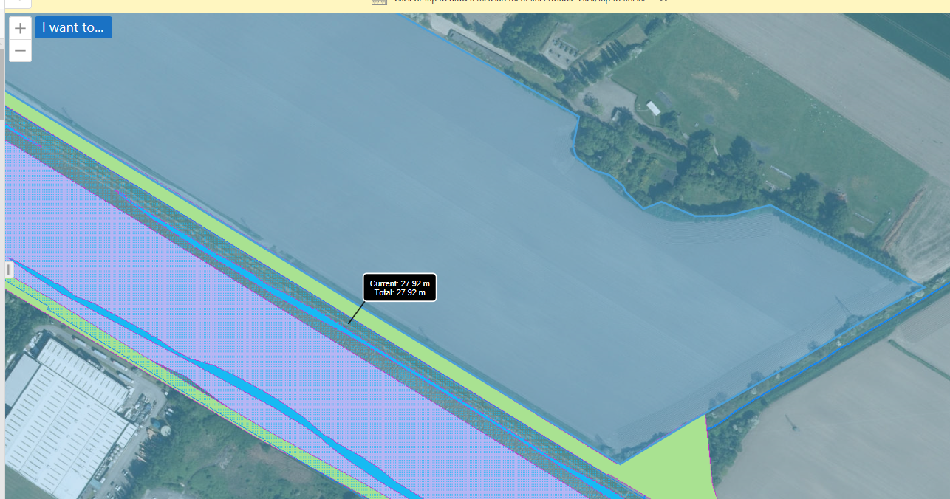
There is approx. 30m distance between the spreading field and the River Dee.

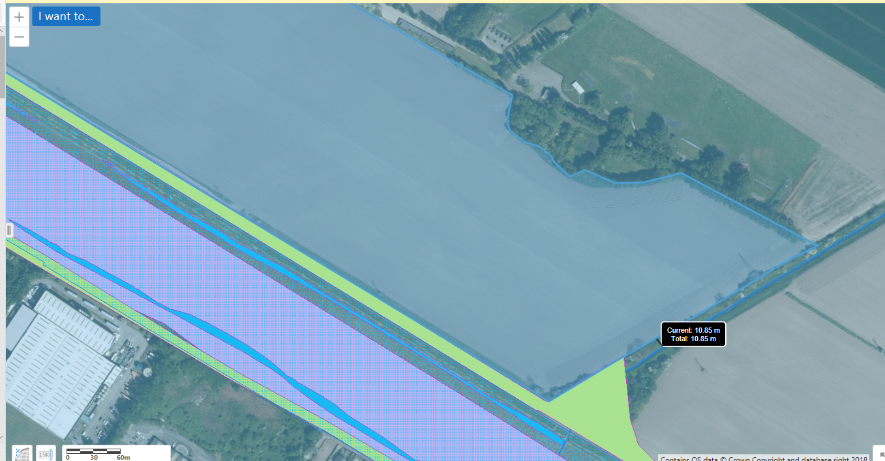
There is approx. 10m distance between the spreading field and the adjacent drain which directly connects to the River Dee.

