CRoW Appendix 4 (140_10_SD02)  CRoW Act 2000: Natural Resources Wales application for permission - Formal Notice |  | 
Natural Resources Wales Formal Notice.
Requirements of Section 28I of the Wildlife & Countryside Act 1981 as amended by the Countryside and Rights of Way Act (CRoW) 2000.
Duty in relation to granting any consent, licence or permit for activities likely to damage Sites of Special Scientific Interest (SSSI).
Guide to filling in this form for Natural Resources Wales staff:
To be completed by Permitting Officers for any applications for a permission which the Natural Resources Wales has considered under S28G duties to protect and enhance SSSIs. This applies to all proposed permissions within a SSSI, and to operations outside the SSSI boundary which are likely to damage its special features.
Refer to OI 140_10 ‘Applying the Countryside and Rights of Way (CRoW) Act 2000 to applications for permits with potential for impact on Sites of Special Scientific Interest (SSSI)’, including the flowchart in Appendix 2.
Pink italic text – drafting notes, to be deleted before completion/consultation.
Blue text – examples, to be replaced with permission-specific information.
Ensure you have completed all sections.
- Natural Resources Wales area/region/NPS hub: | North
- Name of SSSI: | River Dee
- Type of permission: | Landspreading deployment under standard rules permit SR2010 No4 – Mobile plant for landspreading
- Date for Natural Resources Wales permit determination: | 01/03/2020
- Predicted 28 day date for response from NRW conservation/ecology (under S28 I(4)): | N/A
- Natural Resources Wales reference no: | PAN-008831
- National grid reference: | Farm location: SJ 35440 44430  Fields:  1 SJ 35437 41759  2 SJ 35541 41731  4 SJ 35623 41647  5 SJ 35874 41728  Manor Triangle SJ 35565 44178  MF Adjoined Triangle SJ 35607 43954  Storage:  SJ 35560 41795  SJ 35502 44281
- Description of proposal: | A landspreading deployment application to spread 10 waste streams at or near to Manor Farm, Eyton, Wrexham, LL13 0SN (please see maps at bottom of form). Wastes are to be spread by sub-soil injection using a deep-leg injector, but a shallow injector or surface application may be used, depending on environmental conditions at the time of spreading. All 6500 tonnes of waste are expected to be applied over 26.3ha in February 2020. All waste will be spread in accordance with COGAP.  Waste will be stored in two temporary storage tanks, storing 30 tonnes each at any one time.  A 30m buffer zone will be put in place in the field adjacent to the River Dee. The remaining fields are not directly connected to the river and are buffered by surrounding fields.
- Is the proposed activity within (wholly or partially) the SSSI boundary? | NO  SSSI adjacent to fields “Manor Triangle” and “MF Adjoining Triangle”, and within 200m of the fields further south.  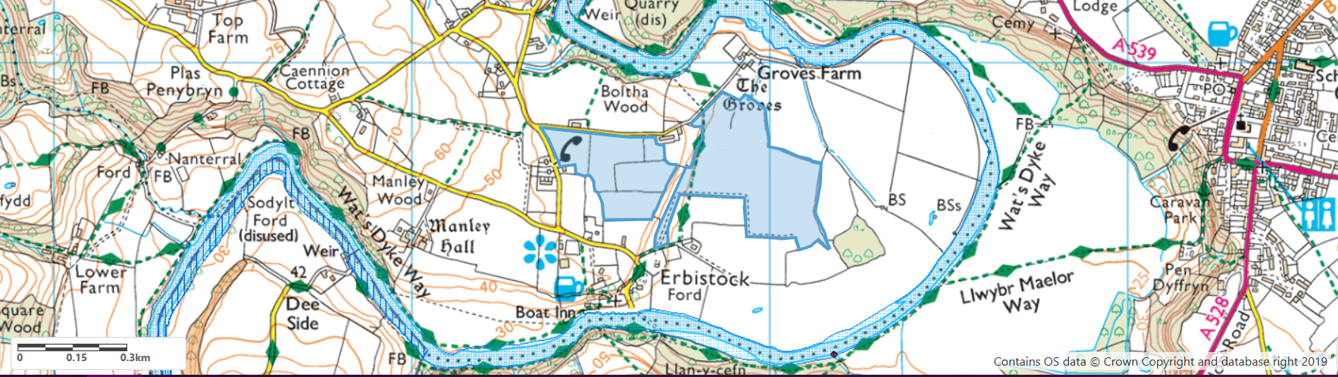  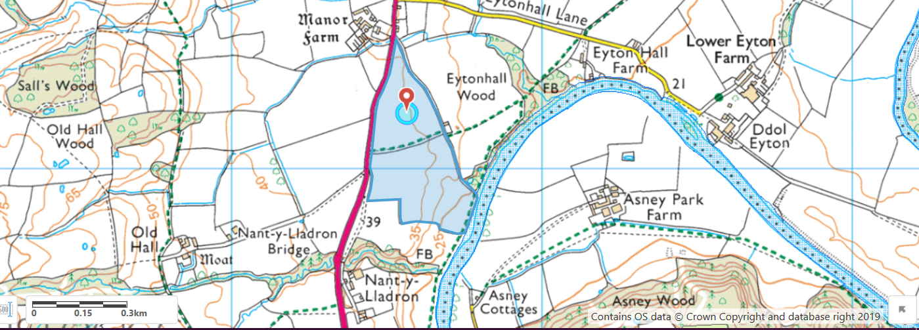
- Has there been any pre-application discussion or correspondence with NRW conservation/ecology | No
- What aspect(s) of the proposed permission may damage the features which are of special interest for the SSSI?
The following ‘Operations Requiring Consent’ (or other activities associated with the permission) that may cause damage) are relevant to the proposed permission.
7. Dumping, spreading or discharging of any materials
22. Storage of materials
26. Use of vehicles, vessels or crafts

The following SSSI features and mechanisms of impact have been considered to assess the likelihood of damage:
- 2.1 Fish (Salmon, bullhead, brook lamprey, river lamprey, sea lamprey)
- 2.2 Otter
- 2.3 Aquatic and shingle dwelling invertebrates (club-tailed dragonfly, the stonefly Isogenus nubecula and the weevil Baris lepidii)
- 2.4 Floating water plantain
- 2.7 Vascular plants (slender hare’s-ear, sea barley, and hard-grass)

The River Dee and its associated plants, mammals, fish and invertebrates may receive increased levels of nutrients due to the possibility of run off from the surrounding fields, including the spreading products in this application. This could affect the water quality of the river from increased risk of eutrophication to increased levels of siltation within the water course. Both of these factors could see detrimental impacts on the health of the flora and fauna within the river. Ensuring buffer zones are adhered to will reduce the chance of any of these detrimental environmental impacts.
- Decision
i) The proposed permission is not likely to damage any of the flora, fauna or geological or physiological features which are of special interest.
- The operator will comply with the Code of Good Agricultural Practice (CoGAP)
- Non-spreading buffer zone of 30m in field closest to SSSI will be maintained, so no pathway present for sensitive features to be affected. The remaining fields are not directly connected to the river and are buffered by surrounding fields.

Natural Resources Wales is minded to:
Issue the permission

- Name and job title of Natural Resources Wales officer: | Rhiannon Smith  Permitting Officer
- Date form sent to NRW conservation/ecology | N/A



