CRoW Appendix 4 (140_10_SD02)  CRoW Act 2000: Natural Resources Wales application for permission - Formal Notice |  | 
Natural Resources Wales Formal Notice.
Requirements of Section 28I of the Wildlife & Countryside Act 1981 as amended by the Countryside and Rights of Way Act (CRoW) 2000.
Duty in relation to granting any consent, licence or permit for activities likely to damage Sites of Special Scientific Interest (SSSI).
Guide to filling in this form for Natural Resources Wales staff:
To be completed by Permitting Officers for any applications for a permission which the Natural Resources Wales has considered under S28G duties to protect and enhance SSSIs. This applies to all proposed permissions within a SSSI, and to operations outside the SSSI boundary which are likely to damage its special features.
Refer to OI 140_10 ‘Applying the Countryside and Rights of Way (CRoW) Act 2000 to applications for permits with potential for impact on Sites of Special Scientific Interest (SSSI)’, including the flowchart in Appendix 2.
Pink italic text – drafting notes, to be deleted before completion/consultation.
Blue text – examples, to be replaced with permission-specific information.
Ensure you have completed all sections.
- Natural Resources Wales area/region/NPS hub: | ElyVale.Consultations
- Name of SSSI: | Severn Estuary SSSI, Penarth Coast SSSI, Cosmeston Lakes
- Type of permission: | SR2010No4 Mobile plant for landspreading (land treatment resulting in agricultural or ecological benefit)
- Date for Natural Resources Wales permit determination: | 19/10/2018
- Predicted 28 day date for response from NRW conservation/ecology (under S28 I(4)): | n/a
- Natural Resources Wales reference no: | PAN-003262  EPR/GP3792SK
- National grid reference: | Farm location: 317919,168935  Fields: 7 317436,168258  11 317561,168356  12 317717,168306  13 317844,168380  15 317976,168168  16 317870,167962  19 318135,168486  18 318082,168681  21 318423,168689  24 318315,168837  25 318241 168962  26 318399 169105  Storage: 318487,169016
- Description of proposal: | No:  Application to spread a maximum of 1250 tonnes of liquid Digestate waste to 48.2 hectares of land within the listed fields at Cosmeston Farm. The waste will be spread subject to ground conditions, particuluarly when there is a significant crop requirement. For Grass: March-April prior to first cut, May-June after first cut, July-August after second cut and laste summer for grazing. For Winter Barley: The waste will be applied in the spring as a surface dressing.Waste will be spread onto the crop using a mounted umbilical system connected to a dribble bar spreading equipment.  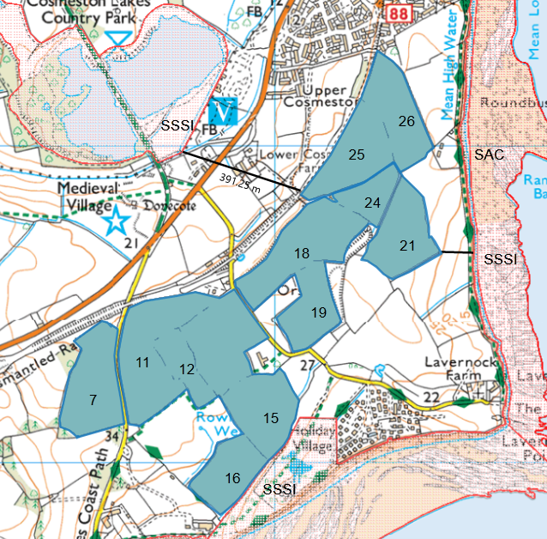
- Is the proposed activity within (wholly or partially) the SSSI boundary? | NO  No: Cosmeston Lakes SSSI is located approximately 400m to the NW of spreading fields. Penarth coast SSSI located directly to the SE of the border of fields 15 and 16. Severn estuary SSSI located approximately 95m to the east of fields 26 and 21.
- Has there been any pre-application discussion or correspondence with NRW conservation/ecology | NO
- What aspect(s) of the proposed permission may damage the features which are of special interest for the SSSI?
The following ‘Operations Requiring Consent’ (or other activities associated with the permission) that may cause damage) are relevant to the proposed permission.

Application of manure, fertilisers and lime.
Dumping, spreading or discharging of any materials.
Storage of materials
Use of vehicles likely to damage or disturb features of interest

The following SSSI features and mechanisms of impact have been considered to assess the likelihood of damage:

Severn Estuary SSSI:

- The estuary processes create a unique environment due to millions of tonnes of sediment that produces highly mobile banks of sand/mud – many species and habitats are dependent on these natural processes. Habitats include the intertidal sand/mud flats, rocky shores, salt marshes, reed beds, swamps and eel grass beds. The species that these habitats support include a diversity of birds (including Shelduck, Dunlin, Ringed Plover and Curlew), fish (e.g. Allis shad, Atlantic Salmon and Eel) and an assemblage of invertebrates (include rare species of beetle, fly and shrimp).
- These habitats and species are potentialy impacted by various industrial and agricultural activities due to pollution. The spreading of waste material onto agricultural land can potentially run-off into the River Severn, thus suitable mitigation measures are required to minimse this risk. These measures include the use of non-spreading buffer zones on the border of the fields running parallel to the shoreline, compliance with the Water Code, Sludge Regs and EPR, and the prohibition of application prior to heavy rain forecast.
- The better control and regulation of pollution and waste disposal within the Severn Estuary catchment area has significantly improved water quality in recent years.

Penarth Coast SSSI:

- Includes the exposed geological features on the cliff-face and cliff-top fields, which support a variety of habitats such as scrub, secondary woodland, and species-rich grassland within a relatively small area. Areas of softer rock and bare soil immediately adjacent on the south facing cliffs are home to specialist invertebrates such as certain bees/wasps. On the foreshore, intertidal communities include soft paddock-bored substrata, rock pools, tide-swept algae and reefs of honeycomb worms.
- Like the Servern Estuary, these species and habitats are susceptible to inorganic fertilsers and chemicals due to the ecological changes they may cause. This includes the potential to stimulate the growth of one or two grass species at the expense of many different plants we are trying to encourage. The same appropriate risk minimisation measures should address this concern appropriately.

Cosmeston Lakes SSSI:

- The Lakes are home to a variety of species including the Starry Stonewort agrren algae – it is the only place in Wales where this particular algae is found. The are currently no signs of pollution from the surrounding environment that might uproot the stonewort. It is therefore important to ensure that the water quality of the lakes remains unpolluted, in order to remain as an optimum environment for the Starry Stonewort to continue thriving, and act as a clean habitat for other freshwater plants.
- One of the greatest threats to the Starry Stonewort relates to the pollution from agricultural run-off – increase in phosphates/nitrates would be damaging to the plant due to its requirement for low nutrient calcareous water, and because of the potential for algal blooms.
- The considerable distance between the spreading fields and this SSSI (approximately 400m) is appropriate for deterring any pathway of agricultural run-off.
- Decision
The proposed permission is not likely to damage any of the flora, fauna or geological or physiological features which are of special interest.

There is no pathway for features to be affected. Where there is a potential pathway, the use of 20m buffer zones where mitigates any associated risk (i.e. on the border of fields 15 and 16 with the Penarth Coast SSSI boundary).

Natural Resources Wales is minded to:
Issue the permission

- Name and job title of Natural Resources Wales officer: | Rohini Sawant  Permitting Officer
- Date form sent to NRW conservation/ecology | n/a

