CRoW Appendix 4 (140_10_SD02)  CRoW Act 2000: Natural Resources Wales application for permission - Formal Notice |  | 
Natural Resources Wales Formal Notice.
Requirements of Section 28I of the Wildlife & Countryside Act 1981 as amended by the Countryside and Rights of Way Act (CRoW) 2000.
Duty in relation to granting any consent, licence or permit for activities likely to damage Sites of Special Scientific Interest (SSSI).
Guide to filling in this form for Natural Resources Wales staff:
To be completed by Permitting Officers for any applications for a permission which the Natural Resources Wales has considered under S28G duties to protect and enhance SSSIs. This applies to all proposed permissions within a SSSI, and to operations outside the SSSI boundary which are likely to damage its special features.
Refer to OI 140_10 ‘Applying the Countryside and Rights of Way (CRoW) Act 2000 to applications for permits with potential for impact on Sites of Special Scientific Interest (SSSI)’, including the flowchart in Appendix 2.
Pink italic text – drafting notes, to be deleted before completion/consultation.
Blue text – examples, to be replaced with permission-specific information.
Ensure you have completed all sections.
- Natural Resources Wales area/region/NPS hub: | North Wales
- Name of SSSI: | Corsydd Nug a Merddwr SSSI
- Type of permission: | SR2010No4 Mobile plant for landspreading (land treatment resulting in agricultural or ecological benefit)
- Date for Natural Resources Wales permit determination: | 25/01/2019
- Predicted 28 day date for response from NRW conservation/ecology (under S28 I(4)): | 20/02/2019
- Natural Resources Wales reference no: | PAN-004251  EPR-GP3792SK
- National grid reference: | Farm location: SH 93513 49459  Fields:  5194 SH 92983 51969  5154 SH 92872 51667  4964 SH 93157 49652  4944 SH 92944 49340  4939 SH 93347 49457  Storage:  1 SH 92860 52060  2 SH 92941 51660  3 SH 92793 51428  4 SH 93082 49767  5 SH 93074 49320
- Description of proposal: | This is a mobile plant deployment for land spreading for agricultural benefit.  It is to spread a maximum of 12300 tonnes of water treatment sludge (waste code 19 09 02) from Welsh Water to 49.2 hectares of land within the listed fields. The Sludge cake will be spread using conventional rear discharge spreaders. Liquid sludges will be surface spread by tractor and tanker using a low-trajectory splash plate. The wastes may be applied separately or in combination. If the wastes are applied in combination the total combined amount applied will not exceed 250t/ha. Liquid sludges will be spread on delivery.No more than 50t/ha of liquid sludge will be spread on a field in any 3-week period in accordance with CoGAP.  Stackable: 3,000t  Non-Stackable: Spread on delivery
- Is the proposed activity within (wholly or partially) the SSSI boundary? | NO  Small part of field 4964, 4939 and corner part of 4944 are on the boundary of Corsydd Nug AMerddwr SSSI.  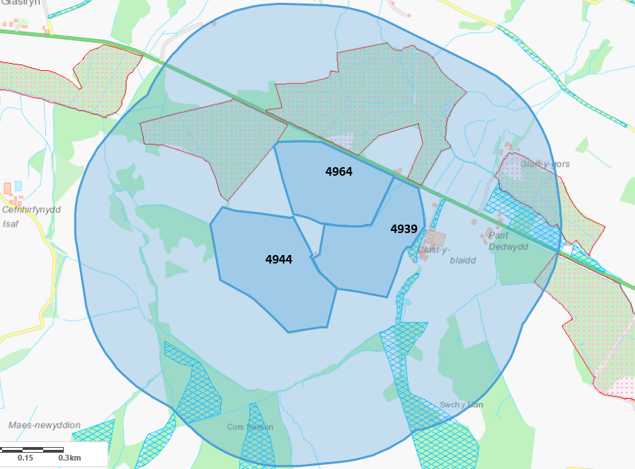
- Has there been any pre-application discussion or correspondence with NRW conservation/ecology | NO
- What aspect(s) of the proposed permission may damage the features which are of special interest for the SSSI?
The following ‘Operations Requiring Consent’ (or other activities associated with the permission) that may cause damage) are relevant to the proposed permission.

- Cultivation, including ploughing, rotovating, harrowing and re-seeding
- The introduction of grazing and/or alterations to the grazing regime, (including type of stock, intensity or seasonal pattern of grazing).
- Mowing or cutting vegetation, the introduction of mowing or cutting and alterations to the mowing or cutting regime (such as from haymaking to silage).
- Application of manure, slurry, silage liquor, fertilisers and lime.
- Dumping, spreading or discharging of any materials.
- Use of vehicles or craft

The following SSSI features and mechanisms of impact have been considered to assess the likelihood of damage:

The blanket mire is of special scientific interest and is made up of various plant communities, including bog-mosses, sedges, rushes and dwarf shrubs growing in a layer of deep peat. The peat environment relies almost exclusively on rainfall for nutrients and water supply – they are therefore acidic and nutrient poor in character.

Half of the site is covered by the mire, and represents the largest blanket mire in Northeast Wales. A variety of plant and animal species support its acidic and nutrient poor conditions.

Areas within the site where these conditions do not prevail support the presence of other wildlife habitats: including wetland habitats such as swamps, marshy grassland, fen and lowland raised bog; and dry habitats such as scrub, neutral and acidic grasslands. These habitats altogether support a range of species including rare species of liverworts and uncommon species of invertebrate, such as the rare fungus gnat, money spider and nationally scarce species of beetle.

With regards to water quality, the site is located in a natural hollow and is therefore susceptible to pollution and nutrient enrichment from surface run off, ditches or drains. In order to help filter the run off of unwanted agricultural components, the establishment of buffer zones in fields with the potential for pollutant run off should be in place.
- Decision
ii) The permission is not likely to damage any of the flora, fauna or geological or physiological features which are of special interest because of conditions.

The SSSI is located within 500m of catchment but it is outside of the spreading area. Small part of field 4964, 4939 and corner part of 4944 are on the boundary of Corsydd Nug AMerddwr SSSI. The operator has confirm that they will apply 20m non-spread buffer zone and Water courses flowing directly into SSSI will have 20m non-spread buffer zone. There is also a road between the spreading fields and the SSSI, which will also help to mitigate any potential run-off.

Natural Resources Wales is minded to:
Issue the permission with conditions to ensure no damage to SSSI

- Name and job title of Natural Resources Wales officer: | Rohini Sawant  Permitting Officer
- Date form sent to NRW conservation/ecology
For Natural Resources Wales use only, once NRW conservation/ecology response received
- NRW conservation/ecology comment on assessment: | Please delete as appropriate:  ii) NRW conservation/ecology advise the operation can go ahead with conditions
- Name and job title of NRW conservation/ecology officer: | Charlotte Williams
- Date of receipt of NRW conservation/ecology response: | 25/01/2019

