Deployment Details
Deployment Reference Number: | PAN-004407
Permit Reference Number: | GP3792SK
Permit Holder: | ByProduct Recovery Ltd
Site Address: | Ffynnon Cyff  Ferwig  Cardigan  Ceredigion  SA43 1QD
Grid Reference: | Farm location: SN 23703 48031
Grid Reference: | Fields:  1A  1B  2  3A  3B  4  5  14  15  16  17  19  29  30  31 | SN 19198 50737  SN 19167 50908  SN 19014 50812  SN 18835 50805  SN 18802 50973  SN 18794 50632  SN 18984 50561  SN 19240 51250  SN 19046 51299  SN 18971 51404  SN 18920 51510  SN 19284 51521  SN 19588 50257  SN 19776 50245  SN 19503 50533
Grid Reference: | Storage:  1 – SN 19354 50568  2 – SN 19360 50448  3 – SN 18904 50714

Administrative Checks- By admin officer
 | Comments
Internal consultation | Waste reg team: waste.northmid@cyfoethnaturiolcymru.gov.uk  NRM team: NRMCeredigion@cyfoethnaturiolcymru.gov.uk  NRW NLO: N/A
External consultation | EA NLO: josh.tinsley@environment-agency.gov.uk
Date due: | 30/01/19
Are fields within Gower AONB? If yes, then consult. |  | N/A
Are fields within Clwydian Range and Dee Valley AONB? If yes, then consult. |  | N/A
Are fields within a National Park? If yes, then consult with Parks Authority. |  | N/A
Permit compliance rating and multiplier |  | Rating A - 100%

Administrative Checks- By determining officer
 | Action completed, or document provided? (Yes, No or n/a) | Comments
Is the base permit still live? Has there been any variations? | Y | Welsh - check DMS/PalS  English – EA NLO will inform if no longer live or check public register
Correct application form | Y
Correct fee: | Y | See permit compliance rating and multiplier
Original fee received and cleared | Y | Amount: 994.00  Date cleared on MyNRW: 11/01/2019  Transaction number: 2061341
Additional fee received and cleared | n/a | Amount:  Date cleared on MyNRW:  Transaction number:
MyMap report completed | Y
Location map | Y
Waste Analysis | Y
Soil Analysis | Y
Certificate of Agricultural Benefit | Y
Site Specific Risk Assessment | Y | High risk location only

Application Form | Y N n/a | Comments
4a Multiple deployments Qu answered? | Y
4b1 Has the NCP information been given? | Y
4c Is the risk banding correct? | Y
4d/4e Does the operator need to provide a risk assessment? | Y
4f Has all of Table 2- waste types been completed? | Y
4f Are the wastes listed in the deployment specifically listed in the permit? | Y
4g1 Does the farm address match the grid reference? | Y
4g2 If it is agricultural land; has the holding number been given?  Verify on MyMap (normal)>Resource Management Terrestrial > LPIS/IACS Field Boundaries/Identify >Attributes >CRN1_CPH | Y | 55/226/0017
4h Has all of Table 3- parcels of land been completed? | Y
4h Is the total area of land to be treated less than 50 ha, or 100 hectares for a single continuously managed area of land? | Y | 44.3 ha
4g/4h Is the land to be treated within a 10 miles radius of the main address? | Y
4i Has consent been given to carry out the activity? | Y
4k Has all of Table 4- previous land treatment been completed? | Y
4l Has all of Table 5- waste storage details been completed? | Y
4l Is the storage total no more than 1250 tonnes shall be non- stackable waste, and no more than 3000 tonnes of all other wastes? | Y
6b/6c Have both Table 6 and Table 7 been completed? | Y
8 Has confidentially been claimed? | N
8 Has national security been claimed? | N
9a If signing on behalf of a relevant person, has written confirmation from a relevant person been given? | n/a
9b Has the operator confirmed they will comply with the conditions of the rule set? | Y
9c Has a relevant person or approved person (Qu 9a) signed the declaration? | Y

Location | Y N n/a | Comments
Do the grid references match the site plan? | Y
If there is storage; do the grid references match the site plan? | Y
Does the map include all of the following from TGN 8.01, box 3.1 in relation to both storage and spreading:
- location of all storage sites for the waste to be spread | Y
- the location of any public rights of way  (layer on MyMap, not MyMap for Perm) | Y
- groundwater source protection zones  (no spreading in SPZ1) | n/a
- surface water courses  (no spreading within 10 meters) | Y
- any spring, well or borehole not used to supply water for domestic or food production purposes within 50m | Y
- any spring, well or borehole used to supply water for domestic or food production purposes within 250m  (no spreading within 50 metres) | Y
- any buildings or houses within 250 m | Y
- any European designated sites- Natura 2000 (SPA, pSPA, SAC or cSAC) or Ramsar- or SSSI within 500 m | Y | SAC:  - Cardigan Bay / Bae Ceredigion  - West Wales Marine / Gorllewin Cymru Forol  SSSI:  - ABERARTH - CARREG WYLAN  - CAEAU CRUG BYCHAN, TY GWYN A LLWYN YSGAW
Also check for any other environmentally sensitive sites within 500 meters. Suggested list includes, but is not limited to:
- Species for Permitting | Y | - Threatened Lichen
- Habitats for Permitting | Y | - Purple moor grass and rush pastures  - Lowland dry acid grassland and lowland calcareous grassland
- Scheduled Ancient Monument | n/a
- Local Nature Reserve | n/a
- National Nature Reserve | n/a
- Ancient Woodlands | n/a
- Local Wildlife Sites | n/a
- AONB | n/a
- National Park | n/a
- NVZ | n/a
- groundwater Safeguard Zone (new rule set condition) | n/a
- Other (please specify in comments) | n/a

Waste Analysis | Y N n/a | Comments
Is the waste analysis report less than 12 months old at time of application? | Y
Does the analysis include the following?
- pH | Y
- Nitrogen (N) | Y
- Phosphorus (P) | Y
- Potassium (K) | Y
- % dry matter | Y
Does the analysis include the following?
If it is a required parameter for the waste (see section below) and has not been tested for; has adequate justification been provided?
- Zinc | Y
- Copper | Y
- Nickel | Y
- Lead | Y
- Cadmium | Y
- Mercury | Y
- Magnesium | n/a | Very low value, Justification has been given.
- Sodium | Y
- Sulphur | Y
Check Appendix A of TGN 8.01 for the wastes types applied for.
- Are there any special testing requirements? | Y
- If yes; have they been tested for?  N.B. for 190902 only aluminium, sulphur and iron need to be tested for | Y
If spreading waste soil, has the analysis for the waste soil been carried out at an MCERTS Lab | n/a
If the spreading is in a groundwater safeguard zone; are any wastes “high readily available nitrogen wastes”? i.e. organic wastes in which more than 30% of the total nitrogen content is available to the crop at the time of spreading. | n/a
- If yes, have they stated condition 2.1.8 of the permit will be complied with? | n/a

Soil Analysis | Y N n/a | Comments
Is the soil analysis report less than 4 years old at time of application? | Y
Does the analysis include the following?
- pH | Y
- Potassium (K) | Y
- Phosphorus (P) | Y
- Magnesium (Mg) | Y
If the waste analysis shows high PTE’s; have these been tested for in the soil? | n/a
Have the soil indices for P, K and Mg on each field been given? | Y
Does analysis show that the soils are deficient in the nutrients or properties required by the proposed cropping? | Y

Benefit Statement | Y N n/a | Comments
Has the writer of the benefit statement have appropriate technical expertise? | Y
Has information been given on?
- Cropping regime and plant nutrient requirements | Y
- Timing of application | Y
- Amount of waste to be applied and application rate | Y
- Soil chemical properties (e.g. liming and pH) | Y
- Soil physical properties (e.g. organic matter and soil structure) | Y
- Soil water content | n/a
- Levelling the land | n/a
If an operator wants to apply more nutrients than is recommended in RB209 have they?
- Justified the nutrient level with appropriate technical expertise | n/a
- Included the nutrient level in their environmental risk assessment | n/a
- Stated the source of information that they used to set the nutrient level. | n/a
Have any potential negative impacts of the activity been addressed?  See box 6.5 of TGN 8.01 for more details | Y
Is the application rate appropriate for the:
- Waste type? | Y
- Waste analysis? | Y
- Crop nutrient requirements? | Y
If multiple wastes are being mixed:
- Does each waste confer benefit in its own right? | Y
- Is it only for operational purposes? | Y
- Have actual application rates for each waste been given? | Y
- Is there a statement saying that the waste will be spread at the lowest applicable application rate? | Y
Application of waste
- Is method of application appropriate for the waste type and cropping? | Y
- Is the timing of application appropriate? | Y
- Have they stated when the waste will be spread? | Y
- Have they stated how often the waste will be spread? | Y
Have the total nutrients supplied by the waste been given? | Y
Has total nutrients supplied been given in oxide format? | Y
Has the SNS for each field been provided? (Or enough information provided to calculate the SNS) | Y
If the operator has stated (or intelligence from area ops teams have told us) that other sources of nutrients have been applied in the last 12 months have they stated:
- What material was spread? | Y
- How much material was spread? | Y
- At what application rate material was spread? | Y
- The nutrients supplied by the material? | Y
Does the activity meet the definition of recovery?
See box 6.2 of TGN 8.01 for more details
- Is there a clear benefit from the activity? | Y
- Is the material suitable for its intended use? | Y
- Is the minimum amount of waste being used to achieve the intended benefit? | Y
- Is the waste being used as a substitute for a non-waste material? | Y
- Will the proposal be completed to an appropriate standard?  For this activity, the standard is the deployment application that has been assessed and approved. Any deviation from this which has not been agreed is likely to be viewed as disposal. | Y

Site specific risk assessment | Y N n/a | Comments
If the deployment is in a high-risk location (Medium (2) or high-risk deployment) has a site-specific risk assessment been submitted? | Y
If there are other potential sensitive receptors has a site-specific risk assessment been submitted? | Y
Does the site-specific risk assessment identify all potential?
- Sources of pollution or hazards | Y
- Pathways | Y
- Receptors that can be affected by that source of pollution | Y
- Measures that will minimise or mitigate the impact will be put in place | Y

SSSI/ Appendix 4 assessment | Y N n/a | Comments
Is the site within 500 meters of a SSSI?  - If yes, the complete an Appendix 4 CroW assessment. | Y
Has a “likely significant effect” been identified?  - If yes, consult with the relevant NRM team.  - If no, save the Appendix 4 to the DMS as “information only” | Y

Natura 2000 or Ramsar site/ Habitat Regulation Assessment | Comments
Is the site within 500 meters of a Natura 2000 (SPA, pSPA, SAC or cSAC) or a Ramsar site? | Yes
Appropriate assessment:
In light of the conclusions of an appropriate assessment, and taking account of the advice received from protected sites advisors, it has been established that the project will not adversely affect the integrity of any Natura 2000/Ramsar site, taking into account any conditions or restrictions as applicable, either alone or in-combination with other plans and projects. (As documented in section 4 of OGN 200 form 1, and section 5 if applicable)

Comments
Consultation responses:
- FORM 1 and Appendix 4 needs to complete.
- Extra buffer zone
MyMap and location assessment: MyMap Report

Agricultural benefit calculations: DMS

Request for information: RFI email sent on 18/02/19
- The Lab reports for Llechryd liquid, Iron is 16738 mg/kg. This value does not match with Analysis of Water Treatment works Sludge table which states 8097 mg/kg.
- Missing information for SAC and SSSI in Site Specific Risk Assessment.

Decision
Can the deployment application be approved? | Yes
Permitting Officer: Rohini Sawant | Date:15/03/2019
Team leader or Transfer of Powers (ToP) approval: Huw Davies | Date: 15/03/2019

Appendix 1 – Time recording
Admin/consultations | 60
Determination | 700
Sign off | 10
Issuing | 30
Total | 800minutes

https://mapsinternal.cyfoethnaturiolcymru.gov.uk/Html5Viewer2101/index.html?viewer=MyMap_Permitting.MyMapPermittingHTML5&project=280abed4b3f3410a8b846d66788d4812

https://mapsinternal.cyfoethnaturiolcymru.gov.uk/Html5Viewer2101/index.html?viewer=MyMap_Permitting.MyMapPermittingHTML5&project=280abed4b3f3410a8b846d66788d4812

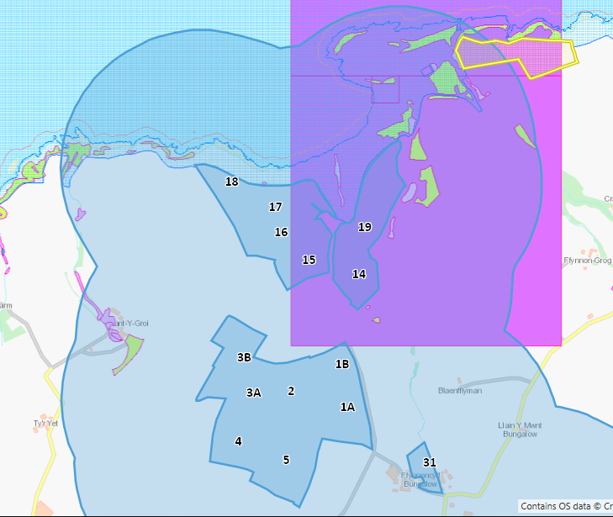

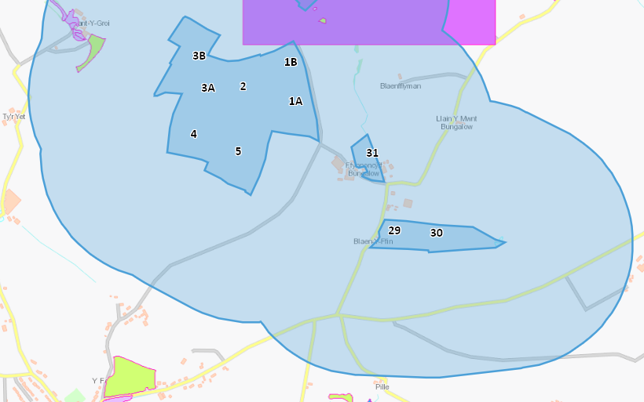

High Risk locations are within an SPZ2 or with 500 metres of Natura 2000 (SPA, pSPA, SAC or cSAC), Ramsar or SSSI site.
AONB’s, Ancient Woodlands, Scheduled Ancient Monuments, Local and National Nature Reserves, National Parks and Heritage Coasts.
Potential hazards include dust, odours and run-off / leachate.
Receptors to be affected include environmentally sensitive sites, watercourse, local residents, public rights of way, housing, schools, workplaces and recreational facilities.

