- Application type
New impoundment licence ☐
Removal of an existing impoundment ☒ Complete sections 2 and 4
To licence an existing impoundment ☐
Technical variation to an impoundment licence ☐

Give existing licence or pre- application reference number(s)

2. Impoundment details
All information should correspond with any maps and drawings submitted with this application

2.1 Provide details of all impoundment points. For structures spanning a watercourse, provide a National Grid Reference for each bank. If necessary, continue on a separate sheet and tick here to show that you have done this. ☒

Impoundment  location name / reference | National Grid Reference for each bank,  looking downstream  (12 digit)
Impoundment  location name / reference | Left bank | Right bank
Vicars Mill weir | SN 10630 22550 | SN 10617 22546
2.2 Please provide a full description of the impoundment, outlining its purpose and how it will operate. If this information is detailed in a supporting document, provide the document title
or reference in the space below.
If necessary, continue on a separate sheet and tick here to show that you have done this. ☒

The weir at Vicars Mill, Llandisillio, increases the upstream water level on the Eastern Cleddau allowing the water to be drawn into the adjacent leat which in the past fed a trout farm. The trout farm is no longer in operation and the leat has been partially infilled preventing the through flow of water.

In order to restore the river to a more natural state and improve fish passage it is proposed that the weir be partially removed (i.e. 70% removal).

Reference: Vicars Mill Flood Consequence Assessment Report

- Description of impoundment

3.1 Name of watercourse
Eastern Cleddau

3.2 Will your proposed impoundment result in a change to the wetted perimeter (downstream) or new submerged areas behind (upstream of) the impounding works?
No ☐ Yes ☐ If yes, ensure this is shown on any map or drawings submitted

3.3 Will the ponded area created by the impoundment be lined? No ☐ Yes ☐
If yes, give details.

3.4 Give the height of the impoundment structure, from the downstream toe to crest or top of spillway (in metres above Ordnance Datum). If the proposal involves an existing impoundment, state the change in height (in millimetres).

3.5 What is the overflow or crest level of the impoundment (in metres above Ordnance Datum)?

3.6 What is the proposed capacity of the impoundment when full to spillway level (in cubic metres)?

3.7 Will the proposal create a raised reservoir? No ☐ Yes ☐

3.8 Does the proposal involve the controlled release of water to safeguard downstream flows? No ☐ Yes ☐ If yes, provide details

3.9 Is the impounded water to be used for a subsequent purpose? No ☐ Yes ☐

If yes, provide details (for abstractions, state the daily and annual quantities in cubic metres).

3.10 How will the impounded area be filled initially, and subsequently refilled if applicable?

- Fish and eel passage
4.1 Confirm the fish species present at your site.
- Salmon
- Sea Trout
- Brown Trout
- Eels
- Shad
- Sea Lamprey
- River Lamprey
- Brook Lamprey
- Minor species e.g. bullhead, minnows, stone loach

4.2 Complete the table below with full details of the measures you intend to take to safeguard these fish species.

 | Intake | Outfall
Type of fish screen | N/A | N/A
Screen aperture size (mm) | N/A | N/A
Screen height and width (mm) | N/A | N/A
Type of upstream fish passage | Open channel
Proposed flow for fish pass (m/s) | Natural area average flow velocity
Type of downstream fish passage | Open channel
- Construction, maintenance and operation

5.1 Provide details of maintenance or activities relating to the operation of the impoundment. If necessary, continue on a separate sheet and tick here to show that you have done this. ☐

N/A – impoundment removal therefore no operational works or maintenance required.

5.2 Provide details of diversion works or removal of existing works.
See attached documents:

Method statement/construction plan: VMW Removal Diagrams for NRW Permits

Drawing: Vicars Mill-XS-1001-P01_wImage

Permanent Flood Risk Activity Permit: FRA/SW/2019/0041
Temporary Flood Risk Activity Permit: FRA/SW/2019/0043

Demolition of the weir will be carried out in two passes, with removal taking place in one half of the channel at a time. A centre width of 7.6m will be removed from the weir, leaving 2.0m wide and 1.8m wide sections on the left and right banks respectively.

A temporary construction of sandbag bunds will be used to create a dry working area. The sand bag bund will be reversed / swapped to opposing sides of the river as required in order to maintain a dry working area without the need for completely drying out the full river channel.

Associated diversion works to be carried out are downstream sediment control measures.
4 x rows of SediMats & silt booms will be installed within 30m downstream of the weir. In each row of SediMats a gap of 2m is to be left in alternating sides to allow water through.

- Planning application
Have you sought advice on your planning application?
No ☐ Yes ☒
If yes, submit a copy of the Planning Authority’s response.
See attached ‘FW query re Vickers Mill Weir.msg’

- Declaration

Please see Guidance Note WRX for details of who can sign this section and note the information in that document relating to the Data Protection Act 1998.

By signing below, you are declaring that as far as you know and believe the information given in this form, on any map and in any supporting or additional information, is true.

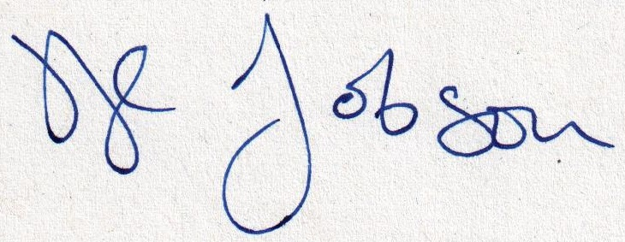

Signed

Helen Jobson

Print name

Senior Executive Officer

Position

07/05/2020

Date

Application Checklist

Please tick the following checklist items to indicate that you have included the required information. If any sections of the form are left blank and no supporting information submitted, where we have insufficient information to make a decision
on your application, we will return your application to you.

Essential:
Form WRA completed, if there have been any changes since pre-application an updated Form WRA is required ☒
Map with all impoundment points and new wetted perimeters/submerged areas ☒
clearly marked
Drawings and Design Statement ☒
State number of continuation sheets (enter 0 if none included)
0

Where relevant:
Form WRD completed, if your proposal also requires an abstraction licence ☐
Stage 1 photo survey (contact us for more details on this requirement) ☒
Letter of authorisation from the applicant, allowing an agent to act as signatory ☐
Further information requested in our pre-application response letter to you ☐
Planning Authority response, where available ☒

Additional supporting information - please list below:

Method statement/construction plan: VMW Removal Diagrams for NRW Permits
Drawing: Vicars Mill-XS-1001-P01_wImage
Permanent Flood Risk Activity Permit: FRA/SW/2019/0041
Temporary Flood Risk Activity Permit: FRA/SW/2019/0043

Land ownership map: Landowners v2

Landowner access permission – Signed Permission to enter land form – Mr. Ashby (JPG File)

Flood Consequence Assessment: Vicars Mill Flood Consequence Assessment Report

Topographic Survey: E157 001 18_Topographic Levels Survey Cross sections 1 – 10

Planning Authority’s response: ‘FW query re Vickers Mill Weir.msg’

Vicars Mill Weir – Stage 1 Photo Survey

