CRoW Appendix 4 (140_10_SD02)  CRoW Act 2000: Natural Resources Wales application for permission - Formal Notice |  | 
Natural Resources Wales Formal Notice.
Requirements of Section 28I of the Wildlife & Countryside Act 1981 as amended by the Countryside and Rights of Way Act (CRoW) 2000.
Duty in relation to granting any consent, licence or permit for activities likely to damage Sites of Special Scientific Interest (SSSI).
- Natural Resources Wales area/region/NPS hub: | Mid
- Name of SSSI: | Carreg Wylan SSSI & Caeau Crug Bychan SSSI
- Type of permission: | Landspreading deployment under SR2010no4
- Date for Natural Resources Wales permit determination: | 02/06/2020
- Predicted 28 day date for response from NRW conservation/ecology (under S28 I(4)): | n/a saved for information only
- Natural Resources Wales reference no: | PAN-010128
- National grid reference: | Farm location: SN 18094 50342  Fields:  Hafod Farm  Tyriet 8 SN 17655 50758  Tyriet 9 SN 17428 50710  Storage:  SN 17956 50063
- Description of proposal: | Application to spread a maximum of 5,112 tonnes of 2 waste streams both comprising of sludge from dairy waste treatment. The waste will be spread over 8.3 hectares of land within the listed fields at Hafod Farm.  The fields will be spread subject to ground conditions being suitable and when there is a significant crop nutrient requirement (i.e. early spring, after a silage cut, in advance of periods of grazing). Spreading of these grass fields will be split into multiple applications throughout the season.  Spreading of the waste will be carried out in accordance with the Code of Good Agricultural Practice (“Protecting our Water, Soil and Air. Defra, 2009) and in accordance with the requirements of the deployment and environmental permitting regulations.  NRW will be informed at least 48 hours prior to any spreading commencing and no spreading will occur within 48 hours of forecasted rainfall.  The waste will be either directly spread onto the fields with shallow injection equipment assuming ground conditions are suitable at the time of waste receipt, stored in an above ground liquid storage tank for future application when conditions are suitable and there is requirement for application. Should the ground or weather conditions mean it’s unsuitable for spreading then contingency field storage in nurse tanks may also be required. These potential locations are also detailed within the LPD1 form.  Waste will not be stored or spread in combination.  The maximum application rate for each field will be split into multiple applications and will not exceed 50t/ha in any one application to a field.  The wastes are a source of nitrogen, phosphate, potassium, magnesium, sulphur, sodium, calcium and organic matter.  The wastes can be beneficially used to replace a proportion of bagged mineral fertiliser. The nutrients within the waste fall safely below their respective limits.
- Is the proposed activity within (wholly or partially) the SSSI boundary? | No – The proposed activity location is a minimum proximity of >350m to both SSSI’s.
- Has there been any pre-application discussion or correspondence with NRW conservation/ecology | No
- What aspect(s) of the proposed permission may damage the features which are of special interest for the SSSI?
The following ‘Operations Requiring Consent’ (or other activities associated with the permission) that may cause damage) are relevant to the proposed permission.

Carreg Wylan SSSI:

- Cultivation, including ploughing, rotovating, harrowing and re-seeding.
- Mowing or cutting vegetation, the introduction of mowing or cutting and alterations to the mowing or cutting regime.
- Application of manure, slurry, silage liquor, fertilisers and lime.
- Dumping, spreading or discharging of any materials.

Caeau Crug Bychan SSSI:
- Cultivation and alterations to the ploughing, rotovating, harrowing and reseeding regime
- Application of manure, slurry, silage liquor, fertilisers and lime.
- Dumping, spreading or discharging of any materials
- Storage of materials.

Please note that none of the above activities under this deployment application are occurring on or within the SSSI

The following SSSI features and mechanisms of impact have been considered to assess the likelihood of damage:

Carreg Wylan SSSI:

The intertidal features are vulnerable to pollution either from accidental releases such as oil spills or from regular discharges for example those which cause nutrient enrichment in sensitive areas.

Traditionally the coastal grasslands have been grazed by sheep or ponies and this has generally been successful in maintaining an open, short and uneven maritime grassland sward and has prevented encroachment by scrub, bracken or coarse grassland however, some additional management may now be required on areas where traditional grazing has ceased. A mixed grazing regime with cattle and /or ponies is recommended for the coastal heathland.

Although grazing is the preferred management for these features, mowing can be useful where problems have developed. Mowing can provide a good way of opening up areas that have been invaded by scrub or bracken or have become overgrown. The cuttings are best collected and removed to prevent smothering of regrowth and nutrient enrichment. It is important to follow mowing with grazing to deter re-invasion of bracken, scrub and coarse grasses

Scrub and bracken control may be necessary in some areas where scrub and bracken are encroaching, but it should always be followed up by grazing.

Maritime grassland and heathland require low soil fertility so use of fertilizers should be avoided.

Many of the rare and uncommon plant species have very restricted distributions within the SSSI. It is therefore important that works which would disturb or destroy the plants do not take place in their immediate vicinity. The activity is not likely to have any significant negative impact on the rare and uncommon species as it will not take place within the SSSI.

Caeau Crug Bychan SSSI:

Regular cultivation and the growth of a variety of crops is necessary for the germination and development of a rich arable plant community. It is believed that tillage alone would be less likely to provide a suitable environment for the arable plant community. Species apparently lost from a site can sometimes be restored following deep ploughing and this may be a management tool worth considering in some circumstances.

Cultivation of every field is not necessary in every year. Fallow land, grass leys, hay or silage crops and set-aside may all be compatible with the interest of the site, provided that crops are grown on each field at least three consecutive years in five.

Arable plant communities appear to be able to tolerate limited herbicide applications. In some circumstance’s herbicide applications may be a necessary management tool in controlling perennial plants which could otherwise become overdominant in the arable plant community. However, depending on the particular chemical involved, the time it is applied and the growing conditions at that time, a herbicide application is likely to eliminate at least some components of the arable flora. The effect of repeated applications over a number of years could well become harmful. Individual species could be eliminated very quickly by inappropriate use of herbicides.

There is a history of fertiliser application on this site and the continuation of applications at a low level may be appropriate. However, heavy applications of fertiliser are likely to eliminate some species from the arable plant community and produce a poorer community dominated by a few competitive species.

- Decision
i) The proposed permission is not likely to damage any of the flora, fauna or geological or physiological features which are of special interest because of the mitigation strategies as set out below:

- Potentially Toxic Elements: The supplied concentrations at the proposed application rates are all significantly lower than the maximum permissible levels detailed in the Sludge (Use in Agriculture) Regulations for biosolids applied to agricultural land, which is believed to be a suitable comparison for wastes applied to agricultural land.
- Physical contaminants: The wastes are produced by managed processes. The sludges do not contain physical contaminants.
- Waste pH: The wastes are acidic in nature. The acidic nature is most probably associated with the presence of food based organic acids. Acidic food-based wastes are routinely applied to agricultural land without adverse effects on crop health, or significant decreases in soil pH. Use of the Dairy Partners and Volac waste streams will be carefully monitored, through low rates of individual application across the growing season and close monitoring of crop health, for any adverse signs resulting from acidity around roots.
- Receiving soils are below the limits set for grassland soils under the Sludge (Use in Agriculture) Regulations.
- Potential run-off after application: The fields are level or gently sloping and the wastes will be applied following the Codes of Good Agricultural Practice. The maximum application rate for each field will be split into multiple applications throughout the growing season and will not exceed 50t/ha in any one application to a field.
- Spillages: all spillages will be reported immediately to NRW.
- Waste will be spread on delivery (or securely stored as stated above). Operators will aim to empty spreading equipment before the end of each working day to avoid overnight storage of waste in machinery.
- Regular servicing of all machinery is conducted and spreading equipment is annually calibrated. To prevent waste being held in faulty machinery replacement spreading equipment will be available.
- Spreading machinery will travel over the field in a direction which will most easily allow the machinery to turn within the boundaries of the field. Any spreading equipment will be turned off and/or lifted out of the soil prior to turning at the end of each run.
- Machinery turns will be routed to avoid rutting and wheel slip. The turns will not be executed on any buffer strips.
- There will be sufficient trained staff available to ensure that the operation continues throughout operational hours (i.e. there will be sufficient cover for illness, holiday etc.).
- Consideration for the public and local residential receptors will be taken before and during application.
- The operator will assess wind speed and direction before spreading and proximity to surrounding receptors when spreading all fields but the Hafod Farm fields, in particular in relation to this SSSI. Spread when conditions are suitable with no or little wind and when the potential of any gusts is not in the direction of the SSSI. Material sub surface injected for grass fields. 10m no spread areas enforced to watercourses, Min 20m no spread buffer to SSSI. Ensure field conditions are appropriate for spreading.
- No waste will be spread within 10m of any ditch, pond or surface water, within 50m of any spring, well, borehole, or reservoir that supplies water for human consumption or farm dairies.
- The activity will take place at a minimum of 350m from the designated areas.

Natural Resources Wales is minded to: Issue the permission

- Name and job title of Natural Resources Wales officer: | Sion Sleep  Permitting Officer
- Date form sent to NRW conservation/ecology | n/a saved for information only

Operator Map

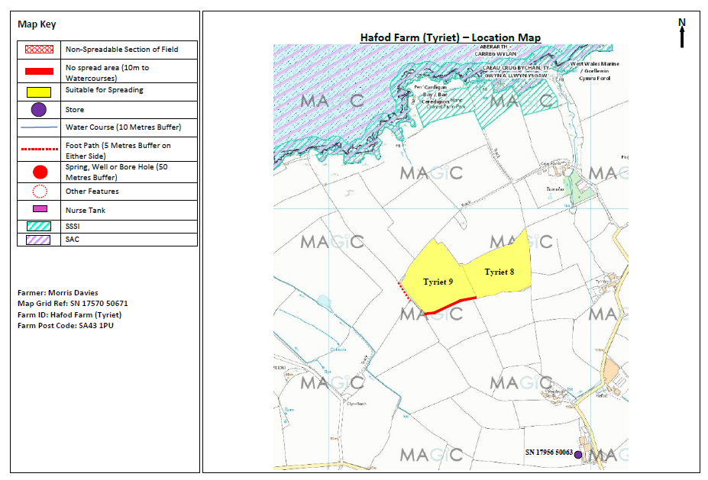
Risk Screening Map
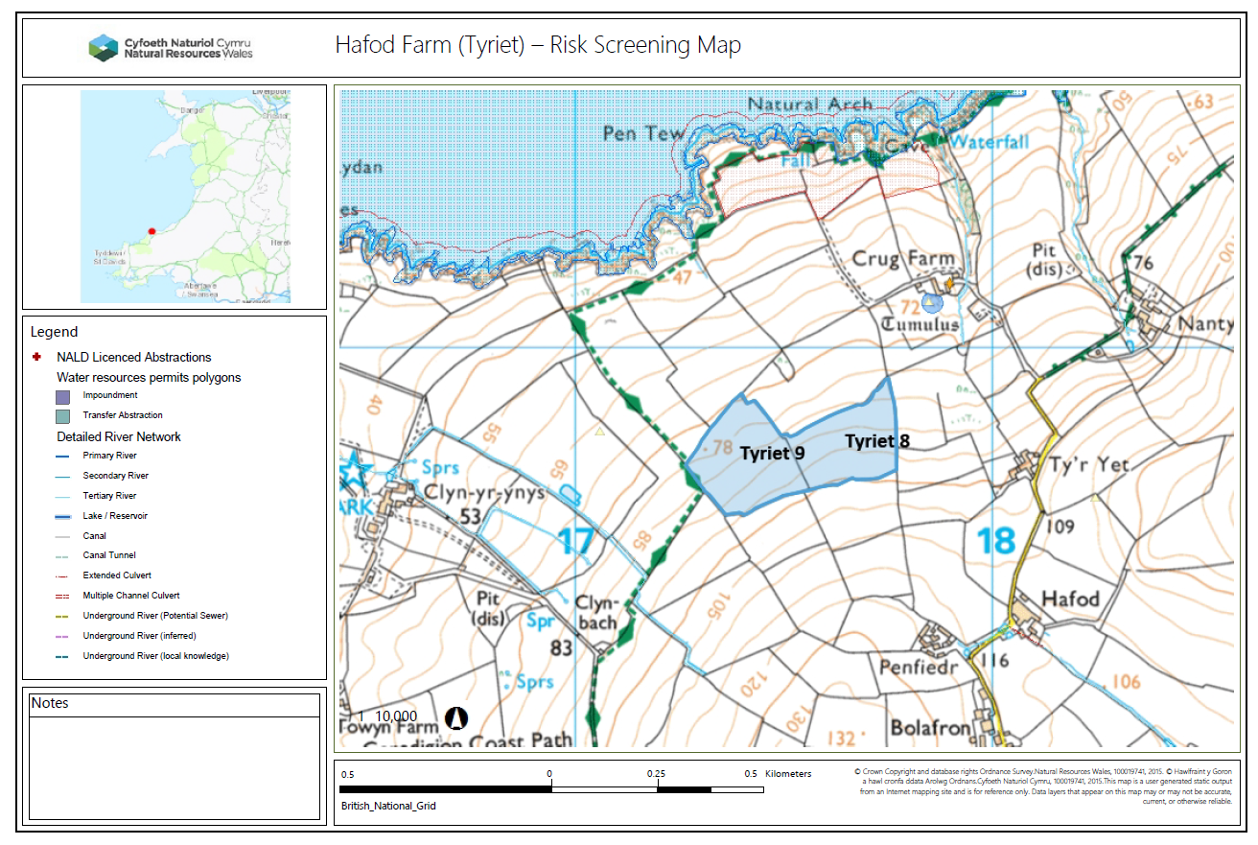
Note: The SSSI’s are denoted by the red hatched area on figure, directly above.

