Ein cyf/Our ref: EPR-BB3296CU
Eich cyf/Your ref:

Welsh Government Offices
Rhodfa Padarn
Llanbadaran Fawr
Ceredigion
SY23 3UR

Ebost/Email: malcolm.dines@cyfoethnaturiolcymru.gov.uk
Ffôn/Phone: 03000 653403

Mr. Mark Skitt
Brynhyfryd
New Cross
Ceredigion
SY23 4LZ

10th September 2019

Dear Mr Skitt,

Please find enclosed a copy of the Compliance Assessment Report from the compliance visit carried out in July. Apologies for the delay in you receiving this and although the compliance deadlines were agreed on-site, if you think you will have any problems in complying with those deadlines, please get in touch at the earliest opportunity.

Further to our telephone conversation regarding changing the correspondence address for your site, I have checked with our permitting team and you will have to submit an admin-only variation. This is a free-of-charge variation but will require you to complete and submit part A and C0.5 of the permit application form. This is the only way to formally change the correspondence address of the site and until you do so all posted correspondence other than from myself will continue to be sent to the correspondence address that was in your original permit application.

Yours sincerely
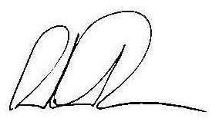
Malcolm Dines
Swyddog Rheolaeth Gwastraff / Waste Regulation Officer

