Ein cyf/Our ref: EPR-QP3494FL
Eich cyf/Your ref:

Welsh Government Offices
Rhodfa Padarn
Llanbadarn Fawr
Ceredigion
SY23 3UR

Ebost/Email: Malcolm.dines@cyfoethnaturiolcymru.gov.uk
Ffôn/Phone: 03000653403

Mr. Dai Jones
Dyfi Skips
Tan-y-ffordd
Derwenlas
Powys
SY20 8TN

13th September 2019

Dear Mr Jones,

Please find enclosed a copy of the latest Compliance Assessment Report for a review of the waste returns that you have submitted for your site for the period from 1st July 2018 until 30th June 2019. Natural Resources Wales’ duty to undertake appropriate periodic assessment can include reviewing information supplied by the operator as well as site inspections.

Please read the report carefully and ensure that you take note of, and carry-out, the required actions. Following a re-organisation within Natural Resources Wales I will be your Regulating Officer, if you have any queries regarding the contents of the report please contact me and I will be happy to assist, my details are at the top of this letter.

Yours sincerely
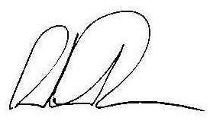
Malcolm Dines
Swyddog Rheolaeth Gwastraff / Waste Regulation Officer

