- Application type
New impoundment licence ☒
Removal of an existing impoundment ☐ Complete sections 2 and 4
To licence an existing impoundment ☐
Technical variation to an impoundment licence ☐

Give existing licence or pre- application reference number(s)

2. Impoundment details
All information should correspond with any maps and drawings submitted with this application

2.1 Provide details of all impoundment points. For structures spanning a watercourse, provide a National Grid Reference for each bank. If necessary, continue on a separate sheet and tick here to show that you have done this. ☐

Impoundment  location name / reference | National Grid Reference for each bank,  looking downstream  (12 digit)
Impoundment  location name / reference | Left bank | Right bank
Gas Works Weir (Ebbw Fach) | SO 21736 03745 | SO 21734 03744
2.2 Please provide a full description of the impoundment, outlining its purpose and how it will operate. If this information is detailed in a supporting document, provide the document title
or reference in the space below.
If necessary, continue on a separate sheet and tick here to show that you have done this. ☒

The project aims to improve fish passage beyond the weir on the Ebbw Fach River, west of Abertillery, Blaenau Gwent. This will provide access to 5.4km of suitable spawning and juvenile salmonid habitat.

The weir is a crump weir and is within a masonry lined channel. The formed channel extends upstream and downstream of the weir. It is 1 m high, 7 m long stone pitched structure, with a concrete apron.

A Larinier fish pass and an eel pass shall be installed along the right-hand bank. Full details are given in Section 8 of form-wra.

- Description of impoundment

3.1 Name of watercourse
Ebbw Fach

3.2 Will your proposed impoundment result in a change to the wetted perimeter (downstream) or new submerged areas behind (upstream of) the impounding works?
No ☐ Yes ☒ If yes, ensure this is shown on any map or drawings submitted

3.3 Will the ponded area created by the impoundment be lined? No ☐ Yes ☒
If yes, give details.
The upstream lead in channel will be concrete lined.

3.4 Give the height of the impoundment structure, from the downstream toe to crest or top of spillway (in metres above Ordnance Datum). If the proposal involves an existing impoundment, state the change in height (in millimetres).
Weir height: 1m

3.5 What is the overflow or crest level of the impoundment (in metres above Ordnance Datum)?
Weir crest: 189.30mAOD

3.6 What is the proposed capacity of the impoundment when full to spillway level (in cubic metres)?
No change to existing capacity. 5% exceedance value = 2.1m3/s

3.7 Will the proposal create a raised reservoir? No ☒ Yes ☐

3.8 Does the proposal involve the controlled release of water to safeguard downstream flows? No ☒ Yes ☐ If yes, provide details

3.9 Is the impounded water to be used for a subsequent purpose? No ☒ Yes ☐

If yes, provide details (for abstractions, state the daily and annual quantities in cubic metres).

3.10 How will the impounded area be filled initially, and subsequently refilled if applicable?

N/A

- Fish and eel passage
4.1 Confirm the fish species present at your site.
Salmon, sea trout, brown trout, grayling, fast water coarse fish, slow water coarse fish, minor species

4.2 Complete the table below with full details of the measures you intend to take to safeguard these fish species.

 | Intake | Outfall
Type of fish screen | N/A | N/A
Screen aperture size (mm) | N/A | N/A
Screen height and width (mm) | N/A | N/A
Type of upstream fish passage | Larinier fish pass
Proposed flow for fish pass (m/s) | 95% exceedance flow = 0.1 m3/s
Type of downstream fish passage | Existing weir, Larinier pass
- Construction, maintenance and operation

5.1 Provide details of maintenance or activities relating to the operation of the impoundment. If necessary, continue on a separate sheet and tick here to show that you have done this. ☐

Maintenance will include clearing the fish/eel pass of accumulated debris by NRW staff. An upstream debris boom will limit the amount of maintenance required.

5.2 Provide details of diversion works or removal of existing works.
We are currently in communication with the Flood Risk Activity permitting department within NRW to determine requirements for temporary flow diversion works. At this stage it is envisaged that the river will be dammed upstream of the weir using 1 tonne bags (or similar) and the river flow over pumped and returned downstream of the weir.

To permit fish passage at and above Q95 flows, the weir crest will be locally lowered by 0.18m across the width of the fish pass; from 189.30 mAOD to 189.12 mAOD.

- Planning application
Have you sought advice on your planning application?
No ☐ Yes ☒
If yes, submit a copy of the Planning Authority’s response.

- Declaration

Please see Guidance Note WRX for details of who can sign this section and note the information in that document relating to the Data Protection Act 1998.

By signing below, you are declaring that as far as you know and believe the information given in this form, on any map and in any supporting or additional information, is true.

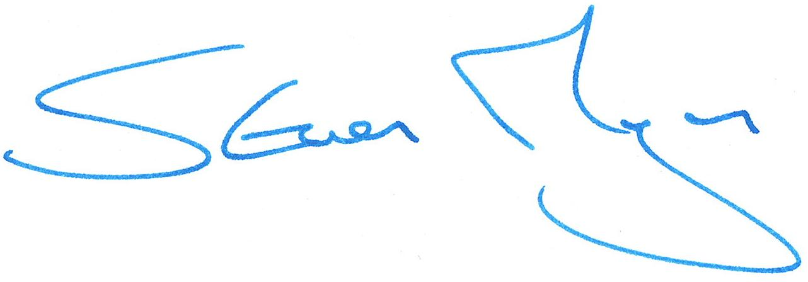

Signed

Steve Morgan

Print name

Head of South East Operations

Position

26/05/20

Date

Application Checklist

Please tick the following checklist items to indicate that you have included the required information. If any sections of the form are left blank and no supporting information submitted, where we have insufficient information to make a decision
on your application, we will return your application to you.

Essential:
Form WRA completed, if there have been any changes since pre-application an updated Form WRA is required ☒
Map with all impoundment points and new wetted perimeters/submerged areas ☒
clearly marked
Drawings and Design Statement ☒
State number of continuation sheets (enter 0 if none included)
0

Where relevant:
Form WRD completed, if your proposal also requires an abstraction licence ☐
Stage 1 photo survey (contact us for more details on this requirement) ☐
Letter of authorisation from the applicant, allowing an agent to act as signatory ☐
Further information requested in our pre-application response letter to you ☐
Planning Authority response, where available ☒
Additional supporting information - please list below:

