- Application type and fee
For the application types listed, complete this form and/or the relevant additional forms named below. Please tick which forms have been included with your application. Forms should be completed with reference to Guidance Note WRX.
* Pre-application enquiry (non-hydropower) ☐ Only complete this form
* Pre-application enquiry (hydropower) ☐ Also complete form WRB
* Application for a Groundwater Investigation Consent ☐ Only complete form WRC
New full abstraction licence ☐ Also complete form WRD
New temporary abstraction licence ☐ Also complete form WRD
New licence to transfer water ☐ Also complete form WRD
New impoundment licence ☒ Also complete form WRE
Renewal of a time-limited licence ☐ Also complete form WRD
Removal of an existing impoundment ☐ Also complete form WRE
Technical variation of an abstraction licence ☐ Also complete form WRD
Technical variation of an impoundment licence ☐ Also complete form WRE
* Administrative variations to existing licences ☐ Only complete form WRF
* No fee required

Please indicate how you wish to pay your application fee and provide a reference number where relevant.
Cheque ☐ BACS ☐ Credit or debit card ☐ Your reference number

- Applicant details

This is who the licence would be issued to and must be a legal entity such as an individual, registered company, charity or public body. If you are an agent acting on behalf of an applicant, provide their details here and yours in Section 3. See Guidance Note WRX for clarification of the details required and signatories permissible for organisations.

Applicant type:

Individual ☐ Limited company ☐ Charity ☐ Corporate body ☒ Partnership ☐ Sole trader ☐ Club ☐ Other ☐

If other, please specify

Steve Morgan
Mr
Title Full Name

Company, Charity or
Natural Resources Wales
Trading Name

Company or Charity
Registration Number
Hadnock Road
Monmouth
Monmouthshire
NP25 3NQ
Registered Address

Office: 03000 653506
Mobile:

Telephone Number
Steve.Morgan@cyfoethnaturiolcymru.gov.uk
Email Address

We will contact you by email unless you tick here ☐

Please specify who we should contact with regard to your site operation.
Site operations contact Applicant ☒ Agent ☐

For applications for abstraction licences, please also specify who we should contact for invoices and abstraction records (returns).
Invoice address* Applicant ☐ Agent ☐
Abstraction records contact* Applicant ☐ Agent ☐
* Not required for temporary or transfer licences.

Enter the agent’s details in Section 3, or provide details of alternative or additional contacts on a separate sheet and tick here to show that you have done so. ☐

Details of agent or individual authorised to act as application contact

This is who we will correspond with unless otherwise informed. If an agent has signed on behalf of an applicant, please include a letter of authorisation from the applicant allowing the agent to act as signatory.
Melissa Mahavar-Snow

Mrs
Title Full Name
Natural Resources Wales

Company, Charity or
Trading Name

Position in Company
Project Executive
Tŷ Cambria,
29 Newport Road,
Cardiff

Postcode: CF24 0TP
Postcode:
Registered Address

Office: 03000 654369
Mobile: 07468 742549

Telephone Number

Email Address
Melissa.Mahavar-Snow@cyfoethnaturiolcymru.gov.uk

- Entitlement to apply (only required for abstraction licence applications)
Does the applicant have a legal right of access to the point of abstraction?
Has a right of access ☐ Has an expected right of access ☐
Owner/occupier of land ☐ Date these access rights are expected
For formal abstraction licence applications where you are the landowner/occupier, provide a map with the land boundary and all abstraction and discharge point(s) marked. Please tick here to show that you have done this. ☐

For expected rights of access, please also provide the additional evidence as outlined in Guidance Note WRX. Please tick here to show that you have done this. ☐
- Application reference number
Have you undertaken a pre-application enquiry or had any previous discussions with us?
No ☒ Yes ☐ Provide reference

number or staff
member’s name

- Remediation work
Is this proposal as a result of a Restoring Sustainable Abstraction programme or other work requested by us?
No ☒ Yes ☐ If yes, provide your

licence number
- Source of supply
7.1 State where you intend to abstract from
Surface Water ☐ Groundwater ☐

Give Groundwater Investigation Consent number
if applicable

7.2 Provide a 12 digit National Grid Reference for the proposed or existing abstraction or impoundment point (e.g. ST 19057 76826)
SO
21735
03745

Abertillery
7.3 Source of supply or location of
proposed impoundment

Gas Works

7.4 Site name / reference

- Proposal summary
Please provide an outline of your proposal as described in Guidance Note WRX, including any sketches. If you are submitting a pre-application enquiry, this must include the quantities of water you propose to abstract. If necessary continue on a separate sheet and tick here to show that you have done this. ☒
The project aims to improve fish passage beyond the weir on the Ebbw Fach River, west of Abertillery, Blaenau Gwent. This will provide access to 5.4km of suitable spawning and juvenile salmonid habitat.

Figure 1 shows the location of the weir outside Abertillery.
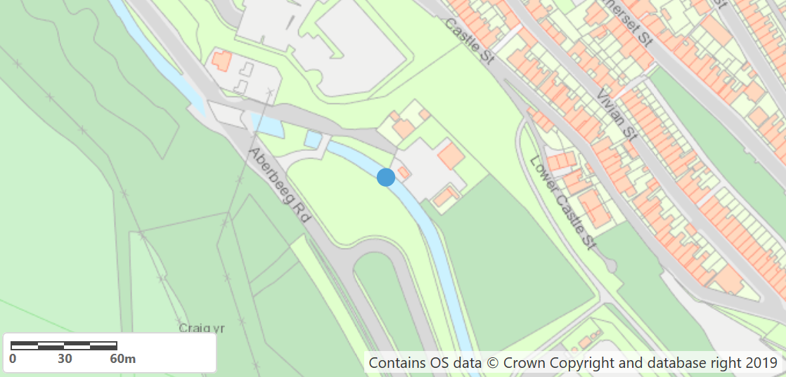
Figure 1: Location of weir (NGR: SO 21735 03745)
The weir is a crump weir (see Figure 2) and is within a masonry lined channel. The formed channel extends upstream and downstream of the weir. It is 1 m high, 7 m long stone pitched structure, with a concrete apron. Downstream of the weir, along river left is a ~2.5 m wide, 97 m long concrete apron. Downstream along river right is a ~4.5 m wide, 10 m long concrete apron which drops by ~0.8 m into a low flow channel.
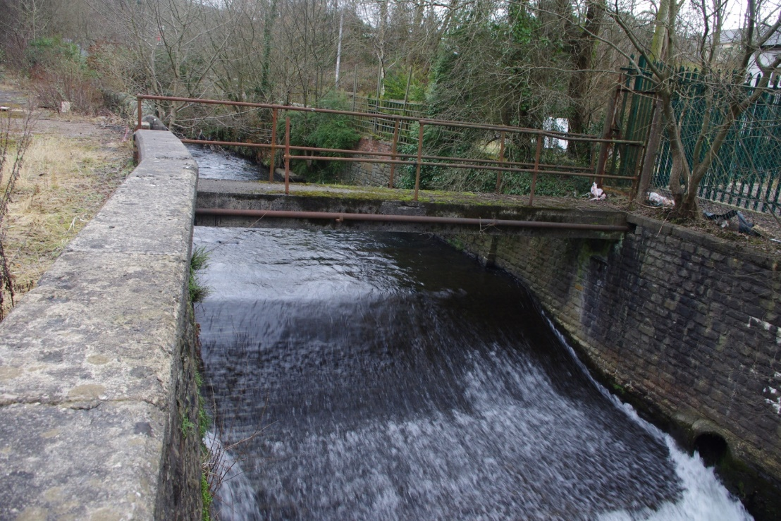
Figure 2: Proposed weir for fish passage improvement, viewed from downstream
The proposed works involve three elements:
(1) Larinier fish pass (0.62m wide to include concrete tolerance, 0.6 m baffle width, 15% slope, 10.55 slope length, 100 mm baffle height);
(2) Two pre-barrages with 0.48 m deep x 0.3 m wide streaming flow notches (full at Q95) and adherent nappe profile;
(3) A separate gravity-fed eel pass (550 mm wide concrete channel with eel tiles on a lateral slope for operation from Q99 to Q70).

The Larinier fish pass and eel pass/tiles will be constructed on river right to; provide easier access for construction/inspection/maintenance from the proposed site compound on the right bank; tie in with the existing low flow channel along river right downstream of the weir; avoid the concrete apron along river left downstream of the weir and; avoid inlets/outlets along the left bank wall.

To permit fish passage at and above Q95 flows, the weir crest will be locally lowered by 0.18m across the width of the fish pass; from 189.30 mAOD to 189.12 mAOD.

A general arrangement and section of the proposed fish/eel pass are shown in Figures 3 and 4, respectively. Note that these are for illustrative purposes; see attached General Arrangement – 0100-02769-A01 and Sections and Details – 0101-02769-A01 for more information.

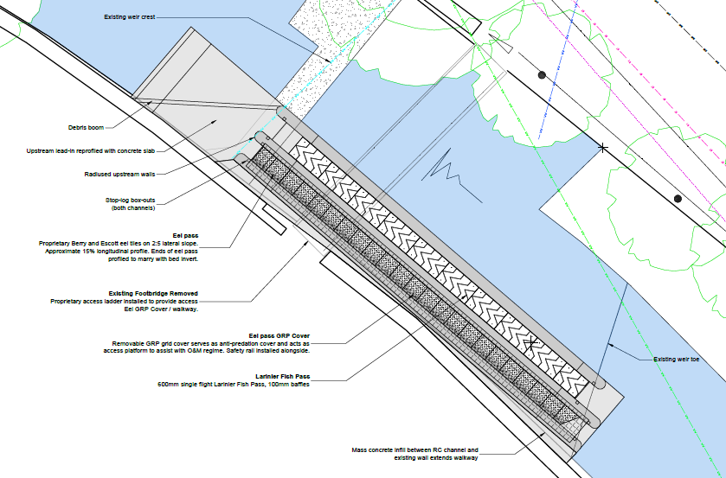
Figure 3: General arrangement of fish/eel pass (see General Arrangement – 0100-02769-A01)
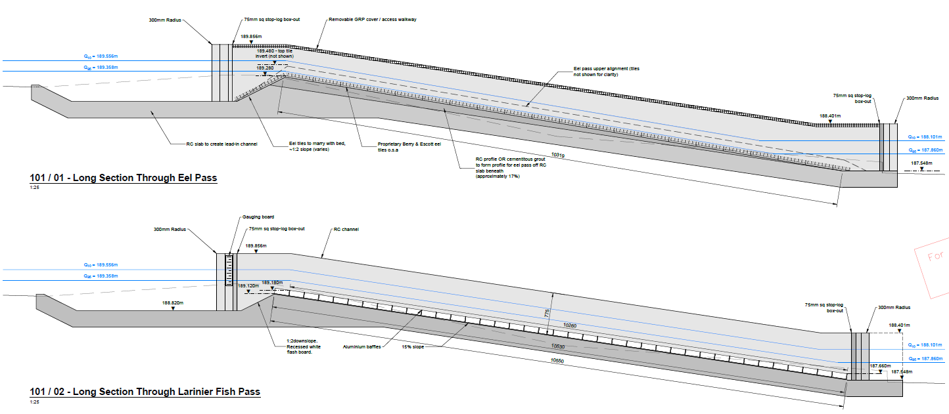
Figure 4: Sectional details through fish/eel pass (see Sections and Details – 0101-02769-A01)

- Declaration

Please see Guidance Note WRX for details of who can sign this section and note the information in that document relating to the Data Protection Act 1998.

By signing below, you are declaring that as far as you know and believe the information given in this form, on any map and in any supporting or additional information, is true.

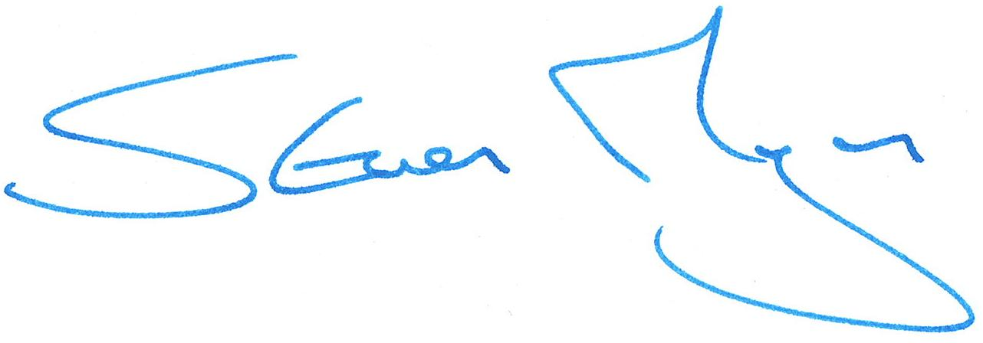

Signed

Steve Morgan

Print name

Head of South East Wales Operations

Position

26/05/20

Date

Application Checklist

Please tick the following checklist items to indicate that you have included the required information. If any sections of the form are left blank and no supporting information submitted, where we have insufficient information to make a decision on your application, we will return your application to you.

Essential:

Letter of authorisation from the applicant, allowing the agent to act as signatory ☐
Map showing the land ownership boundary with all abstraction and discharge point(s) clearly marked ☒

Where relevant:

Evidence of negotiations of expected access rights, if applicable ☐
For groundwater abstractions, results of pump test (if not previously submitted) ☐

For Natural Resources Wales’ use only:

Date received ________________________

Reference Number ________________________

Payment received Yes ☐ Amount received _______________________
No ☐ Not required ☐

