Permit Plan Sweet Wells STW BP0095901

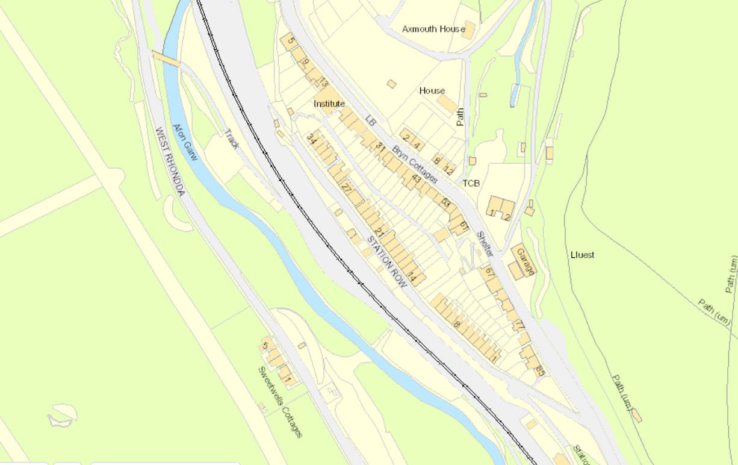
Discharge Point
SS90675 89179
Sample Point
SS90655 89177

