Permit
The Environmental Permitting (England & Wales) Regulations 2016

We Hire Ltd

We Hire Ltd
Traston Road
Newport
NP19 4PW

Permit number

EPR/BB3791CU

Permit
The Environmental Permitting (England and Wales) Regulations 2016
Permit number

EPR/BB3791CU

The Natural Resources Body for Wales (“Natural Resources Wales”) authorises, under regulation 13 of the Environmental Permitting (England and Wales) Regulations 2016

We Hire Ltd (“the operator”),

whose registered office is

Enterprise House

Herbert Road

Newport

Wales

NP19 7BH

company registration number 09921879

to operate waste operations at

We Hire Ltd

Traston Road

Newport

NP19 4RQ

to the extent authorised by and subject to the conditions of this permit.

Under regulation 27(2) of the Regulations, standard rules SR2009No6 are conditions of this permit.

Name | Date
Huw Davies | 02/07/2020

Authorised on behalf of Natural Resources Wales

Schedule 1 - Site plan

This is the plan referred to in the standard rules SR2009No6

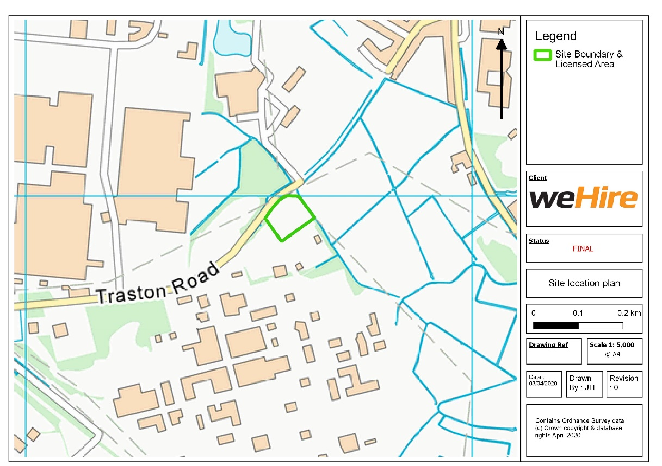

© Crown Copyright and database right [2020]. Ordnance Survey licence number 100019741.

END OF PERMIT

