CRoW Appendix 4 (140_10_SD02)  CRoW Act 2000: Natural Resources Wales application for permission - Formal Notice |  | 
Natural Resources Wales Formal Notice.
Requirements of Section 28I of the Wildlife & Countryside Act 1981 as amended by the Countryside and Rights of Way Act (CRoW) 2000.
Duty in relation to granting any consent, licence or permit for activities likely to damage Sites of Special Scientific Interest (SSSI).
Guide to filling in this form for Natural Resources Wales staff:
To be completed by Permitting Officers for any applications for a permission which the Natural Resources Wales has considered under S28G duties to protect and enhance SSSIs. This applies to all proposed permissions within a SSSI, and to operations outside the SSSI boundary which are likely to damage its special features.
Refer to OI 140_10 ‘Applying the Countryside and Rights of Way (CRoW) Act 2000 to applications for permits with potential for impact on Sites of Special Scientific Interest (SSSI)’, including the flowchart in Appendix 2.
Pink italic text – drafting notes, to be deleted before completion/consultation.
Blue text – examples, to be replaced with permission-specific information.
Ensure you have completed all sections.
- Natural Resources Wales area/region/NPS hub: | Wales South East Industry Reg Team – Bleanau Gwent, Caerphilly & Newport Environment Team
- Name of SSSI: | SSSI Gwent Levels – St. Brides 33WEP
- Type of permission: | Environmental Permit Application – Variation to an existing EPR permit
- Date for Natural Resources Wales permit determination: | 31/10/2020
- Predicted 28 day date for response from NRW conservation/ecology (under S28 I(4)): | 28 days: 28/08/2020
- Natural Resources Wales reference no: | PAN-010620 Application documents on DMS
- National grid reference: | Location of site: Newport Semiconductor Plant, Cardiff Road, Duffryn, Newport, NP10 8 YJ.  Installation is located approximately 900 m north of border of SSSI Gwent Levels – St. Brides.  NGR of stack: 329045.53, 185545.19  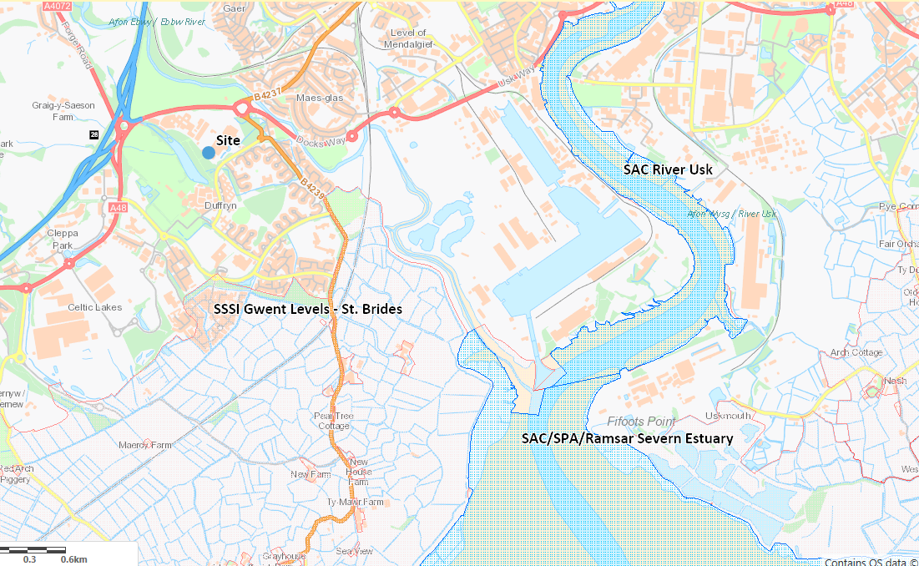
- Description of proposal: | This is a variation application to an existing installation permit.  Newport Wafer Fab Limited propose to install a Combined Heat and Power (CHP) combustion unit at their existing installation site in Duffryn: Newport Semiconductor Plant. The site is already permitted under EPR permit number EPR/BV7460ID.  The variation is to add a natural gas fuelled 5.965 MW thermal input CHP unit which will provide heat and power to the other processes on site. The CHP is classed as a new Medium Combustion Plant (MCP) and an excluded Specified Generator as it is part of an installation as defined in Chapter II of the Industrial Emissions Directive.  As a natural gas engine, the primary emissions from the CHP unit are emissions to air of oxides of nitrogen (NOx) and carbon monoxide (CO). The applicant has completed an air emissions risk assessment based on the recognised H1 methodology. In line with current NRW guidance the applicant has completed H1 tool air emissions risk assessment and provided detailed air dispersion modelling for any parameters that did not screen out as insignificant. CO emissions screened out as insignificant through the use of the H1 tool, the applicant has submitted the H1 tool which has been checked by us and we confirm we agree with their conclusion. There are no environmental standards for protected conservation areas for CO therefore it will not be discussed in this HRA and NOx emissions will be discussed only. Detailed air dispersion modelling has been completed for the NOx emissions as they did not screen out as insignificant in the H1 tool initial screening tests. The detailed air dispersion modelling has been completed at full hours (8760 hours per year) and the maximum permitted emission limit value, this provides a conservative approach as in reality the engine will not be operated for 8760 hours per year due to maintenance and testing.  There are no changes of emissions to water or ground as part of this variation application.
- Is the proposed activity within (wholly or partially) the SSSI boundary? | NO
- Has there been any pre-application discussion or correspondence with NRW conservation/ecology | NO
- What aspect(s) of the proposed permission may damage the features which are of special interest for the SSSI?
The following ‘Operations Requiring Consent’ (or other activities associated with the permission) that may cause damage) are relevant to the proposed permission.

Air emissions from the combustion unit. Increased NOx airborne concentrations. Nutrient nitrogen deposition and acid deposition and smothering impacts. There are no changes to discharges to surface water or ground as part of this variation.

The following SSSI features and mechanisms of impact have been considered to assess the likelihood of damage:

This form has been completed using the following docuemnts for reference:
- Gwent Levels: St Brides Site of Special Scientific Interest SMS January 2008

SSSI Features
- SSSI Gwent Levels – St. Brides
- Reen and ditch habitat
- Insects and other Invertebrates
- Shrill carder bee

Mechanisms of Impact:
Toxic contamination – increased NOx airborne concentration
Nutrient enrichment – nutrient nitrogen deposition from NOx emissions
Acidifcation – acid deposition from NOx emissions
Smothering – from NOx emissions, particulate matter is not a pollutant of concern from natural gas combustion sources of this size.

- Decision
- SSSI Gwent Levels – St. Brides
Toxic Contamination
NOx: A long-term critical level of 30 µg/m³ NOx (annual) and short-term critical level of 75 µg/m³ NOx (daily) have been assumed for SSSI Gwent Levels – St. Brides. The maximum long-term process contribution (PC) is >1 % and predicted environmental concentration (PEC) is >70 % (73.3 %) and <100 % of the long-term critical level therefore long-term impact from NOx emissions can be considered not significant and exceedance of the long-term critical level is unlikely. The modelling has been completed for the full 8760 hours per year, in reality the engine is not expected to be operational for 8760 hours per year so the actual impact is expected to be less due to conservative nature of the modelling. The maximum short-term PC is <10 % of the short-term critical level therefore the short-term impact from NOx emissions can be considered insignificant.

Nutrient Enrichment
There are no critical load values for nitrogen deposition present on APIS to allow to this assessment. Please advise on a site specific basis.

Acidification
There are no critical load values for acidification present on APIS to allow to this assessment. Please advise on a site specific basis.

Smothering
There are no critical load values for nitrogen deposition or acid desposition on APIS to allow for their assessment. As mentioned above particulate matter is not considered a pollutant of concern from natural gas combustion sources of this size.

Conclusion:
i) The proposed permission is not likely to damage any of the flora, fauna or geological or physiological features which are of special interest at SSSI Gwent Levels – St. Brides.

Natural Resources Wales is minded to:
Issue the permission

- Name and job title of Natural Resources Wales officer: | Rebecca Williams  Permitting Officer, Installations & RSR
- Date form sent to NRW conservation/ecology | 31/07/2020
For Natural Resources Wales use only, once NRW conservation/ecology response received
- NRW conservation/ecology comment on assessment: | Please delete as appropriate:  i) NRW conservation/ecology advise the operation can go ahead  ii) NRW conservation/ecology advise the operation can go ahead with conditions  iii) NRW conservation/ecology advise against permitting the operation  Please ensure that the NRW conservation/ecology response is attached to this Formal Notice.
- Name and job title of NRW conservation/ecology officer:
- Date of receipt of NRW conservation/ecology response:

