

Llanfairfechan Sea Wall Repairs - Rail
Initial Environmental Appraisal
CPF7435

CPF6445

Document Control Sheet

Document Title: | Initial Environmental Appraisal
Document Author(s): | Bethan Moseley
Project Ref / Title: | CPF7435 – Llanfairfechan Sea Wall Repair (maintenance work)
Project Manager: | Bethan Moseley

Revision History
Date | Version No. | Summary of Changes
23/09/2020 | 0.01 | Initial draft version

Reviews
Name | Title | Date | Version
Owain E Griffiths | Group Environment Officer | 23/09/2020 | 0.01

Approvals
Name | Title |  | Version
Bethan Moseley | Environment Technical Assistant | 23/09/2020 | 0.01

Distribution
Name | Title | Date | Version
Andrew McMonagle | Project Manager Rail | 23/09/2020 | 0.01
Chris Phillips | Sub Agent Rail | 23/09/2020 | 0.01
Mark Skellon | Environmental Advisor | 23/09/2020 | 0.01

© 2020 2021 Gwynedd Council / YGC. All Rights Reserved.  Copyright in any or all of this documentation belongs to Gwynedd Council / YGC of Council Offices, Shire hall Street, Caernarfon, Gwynedd, LL55 1SH (the 'Owner') and may not be used, sold, transferred, copied or reproduced in whole or in part, in any manner of form or on any media to any person other than in accordance with the terms of the Owner's agreement or otherwise without the prior written consent of the Owner. | 

Contents
Background: 3
Appraisal Method: 4
Environmental Topic, Observations & Recommendation 5
EIA Screening Requirement 5
Air Quality 5
Cultural Heritage 6
Landscape 6
Biodiversity 6
Nature Conservation Sites 9
Invasive Non-Native Species 12
Geology & Soils 12
Materials (including Life Cycle considerations) 13
Noise & Vibration 13
Population & Human Health 14
Drainage and the Water Environment 14
Cumulative Effects 15
Summary of Recommendations & Actions 15
Appendix 17
Photographs
Contractors Method Statement
Species List

Background:
YGC have been commissioned to complete the Initial Environmental Appraisal to identify the need for any consents and licences that might be needed to complete the works of infilling voids with concrete on Llanfairfechan Sea Wall Repairs for Alun Griffiths Contractors on behalf of Network Rail.

The location(s) of the sea wall is SH68707 75684 to SH69650 76126 near Llanfairfechan, Conwy.

Project Details:
The sea wall is of masonry construction and 1052m long, stones at the toe of the wall have dislodged following recent stormy weather and need replacing urgently before the wall is damaged further. There are twenty six small voids which needs repairing the exact details can be found in the Contractor method statement in the appendix. Maintaining the sea wall is paramount to keeping the North Wales Coastline Railway open. The works are expected to start as soon as all consents are to hand. Concrete for the works will be delivered in small ready mixed concrete wagon which will be banked onto the causeway. A small static concrete pump will be towed by pick up to the works location and all vehicles and pump equipment will remain on the concrete causeway path.

The concrete causeway path will be cleaned down to remove algae/seaweed at start of each shift to ensure the path is safe to walk/drive on. This will be undertaken using a jet wash/bowser using fresh water, towed with pick up vehicle. Areas of work will be inspected by operatives and the voids will be prepared as required with the use of hand held breakers/sthil saws where loose material requires breaking/cutting out and removing. A small pump will be on hand should small pockets of water require pumping out of the repair area. Water will generally be pumped/discharged into a suitable drainage point on the causeway which won’t affect the area of repair. Concrete will be discharged into the voids via the concrete pump. Operatives will control the pump hose and monitor the discharge of concrete. The concrete will be trowel finished once void has been filled. Smaller voids will require use of a concrete mortar repair. This material will be mixed in buckets on the causeway and carried down in buckets to the repair location. Hand trowels will be used to apply the mortar repair to the damaged area. Plant/Equipment will generally consist of a small pickup type vehicle, water bowser/jet wash, Concrete mini mix wagon, static towable concrete pump, small hand held tools such as mechanical breakers, sthil saw, 2.6kva generator & small water pump.

Appraisal Method:
A walkover survey was completed on 17/08/2020 with Eleri Evans and Andrew McMonagle of Alun Griffiths Contractors to identify environmental features within the study area. Gwynedd Council’s Map Gwynedd GIS was used to identify statutory and non-statutory designated sites and watercourses. Cofnod historical records centre search was obtained to identify any protected species records within 1km of the works.

Environmental Topic, Observations & Recommendation

EIA Screening Requirement

Observations | Recommendations
The proposed works are located on the Railway Network. As part of the works are located below mean high water, a marine licence (ML) is required under The Marine Licensing (Wales) Regulations 2017. The contractor has applied for a ML but has been advised to provide a WFD and HRA. Any Environmental Impact Assessment requirements would be dealt with under the Marine Works (Environmental Impact Assessment) Regulations 2007 (as amended). However, due to the nature of the proposals, they are not considered to be a Schedule A1 or A2 project as defined in the Regulations, therefore no EIA screening or further action is required. | Due to the nature of the proposals, no EIA is required. The contractor has applied for a marine licence for works below mean high water’

Air Quality

Observations | Recommendations
No significant air quality impacts are considered likely due to the nature and scale of the proposals. | Design: N/A  Tendering: N/A  Construction: Implement working practices that avoid or minimise aerial emissions. Dust suppression measures should be implemented if working in dry weather.
Relevant compliance obligations (if applicable):
• Environmental Protection Act 1990, Part III, Section 80

Cultural Heritage

Observations | Recommendations
There are no listed buildings or scheduled ancient monuments in the area of Llanfairfechan Sea Wall. No other features associated with cultural heritage were found on site during the site visit. | Design: N/A  Tendering: N/A  Construction: N/A
Relevant compliance obligations (if applicable):  Planning (Listed Buildings and Conservation Areas) Act 1990  Ancient Monuments and Archaeological Areas Act 1979  Historic Environment (Wales) Act 2016 | Design: N/A  Tendering: N/A  Construction: N/A

Landscape
Observations | Recommendations
Llanfairfechan Sea Wall is within Gogledd Arllechwedd Landscape of outstanding historical Interest (LOHI) at Grid ref SH69386-76026 to SH696500-76125. The works are of repairing existing sea wall only and are not likely to affect the Landscape designation. There are no Conservation Areas within the area of the works. | Design: N/A  Tendering: N/A  Construction: N/A
Relevant compliance obligations (if applicable):  The Countryside Act, 1949 | Design: N/A  Tendering: N/A  Construction: N/A

Biodiversity

Observations |  | Recommendations
Protected and Notable Species (e.g. European, National, Section 7 and LBAP) | The land adjacent to Llanfairfechan Sea Wall is intertidal and consisted of sand bank with some boulder stone. The sea wall is within the upper intertidal zone and contains green brown seaweed the photos in the appendix show spiral wrack. Barnacles were also present at the northern end of the structure along with evidence of sea birds feeding remains and guano.  There are no main rivers or ordinary watercourses in the area of Llanfairfechan sea wall but there are many drainage outlets.  There are no trees on site. All the work is confined to the Llanfairfechan sea wall structure. Site Compound will be located on existing hard standing turning northeast at Shore Street to car park area at SH686 756 on Network Rail’s land. All the work will be completed with hand tools and no excavators are required on site.  During the site visit it was evident that the lower section of the sea wall would be inundated at high tide so the work would need to take place during a narrow window approximately 4.5 hours over low tide. No night works are associated with this proposal. The area of site compound is of existing hard standing. Quick setting C40 concrete would be used to lower any risk to aquatic species. There was no sign of otter spraint or footprints in the area of Llanfairfechan Sea Wall (see appendix site photographs 1 to 4).  European protected Species  Otters  There nearest Cofnod records are on the Afon Llanfairfechan 684m and 949m southwest from Llanfairfechan Sea Wall. The records are from 2009. No signs of otters were found on site during the walkover.  Bats  There are local Cofnod records of bats within the 1km search area but none on the site itself. The nearest Cofnod record of a Noctule Nuctalus noctula, Soprano Pipistrelle pipistrellus pygmaeus 229m southwest from Llanfairfechan Sea wall. There are all records of flying bats. Bats are likely to use the area adjacent to Llanfairfechan sea wall for foraging and commuting.  There was no suitable habitat for bats at the toe of Llanfairfechan Sea Wall. All the works are confined to daylight hours only and the work is not likely to affect bats.  Nesting birds  There are local records of numerous birds recorded within the 1km search area the nearest records were: Sandwich Tern (Sterna sandvicensis) 18m north, Red-throated Diver (Gavia stellata), Razorbill (Alca torda), Guillemot (Uria aalge), Shag (Phalacrocorax aristotelis) 39m from Llanfairefchan sea wall. There are many other schedule 1 birds See appendix for complete list of birds within the 1km search area).  No nests were found on Llanfairfechan sea wall but there were many signs left by feeding birds. Llanfairfechan Sea Wall during the site visit, it is unlikely that there would be nesting birds in the area of the works because of tidal inundation. There were no suitable ledges for costal birds in the area of the works either.  Seal  One record of seal has been identified off the coast near Llanfairfechan 243m west from the area of the works. Seals are particularly sensitive to noise and loud noise can damage seals hearing. No machinery are proposed for the works at Llanfairfechan sea wall and no impacts are expected on Grey Seal. | Design: Consultation with Marine Licencing and NRW regarding sensitive habitats within the sea wall area.  Tendering: N/A  Construction:  To safeguard the sensitive beach area, the contractor must adhere to the conditions and recommendations listed in the Marine Licence.  The area of the works will be protected from pollution incidents by adhering to GPP 5 Works and Maintenance in or near water.  Should any of the protected species discussed in this report be observed on site during the proposed works, works should cease and an ecologist contacted for support.  Contractor to provide a pollution prevention plan.
Protected and Notable Habitats (e.g. European, National, Section 7 and LBAP) | River corridors and estuaries are protected by Local biodiversity action plans and UK BAP. The contractor should complete a pollution prevention plan to lower any effects on the sand and shingle costal habitats at Llanfairfechan Sea Wall.
Relevant compliance obligations (if applicable):
• The Wildlife and Countryside Act 1981, as amended
• The Conservation of Habitats and Species Regulations 2017
• Protection of Badgers Act 1992
• The Countryside and Rights of Way Act 2000
• The Environmental Wales Act 2016

Nature Conservation Sites
Observations |  | Recommendations
International Sites | Y Fenai a Bae Conwy Special Area of Conservation (SAC) is located directly adjacent to Llanfairfechan sea wall on the western side of the wall three minor repairs need to be completed in the area adjacent to Y Fenai a Bae Conwy SAC. Liverpool Bay SAC and SPA is located 98m north from Llanfairfechan Sea Wall. There are timing restrictions associated with working in or near the Liverpool Bay SPA during October to February because of Common scoters and Red throated diver.  Traeth Lafan SPA is located directly adjacent to Llanfairfechan sea wall on the western 110m of sea wall. Afon Gwyrfai a Llyn Cwellyn SAC is the nearest international sites with otter as a priority feature within 24km of Llanfairfechan Sea Wall. It is not likely that the works at Llanfairfechan sea wall would have an impact on the otters of Afon Gwyrfai and Llyn Cwellyn SAC because it is in a separate river catchment.  Gwydir Forest Mines SAC is the nearest SAC with Lesser horseshoe bats as a mobile priority feature to Llanfairfechan Sea Wall at a distance of 15km southeast. There was no suitable habitat for Lesser horseshoe bats at Llanfairfechan Sea Wall. It is highly unlikely that the works of replacement infilling eroded voids in the sea wall and at the toe of the wall at Llanfairfechan sea wall would have a significant effect on the Lesser horseshoe bats of Gwydir Forest Mines SAC and are not considered further. | Design: As the works is directly adjacent to Y Fenai a Bae Conwy Special Area of Conservation (SAC) within the first 100m and is 98m from Liverpool Bay SAC and SPA a stage 1 screening should be completed. Works in or near Liverpool Bay should be avoided during October to February. All impacts on International Sites will be considered in the HRA.  Section 28h assent for work within the SSSI will need to be applied for from NRW.  Tendering: N/A  Construction:  To safeguard the protected sites, sensitive costal habitat the contractor must adhere to the conditions and recommendations listed in the Marine Licence.  The area of the works will be protected from pollution incidents by adhering to GPP 5 Works and Maintenance in or near water.
National Sites | Traeth Lafan SSSI is located directly adjacent Llanfairfechan sea wall for the first 110m section of sea wall on the western side. Traeth Lafan / Lavan Sands is located in Conwy Bay lying between Bangor and Llanfairfechan in north-west Wales. This large area of intertidal sand- and mud-flats lies at the eastern edge of the Menai Strait. The area has a range of exposures and a diversity of conditions, enhanced by freshwater streams that flow across the flats. The site is of importance for wintering water birds, especially Oystercatcher (Haematopus ostralegus) and Curlew (Numenius arquata). In conditions of severe winter weather, Traeth Lafan acts as a refuge area for Oystercatchers displaced from the Dee Estuary. The site is also an important moulting roost for Great Crested Grebe (Podiceps cristatus) in late summer/early autumn.  As part of the works are within Traeth Lafan SSSI a section 28h assent will need to be applied for from NRW. No machinery are associated with the work and there will only be a few people on site infilling the voids with marine safe concrete. The works of repairing existing sea wall at Llanfairfechan Sea Wall.  There are no other national or local sites within the 500m search area.
Local Sites (within 500m) | Traeth Lafan Local Wildlife Site is located adjacent to the sea wall along the whole stretch of the sea defence. As the work is of repairing existing sea wall no changes are expected to the local wildlife site. But there might be restrictions to visitors during the works.  There are no ancient woodland located within the 500m search area from Llanfairfechan Sea Wall.
Relevant compliance obligations (if applicable):
• The Conservation of Habitats and Species Regulations 2010, as amended
• The Countryside and Rights of Way Act 2000
• The Wildlife and Countryside Act 1981, as amended

Invasive Non-Native Species

Observations | Recommendations
There are records of Japanese knotweed within the 1km search area no invasive non-native species local records of invasive species in the area of the works. No invasive non-native species were found in the area of Llanfairfechan Sea Wall during the site visit and are not considered further in this report. | Design: N/A  Tendering: N/A  Construction: N/A
Relevant compliance obligations (if applicable):  The Wildlife and Countryside Act 1981, Schedule 9, as Amended.  Additional Sources of Information: | Design: N/A  Tendering: N/A  Construction: N/A

Geology & Soils

Observations | Recommendations
There are no designated geological sites within the scheme footprint. | Design: N/A  Tendering: N/A  Construction: N/A
Relevant compliance obligations (if applicable):  The Town and Country Planning Act 1990. | Design: N/A  Tendering: N/A  Construction: N/A

Materials (including Life Cycle considerations)

Observations | Recommendations
Any materials should be disposed of in accordance with the relevant legislation. | Design: N/A  Tendering: N/A  Construction:  Retain and re-use site-won materials identified during the design and tender stages.  Dispose of any surplus materials to a suitably licensed waste facility and retain all relevant transfer documentation.
Relevant compliance obligations (if applicable):
Any materials should be disposed of in accordance with the relevant legislation.

Relevant compliance obligations (if applicable):

• The Waste (England and Wales) Regulations 2011
• Towards Zero Waste, Welsh Government, 2012
• Construction and Demolition (C&D) Sector Plan, Welsh Government, 2012
• Planning Policy Wales, Chapter 4, edition 9, Welsh Government, 2016

Noise & Vibration

Observations | Recommendations
Properties at Mona Terrace are 90m from the works. No significant noise is expected during the works of infilling voids on Llanfairfechan Sea Wall. | Design: N/A  Tendering: N/A  Construction: N/A
Relevant compliance obligations (if applicable):  • Environmental Protection Act 1990, Part III, Section 80  • BS5228:2009 Noise and Vibration Control on Construction and Open Sites  (+A1:2014 Part 1 Noise (BS5228-1) | Design: N/A  Tendering: N/A  Construction: N/A

Population & Human Health

Observations | Recommendations
The work of repairing Llanfairfechan Sea Wall is not likely to have an impact on the human population or the population’s health because of the nature and scale of the works. It is believed that the work is essential for the future safety of the rail network and all rail users. | Design: N/A  Tendering: N/A  Construction: N/A
Relevant compliance obligations (if applicable):  • | Design: N/A  Tendering: N/A  Construction: N/A

Drainage and the Water Environment

Observations | Recommendations
There are no main rivers or ordinary watercourse at Llanfairfechan Sea Wall. As the works are below Mean High Water the contractor will apply for a marine licence. There are no watercourses near the site compound or on the track to the sea wall. | Design:  Tendering:  Construction:  Contractor should adhere to the conditions of the Marine Licence.  The contractor should adhere to GPP5 Works and Maintenance in or near water during the works.
Relevant compliance obligations (if applicable):
• The Water Resources Act, 1991
• The Flood and Water Management Act 2010
• The Water Environment (Water Framework Directive) (England and Wales)
Regulations 2003
• The Water Environment (Water Framework Directive) (England and Wales)
(Amendments) Regulations 2015
• GPP5 Works and Maintenance in or near water

Cumulative Effects
Observations | Recommendations
The project will be completed when the Marine Licence is issued during Autumn 2020. Consultation should be had with the local planning authority, NRW and Network Rail to identify if there are other works proposed in the location after the full project details are known. | Consult with NRW/Conwy Council and Network Rail re works in the area when project details are to hand.

Summary of Recommendations & Actions
Below is a provisional list of environmental actions and recommendations highlighted at this early stage. As the scheme develops and on completion of any recommended actions (e.g. surveys and consultations), this list will need to be updated and included as an Environmental Action Plan for the tender and construction stage. All conditions stipulated in any required consents and licences will need to be incorporated into the Action Plan.

Action |  | Responsibility
Design Stage | Consultation with Marine Licencing and NRW regarding sensitive habitats within the sea wall area. | Designer / Client/ Contractor
Design Stage | Consultation with Marine Licencing and NRW regarding sensitive habitats within the sea wall area. | YGC/Network Rail/Alun Griffiths Contractor
Design Stage | As the works is within adjacent to Y Fenai a Bae Conwy Special Area of Conservation (SAC) within the first 310m and is 98m from Liverpool Bay SAC and SPA a stage 1 screening should be completed. Works in or near Liverpool Bay should be avoided during October to February. All impacts on International Sites will be considered in the HRA.  Section 28h assent for work within the SSSI will need to be applied for from NRW. | Network Rail/Alun Griffiths Contractor/YGC
Tendering Stage |  | Designer / Client / Contractor
 | N/A | Network Rail/Alun Griffiths Contractor
Construction Stage |  | Designer / Client / Contractor
Construction Stage | Implement working practices that avoid or minimise aerial emissions. Dust suppression measures should be implemented if working in dry weather. | Network Rail/Alun Griffiths Contractor
Construction Stage | To safeguard the sensitive beach area, the contractor must adhere to the conditions and recommendations listed in the Marine Licence.  The area of the works will be protected from pollution incidents by adhering to GPP 5 Works and Maintenance in or near water.  Should any of the protected species discussed in this report be observed on site during the proposed works, works should cease and an ecologist contacted for support.  Contractor to provide a pollution prevention plan. | Network Rail/Alun Griffiths Contractor
 | As the works is within adjacent to Y Fenai a Bae Conwy Special Area of Conservation (SAC) within the first 310m and is 98m from Liverpool Bay SAC and SPA a stage 1 screening should be completed. Works in or near Liverpool Bay should be avoided during October to February. All impacts on International Sites will be considered in the HRA.  Section 28h assent for work within the SSSI will need to be applied for from NRW. | Network Rail/Alun Griffiths Contractor
 | Retain and re-use site-won materials identified during the design and tender stages.  Dispose of any surplus materials to a suitably licensed waste facility and retain all relevant transfer documentation. | Network Rail/Alun Griffiths Contractor

Appendix

Figure 1 - Protected Sites Map and Location Map
Photographs
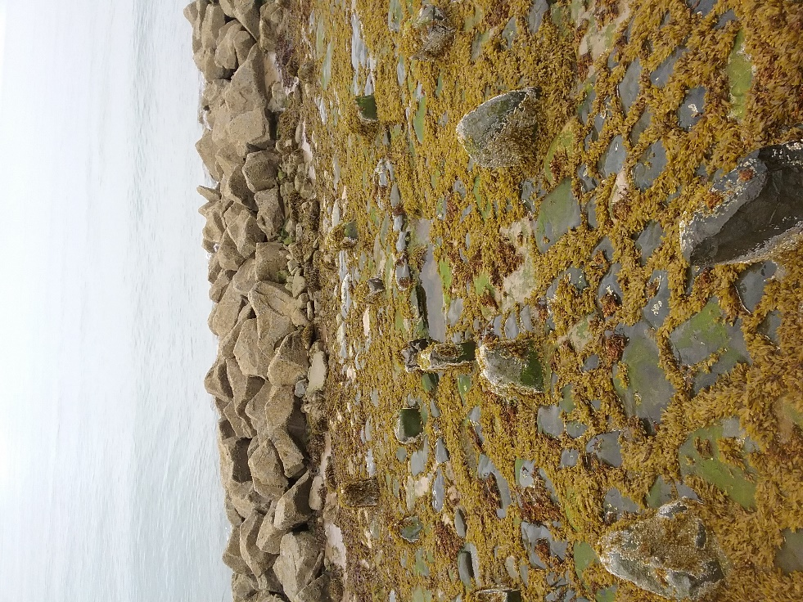  Site Photographs No 1 – View of void on Llanfairfechan sea wall. | 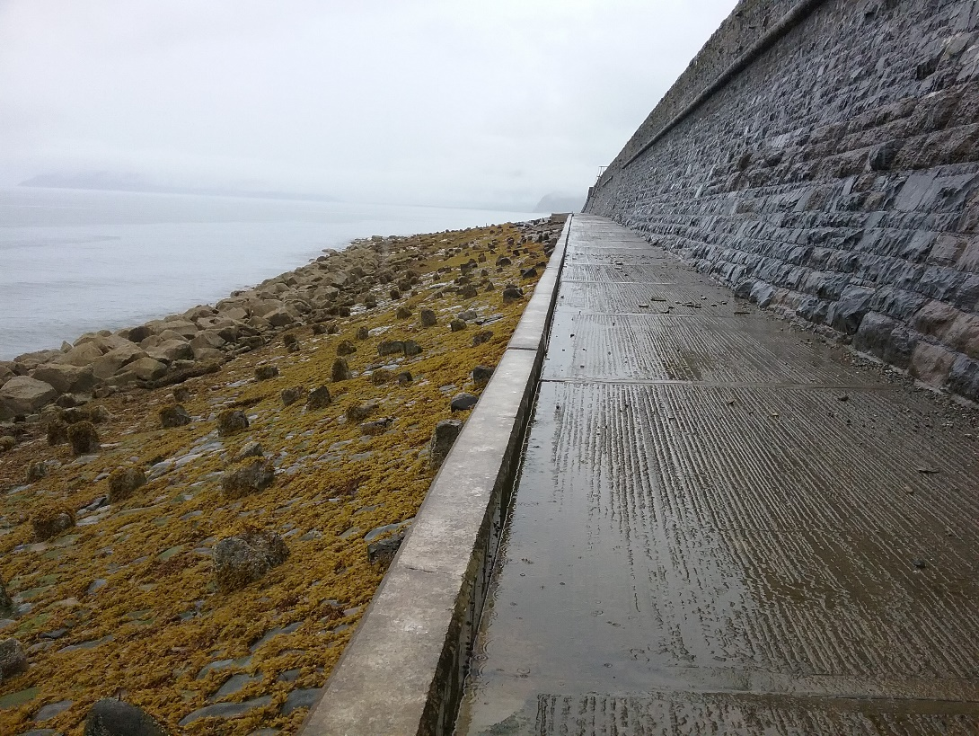  Site Photograph No 2 – View of track where concrete wagon will deliver the concrete to be pumped in to voids.
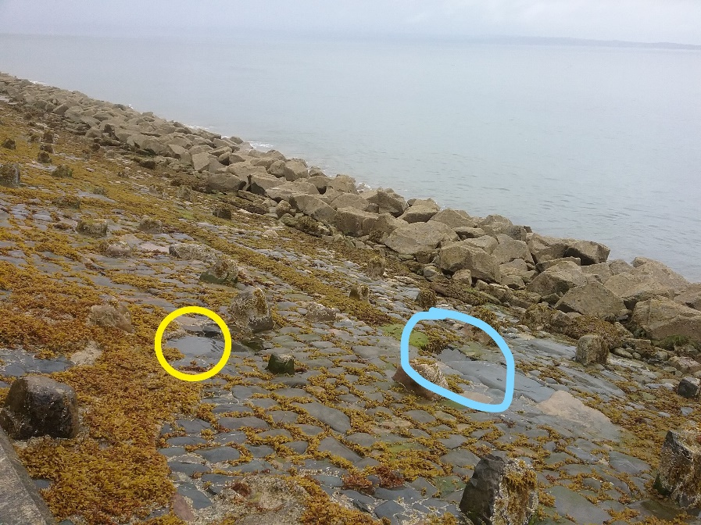  Site Photograph No 3 - Showing voids on sea wall toe. | 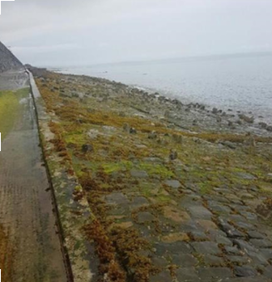  Site Photograph No 4 - View of revetment apron.

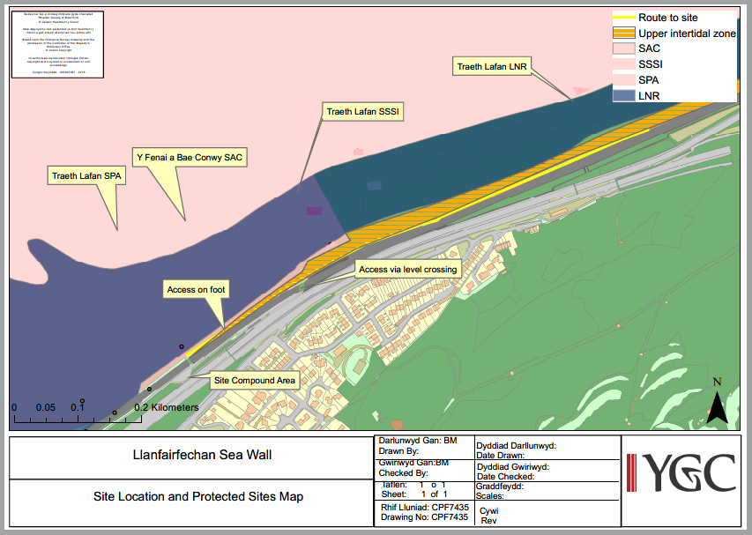

Figure 1 – Site location and protected sites map
Contractor Method Statement
 | Alun Griffiths (Contractors) Ltd | AGR-F000
 | Project Outline Methodology & Plan | AGR-F000

LLANFAIRFECHAN SEA DEFENCES PPM – Yr 2
INTRODUCTION
- Llanfairfechan Sea wall is located on the North Wales Coast on the seaward side of the railway line (CNH3 @ 230m, 22 chain) between Llanfairfechan & Penmaenmawr. Network Rail have identified a number of minor repairs required to this structure which they have instructed AGC / Alun Griffiths (Contractors) Ltd to undertake.
- AGC have employed the services of YGC to assist with processing all required Ecology surveys appraisals & associated documentation, such as Marine Licenses, Assents etc to facilitate these works.
WORKS LOCATION
1. The works are located between Penmaenmawr Viaduct & bridge ref 135 @ Shore Road East.
Uncontrolled when downloaded or printed Page 1 of 5

Issue no: |  | Date: |  | AGC Rail Related Procedure:

NR Doc Ref |  | AGC Rail File Location

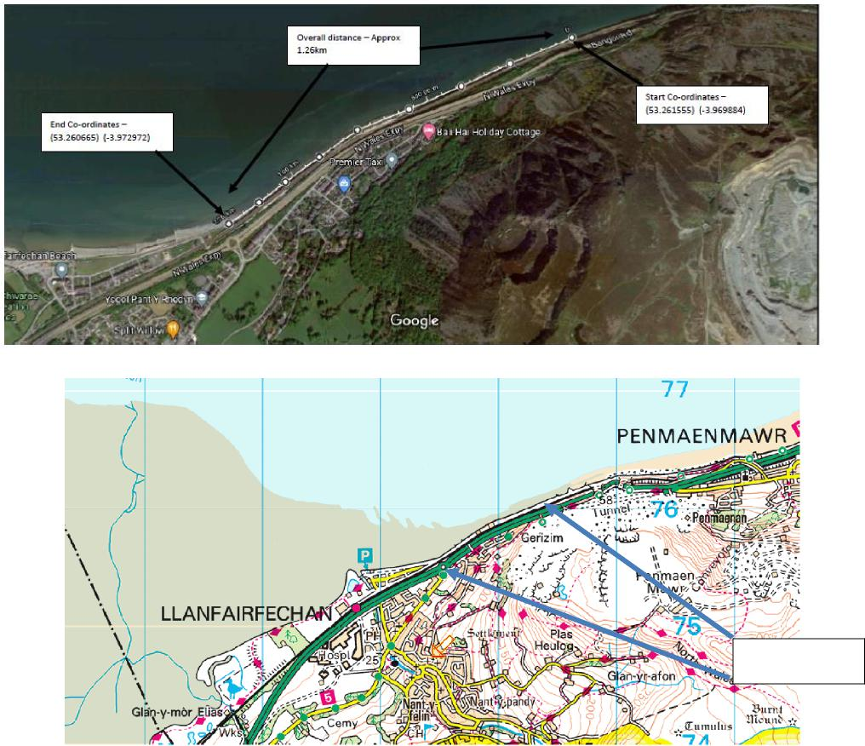
Works Location

 | Alun Griffiths (Contractors) Ltd | AGR-F000
 | Project Outline Methodology & Plan | AGR-F000

ACCESS TO WORKSITE
Vehicle access will be via existing road which runs alongside the railway line and is accessed from Shore Rd East.
The Proposed location of a small site compound is within a wide area along this road as indicated below.
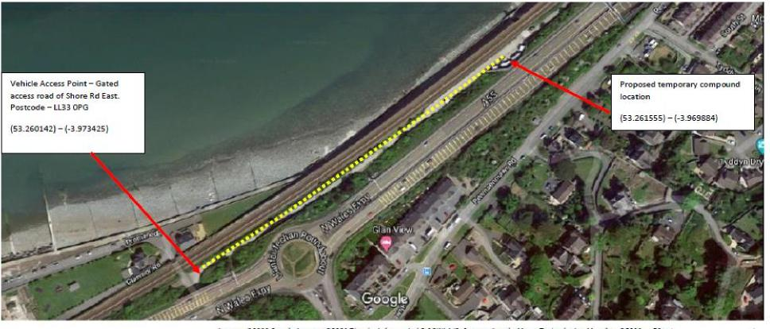
Works access is proposed via routes shown below.
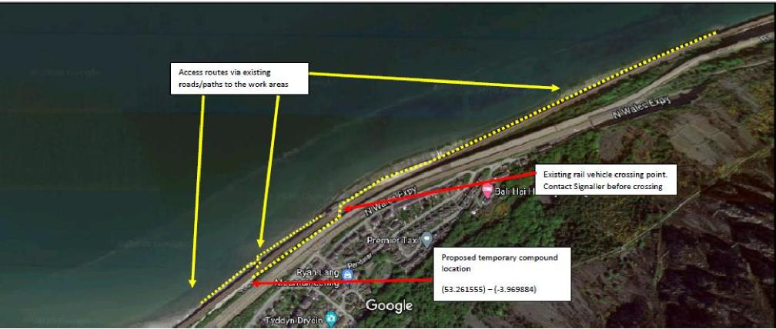
Issue no: |  | Date: |  | AGC Rail Related Procedure:
NR Doc Ref |  |  |  | AGC Rail File Location

Uncontrolled when downloaded or printed Page 2 of 5

 | Alun Griffiths (Contractors) Ltd | AGR-F000
 | Project Outline Methodology & Plan | AGR-F000
SCOPE OF WORKS

The scope of works included the following:
- Filling a number of voids/holes within the revetment apron with Parex concrete. Typical example image below:
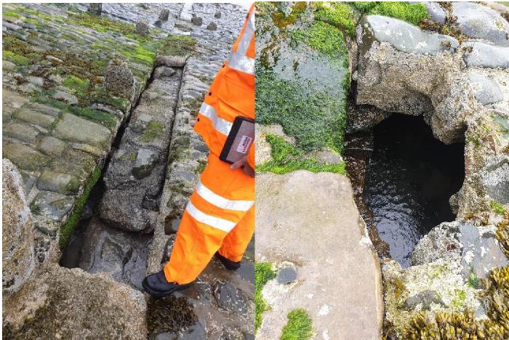
- Undertake minor repairs to existing concrete upstand at base of seawall
- Undertake minor filling of holes/damaged parts using a concrete repair mortar.
- Clean out all drainage weepholes along causeway at bottom of sea wall.
The exact scope of works is as detailed in the table below
Llanfairfechan
Repair recommended
Location Observations (Yes/No)
Tab 2 - 5m | Void in revetment to be filled | Yes  Yes  Yes  Yes  Yes  Yes  Yes  Yes  Yes  Yes  Yes  Yes  Yes  Yes  Yes  Yes
Tab 2 + 10m | Void in revetment to be filled
Tab 2 +15m | Horizontal void to be filled
Tab 2 + 17m | Void in revetment to be filled  Small void in revetment to be filled  Void in revetment to be filled  Large Void all the way towards sea wall approx. 20m x 5m x 1.5m deep  Extend concrete filler approx. 10m  Small Hole and voids to be investigated / potential void (check with endoscope)  Small void in revetment to be filled  Void in revetment at toe to be filled  3no voids at toe of revetment  Small void in revetment to be filled  Horizontal void to be filled  Small start of void middle of revetment  Repair top of wall  2no voids mid wall of revetment  2no voids mid wall of revetment  Voids mid wall of revetment  4no voids mid wall of revetment  Voids mid wall of revetment  Voids mid wall of revetment  Voids top to mid wall + toe of revetment  Voids top to mid wall  Voids mid wall of revetment  Point loose gaps in between timber piles around toe  Clean joints and drainage weep holes along causeway at bottom of Sea Wall
Tab 2 + 18m
Tab 3 + 5m
Tab 3 + 20m
Tab 5 + 15m
Tab 5 + 30m
Tab 6 - 30m
Tab 6 + 20m
Tab 7 - 25m
Tab 7 + 15m
Tab 7 + 20m
Tab 7 + 25m
Tab 7 + 30m
Tab 8
Tab 7 + 30m  Tab 8 |  | Yes
Tab 9 + 20m |  | Yes
Tab 10 -5m |  | Yes
Tab 11-20m |  | Yes
Tab 12 - 10m |  | Yes
Tab 12 + 15m |  | Yes
Tab 12 + 25m |  | Yes
Tab 12 + 40m  Tab 22 - 5m  Tab 26 + 30m  Throughout |  | Yes  Yes  Yes  Yes

Issue no: |  | Date: |  | AGC Rail Related Procedure:
NR Doc Ref |  |  |  | AGC Rail File Location

Uncontrolled when downloaded or printed Page 3 of 5

 | Alun Griffiths (Contractors) Ltd | AGR-F000
 | Project Outline Methodology & Plan | AGR-F000
METHODOLOGY

Typical Images below of revetment apron:
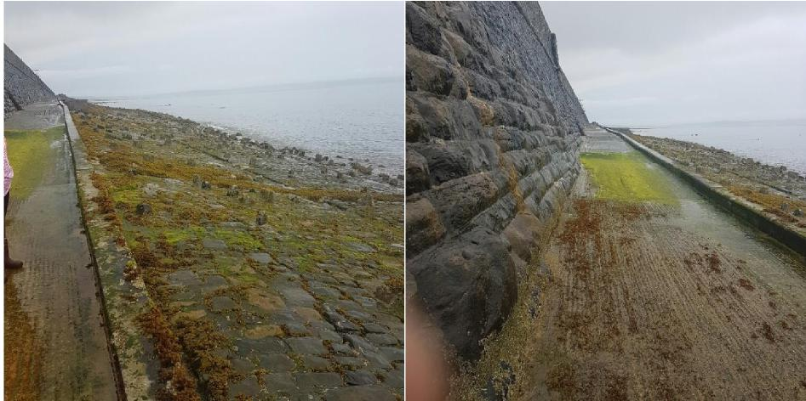
- The works will generally require the use of trained operatives using roped access techniques to work from the top of the existing causeway path to gain safe access to the individual work area’s on the sloping revetment apron. Some locations the angle of slope is relatively flat and in these areas it will be risk assessed if no rope access is required.
- The majority of the work areas are below tidal water levels so all works will be planned to be carried out when the tide is ebbing.
- Operatives will be IRATA (Industrial Rope Access Trade Association) trained.
- Materials and equipment will be brought to the individual work areas using the existing track way access & then onto the concrete causeway path. Equipment will be carried on a small pickup vehicle.
- Concrete for the works will be delivered in small ready mixed concrete wagon which will be banked onto the causeway. A small static concrete pump will be towed by pick up to the works location and all vehicles and pump equipment will remain on the concrete causeway path.
- The concrete causeway path will be cleaned down to remove algae/seaweed at start of each shift to ensure the path is safe to walk/drive on. This will be undertaken using a jet wash/bowser using fresh water, towed with pick up vehicle.
- Areas of work will be inspected by operatives and the voids will be prepared as required with the use of hand held breakers/sthil saws where loose material requires breaking/cutting out and removing.
- A small pump will be on hand should small pockets of water require pumping out of the repair area. Water will generally be pumped/discharged into a suitable drainage point on the causeway which won’t affect the area of repair.
- Concrete will be discharged into the voids via the concrete pump. Operatives will control the pump hose and monitor the discharge of concrete. The concrete will be trowel finished once void has been filled.
- Smaller voids will require use of a concrete mortar repair. This material will be mixed in buckets on the causeway and carried down in buckets to the repair location. Hand trowels will be used to apply the mortar repair to the damaged area.
- Plant/Equipment will generally consist of a small pickup type vehicle, water bowser/jet wash, Concrete mini mix wagon, static towable concrete pump, small hand held tools such as mechanical breakers, sthil saw, 2.6kva generator & small water pump.
- The work areas will generally be fenced off although the area of works is generally none frequented by members of public. No fencing or any materials or equipment will be left on the concrete causeway path overnight. All equipment will be returned to eth site compound area.
Issue no: |  | Date: |  | AGC Rail Related Procedure:
NR Doc Ref |  |  |  | AGC Rail File Location

Uncontrolled when
downloaded or printed Page 4 of 5

List of Species
Birds | Acanthis cabaret |  | Lesser Redpoll |  | Llinos Bengoch Leiaf |  | 2002 |  | 2016 |  | 7
Birds | Accipiter gentilis |  | Goshawk |  | Gwalch Marthin |  | 2002 |  | 2002 |  | 1
Birds | Accipiter nisus |  | Sparrowhawk |  | Gwalch Glas |  | 1999 |  | 2016 |  | 19
Birds | Acrocephalus schoenobaenus |  | Sedge Warbler |  | Telor yr Hesg |  | 2010 |  | 2016 |  | 5
Birds | Acrocephalus scirpaceus |  | Reed Warbler |  | Telor y Cyrs |  | 2016 |  | 2016 |  | 1
Birds | Actitis hypoleucos |  | Common Sandpiper |  | Pibydd y Dorlan |  | 2015 |  | 2016 |  | 2
Birds | Aegithalos caudatus |  | Long-tailed Tit |  | Titw Cynffon-Hir |  | 1999 |  | 2016 |  | 68
Birds | Aix galericulata |  | Mandarin Duck |  | Hwyaden Gribog |  | 2000 |  | 2000 |  | 1
Birds | Alauda arvensis |  | Skylark |  | Ehedydd |  | 2005 |  | 2016 |  | 13
Birds | Alca torda |  | Razorbill |  | Llurs |  | 1999 |  | 2016 |  | 30
Birds | Alcedo atthis |  | Kingfisher |  | Glas y Dorlan |  | 2010 |  | 2014 |  | 3
Birds | Anas acuta |  | Pintail |  | Hwyaden Lostfain |  | 1999 |  | 2016 |  | 13
Birds | Anas clypeata |  | Shoveler |  | Hwyaden Lydanbig |  | 2010 |  | 2016 |  | 6
Birds | Anas crecca |  | Teal |  | Corhwyaden |  | 2009 |  | 2016 |  | 27
Birds | Anas penelope |  | Wigeon |  | Chwiwell |  | 2009 |  | 2016 |  | 31
Birds | Anas platyrhynchos |  | Mallard |  | Hwyaden Wyllt |  | 2000 |  | 2016 |  | 221
Birds | Anas querquedula |  | Garganey |  | Hwyaden Addfain |  | 2011 |  | 2011 |  | 3
Birds | Anas strepera |  | Gadwall |  | Hwyaden Lwyd |  | 2015 |  | 2015 |  | 1
Birds | Anser anser |  | Greylag Goose |  | Gwydd Wyllt |  | 2010 |  | 2016 |  | 3
Birds | Anthus petrosus |  | Rock Pipit |  | Corhedydd y Graig |  | 2010 |  | 2015 |  | 11
Birds | Anthus pratensis |  | Meadow Pipit |  | Corhedydd y Waun |  | 2009 |  | 2016 |  | 28
Birds | Apus |  | Swift |  | Gwennol Ddu |  | 2005 |  | 2020 |  | 43
Birds | Arenaria interpres |  | Turnstone |  | Cwtiad y Traeth |  | 2000 |  | 2016 |  | 35
Birds | Aythya ferina |  | Pochard |  | Hwyaden Bengoch |  | 2011 |  | 2011 |  | 5
Birds | Aythya fuligula |  | Tufted Duck |  | Hwyaden Gopog |  | 2011 |  | 2011 |  | 3
Birds | Aythya marila |  | Scaup |  | Hwyaden Benddu |  | 2000 |  | 2010 |  | 3
Birds | Branta bernicla |  | Brent Goose |  | Gwydd Ddu |  | 2014 |  | 2014 |  | 1
Birds | Branta bernicla subsp. hrota |  | Light-bellied Brent Goose |  |  |  | 2010 |  | 2016 |  | 3
Birds | Branta canadensis |  | Canada Goose |  | Gwydd Canada |  | 2010 |  | 2015 |  | 17
Birds | Bucephala clangula |  | Goldeneye |  | Hwyaden Lygad-Aur |  | 2002 |  | 2011 |  | 5
Birds | Buteo buteo |  | Buzzard |  | Bwncath |  | 1999 |  | 2016 |  | 98
Birds | Calidris alba |  | Sanderling |  | Pibydd y Tywod |  | 2002 |  | 2014 |  | 6
Birds | Calidris alpina |  | Dunlin |  | Pibydd y Mawn |  | 2000 |  | 2016 |  | 26
Birds | Calidris canutus |  | Knot |  | Pibydd yr Aber |  | 1999 |  | 2015 |  | 25
Birds | Calidris ferruginea |  | Curlew Sandpiper |  | Pibydd Cambig |  | 2004 |  | 2014 |  | 5
Birds | Calidris pugnax |  | Ruff |  | Pibydd Torchog |  | 1999 |  | 2015 |  | 5
Birds | Carduelis carduelis |  | Goldfinch |  | Nico |  | 1999 |  | 2016 |  | 113
Birds | Cepphus grylle |  | Black Guillemot |  | Gwylog Ddu |  | 1999 |  | 2016 |  | 14
Birds | Certhia familiaris |  | Treecreeper |  | Dringwr Bach |  | 2003 |  | 2016 |  | 24
Birds | Charadrius dubius |  | Little Ringed Plover |  | Cwtiad Torchog Bach |  | 2014 |  | 2014 |  | 1
Birds | Charadrius hiaticula |  | Ringed Plover |  | Cwtiad Torchog |  | 1999 |  | 2016 |  | 26
Birds | Chlidonias niger |  | Black Tern |  | Cors-Wennol Ddu |  | 2015 |  | 2015 |  | 2
Birds | Chloris chloris |  | Greenfinch |  | Llinos Werdd |  | 2000 |  | 2016 |  | 57
Birds | Chroicocephalus ridibundus |  | Black-headed Gull |  | Gwylan Benddu |  | 2000 |  | 2016 |  | 204
Birds | Cinclus cinclus |  | Dipper |  | Bronwen y Dwr |  | 1999 |  | 2016 |  | 80
Birds | Clangula hyemalis |  | Long-tailed Duck |  | Hwyaden Gynffon-Hir |  | 1996 |  | 2016 |  | 7
Birds | Corvus corax |  | Raven |  | Cigfran |  | 1951 |  | 2016 |  | 69
Birds | Crex crex |  | Corncrake |  | Rhegen yr Yd |  | 1996 |  | 1996 |  | 1
Birds | Cuculus canorus |  | Cuckoo |  | Cog |  | 2004 |  | 2018 |  | 4
Birds | Cyanistes caeruleus |  | Blue Tit |  | Titw Tomos Las |  | 2009 |  | 2020 |  | 205
Birds | Cygnus olor |  | Mute Swan |  | Alarch Dof |  | 1994 |  | 2016 |  | 210
Birds | Delichon urbicum |  | House Martin |  | Gwennol y Bondo |  | 2002 |  | 2016 |  | 74
Birds | Dendrocopos major |  | Great Spotted Woodpecker |  | Cnocell Fraith Fwyaf |  | 1999 |  | 2016 |  | 81
Birds | Egretta garzetta |  | Little Egret |  | Creyr Bach |  | 2005 |  | 2016 |  | 58
Birds | Emberiza citrinella |  | Yellowhammer |  | Bras Melyn |  | 1999 |  | 2011 |  | 100
Birds | Emberiza schoeniclus |  | Reed Bunting |  | Bras y Cyrs |  | 2013 |  | 2015 |  | 3
Birds | Falco peregrinus |  | Peregrine |  | Hebog Tramor |  | 1951 |  | 2016 |  | 17
Birds | Falco tinnunculus |  | Kestrel |  | Cudyll Coch |  | 2006 |  | 2016 |  | 13
Birds | Ficedula hypoleuca |  | Pied Flycatcher |  | Gwybedog Brith |  | 2006 |  | 2016 |  | 13
Birds | Fringilla montifringilla |  | Brambling |  | Pinc y Mynydd |  | 1999 |  | 2010 |  | 32
Birds | Gallinago gallinago |  | Snipe |  | Gïach Cyffredin |  | 2011 |  | 2013 |  | 2
Birds | Gavia arctica |  | Black-throated Diver |  | Trochydd Gyddfddu |  | 1999 |  | 2016 |  | 18
Birds | Gavia immer |  | Great Northern Diver |  | Trochydd Mawr |  | 1996 |  | 2016 |  | 129
Birds | Gavia stellata |  | Red-throated Diver |  | Trochydd Gyddfgoch |  | 1999 |  | 2016 |  | 125
Birds | Haematopus ostralegus |  | Oystercatcher |  | Pioden Fôr |  | 2000 |  | 2016 |  | 196
Birds | Hirundo rustica |  | Swallow |  | Gwennol |  | 2010 |  | 2016 |  | 65
Birds | Hydrocoloeus minutus |  | Little Gull |  | Gwylan Fechan |  | 2011 |  | 2011 |  | 1
Birds | Larus argentatus |  | Herring Gull |  | Gwylan y Penwaig |  | 2000 |  | 2020 |  | 332
Birds | Larus argentatus subsp. cachinnans |  |  |  |  |  | 1999 |  | 1999 |  | 1
Birds | Larus canus |  | Common Gull |  | Gwylan y Gweunydd |  | 1999 |  | 2016 |  | 46
Birds | Larus fuscus |  | Lesser Black-backed Gull |  | Gwylan Gefnddu Leiaf |  | 2010 |  | 2016 |  | 69
Birds | Larus marinus |  | Great Black-backed Gull |  | Gwylan Gefnddu Fwyaf |  | 2010 |  | 2016 |  | 139
Birds | Larus melanocephalus |  | Mediterranean Gull |  | Gwylan Môr y Canoldir |  | 1999 |  | 2015 |  | 20
Birds | Limosa lapponica |  | Bar-tailed Godwit |  | Rhostog Gynffonfraith |  | 2000 |  | 2016 |  | 12
Birds | Limosa limosa |  | Black-tailed Godwit |  | Rhostog Gynffonddu |  | 2010 |  | 2016 |  | 6
Birds | Linaria cannabina |  | Linnet |  | Llinos |  | 2010 |  | 2016 |  | 18
Birds | Linaria flavirostris |  | Twite |  | Llinos y Mynydd |  | 1999 |  | 2014 |  | 40
Birds | Loxia curvirostra |  | Common Crossbill |  | Gylfingroes |  | 2002 |  | 2002 |  | 3
Birds | Lymnocryptes minimus |  | Jack Snipe |  | Gïach Bach |  | 2014 |  | 2014 |  | 1
Birds | Melanitta fusca |  | Velvet Scoter |  | Môr-Hwyaden y Gogledd |  | 1997 |  | 2014 |  | 17
Birds | Melanitta nigra |  | Common Scoter |  | Mor-Hwyaden Ddu |  | 1999 |  | 2016 |  | 82
Birds | Mergus merganser |  | Goosander |  | Hwyaden Ddanheddog |  | 2001 |  | 2016 |  | 29
Birds | Mergus serrator |  | Red-breasted Merganser |  | Hwyaden Frongoch |  | 2000 |  | 2016 |  | 73
Birds | Milvus milvus |  | Red Kite |  | Barcud |  | 2002 |  | 2014 |  | 4
Birds | Morus bassanus |  | Gannet |  | Hugan |  | 1999 |  | 2016 |  | 34
Birds | Motacilla alba |  | Pied Wagtail |  | Siglen Wen |  | 2002 |  | 2016 |  | 21
Birds | Motacilla cinerea |  | Grey Wagtail |  | Siglen Lwyd |  | 1999 |  | 2016 |  | 71
Birds | Motacilla flava subsp. flavissima |  | Yellow Wagtail |  | Siglen Felen |  | 2004 |  | 2004 |  | 1
Birds | Muscicapa striata |  | Spotted Flycatcher |  | Gwybedog Mannog |  | 2004 |  | 2015 |  | 7
Birds | Numenius arquata |  | Curlew |  | Gylfinir |  | 2004 |  | 2018 |  | 90
Birds | Numenius phaeopus |  | Whimbrel |  | Coegylfinir |  | 2000 |  | 2016 |  | 6
Birds | Oceanodroma leucorhoa |  | Leach's Petrel |  | Pedryn Cynffon-Fforchog |  | 2006 |  | 2006 |  | 1
Birds | Oenanthe oenanthe |  | Wheatear |  | Tinwen y Garn |  | 2002 |  | 2016 |  | 8
Birds | Parus major |  | Great Tit |  | Titw Mawr |  | 2009 |  | 2020 |  | 109
Birds | Passer domesticus |  | House Sparrow |  | Aderyn y To |  | 2008 |  | 2020 |  | 175
Birds | Periparus ater |  | Coal Tit |  | Titw Penddu |  | 2009 |  | 2016 |  | 68
Birds | Phalacrocorax aristotelis |  | Shag |  | Mulfran Werdd |  | 2010 |  | 2016 |  | 26
Birds | Phalacrocorax carbo |  | Cormorant |  | Mulfran |  | 2000 |  | 2016 |  | 65
Birds | Phoenicurus ochruros |  | Black Redstart |  | Tingoch Du |  | 2012 |  | 2012 |  | 1
Birds | Phoenicurus phoenicurus |  | Redstart |  | Tingoch |  | 2009 |  | 2016 |  | 8
Birds | Phylloscopus collybita |  | Chiffchaff |  | Siff-Siaff |  | 1999 |  | 2016 |  | 78
Birds | Phylloscopus sibilatrix |  | Wood Warbler |  | Telor y Coed |  | 2006 |  | 2006 |  | 1
Birds | Phylloscopus trochilus |  | Willow Warbler |  | Telor yr Helyg |  | 2010 |  | 2016 |  | 33
Birds | Picus viridis |  | Green Woodpecker |  | Cnocell Werdd |  | 1999 |  | 2016 |  | 39
Birds | Pluvialis squatarola |  | Grey Plover |  | Cwtiad Llwyd |  | 2002 |  | 2012 |  | 2
Birds | Podiceps auritus |  | Slavonian Grebe |  | Gwyach Gorniog |  | 1999 |  | 2016 |  | 135
Birds | Podiceps cristatus |  | Great Crested Grebe |  | Gwyach Fawr Gopog |  | 1999 |  | 2016 |  | 127
Birds | Podiceps grisegena |  | Red-necked Grebe |  | Gwyach Yddfgoch |  | 1999 |  | 2010 |  | 5
Birds | Podiceps nigricollis |  | Black-necked Grebe |  | Gwyach Yddfddu |  | 1999 |  | 2004 |  | 7
Birds | Prunella modularis |  | Dunnock |  | Llwyd y Gwrych |  | 2000 |  | 2020 |  | 159
Birds | Puffinus mauretanicus |  | Balearic Shearwater |  |  |  | 2010 |  | 2010 |  | 1
Birds | Puffinus puffinus |  | Manx Shearwater |  | Aderyn Drycin Manaw |  | 2010 |  | 2015 |  | 2
Birds | Pyrrhocorax pyrrhocorax |  | Chough |  | Brân Goesgoch |  | 1999 |  | 2016 |  | 31
Birds | Pyrrhula pyrrhula |  | Bullfinch |  | Coch y Berllan |  | 1999 |  | 2016 |  | 33
Birds | Regulus ignicapilla |  | Firecrest |  | Dryw Penfflamgoch |  | 2005 |  | 2016 |  | 15
Birds | Regulus regulus |  | Goldcrest |  | Dryw Eurben |  | 2010 |  | 2016 |  | 51
Birds | Riparia riparia |  | Sand Martin |  | Gwennol y Glennydd |  | 2001 |  | 2016 |  | 4
Birds | Saxicola rubicola |  | Stonechat |  | Clochdar y Cerrig |  | 2010 |  | 2016 |  | 12
Birds | Scolopax rusticola |  | Woodcock |  | Cyffylog |  | 2002 |  | 2014 |  | 3
Birds | Sitta europaea |  | Nuthatch |  | Delor y Cnau |  | 2004 |  | 2016 |  | 42
Birds | Somateria mollissima |  | Eider |  | Hwyaden Fwythblu |  | 2001 |  | 2016 |  | 37
Birds | Spinus spinus |  | Siskin |  | Pila Gwyrdd |  | 1999 |  | 2016 |  | 53
Birds | Stercorarius longicaudus |  | Long-tailed Skua |  | Sgiwen Lostfain |  | 2010 |  | 2010 |  | 1
Birds | Stercorarius parasiticus |  | Arctic Skua |  | Sgiwen y Gogledd |  | 2015 |  | 2015 |  | 2
Birds | Stercorarius skua |  | Great Skua |  | Sgiwen Fawr |  | 2000 |  | 2000 |  | 1
Birds | Sterna dougallii |  | Roseate Tern |  | Môr-Wennol Wridog |  | 2010 |  | 2010 |  | 1
Birds | Sterna hirundo |  | Common Tern |  | Môr-Wennol Gyffredin |  | 1999 |  | 2015 |  | 4
Birds | Sterna paradisaea |  | Arctic Tern |  | Môr-Wennol y Gogledd |  | 2014 |  | 2014 |  | 1
Birds | Sterna sandvicensis |  | Sandwich Tern |  | Môr-Wennol Bigddu |  | 1999 |  | 2016 |  | 83
Birds | Sternula albifrons |  | Little Tern |  | Môr-Wennol Fechan |  | 1999 |  | 1999 |  | 1
Birds | Strix aluco |  | Tawny Owl |  | Tylluan Frech |  | 2014 |  | 2014 |  | 2
Birds | Sturnus vulgaris |  | Starling |  | Drudwen |  | 2008 |  | 2020 |  | 75
Birds | Sylvia atricapilla |  | Blackcap |  | Telor Penddu |  | 1999 |  | 2016 |  | 49
Birds | Sylvia borin |  | Garden Warbler |  | Telor yr Ardd |  | 2010 |  | 2016 |  | 3
Birds | Sylvia communis |  | Whitethroat |  | Llwydfron |  | 2010 |  | 2016 |  | 9
Birds | Tadorna tadorna |  | Shelduck |  | Hwyaden yr Eithin |  | 2009 |  | 2016 |  | 25
Birds | Tringa erythropus |  | Spotted Redshank |  | Pibydd Coesgoch Mannog |  | 2010 |  | 2015 |  | 2
Birds | Tringa nebularia |  | Greenshank |  | Pibydd Coeswyrdd |  | 2010 |  | 2016 |  | 13
Birds | Tringa totanus |  | Redshank |  | Pibydd Coesgoch |  | 2000 |  | 2016 |  | 72
Birds | Turdus iliacus |  | Redwing |  | Coch Dan Adain |  | 1999 |  | 2016 |  | 8
Birds | Turdus philomelos |  | Song Thrush |  | Bronfraith |  | 1999 |  | 2016 |  | 81
Birds | Turdus pilaris |  | Fieldfare |  | Socan Eira |  | 2006 |  | 2016 |  | 3
Birds | Turdus torquatus |  | Ring Ouzel |  | Mwyalchen y Mynydd |  | 2003 |  | 2005 |  | 3
Birds | Tyto alba |  | Barn Owl |  | Tylluan Wen |  | 2001 |  | 2005 |  | 2
Birds | Uria aalge |  | Guillemot |  | Gwylog |  | 2011 |  | 2016 |  | 12
Birds | Vanellus vanellus |  | Lapwing |  | Cornchwiglen |  | 2009 |  | 2016 |  | 38
Butterflies and Moths | Acronicta psi |  | Grey Dagger |  | Bidog Llwyd |  | 2009 |  | 2009 |  | 1
Butterflies and Moths | Acronicta rumicis |  | Knot Grass |  | Bidog Tafol |  | 2005 |  | 2005 |  | 1
Butterflies and Moths | Celastrina argiolus |  | Holly Blue |  | Glesyn Celyn |  | 2011 |  | 2019 |  | 6
Butterflies and Moths | Coenonympha pamphilus |  | Small Heath |  | Gweirlöyn Bach y Waun |  | 2010 |  | 2013 |  | 5
Butterflies and Moths | Hipparchia semele |  | Grayling |  | Gweirlöyn Llwyd |  | 2010 |  | 2010 |  | 1
Butterflies and Moths | Lasiommata megera |  | Wall |  | Gweirlöyn y Cloddiau |  | 2010 |  | 2015 |  | 7
Butterflies and Moths | Satyrium w-album |  | White-letter Hairstreak |  | Brithribin W Wen |  | 2006 |  | 2006 |  | 1
Butterflies and Moths | Scotopteryx chenopodiata |  | Shaded Broad-bar |  | Rhesen Lydan Dywyll |  | 2007 |  | 2007 |  | 1
Butterflies and Moths | Xestia agathina |  | Heath Rustic |  | Clai'r Rhos |  | 2008 |  | 2008 |  | 1
Fish | Anguilla anguilla |  | Eel |  | Llysywen |  | 2011 |  | 2011 |  | 1
Fish | Pomatoschistus minutus |  | Sand goby |  | Gobi'r Tywod |  | 2001 |  | 2001 |  | 1
Fish | Salmo trutta |  | Brown/Sea Trout |  | Siwin; Brithyll |  | 2011 |  | 2011 |  | 1
Mammals | Chiroptera |  | Unknown Bat |  | Ystlum Anhysbys |  | 2003 |  | 2010 |  | 4
Mammals | Erinaceus europaeus |  | Hedgehog |  | Draenog |  | 1998 |  | 2020 |  | 17
Mammals | Halichoerus grypus |  | Grey Seal |  | Morlo Llwyd |  | 2018 |  | 2018 |  | 1
Mammals | Lepus europaeus |  | Hare |  | Ysgyfarnog |  | 2005 |  | 2015 |  | 5
Mammals | Lutra lutra |  | Otter |  | Dyfrgi |  | 1968 |  | 2009 |  | 3
Mammals | Martes martes |  | Pine Marten |  | Bele |  | 1892 |  | 1892 |  | 1
Mammals | Mustela nivalis |  | Weasel |  | Gwenci |  | 2012 |  | 2012 |  | 1
Mammals | Mustela putorius |  | Polecat |  | Ffwlbart |  | 2018 |  | 2018 |  | 1
Mammals | Myotis |  | Myotis Bat Species |  |  |  | 2011 |  | 2020 |  | 4
Mammals | Myotis daubentonii |  | Daubenton's Bat |  | Ystlum y Dwr |  | 2020 |  | 2020 |  | 2
Mammals | Neomys fodiens |  | Water Shrew |  | Llyg y Dwr |  | 1969 |  | 2015 |  | 2
Mammals | Nyctalus noctula |  | Noctule Bat |  | Ystlum Mawr |  | 2018 |  | 2020 |  | 3
Mammals | Pipistrellus |  | Pipistrellus Bat Species |  |  |  | 1988 |  | 2018 |  | 8
Mammals | Pipistrellus nathusii |  | Nathusius's Pipistrelle |  | Ystlum Lleiaf Nathusius |  | 2020 |  | 2020 |  | 1
Mammals | Pipistrellus pipistrellus |  | Common Pipistrelle |  | Ystlum Lleiaf Cyffredin |  | 2002 |  | 2020 |  | 9
Mammals | Pipistrellus pygmaeus |  | Soprano Pipistrelle |  | Ystlum Lleiaf Uchelsain |  | 2011 |  | 2020 |  | 7
Mammals | Plecotus auritus |  | Brown Long-eared Bat |  | Ystlum Hirglust |  | 1973 |  | 2012 |  | 5
Mammals | Rhinolophus hipposideros |  | Lesser Horseshoe Bat |  | Ystlum Pedol Lleiaf |  | 2010 |  | 2019 |  | 4
Mammals | Sorex minutus |  | Pygmy Shrew |  | Llyg Lleiaf |  | 1968 |  | 2019 |  | 2
Other Invertebrates | Austrominius modestus |  |  |  |  |  | 1997 |  | 2001 |  | 3
Other Invertebrates | Harmonia axyridis |  | Harlequin Ladybird |  |  |  | 2015 |  | 2017 |  | 2
Other Invertebrates | Trechus fulvus |  |  |  |  |  | 1960 |  | 1960 |  | 1
Plants | Allium triquetrum |  | Three-cornered Garlic |  | Garlleg Trionglog |  | 2010 |  | 2010 |  | 1
Plants | Anastrophyllum minutum |  | Comb Notchwort |  | Hiclys Cribog |  | 2019 |  | 2019 |  | 1
Plants | Blackstonia perfoliata |  | Yellow-wort |  | Y Ganrhi Felen |  | 2012 |  | 2012 |  | 1
Plants | Botrychium lunaria |  | Moonwort |  | Lloer-Redynen |  | 2013 |  | 2013 |  | 2
Plants | Catapodium marinum |  | Sea Fern-grass |  | Gwenithwellt y Morfa |  | 2016 |  | 2016 |  | 1
Plants | Cortaderia selloana |  | Pampas-grass |  | Peithwellt |  | 2016 |  | 2016 |  | 1
Plants | Cotoneaster horizontalis |  | Wall Cotoneaster |  | Cotoneaster Asgwrn Pysgodyn |  | 2009 |  | 2009 |  | 1
Plants | Cotoneaster integrifolius |  | Entire-leaved Cotoneaster |  | Cotoneaster Cyfanddail |  | 2009 |  | 2009 |  | 1
Plants | Crambe maritima |  | Sea-kale |  | Ysgedd Arfor |  | 2005 |  | 2005 |  | 1
Plants | Crassula helmsii |  | New Zealand Pigmyweed |  | Corchwyn Seland Newydd |  | 2000 |  | 2007 |  | 4
Plants | Ctenidium molluscum |  | Chalk Comb-moss |  |  |  | 2019 |  | 2019 |  | 1
Plants | Echium vulgare |  | Viper's-bugloss |  | Gwiberlys |  | 2016 |  | 2016 |  | 1
Plants | Entosthodon fascicularis |  | Hasselquist's Hyssop |  |  |  | 1910 |  | 1910 |  | 2
Plants | Fallopia japonica |  | Japanese Knotweed |  | Clymog Japan |  | 1992 |  | 2019 |  | 11
Plants | Gymnocarpium dryopteris |  | Oak Fern |  | Rhedynen Dridarn |  | 2011 |  | 2013 |  | 4
Plants | Gyroweisia tenuis |  | Slender Stubble-moss |  |  |  | 2019 |  | 2019 |  | 1
Plants | Kindbergia praelonga |  | Common Feather-moss |  |  |  | 1998 |  | 1998 |  | 1
Plants | Leycesteria formosa |  | Himalayan Honeysuckle |  | Bachgen Llwm |  | 2014 |  | 2014 |  | 1
Plants | Malva arborea |  | Tree-mallow |  |  |  | 2005 |  | 2014 |  | 2
Plants | Ophrys apifera |  | Bee Orchid |  | Tegeirian y Wenynen |  | 2007 |  | 2018 |  | 2
Plants | Persicaria wallichii |  | Himalayan Knotweed |  | Y Ganwraidd Himalaiaidd |  | 2008 |  | 2008 |  | 1
Plants | Raphanus raphanistrum subsp. maritimus |  | Sea Radish |  | Rhuddygl Arfor |  | 2005 |  | 2014 |  | 2
Plants | Sorbus rupicola |  | Rock Whitebeam |  | Cerddinen y Graig |  | 2011 |  | 2011 |  | 1
Plants | Teesdalia nudicaulis |  | Shepherd's Cress |  | Berwr y Bugail |  | 2011 |  | 2014 |  | 2
Plants | Ulex gallii |  | Western Gorse |  | Eithinen Fân |  | 1998 |  | 1998 |  | 4
Reptiles and Amphibians | Bufo bufo |  | Common Toad |  | Llyffant Dafadennog |  | 2000 |  | 2020 |  | 4
Reptiles and Amphibians | Lissotriton helveticus |  | Palmate Newt |  | Madfall Ddwr Balfog |  | 2000 |  | 2015 |  | 2
Reptiles and Amphibians | Rana temporaria |  | Common Frog |  | Llyffant Melyn |  | 2006 |  | 2020 |  | 16
Reptiles and Amphibians | Triturus cristatus |  | Great Crested Newt |  | Madfall Ddwr Gribog |  | 2005 |  | 2017 |  | 2

Including any TPO’s and built environment designations such as ‘Conservation Areas’
Natura 2000 and Ramsar sites within 2km of the proposal, and 25km and 30km respectively for Otters and Lesser Horseshoe Bats (if these species are likely to be affected)
Nationally designated sites within 500m of the proposal, extending to 2km dependant on features of interest i.e. wetlands
E.g Local Wildlife Sites, Local Nature Reserves and Ancient Semi-Natural Woodland
Those listed on Schedule 9 of the Wildlife and Countryside Act 1981, as amended.
Including; private property, community assets, development land, agricultural land, walkers, cyclists and horse riders, health outcomes.

