INtroduction
An initial field mine water treatment trial was set-up at the Abbey Consols site from 12th March 2020 and operated from 16th March 2020 until 24th March 2020. The treatment trial was set-up as per the specifications document (WSP, February 2020).
The initial specification described three trials:
- Sodium carbonate dosing
- Investigating the coating/passivation of limestone gravel
- Limestone gravel as a cover material
The main test investigated the sodium carbonate (Na₂CO₃) dosing treatment, focussing on precipitate settlement rate and characteristics. The other two tests focused on investigating the coating/passivation of limestone gravel and use of limestone gravel as cover material for parts of the capped areas to generate an alkaline run-off which could then be mixed with the mine water.
The trials relied on simple, temporary site facilities representing an interim step between the laboratory tests and constructed large-scale trial facilities which allow testing to be undertaken over longer periods.
The field trials were temporarily suspended on the afternoon of 24th March due to restrictions in place on site work and overnight accommodation following government guidance to limit the spread of coronavirus (COVID-19). As such, the trials were limited to a shorter time period (6 days) than originally planned (10 days). The treatment trial equipment was left in place, with permission from the landowner, with additional measures to ensure it was secure so that treatment trials can be re-started if considered necessary.
A second week of field trials was completed from 27th July to 31st July 2020 following the lifting of local restrictions. This technical memo has been updated with a new section to reflect the methodology and results of these trials. The treatment trial was operated as per the original specification and methodology described in this memorandum, apart from a small number of modifications relating to:
- Reducing the turbulence in the settling pond
- Targeting a higher pH of >8.5 in the dosing system
- Use of a geomembrane baffle to promote precipitation formation
- Testing filtering techniques for concentrating the precipitate.
Additional tests were also completed for the limestone gravel as a cover material.
This Memo is structured to describe the initial field trials first, followed by the descriptions and assessments of the second trial period (July 2020), which has been designed to take findings from the initial trials into account.

Methodology (March 2020 field trials)

Trial 1 – Sodium carbonate dosing
A general layout of Trial 1 is shown in Figure 1. Trial 1 was operated by pumping mine water from standpipe TP112 at around 12 l/s. This water filled two caged IBCs to provide the mine water feed for the dosing system (Figure 2). The dosing tank (round black tank in Figure 2) was filled with a 2.6 g/l solution of sodium carbonate. This was mixed by weighing out powdered sodium carbonate and mixing with deionised water on site. The dosing tank and the mine water IBCs were connected to a mixing container and the flows from each controlled by taps (Figure 3). The mixing container then released the dosed mine water via several outfalls to promote laminar flow into the large settling pond (Figure 4). The typical volume held in the settling pond during operation was around 2.36 m³ (with a typical inflow rate of 0.17 l/s) providing an average retention time just under four hours. Treated mine water flowed through the settling tank before draining via the outflow at the end of the tank (Figure 5). The pH in the settling tank was monitored and with the aim of pH 8.4, the dose of the sodium carbonate solution was varied using the tap to try and achieve this. It was planned to operate the dosing system in two 3 hour sessions each day, aiming for 6 operational hours per day. Generally two operational periods were used each day, although the length of time varied based on when the dosing tank required refilling (the break in the dosing system was typically at this point each day). Most days on site the dosing system was operated for at least 6 hours per day.
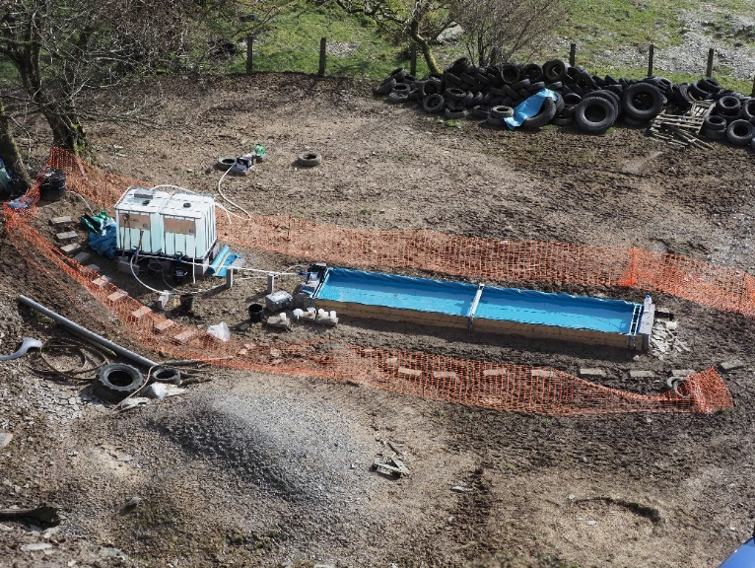
Figure 1 General layout of Trial 1
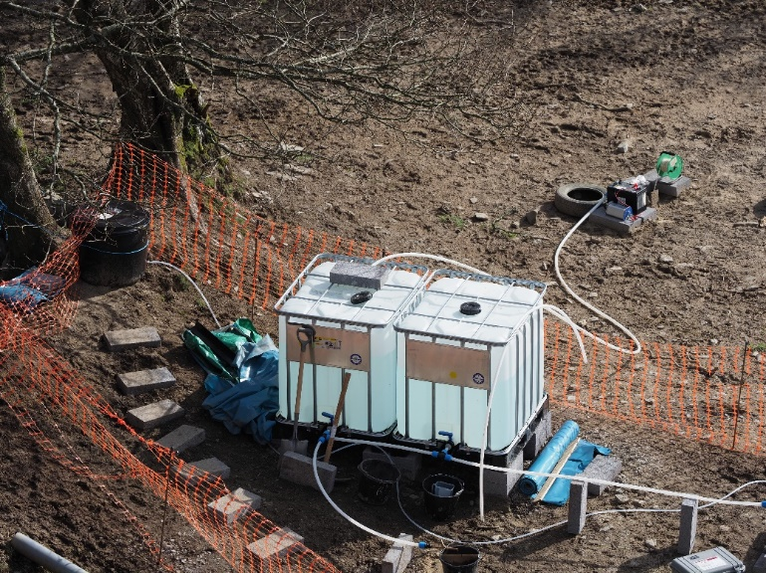
Figure 2 Layout of standpipe and two large IBCs
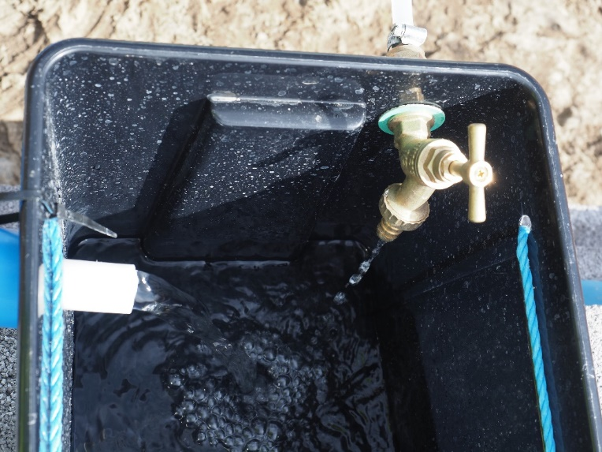
Figure 3 Mixing tank
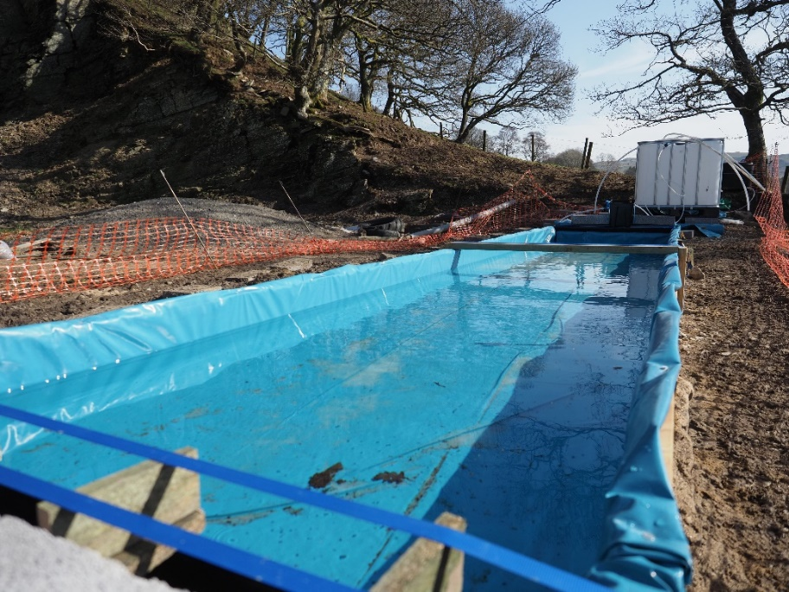
Figure 4 Settling pond
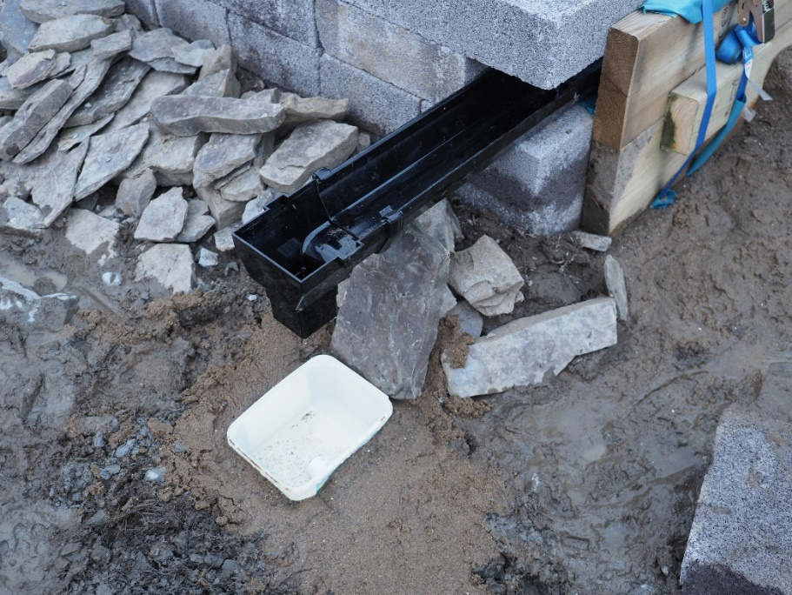
Figure 5 Settling pond outflow
Flow measurements were taken from the inflow, dosing tap and outflow by using a stopwatch and measuring jug. Field measurements (pH, temperature, ORP, DO and conductivity) were also monitored for the mine water inflow, settling pond and treatment outflow using a calibrated YSI multiparameter probe. Field alkalinity was measured on the mine water inflow and the settling pond outflow using a Hach digital titrator test kit. Water samples were taken from the inflow and outflow twice per day, and overall three samples of the settling pond water were also taken (to investigate if standing time changed zinc removal or precipitation overnight). A sample of the white precipitate, forming in the settling pond, was collected on 23rd March, the methodology of which is described later. Liquid and solid samples were sent to ALS laboratories in Hawarden for analysis, twice in the first week and once in the second week of the test. The samples were collected and preserved as per laboratory instruction. The analyses for the samples are presented in Table 1 and Table 2.

Table 1 Liquid laboratory analyses
Parameter | Units | Parameter | Units
Inorganics |  | Unfiltered (Total) Metals
Alkalinity, Total as CaCO₃ | µg/l | Cadmium | µg/l
Chloride | µg/l | Calcium | µg/l
COD, unfiltered | µg/l | Lead | µg/l
pH | pH Units | Magnesium | µg/l
Silica | µg/l | Manganese | µg/l
Sulphate | µg/l | Potassium | µg/l
Suspended solids, Total | µg/l | Sodium | µg/l
Hardness, Total as CaCO₃ | µg/l | Zinc | µg/l
Filtered (Dissolved) Metals
Cadmium | µg/l
Iron | µg/l
Iron, Ferric | µg/l
Iron, Ferrous | µg/l
Lead | µg/l
Manganese | µg/l
Zinc | µg/l

Table 2 Solid laboratory analyses
Parameter | Units | Parameter | Units
Colour | No units | Metals
Description | No units | Aluminium | mg/kg
Inclusion 1) | No units | Cadmium | mg/kg
Inclusion 2) | No units | Chromium | mg/kg
Moisture Content Ratio (% of as received sample) | % | Copper | mg/kg
Carbon |  | Iron | mg/kg
Carbon, Total | % | Lead | mg/kg
Organic Carbon, Total | % | Manganese | mg/kg
Total Inorganic Carbon | % | Zinc | mg/kg
Inorganics |  | Calcium | mg/kg
Sulphate, Total potential | % | Magnesium | mg/kg
Sulphide, Easily liberated | mg/kg | Potassium | mg/kg
Sulphur, Total | % | Sodium | mg/kg
Water Soluble Sulphate as SO₄ 2:1 Extract | g/l
Silica | mg/kg

Average operating conditions for Trial 1 included a mine water inflow rate of 0.17 l/s, a dose rate of 0.003 l/s and settling pond pH of 8.32. On 23rd March the flow rate of the mine water inflow was increased to investigate operating the trial under higher flow conditions (average inflow rate of 0.206 l/s).
The sample of precipitate in the settling pond was collected using a large squeegee and measuring jug containers. The precipitate was very wet, so it was allowed to settle in containers on site (Figure 6), and then filtered using a sieve and paper towel (Figure 7) before being sealed in a container for shipment to the laboratory. The precipitate was very fine and resuspended in water easily.
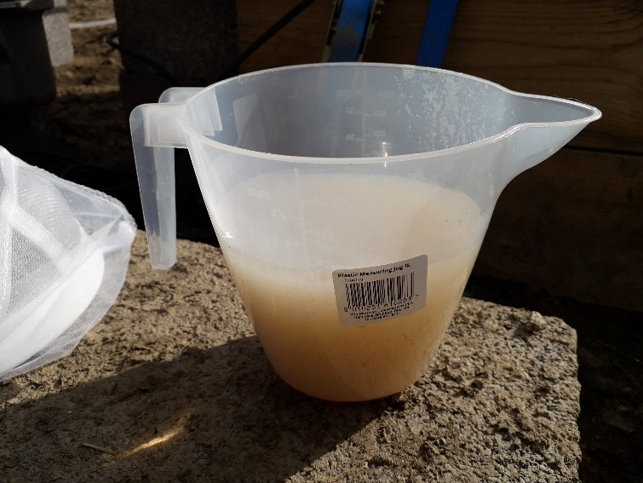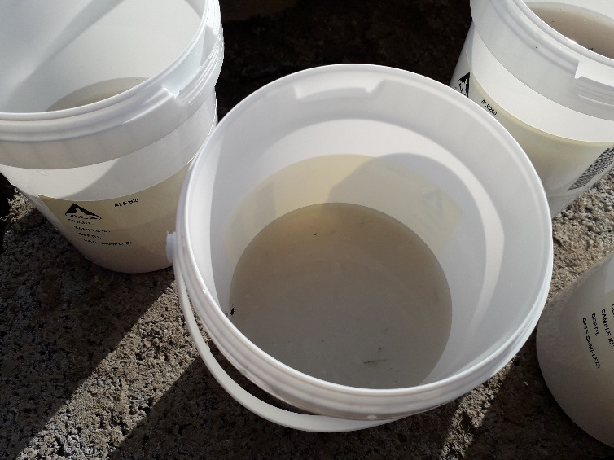
Figure 6 Precipitate settling
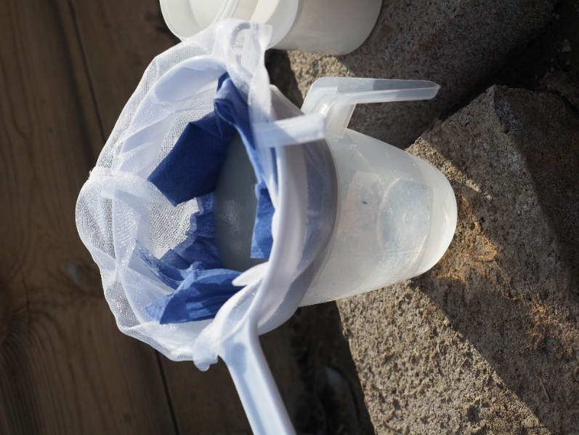
Figure 7 Filtering precipitate on site

Trial 2 - Investigating the coating of limestone gravel
Limestone gravel was not obtained from the Penderyn quarry until the 23rd March. Therefore Trial 2 was operated from late morning on 23rd March to early afternoon on 24th March. Limestone gravel was placed in a bucket and mine water inflow fed into the bucket at a flow rate of around 0.00875 l/s. A baffle was placed in the bucket to force the water through the body of gravel, and a v-notch cut into the bucket to allow an outflow of mine water following limestone gravel contact. The test was operated for just under 24 hours as the inflow was left open overnight. Field measurements and water samples were taken of the inflow and outflow on 23rd and 24th March. A sample of the limestone gravel was taken prior to the trial commencement, and following the trial, to assess changes to the limestone gravel. Laboratory and field analyses are as presented in Table 1 and Table 2. Figure 8 shows the operations of Trial 2.
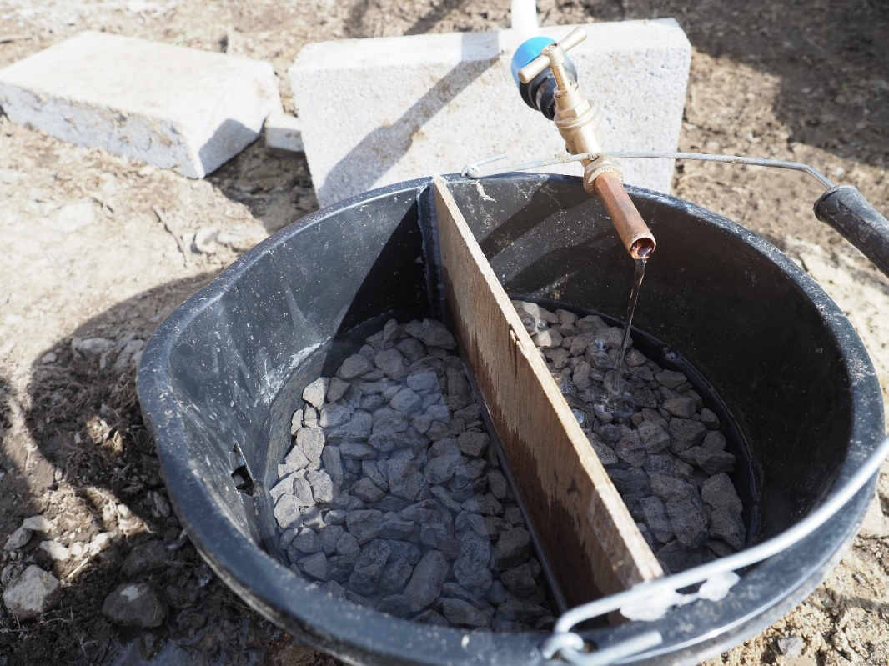
Figure 8 Operating Trial 2

Trial 3 - Limestone gravel as a cover material
The Penderyn limestone gravel was used on 23rd March to test the limestone gravel as a cover material. A volume of 24 litres of deionised water was placed in a large mixing container, which was also a third full of gravel. The water and limestone gravel were gently mixed for several minutes. Field measurements were recorded for the initial deionised water, at 15 minutes, 45 minutes and 1hr 30 minutes following mixing with limestone gravel. Mine water from the standpipe was mixed at a 1:1 ratio (3 litres of each) with the final gravel influenced water (1hr 30 min reaction time) and left to stand for 20 minutes. Field parameters were measured following standing time. A sample of the initial water, the final gravel influenced water (1 hr 30 min reaction time), and final mixed water was taken and analysed at ALS laboratories for the analysis suite presented in Table 1.

Results (march 2020 field trials)

Trial 1 – Sodium carbonate dosing
Precipitate began to form in the settling pond by the second day of operation. Precipitate started settling in the pond within 1 metre of the inflow (Figure 9). The estimated flow rates and total volumes per treatment session for the mine water inflow and dosing inflow are shown in Table 3. The distribution of flow rates for the test are shown in the box and whisker plot provided in Appendix B. The average flows per day versus daily zinc removal rate are shown in Figure 10. Around 47 litres of mine water was treated with every 1 litre of 2.6 g/l sodium carbonate dose. The average mine water total zinc concentration was 15 mg/l. The dose equates to between 80 and 100 litres a day, and the ratio of zinc to sodium carbonate is on average 1:2.2, but at times reaches as high as 1:3. The average inflow is typically measured as higher than the outflow, by a small margin, but this is unlikely to be true in practice. The variation is assumed to be due to a reduction in accuracy in the measurement of the outflows, as the inflow location is more easily accessible for measurement than the outflow location.
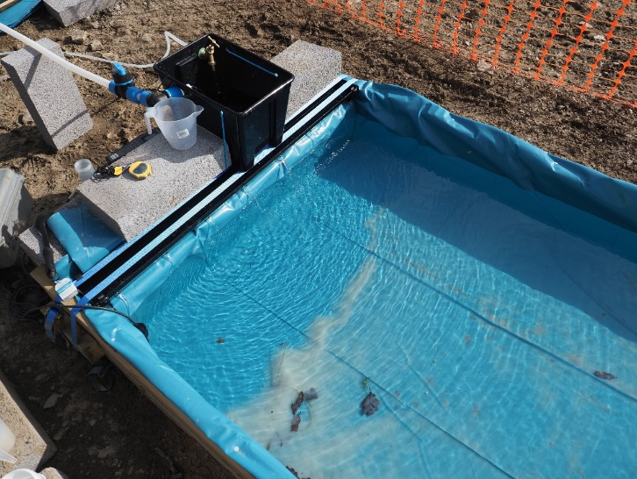
Figure 9 Precipitate formation in settling pond
Figure 10 Average flow rates and zinc removal rates

Table 3 Estimated mine water treatment and dosing volumes
Date | Time started | Time stopped | Total length (hours) | Total length (seconds) | Average MW flow (l/s) | MW treated (litres) | Average dosing flow (l/s) | Dosing volume (litres) | Zinc to sodium carbonate ratio
16/03/2020 | 16:30 | 17:30 | 01:00:00 | 3600 | 0.167 | 601 | 0.002 | 7.2 | 1:1.2
17/03/2020 | 09:30 | 12:00 | 02:30:00 | 9000 | 0.167 | 1503 | 0.005 | 46.8 | 1:3.1
17/03/2020 | 13:30 | 17:00 | 03:30:00 | 12600 | 0.167 | 2105 | 0.005 | 65.5 | 1:3.1
18/03/2020 | 10:00 | 14:17 | 04:17:00 | 15419 | 0.163 | 2511 | 0.003 | 52.9 | 1:2.1
18/03/2020 | 14:50 | 17:30 | 02:40:00 | 9612 | 0.163 | 1565 | 0.003 | 33.0 | 1:2.1
19/03/2020 | 09:30 | 12:30 | 03:00:00 | 10800 | 0.181 | 1958 | 0.004 | 42.4 | 1:2.2
19/03/2020 | 12:50 | 16:20 | 03:30:00 | 12600 | 0.181 | 2283 | 0.004 | 49.4 | 1:2.2
20/03/2020 | 09:50 | 14:15 | 04:25:00 | 15900 | 0.165 | 2628 | 0.002 | 36.5 | 1:1.4
23/03/2020 | 13:15 | 18:00 | 04:45:00 | 17100 | 0.206 | 3516 | 0.004 | 73.1 | 1:2.1
24/03/2020 | 09:30 | 11:10 | 01:40:00 | 6012 | 0.190 | 1142 | 0.003 | 20.0 | 1:1.8
Totals |  |  |  | 112643 |  | 19813 |  | 427 | Average: 1:2.2
Numbers highlighted are estimated volumes and rates

The variations in field parameters measured over the treatment period are shown in the box and whisker plots in Figures 11 to 13 and the summary statistics in Table 4, plus additional figures in Appendix B. The average pH in the mine water inflow was recorded as 7.8, 8.3 in the settling pond and 8.1 in the outflow. The pH of the mine water measured in the field is slightly higher than laboratory analyses and also previous field measurements of pH from TP112. There could be a range of possible explanations for this variation, including variation in pH in the samples from field to laboratory. This variation will not impact the conclusions of this report. The dissolved oxygen generally increased from the inflow to the outflow of the treatment system. The field conductivity increased following the dosing of the mine water. Precise field ORP measurements are difficult to achieve, however the relative trend suggests ORP reduced between the mine water inflow and the settling pond, increasing slightly by the outflow. Temperature varied with weather conditions, but typically decreased from the inflow to the outflow of the system (Appendix B). The rainfall series for the experiment (based on the nearest monitoring location at Pontrhydfendigaid) is shown in Figure 14.
Figure 11 Field pH box and whisker diagram
Figure 12 Field ORP box and whisker plot
Figure 13 Field alkalinity box and whisker plot

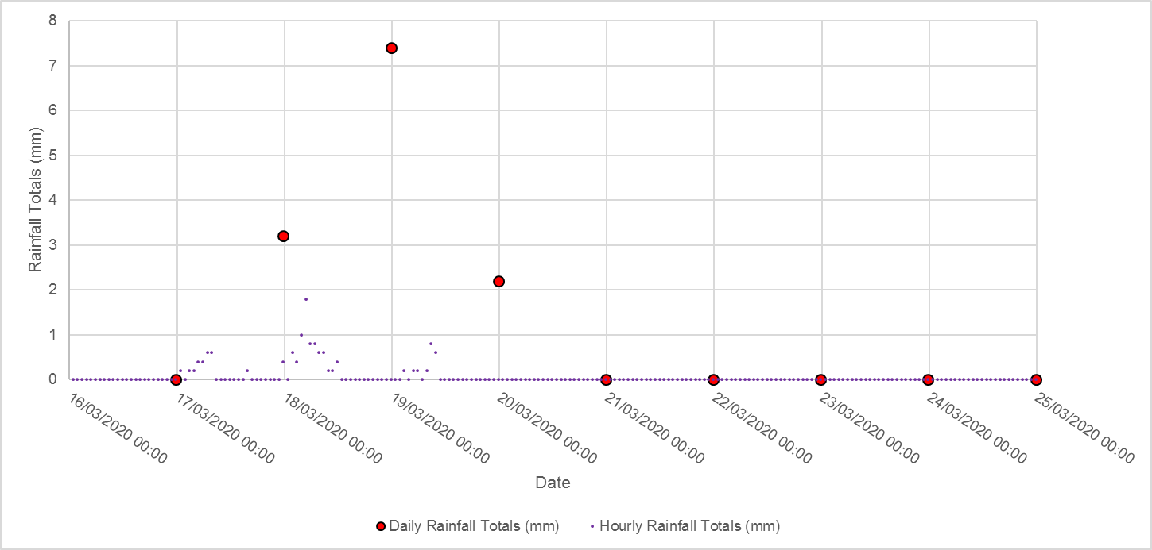
Figure 14 Rainfall at Pontrhydfendigaid during the test

Table 4 Summary statistics for field parameters
Sample | Parameter | Minimum | Q25 | Average | Median | Q75 | Maximum | Count
Inflow | pH | 7.2 | 7.8 | 7.8 | 7.9 | 7.9 | 7.9 | 15
Inflow | DO (mg/l) | 6.7 | 7.6 | 8.4 | 8.2 | 8.9 | 11.3 | 14
Inflow | SPC (µS/cm) | 135.6 | 144.2 | 147.2 | 148.8 | 150.2 | 152.9 | 15
Inflow | ORP (Eh) | -26.3 | 29.3 | 46.1 | 48.7 | 66.1 | 105.0 | 15
Inflow | T (ºC) | 6.7 | 9.5 | 9.7 | 9.7 | 10.3 | 11.8 | 15
Inflow | Alkalinity (mg/l) | 2.0 | 3.5 | 8.6 | 5.0 | 13.0 | 22.0 | 9
Settling Pond | pH | 7.2 | 8.1 | 8.3 | 8.3 | 8.5 | 9.7 | 47
Settling Pond | DO (mg/l) | 8.2 | 8.7 | 9.8 | 9.5 | 10.5 | 12.4 | 14
Settling Pond | SPC (μS/cm) | 172.5 | 182.9 | 190.2 | 187.3 | 196.5 | 218.0 | 16
Settling Pond | ORP (Eh) | -36.4 | 3.1 | 17.7 | 17.7 | 27.8 | 59.0 | 16
Settling Pond | T (ºC) | 5.1 | 8.5 | 8.9 | 9.2 | 9.9 | 11.3 | 16
Outflow | pH | 7.5 | 8.1 | 8.1 | 8.2 | 8.3 | 8.5 | 15
Outflow | DO (mg/l) | 8.7 | 9.3 | 10.1 | 9.9 | 10.7 | 13.9 | 15
Outflow | SPC (μS/cm) | 172.0 | 179.2 | 187.5 | 185.8 | 196.6 | 202.7 | 15
Outflow | ORP (Eh) | -12.7 | 14.5 | 29.2 | 27.1 | 53.3 | 61.7 | 15
Outflow | T (ºC) | 6.3 | 8.4 | 9.0 | 8.8 | 10.0 | 11.3 | 15
Outflow | Alkalinity (mg/l) | 14.0 | 17.5 | 34.3 | 40.0 | 45.0 | 65.0 | 9

Time series plots for the daily average pH, alkalinity and total rainfall versus the average zinc removal percentage from inflow to outflow are shown in Figures 15 to 17 below. Some inconsistencies were noted in pH and alkalinity measurements of the outflow, particularly on the last day of the trial. A number of reasons may explain this, including running down the system and removal of the precipitate on the penultimate day. These inconsistencies are not thought to be of importance for the overall results of the trial. It was noted on site that increased rainfall and wind appeared to reduce the efficiency of the precipitation formation, and thus assuming reducing the zinc removal rate. This is not shown clearly in the daily rainfall and zinc removal rates, but there is some reduction in removal on 19th March, the day after the highest daily rainfall total.
Figure 15 Daily average field pH versus daily average zinc removal rates
Figure 16 Daily average field alkalinity versus daily average zinc removal rates
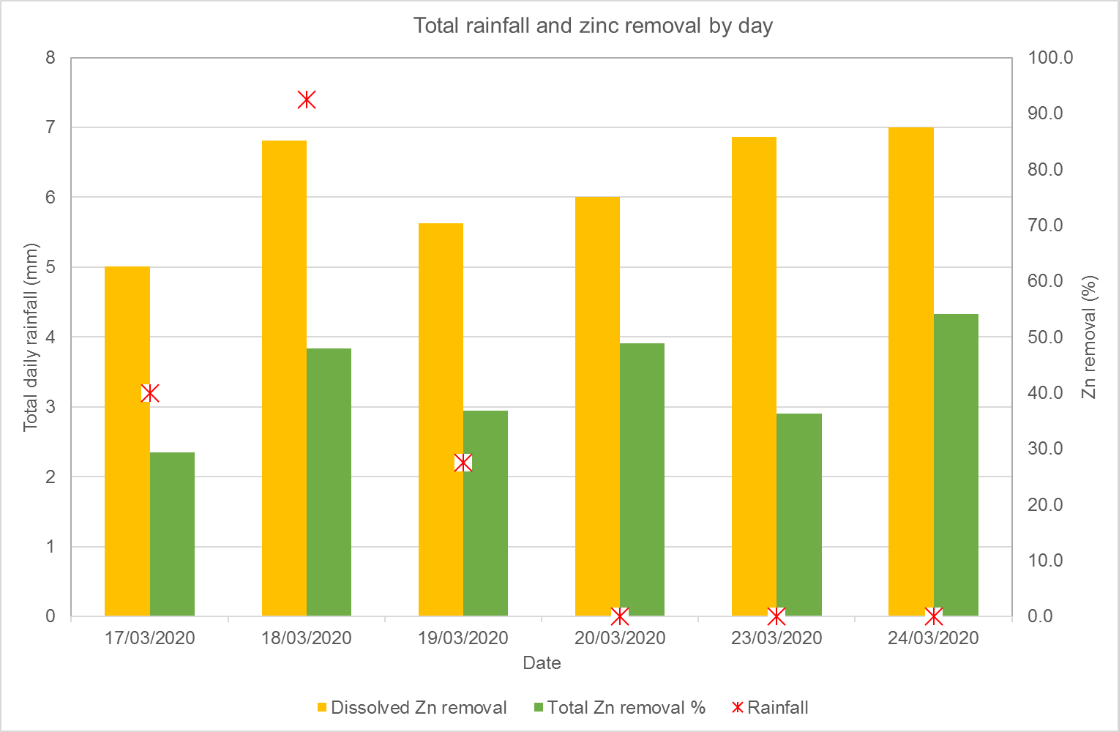
Figure 17 Daily total rainfall and zinc removal rates
The zinc removal rate per sample set (one inflow and one outflow taken at the same time) is calculated and presented versus individual field settlement pond pH measurements in Figure 18. There is more correlation between pH and higher zinc removal rates in individual samples and measurements than the overall averages (which provide a higher level indication). This reflects the variations in pH through the day as the dosing rate was varied to maintain as close to the target pH as possible (and an estimated retention period within the pond of 3 – 4 hr). The lead and cadmium removal rates versus pH for individual sample sets are presented in Figure 19 and Figure 20. These figures also present the removal rates calculated for settling pond samples (blue and green bars) as opposed to the operating outflow (orange and yellow). Settling pond samples were taken when the treatment system was not operating. On 19th March the settling pond sample removal rate mimics that of the outflow, as it was taken at the end of the day following a day of treatment (i.e. no additional settling time for removal of metals). The settling pond samples taken on 20th and 24th March were at the beginning of the day before the treatment system was restarted, therefore indicating the potential removal rate following over 12 hours of additional settling time in the treatment system. Although the dissolved metal removal rates are similar to the operating conditions, the total metal removal rates are much higher, essentially matching those of dissolved metals and for the 24th March reach over 80%. This suggests that the current operating system could be further optimised for the time required to remove higher metal load mainly due to the settling velocity of the particles formed.

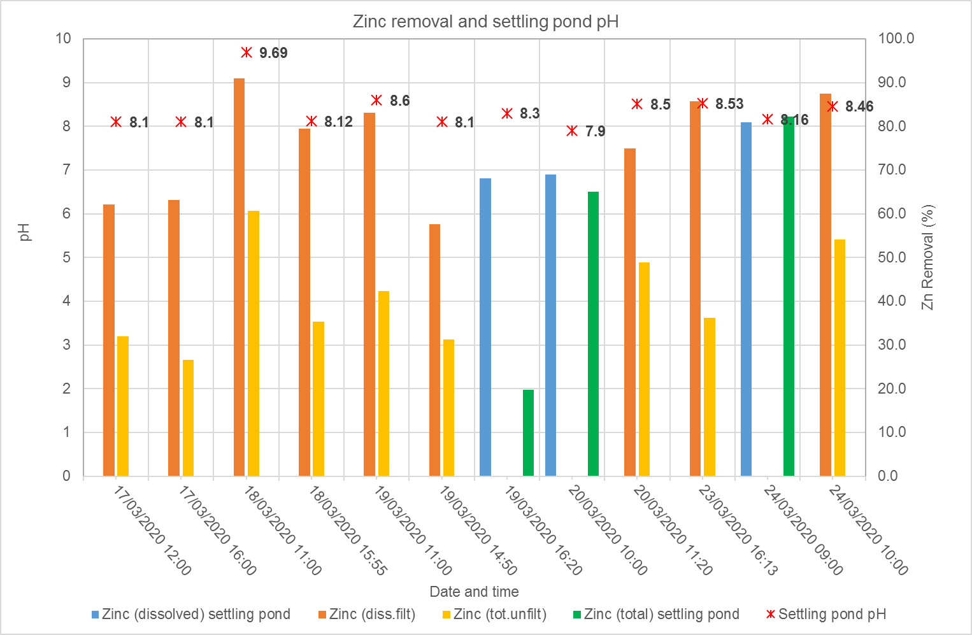
Figure 18 Individual sample zinc removal rates and settling pond field pH

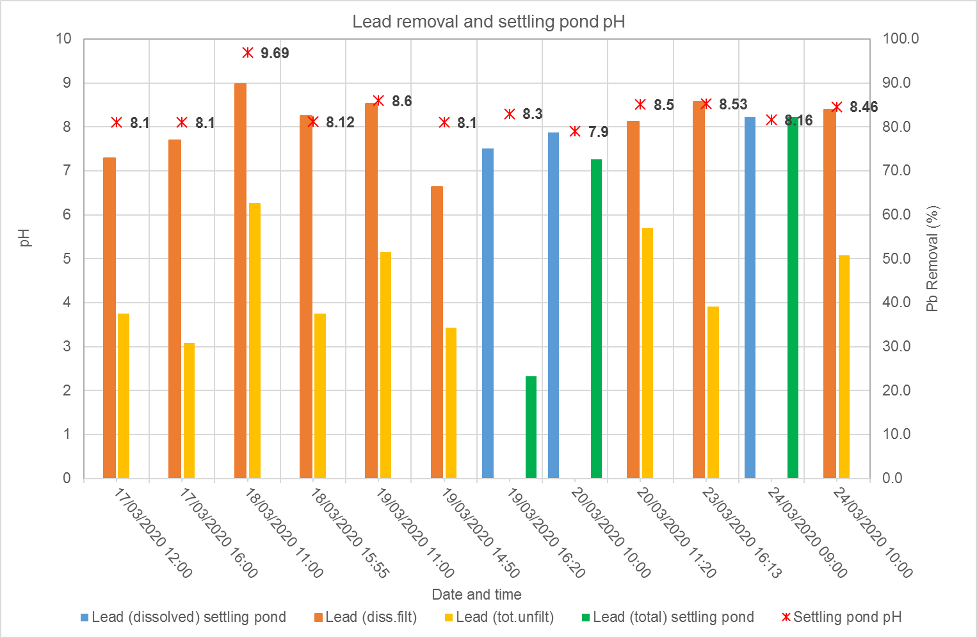
Figure 19 Individual lead removal rates and settling pond field pH measurements

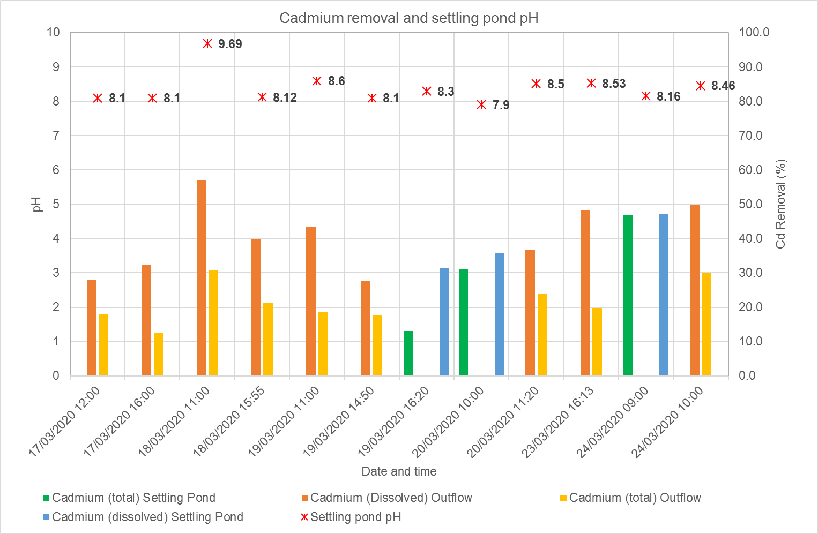
Figure 20 Individual sample cadmium removal rates and settling pond field pH measurements
Time series plots to show the variation in major ions and metals analysed in water samples over the treatment period are shown for major elements in Appendix B and for a range of other elements in Figures 21 to 26. Removal rates for zinc, lead and cadmium are calculated per sample set (inflow and outflow pair) in Table 5. Samples were taken twice daily of the mine water inflow and the outflow. Several settling pond samples were also taken either at the end of a day of treatment (19th March), or first thing in the morning before treatment began (20th and 24th March). These are plotted on the same graphs to show the variation in concentrations following standing time (i.e. overnight). The removal rates for zinc, lead and cadmium for samples taken from the settling pond after overnight standing time are calculated in Table 6. The water collected from the filtration of the precipitate on site was also analysed and results presented on these graphs. Iron and manganese were not found above detection limits so the results are not presented here or in Appendix B. A number of trends can be seen:
- Ca, Mg, K, Cl and Sulphate concentrations see little variation between mine water inflow and treatment system outflow.
- Alkalinity and sodium increase between mine water inflow and treatment system outflow as expected due to the dosing regime.
- Silica is around 1 mg/l higher in concentration in the mine water inflow than the treatment system outflow
- Zinc, lead and cadmium all see reductions in dissolved and total concentrations from mine water inflow to the treatment system outflow. Zinc and lead show the highest removal rates and cadmium the lowest.
- Dissolved metal concentrations exhibit a greater reduction between mine water inflow and treatment system outflow.
- Samples taken from the settling pond after standing time (overnight) and prior to treatment trial re-start show a much greater reduction in total metal concentrations. The suspended solids concentrations (Figure 27) also suggest that more precipitate is settling following standing time in the settling pond.

Figure 21 Sodium concentrations through treatment trial
Figure 22 Laboratory alkalinity through treatment trial
Figure 23 Silica concentrations through treatment trial
Figure 24 Zinc concentrations through treatment trial
Figure 25 Lead concentrations through treatment trial
Figure 26 Cadmium concentrations through treatment trial
Table 5 Removal rate percentages per sample set between mine water inflow and treatment system outflow
Time/date | Zinc (diss.filt) | Zinc (tot.unfilt) | Lead (diss.filt) | Lead (tot.unfilt) | Cadmium (diss.filt) | Cadmium (tot.unfilt)
 | % | % | % | % | % | %
17/03/2020 12:00 | 62 | 32 | 73 | 37 | 28 | 18
17/03/2020 16:00 | 63 | 27 | 77 | 31 | 32 | 13
18/03/2020 11:00 | 91 | 61 | 90 | 63 | 57 | 31
18/03/2020 15:55 | 79 | 35 | 82 | 38 | 40 | 21
19/03/2020 11:00 | 83 | 42 | 85 | 51 | 43 | 19
19/03/2020 14:50 | 58 | 31 | 66 | 34 | 28 | 18
20/03/2020 11:20 | 75 | 49 | 81 | 57 | 37 | 24
23/03/2020 16:13 | 86 | 36 | 86 | 39 | 48 | 20
24/03/2020 10:00 | 87 | 54 | 84 | 51 | 50 | 30
Average* | 76 | 41 | 81 | 45 | 40 | 21
* Average shows the variable conditions during the trial

Table 6 Metal reduction rates as percentages in settling pond samples
Sample description | Settling Pond at the end of the day | Settling pond at the start of the day | Settling pond at the start of the day
Parameter | % (19/03/2020) | % (20/03/2020) | % (24/03/2020)
Dissolved Zn | 68 | 69 | 81
Total Zn | 20 | 65 | 82
Dissolved Pb | 75 | 79 | 82
Total Pb | 23 | 73 | 82
Dissolved Cd | 31 | 36 | 47
Total Cd | 13 | 31 | 46

Figure 27 Suspended solids measured in inflow, outflow and settling pond
A photograph of the stored wet precipitate is shown in Figure 28. In the settling pond the precipitate sometimes appeared to be forming as lenses and typically it collected as a fine covering across the bottom of the pond, but with greater amounts around windblown debris in the pond and also along folds of the liner of the pond. The chemical analysis of the precipitate is presented in Table 7. Moisture content of the precipitate, measured at the laboratory, was 95% despite being filtered using paper roll on site. The weight of the sample collected on site was between 800 – 900 g. The precipitate was fine and resuspended in solution easily. The zinc concentration is almost 50%, however the total inorganic carbon only around 1.2%, much lower than expected if a pure zinc carbonate is forming. There are few other key parameters above 1%, only lead at 1.5%. The ratios of zinc to carbon suggest hydrozincite or another hydroxide zinc carbonate may be forming rather than a purer zinc carbonate such as smithsonite.
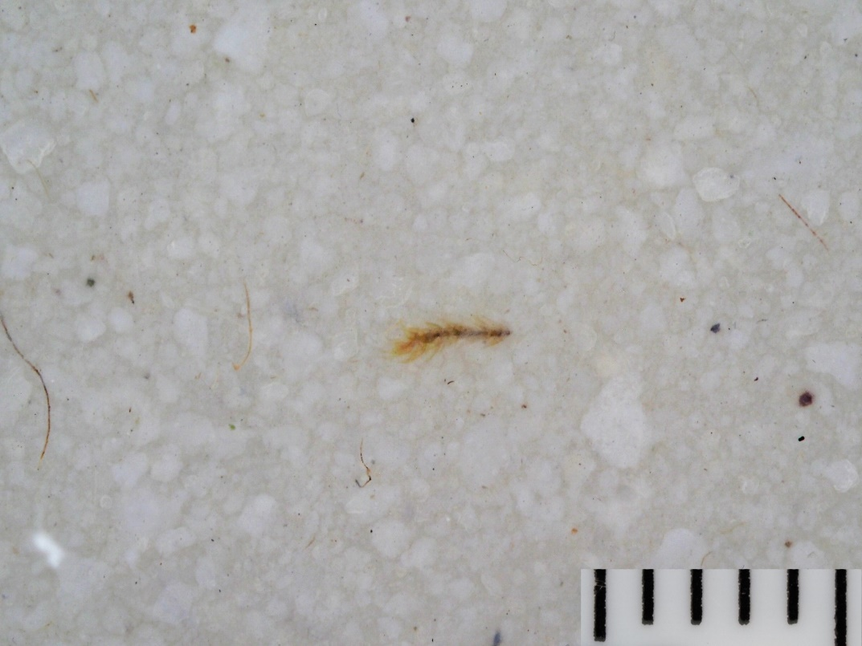
Figure 28 Photograph of stored wet precipitate (scale bar in mm)
Table 7 Chemical analysis of zinc precipitate
Parameter | Unit | Precipitate
Carbon, Total | % | 1.7
Organic Carbon, Total | % | 0.5
Total Inorganic Carbon | % | 1.2
Sulphate, Total potential | % | 0.06
Sulphide, Easily liberated | % | 0.00075
Sulphur, Total | % | 0.01
Water Soluble Sulphate as SO4 2:1 Extract* | % | 0.000113
Aluminium | % | 0.187
Cadmium | % | 0.0479
Chromium | % | 0.000293
Copper | % | 0.0133
Iron | % | 0.16
Lead | % | 1.5
Manganese | % | 0.00567
Zinc | % | 46
Calcium | % | 0.15
Magnesium | % | 0.026
Potassium | % | 0.0187
Silica | % | 0.0005
Sodium | % | 0.06
*assuming density of 1 litre=1000g
Values in bold italic are below detection limits

Trial 2 - Investigating the coating of limestone gravel
The field measurements taken on the inflows and outflows to Trial 2 are shown in Table 8, the laboratory analyses of water samples in Table 9. The removal rates for zinc, lead and cadmium between the mine water inflow and outflow from the test are presented in Table 10. The limestone contact has achieved only a minor increase in pH in the laboratory results, which could explain the limited heavy metal removal rates. The field pH shows a slight decrease between inflow and outflow. The solid chemical analysis of the gravel before and after the test are shown in Table 11. An increase in heavy metal content of the gravel has been observed which could indicate the coating of the limestone gravel with heavy metal carbonates.
Table 8 Field measurements for Trial 2 inflow and outflows
Field parameter | Unit | 23/03/2020 |  | 24/03/2020
Field parameter | Unit | Inflow | Outflow | Inflow | Outflow
Temp | ºC | 10.7 | 10.7 | 8.4 | 8.7
DO | mg/l | 6.35 | 7.3 | 7.4 | 8.6
Conductivity | μg/l | 149 | 152 | 145.8 | 152.4
pH |  | 7.57 | 7.53 | 7.38 | 7.05
ORP | mV | 41.9 | 33 | 37.1 | 62.6
Field alkalinity | mg/l CaCO₃ | - | - | 10 | 22

Table 9 Laboratory analysis of Trial 2 inflows and outflows
Sample Description |  | T2 inflow | T2 inflow | T2 outflow | T2 outflow
Date Sampled |  | 23/03/2020 | 24/03/2020 | 23/03/2020 | 24/03/2020
Alkalinity, Total as CaCO₃ | µg/l | 19500 | 19000 | 23500 | 30500
Chloride | µg/l | 11700 | 12600 | 11700 | 13100
COD, unfiltered | µg/l | 3500 | 3500 | 3500 | 3500
pH | pH Units | 6.72 | 6.8 | 6.88 | 6.98
Silica | µg/l | 5700 | 5900 | 5560 | 5720
Sulphate | µg/l | 32800 | 32600 | 32700 | 32700
Suspended solids, Total | µg/l | 1000 | 1000 | 1000 | 55800
Cadmium (diss.filt) | µg/l | 33.5 | 34.2 | 29.5 | 29.9
Cadmium (tot.unfilt) | µg/l | 36 | 38.4 | 33.6 | 36.4
Iron (Dis.Filt) | µg/l | 9.5 | 9.5 | 9.5 | 9.5
Iron, Ferric | µg/l | 25 | 25 | 25 | 25
Iron, Ferrous | µg/l | 50 | 50 | 50 | 50
Lead (diss.filt) | µg/l | 369 | 363 | 264 | 167
Lead (tot.unfilt) | µg/l | 415 | 446 | 346 | 399
Manganese (diss.filt) | µg/l | 1.5 | 1.5 | 1.5 | 3.37
Manganese (tot.filt) | µg/l | 1.34 | 1.82 | 4.37 | 23.3
Zinc (diss.filt) | µg/l | 13700 | 14000 | 12800 | 13800
Zinc (tot.unfilt) | µg/l | 15800 | 15900 | 15200 | 15600
Calcium (Tot. Unfilt.) | µg/l | 8670 | 8810 | 12600 | 43600
Hardness, Total as CaCO₃ unfiltered | µg/l | 36100 | 36700 | 45900 | 125000
Magnesium (Tot. Unfilt.) | µg/l | 3500 | 3560 | 3490 | 3850
Potassium (Tot. Unfilt.) | µg/l | 1140 | 1200 | 1190 | 1260
Sodium (Tot. Unfilt.) | µg/l | 7960 | 8100 | 8170 | 8470
Results in bold italics are at half detection limits

Table 10 Percentage removal in Trial 2
 |  | 23/03/2020 | 24/03/2020
Zinc dissolved | % removed | 6.6 | 1.4
Zinc total | % removed | 3.8 | 1.9
Lead (diss.filt) | % removed | 28.5 | 54.0
Lead (tot.unfilt) | % removed | 16.6 | 10.5
Cadmium (diss.filt) | % removed | 11.9 | 12.6
Cadmium (tot.unfilt) | % removed | 6.7 | 5.2

Table 11 Laboratory analysis of gravel before and after Trial 2
Sample Description |  | Gravel fresh | Gravel end of trial
Date Sampled |  | 23/03/2020 | 24/03/2020
Colour | No units | Grey | Grey
Moisture Content Ratio (% of as received sample) | % | 0 | 1.2
Carbon, Total | % | 11.8 | 10.6
Organic Carbon, Total | % | 0.1 | 0.1
Total Inorganic Carbon | % | 11.6 | 10.4
Sulphate, Total potential | % | 0.117 | 0.205
Sulphide, Easily liberated | mg/kg | 7.5 | 7.5
Sulphur, Total | % | 0.0389 | 0.0682
Water Soluble Sulphate as SO4 2:1 Extract | g/l | 0.0154 | 0.0139
Aluminium | mg/kg | 5.5 | 5.5
Cadmium | mg/kg | 0.0216 | 0.0693
Chromium | mg/kg | 2.7 | 2.67
Copper | mg/kg | 3.4 | 2.81
Iron | mg/kg | 500 | 500
Lead | mg/kg | 3.63 | 9.57
Manganese | mg/kg | 64.7 | 69.7
Zinc | mg/kg | 4.91 | 36.4
Calcium | mg/kg | 352000 | 338000
Magnesium | mg/kg | 1820 | 2080
Potassium | mg/kg | 83.5 | 71.7
Silica | mg/kg | 1.48 | 1.92
Sodium | mg/kg | 110 | 125
Results in bold italics are at half detection limits

Trial 3 – limestone gravel as a cover material
The field measurements for the initial clean water and the gravel influenced water at varied time intervals are presented in Table 12. This table also includes the field measurements for the mine water and the final 1:1 mix of mine water with gravel influenced water (following 90 min reaction time). The field measurements were measured in the mixed water after a 20-minute standing time. A basic spreadsheet calculation of the measurements under a 1:1 ratio of mine water and gravel influenced water is also presented. The laboratory analysis results for the initial clean water, the final gravel influenced water, the mine water (as tested for Trial 2) and the 1:1 mix of mine water and gravel influenced water is presented in Table 13. This table also includes a calculation of the predicted mix water given no reaction between the mine water and gravel influenced water, simply a mix of the two waters. This calculation can be used to infer if there is metal removal from mixing the gravel influenced water with mine water, or whether the reduction in metal concentrations in the mix is simply due to dilution. There is little difference between cadmium concentrations in the measured and calculated mix. There is a small reduction in lead and zinc concentrations in the measured mix as opposed to the calculated mix, suggesting potentially a small amount of lead and zinc is being removed by a reaction rather than just dilution of the sample. It should be noted that the mixed water shows only a minor increase in pH (well below the target pH tested in Trial 1).
Table 12 Field measurements of gravel influenced water, mine water and mixed water
Parameter | Unit | Initial water | 15 mins | 45 mins | 90 mins | Mine water | Mix 1:1 gravel influenced (90 mins) and mine water (following 20-minute standing time) | Calculated mix of gravel water plus mine water (1:1)
pH |  | 7.71 | 9.92 | 9.18 | 9.88 | 7.77 | 7.8 | 8.07
Temp | ºC | 10 | - | - | 13.7 | 11.3 | 12.3 | 12.5
DO | mg/l | 9.91 | - | - | 9.02 | 6.43 | 8.93 | 7.73
Conductivity | μS/cm | 1.3 | - | - | 33.4 | 149.6 | 93.7 | 91.5
ORP | mV | 34 | - | - | 38 | 63.5 | 37.3 | 50.75
Alkalinity | mg/l CaCO₃ | 1 | 92 | 52 | 56 | - | - | -

Table 13 Laboratory analyses for initial water, final gravel influenced water, mine water (Trial 2) and final mix (1:1)
Parameter | Unit | Initial water | Final gravel influenced water (90 min reaction) | Mine water (as tested for Trial 2) | Mix 1:1 | Calculated mix of gravel water plus mine water (1:1)
Alkalinity, Total as CaCO₃ | µg/l | 2000 | 23800 | 19500 | 202000 | 21650
Chloride | µg/l | 1000 | 1000 | 11700 | 5900 | 6350
COD, unfiltered | µg/l | 3500 | 3500 | 3500 | 3500 | 3500
pH | pH Units | 6.97 | 8.88 | 6.72 | 7.27 | 7.02
Silica | µg/l | 1140 | 1000 | 5700 | 2960 | 3350
Sulphate | µg/l | 1000 | 1000 | 32800 | 17500 | 16900
Suspended solids, Total | µg/l | 1000 | 20700 | 1000 | 29100 | 10850
Cadmium (diss.filt) | µg/l | 0.04 | 0.04 | 33.5 | 16.1 | 17
Cadmium (tot.unfilt) | µg/l | 0.25 | 0.25 | 36 | 18.4 | 18
Iron (Dis.Filt) | µg/l | 9.5 | 26.3 | 9.5 | 9.5 | 18
Iron, Ferric | µg/l | 25 | 25 | 25 | 25 | 25
Iron, Ferrous | µg/l | 50 | 50 | 50 | 50 | 50
Lead (diss.filt) | µg/l | 0.1 | 0.759 | 369 | 117 | 185
Lead (tot.unfilt) | µg/l | 0.5 | 7.75 | 415 | 220 | 211
Manganese (diss.filt) | µg/l | 1.5 | 4.3 | 1.5 | 3.17 | 3
Manganese (tot.filt) | µg/l | 0.5 | 19.2 | 1.34 | 14.4 | 10
Zinc (diss.filt) | µg/l | 4.23 | 10.9 | 13700 | 5990 | 6855
Zinc (tot.unfilt) | µg/l | 5.63 | 53.9 | 15800 | 7620 | 7927
Calcium (Tot. Unfilt.) | µg/l | 73.5 | 32200 | 8670 | 23300 | 20435
Hardness, Total as CaCO₃ unfiltered | µg/l | 175 | 81700 | 36100 | 66200 | 58900
Magnesium (Tot. Unfilt.) | µg/l | 25 | 297 | 3500 | 1920 | 1899
Potassium (Tot. Unfilt.) | µg/l | 100 | 100 | 1140 | 648 | 620
Sodium (Tot. Unfilt.) | µg/l | 23.5 | 23.5 | 7960 | 3980 | 3992

Discussion Of the March Trial Results
In the first trial, dosing with sodium carbonate, the system successfully removed zinc from the mine water. The average pH achieved in the settling pond during the trial is slightly lower than targeted (pH 8.3 as opposed to pH 8.4). It is expected that a pH between 8.5 and 9.0 would provide much greater efficiency in removal of zinc from the mine water (greater than 80% removal). The lower operating pH of the system is attributed to the sensitivity of dosing control with the tap installation, including optimisation required from dilution by rainfall. It’s expected that at full-scale the dose control will be finer, managed via an automated system triggered by the settling pond pH.
The zinc removal rate for the operating system was an average of 76% removal of dissolved zinc, and 41% removal of total zinc concentrations. Samples from the settling pond after standing time overnight showed that dissolved zinc removal rates remained similar, whereas total zinc removal rates increased to generally match dissolved zinc removal rates. The change in removal rates following a longer retention time within the settling pond revealing that precipitate is being lost in the outflow during operation. The settling time for the precipitate formation is longer than the 3 – 4 hours designed within the trial settling pond. The current outline design of the large-scale trial lagoons has a 50 hour settling time, so will likely achieve higher removal efficiencies than this trial.
The precipitate settling in the pond is not considered to be smithsonite. The ratios of zinc to carbon in the precipitate sample suggest it’s more likely to be hydrozincite (Zn₅(CO₃)₂(OH)₆), although potentially with some additional lead and water or hydroxides co-precipitated or adsorbed within the precipitate. Hydrozincite is less dense than smithsonite (i.e. potentially more easily resuspended within the water) and tends to form by accretion rather than flocculation. The system therefore may benefit from a longer settling pond retention time and seeding of the settling pond to accelerate the accretion precipitation process by re-using precipitate within the process. The formation of hydrozincite could be an intermediate product, and with more time it may recrystallise, although this has not been observed.
A high level review of the life cycle cost assessment is included as a Technical Memo in Appendix C, suggesting life cycle CAPEX and OPEX costs (over a 40-year period) are likely to range from £993K to £1,420K, dependent on flow rates varying between 1 – 3 l/s and waste disposal costs. The key risks identified include land take and earthworks, the dry solids content of the precipitated sludge and the chemical storage and handling on site (in terms of environmental and human health risk). Opportunities identified include an upward settling pond design to improve solids removal, optimisation of Vertical Flow Reactor (VFR) sizing at larger-scale field trials (potentially leading to reduced CAPEX costs), potential re-use of treatment waste leading to further reduction in waste disposal costs and the involvement of competent Welsh Water staff from the nearby water treatment site, where sodium carbonate is also used, to reduce OPEX costs. Identified risks and opportunities will be considered further at detailed design stage.
The gravel in Trial 2 appears to increase in zinc, lead and cadmium concentrations after the 24 hours of testing, but no substantial increase in pH has been achieved (and minimal heavy metal reductions after contact with the gravel). This indicates the suspected coating of the gravel surfaces, which requires longer tests to confirm.
In Trial 3 the pH of the gravel influenced deionised water was higher than anticipated, but after mixing with mine water the pH of the mixed water remained well below the target pH 8.4 from Trial 1 (which achieved heavy metal precipitation). Further tests would be required to optimise the mixing ratios aiming for a higher pH increase in the mixed water. Trial 1 shows that zinc removal is strongly related to pH.

Conclusions (Following the March 2020 Trial)
Trial 1, dosing with sodium carbonate, successfully removed dissolved zinc from the mine water. The target pH for the final system should aim for a slightly higher pH (8.5-9) to optimise removal efficiencies. Total zinc removal was lower during operation than following overnight standing time in the settling pond. The current outline design has a 50-hour retention time, so will provide adequate time for total zinc removal to match dissolved zinc removal. The vertical filter effect of the proposed VFR offers an additional mechanism to remove finer precipitate. Some additional field testing would help to inform the design of the large scale trial system (e.g. run the trial with higher pH and try filtering techniques for the precipitate sludge).
The life cycle cost assessment for the dosing system (Appendix C) has identified a number of risks and opportunities during detailed design and large-scale field trials to optimise costs and the design. Overall life cycle costs were found to be in a similar range as estimated for a VFR with iron sulphate dosing during feasibility stage. A more conservative costing approach has led to a higher CAPEX estimate, whereas operational costs are expected to be lower compared to the original VFR with iron sulphate dosing.
Zinc precipitation is suspected to be predominantly as hydrozincite, which would benefit from optimisation of the settling time and also potentially by considering seeding to accelerate precipitation within the system. Mechanisms to reduce the water content of the sludge will need to be considered in the design to reduce disposal costs.
Trial 2 was only completed for a limited time period, but indicated again that coating of the limestone gravel surfaces occurs. The use of limestone gravel as carbonate source and to increase pH in direct contact with mine water is not considred a viable option for this site.
Trial 3 requires further testing to optimise the mixing ratio between the waters. The contact of the de-ionised water with the limestone gravel has led to a significant increase in pH but with a 1:1 mixing ratio the pH of the mixed water was found to be only slightly above the mine water pH which explains the limited heavy metal removal rate.

Additional July 2020 Field trials

Modifications of dosing treatment trial methodology
Additional dosing trials were completed between 27th July – 31st July taking the findings from the March 2020 trials into account. The dosing system was re-instated on 27th July, and tested to ensure all equipment was operational. Mine water was dosed for around 8 hours on 28th – 30th July (3 days), plus a further 2.5 hours on Friday 31st July. On 31st July several methods for filtering the water in the settling pond were tested to provide information on the best approach to collecting precipitate from the treatment scheme. The methodology was implemented as per the original March 2020 trial, but with the following adjustments:
- The pH of the trial was targeted as between pH 8.5 and pH 9, to increase the efficiency of precipitation of zinc within the system. The concentration of the dosing solution was made up as before, but a higher flow rate was used to maintain the higher pH.
- A liner cover was installed on the settling pond (Figure 29) to reduce wind turbulence with an aim of increasing efficiency of precipitate formation/settlement. The cover was a section of plastic liner (the same used in the base of the settling pond) and was held in place with blocks so it could be removed to check the settling pond and take measurements and samples.
- The dosing tank location was modified slightly to make it easier to fill and check (Figure 30). This is unlikely to have changed the trial, as the flow rate adjustment was still made to target the desired pH rather than based on a constant flow from the dosing tank.
- Use of a geomembrane curtain to promote precipitation formation (visible in Figure 31). This comprised of wooden batons and stretching geomembrane material (‘Terram 1000’) with pore space of 75 µm across the pond. The curtain was installed towards the far end of the pond to allow a longer period of settling time, and then try to catch any solid material that hadn’t precipitated before the outflow of the pond.
As the design of the second field trial had a different aim to the initial trial the amount of data collected on site was deemed to be not as necessary as previously. A sample of the mine water inflow and dosing system outflow was taken each day, towards the end of the day. The water samples were sent for analyses as described previously. An onsite alkalinity test was completed on the water at the same time as sampling. The mine water inflow rate was montitored several times per day using a litre jug and stopwatch as before. The dosing volume used per day has been estimated based on the amount of dosing solution made up and used during the week. Physico-chemical parameters (as described previously) were measured in the inflow, outflow and in the settling pond, both before and after the geomembrane curtain at several points through each day.
At the end of the dosing trial a series of filtering tests were completed to assess the best method for precipitate collection. Prior to this the settling pond was drained down slightly from one end to collect the precipitate in one area, as it typically forms across the whole base of the pond (Figure 31). Two geomembrane socks were tested as a filtering method, with void space 25 µm and 5 µm. A geomembrane with 70 µm voids was going to be trialled, however it was decided during the trial operation that the 70 µm was not fine enough as precipitate appeared to be moving through the geomembrane curtain installed in the settling pond. The methodology for geomembrane sock filtration is shown in Figure 32.
A sand filter was constructed on site. The sand filter comprised a 50-60 mm depth of concreting sand on two layers of geotextile filter fabric (‘Terram 1000’ with 75 µm nominal pore size) on the 220 mm diameter perforated base of a 12 litre bucket. The filter bucket fitted into the top of a second bucket to collect the filtrate. A polyethylene sheet was laid on top of the sand to protect it from erosion when the liquid was poured into the filter, and then removed to allow filtration to proceed. 90 mm depth of water & precipitate was poured into the filter. After 8 minutes this had separated into a 35 mm thick layer of precipitate with 30 mm of clear water above; after 20 minutes there was 35 mm precipitate and 5 mm clear water, and after 26 minutes, 30 mm precipitate and 5 mm clear water. The sand filter is shown in Figure 33. Samples of both the precipitate sludge for each of the three filtering methods and the filtrate water were collected on site and sent to the laboratory for analyses as per the analysis suites described previously. Physico-chemical parameters of the filtrate water were also collected.
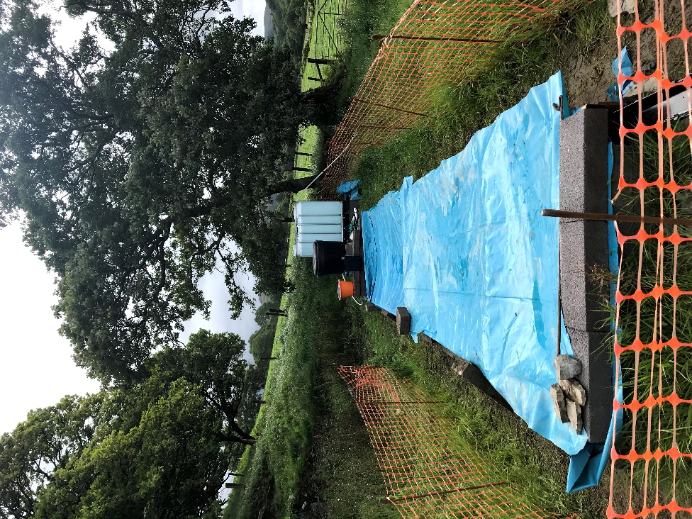
Figure 29 Modified dosing trial set-up
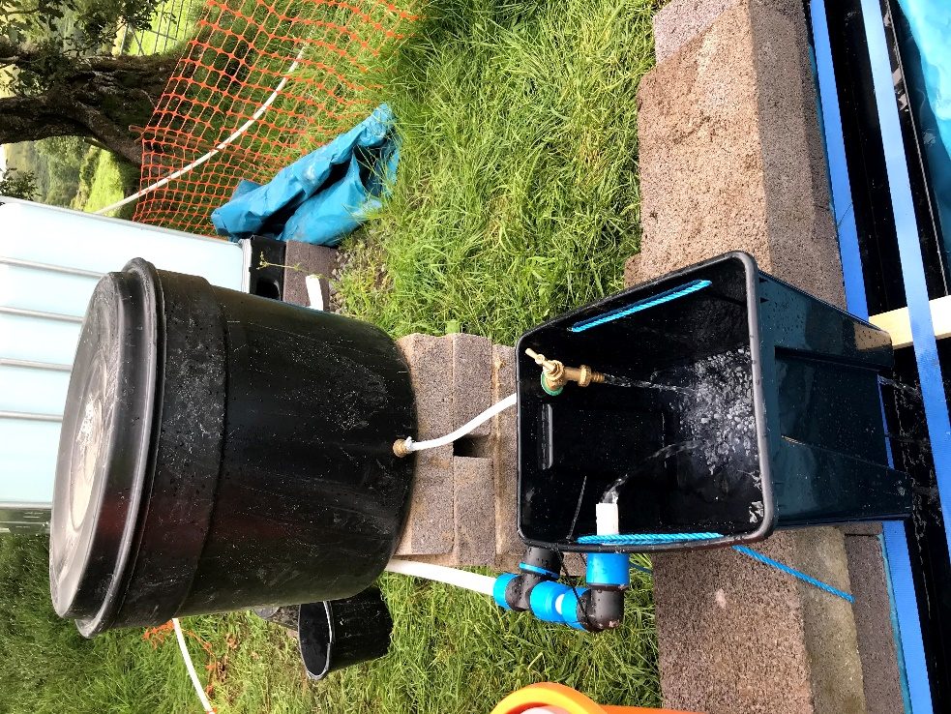
Figure 30 Modification to dosing tank location
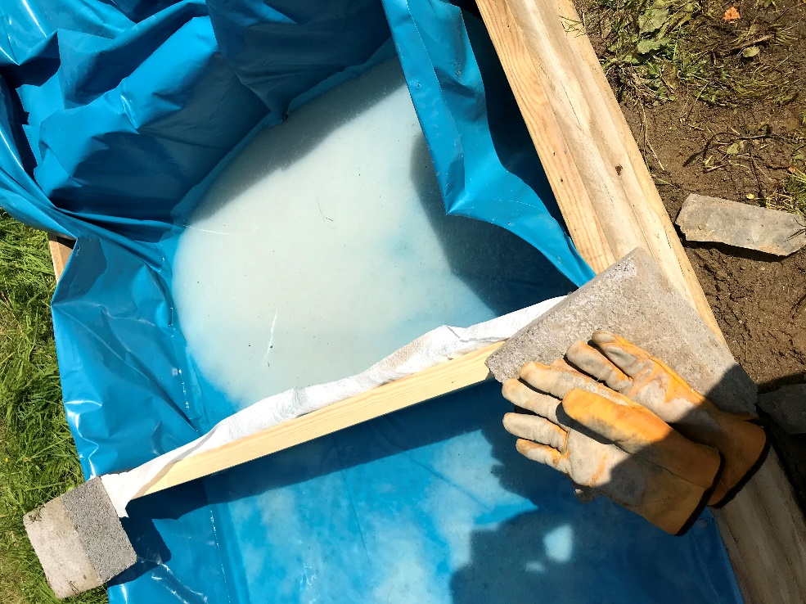
Figure 31 Draining the settling pond and collecting precipitate at one end of the pond
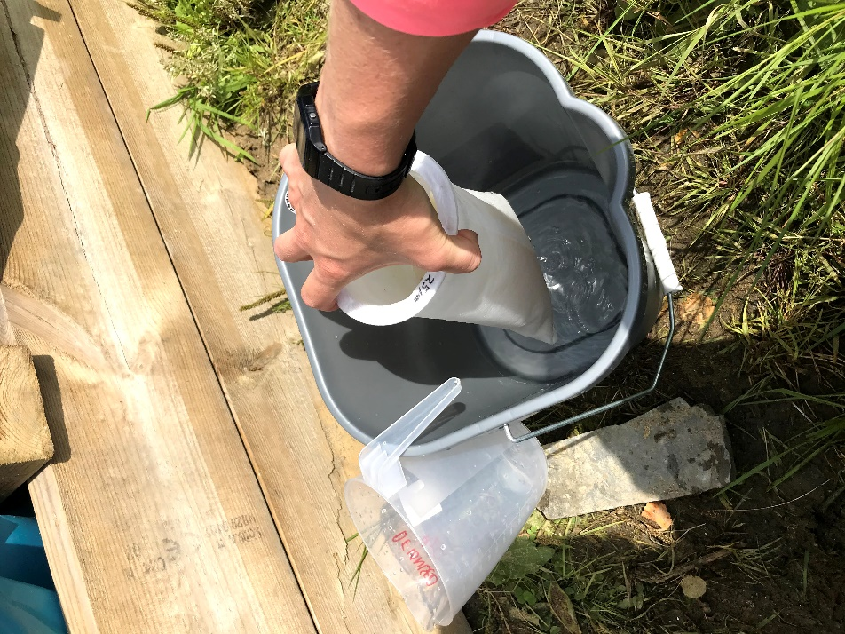
Figure 32 Method for filtering using geomembrane socks
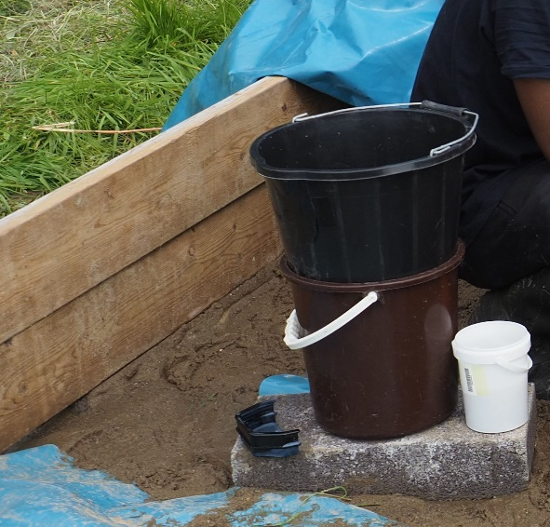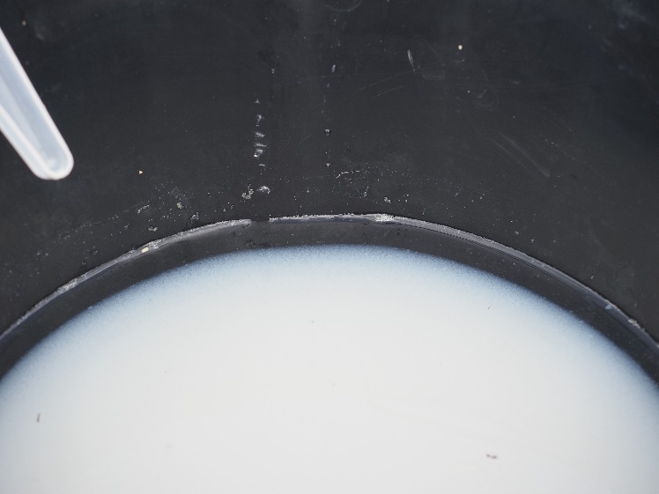
Figure 33 Set-up of sand filter and close-up of sand filter

Results of dosing treatment trial
The treatment trial started to show precipitate forming on the first day of the trial. Overall around 12,613 litres of mine water were treated over the 3.5 days, using a dosing volume of around 320 litres. On average 1 litre of 2.6 g/l sodium carbonate dose treated 39.5 litres of mine water. The estimated inflow and dosing volumes are presented in Table 14. The average mine water total zinc concentration was 19.5 mg/l (i.e. higher than in the previous trial and previous water sampling rounds). The ratio of zinc to sodium carbonate was on average 1:3.5, but at times reaches as high as 1:5.5. This was higher than during the trial in March and is reflective of the aim to maintain a higher pH within the settling pond. The raw data for the trial (both field parameters and laboratory analyses) are attached in Appendix D. The field data (physico-chemical) parameters are summarised in Table 15 and Table 16, and the laboratory analysis results summarised in Table 16.
The mine water inflow was recorded with an average pH 7.5 and electrical conductivity of 197 µS/cm. Field parameters (physico-chemical) were measured in different places within the settling pond, at the inflow of the mine water and dosing solution, at the mid-point, and following the geomembrane curtain. Measurements were also taken at the treatment outflow. The pH was roughly similar across the system, the average between pH 8.6 and pH 8.7, and no discernable trend in the individual data. The electrical conductivity data was similar, averaging between 268 µS/cm and 308 µS/cm, again with limited discernable variation across the system. A number of dissolved oxygen results have been removed from the summary in Table 15 as they were recorded as higher than 100% which is likely to be a measurement error. Higher temperatures in the field data correspond to the warmer days on Thursday and Friday of the trial week. Alkalinity was measured onsite. The inflow alkalinity average over the week was 21.8 mg/l CaCO₃ and at the outflow following treatment was 80.2 mg/l CaCO₃.
The major ion water chemistry of the mine water inflows and treatment system outflows showed a similar trend to the March treatment trials. One small difference was that the concentration of silica was slightly elevated, an average of 10 mg/l for the mine water inflow (Table 17). The zinc concentration of the inflow was slightly higher than in March, between 18.8 mg/l and 21.4 mg/l. The zinc concentration at the outflow was between 0.1 mg/l and 1.8 mg/l (dissolved) and 3 mg/l and 11.8 mg/l (total). A sample taken in the settling pond early on in the week of the trial had zinc concentrations similar to the outflow. The lead concentration at the mine water inflow was around 0.3 mg/l, and reduced to around 0.03 mg/l (dissolved) and 0.12 mg/l (total) at the outflow. The cadmium concentration was around 0.04 mg/l in the mine water inflow and decreased to around 0.01 mg/l following treatment.

Table 14 July treatment trial estimated minewater and dosing volumes
Date | Time started | Time stopped | Total length (hours) | Total length (seconds) | Average MW flow (l/s) | MW treated (litres) | Average dosing flow (l/s) | Dosing volumes (litres) | Zinc to sodium ratio
28/07/2020 | 09:30 | 18:20 | 08:50 | 31788 | 0.23 | 7417 | 0.003 | 95 | 1:1.3
29/07/2020 | 08:55 | 17:05 | 08:10 | 29401 | 0.08 | 2412 | 0.003 | 88 | 1:3.7
30/07/2020 | 08:55 | 17:50 | 08:55 | 32100 | 0.06 | 1883 | 0.003 | 103 | 1:5.5
31/07/2020 | 07:40 | 10:10 | 02:30 | 9000 | 0.10 | 900 | 0.004 | 33 | 1:3.7
 |  |  |  | 102289 |  | 12613 |  | 320 | Average: 1:3.5

Table 15 Summary of field data physico-chemical parameters
 |  | pH | DO (%) | EC (µS /cm) | ORP (mV) | Temp (°C)
Inflow
 | Min | 6.7 | 43 | 118 | 67 | 12
 | Median | 7.6 | 52 | 202 | 111 | 14
 | Average | 7.5 | 57 | 197 | 142 | 15
 | Max | 8.0 | 90 | 207 | 514 | 21
Settling pond (near inflow)
 | Min | 7.7 | 47 | 205 | 56 | 12
 | Median | 8.7 | 73 | 275 | 85 | 13
 | Average | 8.7 | 69 | 308 | 82 | 13
 | Max | 10.4 | 88 | 706 | 122 | 14
Settling pond (middle)
 | Min | 7.6 | 47 | 224 | 58 | 13
 | Median | 8.6 | 66 | 269 | 92 | 13
 | Average | 8.6 | 70 | 274 | 88 | 14
 | Max | 9.1 | 112 | 313 | 145 | 16
Settling pond (after geomembrane curtain)
 | Min | 8.2 | 59 | 257 | 57 | 13
 | Median | 8.5 | 68 | 268 | 79 | 13
 | Average | 8.7 | 71 | 268 | 77 | 13
 | Max | 10.3 | 91 | 275 | 97 | 14
Outflow
 | Min | 8.3 | 61 | 256 | 56 | 13
 | Median | 8.6 | 66 | 281 | 92 | 14
 | Average | 8.7 | 69 | 298 | 128 | 15
 | Max | 10.2 | 90 | 500 | 478 | 17

Table 16 Field alkalinity measurements through the trial
 | Inflow alkalinity (mg/l CaCO₃) | Outflow alkalinity (mg/l CaCO₃)
28/07/2020 | 11 | 83
29/07/2020 | 9 | 80
30/07/2020 | 26 | 54
30/07/2020 | 32 | 49
31/07/2020 | 24 | 108
31/07/2020 | 28 | 107

Table 17 Summary of treatment trial laboratory analyses
Parameter | Unit | Mine water inflow |  |  | Settling pond | Treatment system outflow
Parameter | Unit | Minimum | Average | Maximum | One sample (Tues 28th) | Minimum | Average | Maximum
Alkalinity (total as HCO₃) | mg/l | 29.3 | 32.6 | 34.2 | 360.0 | 97.6 | 117.7 | 159.0
Cadmium (Diss) | mg/l | 0.0413 | 0.0438 | 0.0455 | 0.0007 | 0.0018 | 0.0098 | 0.0187
Cadmium (Total) | mg/l | 0.0431 | 0.0457 | 0.0476 | 0.0104 | 0.0093 | 0.0213 | 0.0317
Calcium (Total) | mg/l | 10.5 | 10.9 | 11.2 | 9.1 | 10.5 | 10.7 | 10.9
Chloride | mg/l | 10.8 | 11.0 | 11.3 | 10.5 | 10.5 | 10.8 | 11.0
COD | mg/l | 3.5 | 3.5 | 3.5 | 3.5 | 3.5 | 3.5 | 3.5
Hardness as CaCO₃ | mg/l | 42 | 43 | 45 | 35 | 41 | 42 | 43
Iron (Diss) | mg/l | 0.0095 | 0.0095 | 0.0095 | 0.0095 | 0.0095 | 0.0095 | 0.0095
Iron (ferric) | mg/l | 0.025 | 0.025 | 0.025 | 0.025 | 0.025 | 0.025 | 0.025
Iron (ferrous) | mg/l | 0.05 | 0.05 | 0.05 | 0.05 | 0.05 | 0.05 | 0.05
Lead (Diss) | mg/l | 0.31 | 0.32 | 0.32 | 0.03 | 0.02 | 0.03 | 0.04
Lead (Total) | mg/l | 0.32 | 0.33 | 0.34 | 0.10 | 0.06 | 0.12 | 0.18
Magnesium (Total) | mg/l | 3.7 | 3.9 | 4.1 | 3.03 | 3.69 | 3.74 | 3.79
Manganese (Diss) | mg/l | 0.0015 | 0.0015 | 0.0015 | 0.0015 | 0.0015 | 0.0015 | 0.0015
pH | SI | 6.7 | 6.8 | 6.9 | 10.3 | 8.1 | 8.8 | 9.6
Potassium (Total) | mg/l | 0.94 | 0.97 | 1.00 | 0.90 | 0.91 | 0.95 | 0.99
Silica | mg/l | 5.7 | 9.9 | 21.8 | 3.1 | 4 | 16 | 35
Sodium (Total) | mg/l | 7.7 | 7.8 | 8.0 | 135 | 38.9 | 47.8 | 65.9
Sulphate | mg/l | 41.7 | 44.0 | 45.5 | 35.7 | 42.4 | 43.7 | 44.2
Suspended solids | mg/l | 1 | 1 | 1 | 11 | 5 | 12 | 18
Zinc (Diss) | mg/l | 18.8 | 19.9 | 21.4 | 0.1 | 0.1 | 0.6 | 1.8
Zinc (Total) | mg/l | 19.5 | 19.9 | 20.7 | 4.5 | 3.0 | 7.2 | 11.8
Bold italic values are at detection limits
The percentage removal of total and dissolved zinc, lead and cadmium is calculated per day (sample set) in Table 18. The average removal rate is also presented. The removal rates versus field pH measurements and alkalinity are presented in Figure 34 to Figure 37. More than 90% of dissolved zinc was removed every day within the system. The total zinc removal initially starts at ~40% and gradually increases to over 85% by the last day. The average removal of dissolved lead was 92% and total lead 63%, the maximum removed was 94% (dissolved lead) and (82% total lead). Cadmium removal was slightly lower, averaging 77% dissolved and 53% total, but with a maximum of 96% (dissolved) and 80% (total) on Friday 31st.
As the treatment trial progresses the removal of metals increased for zinc, lead and cadmium. There was no equivalent change in pH or alkalinity. It is thought that the increase in removal might be linked to the precipitation of the zinc carbonate moving from a homogenous precipitation within the water column towards a heterogenous precipitation that settles more easily/readily? (i.e. as the system stabilises). This shows that targeting a higher pH and reducing turbulence increases the efficiency of the zinc removal and settlement within the system.
Table 18 Percentage removal of metals from minewater following treatment dosing
Percentage removal (%) | 28/07/2020 | 29/07/2020 | 30/07/2020 | 31/07/2020 | Average
Zinc dissolved | 90.5 | 97.9 | 98.8 | 99.6 | 96.7
Zinc total | 39.5 | 54.8 | 76.9 | 85.1 | 64.1
Lead dissolved | 87.2 | 92.4 | 92.9 | 94.4 | 91.7
Lead total | 43.3 | 53.6 | 73.8 | 81.7 | 63.1
Cadmium dissolved | 54.7 | 75.2 | 83.1 | 96.0 | 77.2
Cadmium total | 26.5 | 39.9 | 64.7 | 80.0 | 52.8

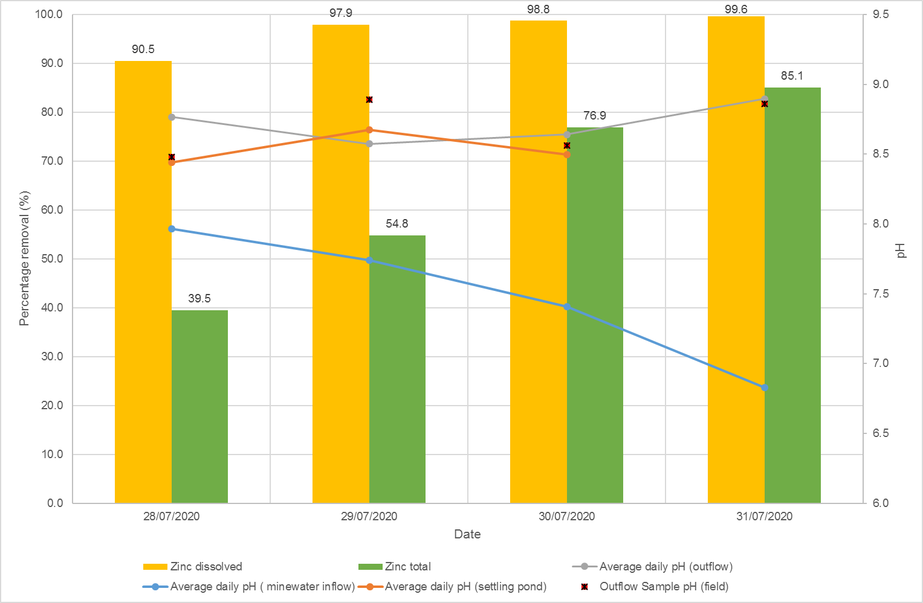
Figure 34 Zinc removal and field pH measurements
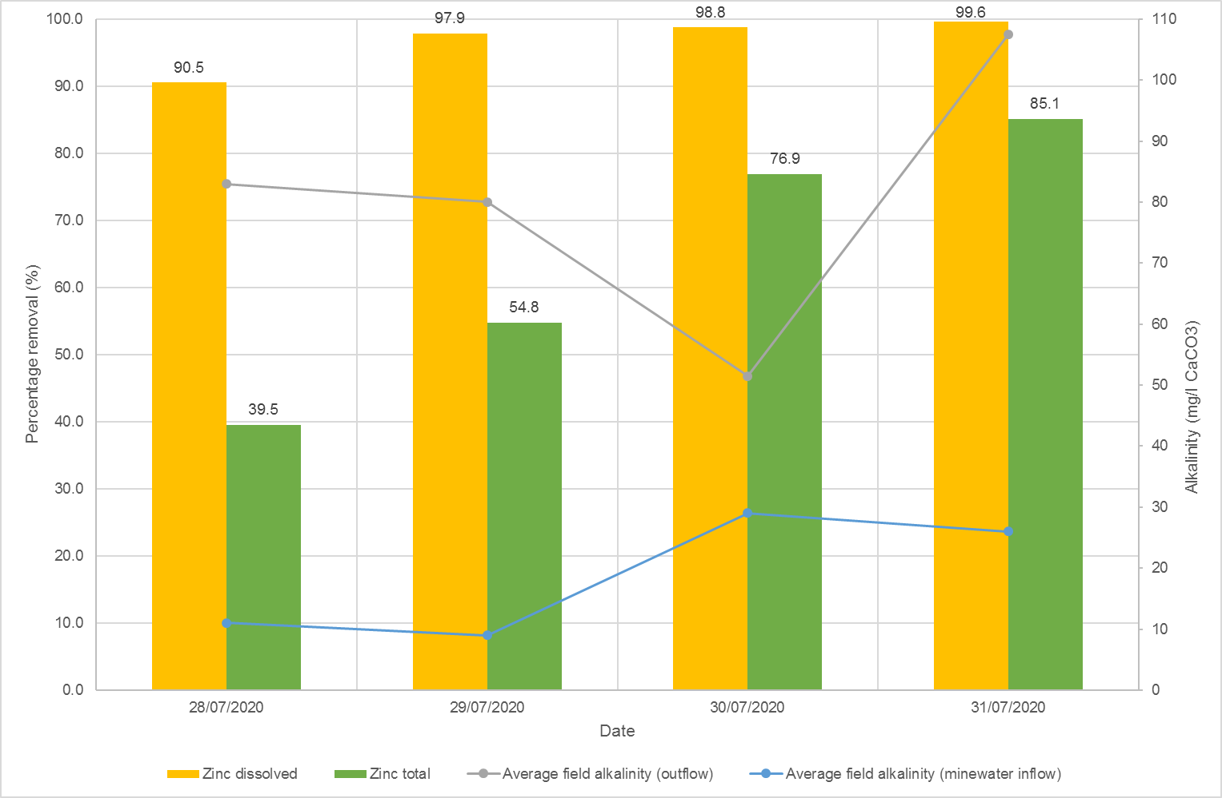
Figure 35 Zinc percentage removal and field alkalinity
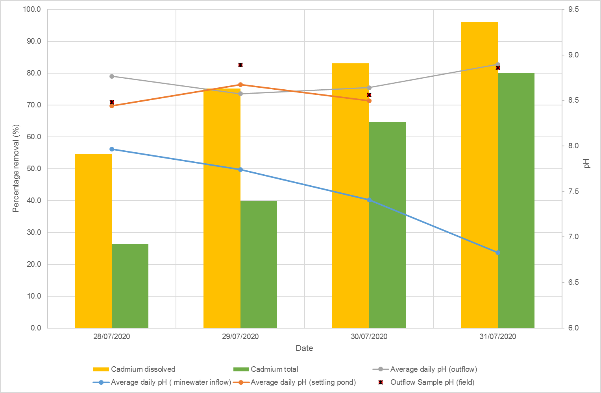
Figure 36 Cadmium percentage removal and field pH
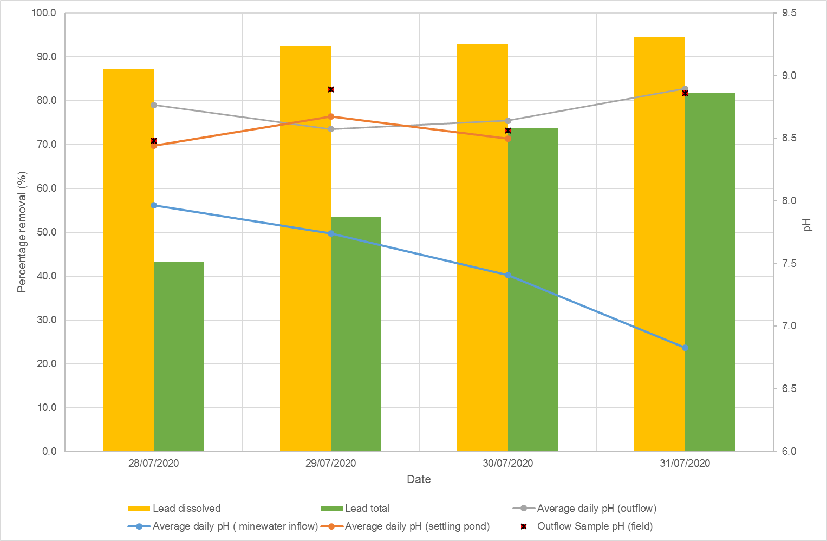
Figure 37 Lead percentage removal and field pH
The geomembrane curtain did not effectively work in the trial. Precipitate formed after the geomembrane curtain in the system (Figure 38). The geomembrane had a pore size of 75 µm. The precipitate may be finer than that, and thus passed through the membrane. It was noted that gas bubbles were forming on the surface of the geomembrane (Figure 39). It was also theorised that changes to the flow (turbulence as it moves through the geomembrane) and a forced change in chemical equilibrium could also be reasons for precipitation occurring at the downstream side of the geomembrane.

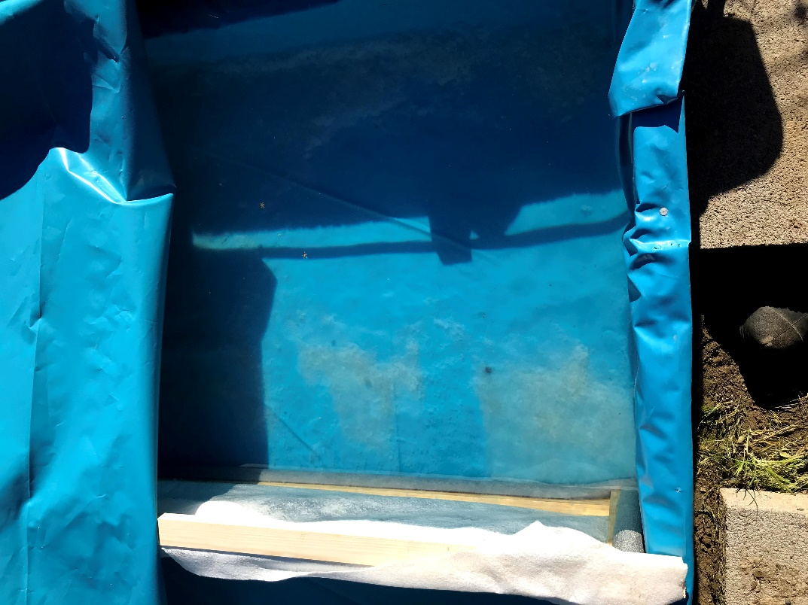
Figure 38 Formation of precipitate after the geomembrane curtain
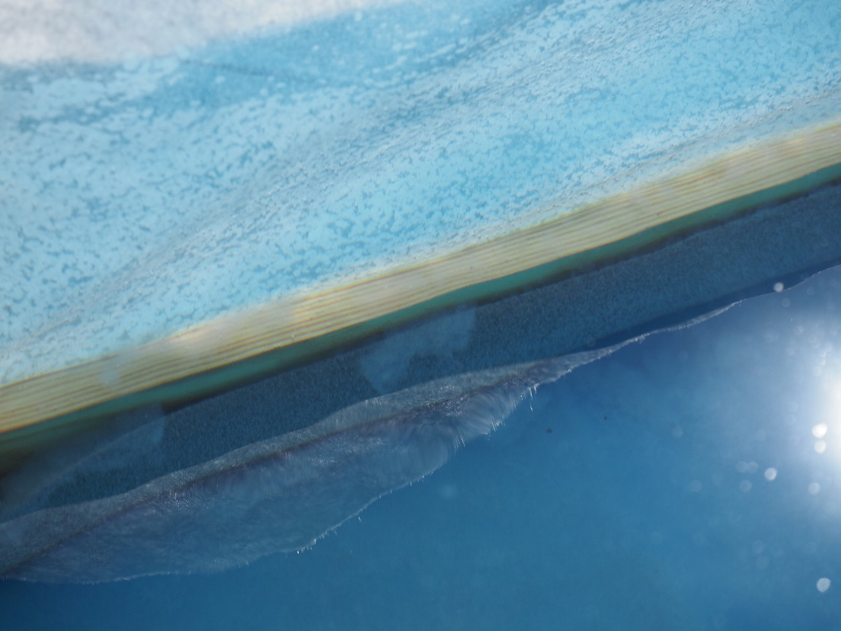
Figure 39 Gas bubble formation at the geomembrane curtain

The precipitate forming in the settling pond was collected as described above in the final day of the July trial. A solid sample of precipitate and a sample of filtrate water was collected from each of the three filtering methods. The results are presented in Table 19 and Table 20. Total zinc was found at around 50% of precipitate from the geomembrane filtered samples and 40% of the sand filter. The lower zinc concentration in the precipitate from the sand filter was thought potentially to be a contamination with some of the sand during collection, however silica is low in all three samples suggesting this is not correct. Total inorganic carbon was less than 1% for each of the samples, slightly lower than found in the March trial.
Lead was found at around 1% within all samples. Some parameters such as iron and calcium were slightly elevated in the sand filter test. A number of parameters such as magnesium, cadmium and aluminium were found in slightly higher concentrations in the July samples compared with the March precipitate sample.
The filtrate water shows that zinc was lost in the filtering process when using the two geomembranes. The high total zinc concentration in the 5 µm poresize geomembrane (143 mg/l) suggests that precipitate must have been collected within that sample. The total zinc recorded in the 25 µm filtered sample is lower, but still around 14 mg/l suggesting zinc precipitate was not trapped within the filtering process. The sand filter worked very successfully, with only 0.1 mg/l total zinc recorded in the filtrate water.

Table 19 Precipitate chemical analysis
Parameter | Unit | March trial | 25µm filter | 5 µm filter | Sand filter
Carbon, Total | % | 1.7 | 1.0 | 0.9 | 0.8
Organic Carbon, Total | % | 0.5 | 0.3 | 0.3 | 0.1
Total Inorganic Carbon | % | 1.2 | 0.7 | 0.6 | 0.6
Sulphate, Total | % | - | 0.159 | - | -
Sulphate, Total potential | % | 0.06 | 0.06 | 0.06 | 0.06
Sulphide, Easily liberated | % | 0.00075 | 0.00075 | 0.00075 | 0.00075
Sulphur, Total | % | 0.01 | 0.01 | 0.01 | 0.01
Water Soluble Sulphate as SO4 2:1 Extract* | % | 0.000113 | - | 0.000105 | 0.000152
Aluminium | % | 0.187 | 0.371 | 0.235 | 0.330
Cadmium | % | 0.0479 | 0.0850 | 0.0844 | 0.0776
Chromium | % | 0.00029 | 0.00015 | 0.00016 | 0.00017
Copper | % | 0.0133 | 0.0072 | 0.0072 | 0.0068
Iron | % | 0.16 | 0.10 | 0.12 | 0.22
Lead | % | 1.5 | 1.1 | 1.1 | 1.0
Manganese | % | 0.00567 | 0.00844 | 0.00845 | 0.00993
Zinc | % | 46 | 53 | 56 | 40
Calcium | % | 0.15 | 0.25 | 0.25 | 0.32
Magnesium | % | 0.026 | 0.123 | 0.127 | 0.125
Potassium | % | 0.0187 | 0.0103 | 0.0100 | 0.0129
Silica | % | 0.0005 | 0.0002 | 0.0001 | 0.0001
Sodium | % | 0.06 | 0.11 | 0.06 | 0.10
*assuming density of 1 litre=1000g
Values in bold italic are below detection limits

Table 20 Filtrate water chemical analysis
Parameter | Units | 25 µm filter | 5 µm filter | Sand filter
Alkalinity total as HCO₃ | mg/l | 171 | 390 | 146
Cadmium (Diss) | mg/l | 0.00126 | 0.00132 | 0.00004
Cadmium (Total) | mg/l | 0.02360 | 0.25700 | 0.00025
Calcium (Total) | mg/l | 11 | 12 | 17
Chloride | mg/l | 11 | 12 | 12
COD, unfiltered | mg/l | 35 | 52 | 13
Hardness, Total as CaCO₃ unfiltered | mg/l | 41 | 45 | 44
Iron (Diss) | mg/l | 0.0095 | 0.0095 | 0.0095
Iron, Ferric | mg/l | 0.025 | 0.025 | 0.025
Iron, Ferrous | mg/l | 0.05 | 0.05 | 0.05
Lead (Diss) | mg/l | 0.024 | 0.025 | 0.001
Lead (Total) | mg/l | 0.23 | 2.27 | 0.01
Magnesium (Total) | mg/l | 3.6 | 3.9 | 0.5
Manganese (Diss) | mg/l | 0.0015 | 0.0015 | 0.0015
pH | pH Units | 9.4 | 9.3 | 9.3
Potassium (Total) | mg/l | 1.9 | 1.6 | 4.3
Silica | mg/l | 1.25 | 1.25 | 1.25
Sodium (Total) | mg/l | 72 | 72 | 59
Sulphate | mg/l | 44 | 44 | 46
Suspended solids, Total | mg/l | 23 | 239 | 12
Zinc (Diss) | mg/l | 0.17 | 0.17 | 0.02
Zinc (Total) | mg/l | 13.2 | 143.0 | 0.1
Bold italic values at half of detection limits

A settling test was completed on the precipitate collected from the March trials. A volume of 90 ml of the March precipitate was used in the test, where 230 ml deionised water was added to a graduated cylinder. The contents were stirred to suspend all of the precipitate and left to settle. Photos were taken as the precipitate settled, and recorded in elapsed seconds. If the particle size of the precipitate is similar, it would have taken around 4 minutes for the precipitate to settle to the 35 mm depth recorded during the sand filtration test. A picture of the settling test and the precipitate settling curve are presented in Figure 40 and Figure 41.

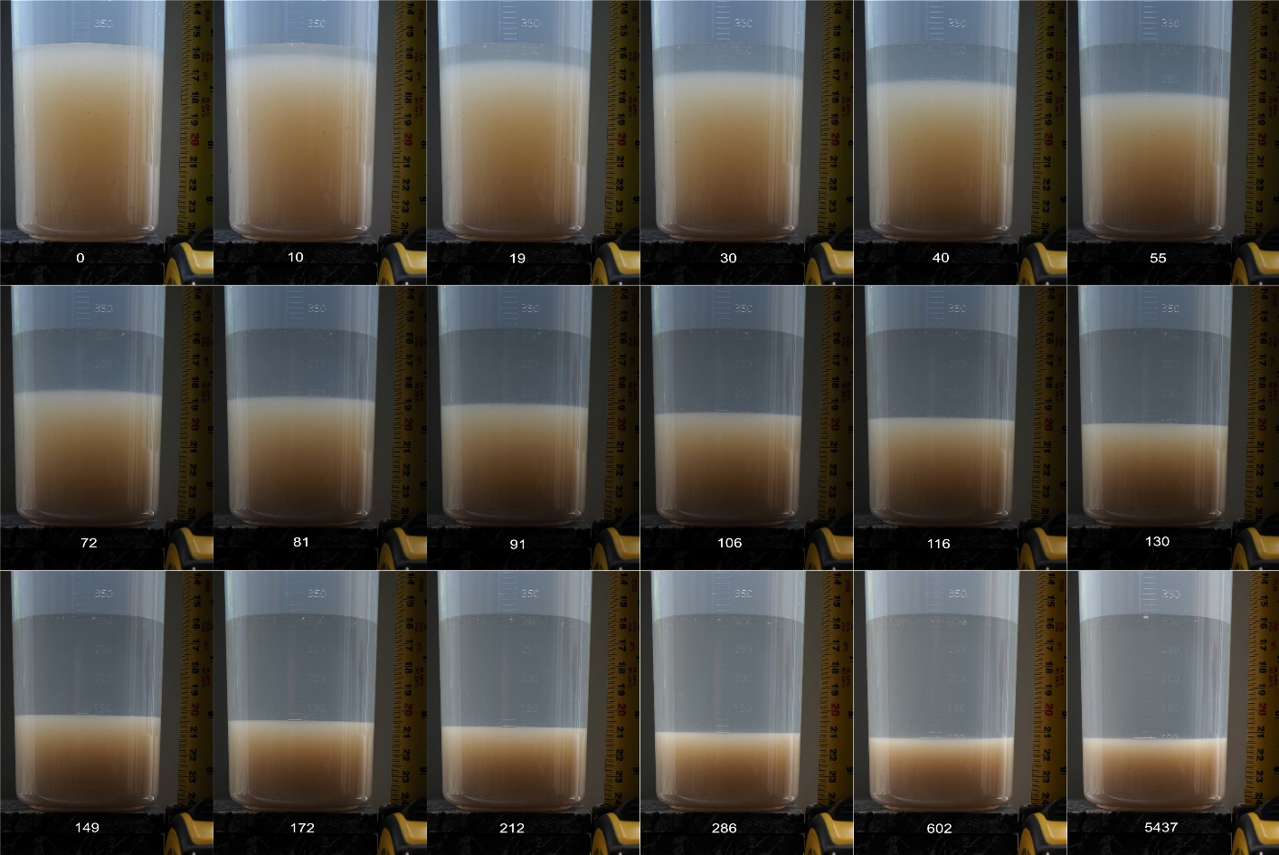
Figure 40 Timelapse (in seconds) photographs of precipitate settling test
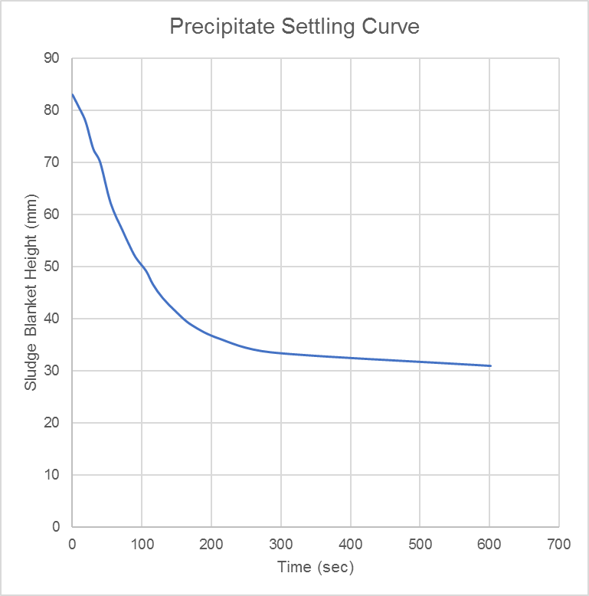
Figure 41 Precipitate settling curve

Trial 3 – additional limestone gravel as a cover material mixes
As described for Trial 3 previously a number of mixes between a simulated runoff (gravel influenced deionised water) and mine water were completed to investigate if runoff from the gravel produces any additional removal of zinc other than just dilution. A new gravel influenced water was developed using the same method as before. This was then used in a mix with the mine water in the following ratios:
- 3 litre gravel influenced water : 1 litre minewater
- 3 litre gravel influenced water : 0.25 litre minewater
The field measurements for the gravel influenced water at varied time intervals are presented in Table 21. This table also includes the field measurements for the mine water and the final 1:3 mix and 0.25:3 mix (mine water to gravel influenced water) with gravel influenced water (following 90 minute reaction time for the gravel and deionised water). The field measurements were measured in the mixed water after 30, 60 and 90 minute standing times. A calculation of the measurements under the ratio of mine water and gravel influenced water is also presented.
The laboratory analysis results for the final gravel influenced water, the mine water (as tested for the dosing trial) and the mixes of mine water and gravel influenced water are presented in Table 22. This table also includes a calculation of the predicted mix water given no reaction between the mine water and gravel influenced water, simply a mix of the two waters. This calculation can be used to infer if there is metal removal from mixing the gravel influenced water with mine water, or whether the reduction in metal concentrations in the mix is simply due to dilution.
There is a reduction in cadmium, lead and zinc concentrations in the measured mix as opposed to the calculated mix, suggesting potentially dissolved lead and zinc is being removed by a reaction rather than just dilution of the sample. Even if the pH for the 3:1 mix was lower than pH 8 (although calculated to be higher than this), the pH of the 3:0.25 mix is over 8, and thus closer to the target pH used in the dosing trials.

Table 21 Trial 3 July field measurements
Parameter | Unit | Gravel influenced water |  |  |  | Mine water | Mix 3:1 gravel influenced (90 mins) and mine water |  |  |  | Mix 3:0.25 gravel influenced (90 mins) and mine water
Parameter | Unit | Initial | 30 mins | 60 mins | 90 mins | Mine water | 30 minutes standing time | 60 minutes standing time | 90 minutes standing time | Calculated mix | 30 minutes standing time | 60 minutes standing time | 90 minutes standing time | Calculated mix
pH |  | 9.35 | 9.51 | 9.25 | 9.44 | 7.78 | 7.94 | 7.65 | 7.65 | 8.4 | 8.49 | 8.34 | 8.35 | 8.8
DO | % | 87.1 | - | 69.2 | - | 51 | 85.2 | 84 | 84 | 64.7 | 87.1 | 64.6 | 72.4 | 67.8
Conductivity | μS/cm | 43.5 | 49.9 | 49.3 | 49.7 | 117.5 | 93 | 91.9 | 91.9 | 66.7 | 66 | 64.8 | 66.1 | 54.9
ORP | mV | 5 | 31.3 | 29.4 | 38.1 | 1221.4 | 113.1 | 103.1 | 103.1 | 333.9 | 52.1 | 49.7 | 52.7 | 129.1
Temp | ºC | 16.5 | 16.7 | 16.8 | 16.9 | 13.70 | 17.40 | 18.10 | 18.1 | 16.1 | 17.7 | 18.3 | 19.2 | 16.7
Alkalinity | mg/l CaCO₃ | - | - | - | - | 29 | 60 | 43 | 41 | - | 114 | 88 | 72 | -

Table 22 Trial 3 July laboratory results
Parameter | Unit | Gravel influenced water | Mine water | 3:1 Gravel to Minewater Mix | 3:1 Gravel to Minewater Mix Calculated | 3:0.25 Gravel to Minewater mix | 3:0.25 Gravel to Minewater Mix Calculated
Alkalinity total as HCO₃ | mg/l | 153 | 34 | 28 | 123 | 128 | 144
Cadmium (Diss) | mg/l | 0.00004 | 0.0442 | 0.00598 | 0.01108 | 0.00020 | 0.00344
Cadmium (Total) | mg/l | 0.00025 | 0.0476 | 0.00926 | 0.01209 | 0.00245 | 0.00389
Calcium (Total) | mg/l | 55 | 11 | 26 | 44 | 37 | 51
Chloride | mg/l | 1 | 11 | 3 | 3 | 1 | 2
COD, unfiltered | mg/l | 3.5 | 3.5 | 3.5 | 3.5 | 8.3 | 3.5
Hardness, Total as CaCO₃ unfiltered | mg/l | 139 | 45 | 71 | 115 | 95 | 132
Iron (Diss) | mg/l | 0.0095 | 0.0095 | 0.0095 | 0.0095 | 0.0095 | 0.0095
Iron, Ferric | mg/l | 0.025 | 0.025 | 0.025 | 0.025 | 0.025 | 0.025
Iron, Ferrous | mg/l | 0.05 | 0.05 | 0.05 | 0.05 | 0.05 | 0.05
Lead (Diss) | mg/l | 0.0002 | 0.3120 | 0.0159 | 0.0782 | 0.0021 | 0.0242
Lead (Total) | mg/l | 0.012 | 0.336 | 0.062 | 0.093 | 0.028 | 0.037
Magnesium (Total) | mg/l | 0.6 | 4.1 | 1.4 | 1.5 | 0.8 | 0.9
Manganese (Diss) | mg/l | 0.0015 | 0.0015 | 0.0015 | 0.0015 | 0.0015 | 0.0015
pH |  | 9.4 | 6.8 | 7.7 | 7.4 | 8.8 | 7.9
Potassium (Total) | mg/l | 0.2 | 1.0 | 0.4 | 0.4 | 0.4 | 0.3
Silica | mg/l | 0.3 | 5.9 | 1.3 | 1.7 | 1.3 | 0.7
Sodium (Total) | mg/l | 0.2 | 8.0 | 2.4 | 2.2 | 1.1 | 0.8
Sulphate | mg/l | 6.1 | 45.5 | 16.4 | 16.0 | 9.5 | 9.1
Suspended solids, Total | mg/l | 141 | 1 | 6 | 106 | 88 | 130
Zinc (Diss) | mg/l | 0.0 | 19.2 | 2.8 | 4.8 | 0.1 | 1.5
Zinc (Total) | mg/l | 0.03 | 19.50 | 4.01 | 4.90 | 1.20 | 1.53
Bold italic values are at detection limits

Overall Conclusion and implications for the treatment design
Overall it was found that the treatment trial using sodium carbonate dosing successfully removed zinc and other metals from the Abbey Consols mine water. The trials generated a range of important design information which will be used in the next stage of the project, including:
- The target pH range of between 8.5 and 9 (on average pH 8.7) successfully removed zinc and other metals from the mine water to a greater extent than the initial target of pH 8.4. The dissolved zinc removal rate in the second trial iteration (average pH 8.7) was between 90-99%. The total zinc removal rate was recorded at a maximum of 85% on the final day of the trial (on average 64% over the four days). Lead removal was on average >90% for dissolved lead and around 63% for total lead (again at a maximum on the final day of the trial). Cadmium had an average removal rate of 77% for dissolved cadmium (maximum up to 96%) and 52% for total cadmium (with a maximum of 80%).
- In the July 2020 trials around 12,613 litres of mine water was treated using 320 litres of dosing solution at a concentration of 2.6 g/litre. This equates to around 2.6 g sodium carbonate treating 39.5 litres of mine water. The zinc mass treated during the July trial equates to around 250 grams (both dissolved and total, 250,998 mg). At an average treatment efficiency of 96% the dissolved zinc removed by mass equates to around 240 g over the July 2020 trial. For total zinc at a treatment efficiency of 64% around 160 g of zinc mass is removed. The sodium carbonate mass was 832 g.
- Protection from wind and rainfall also helped with turbulence within the temporary settling pond, increasing the removal efficiency in the second trial.
- The trials confirm that to recover the precipitate following the dosing treatment a filtering system will be required to separate the fine precipitate that forms from the treated mine water. The sand filter used in the July 2020 trial worked more effectively than the geomembrane socks which seemed to allow precipitate through the pores on all sizes. The water content was effectively reduced to a point, but any further dewatering may depend on evaporation in the full-scale trials. The removal of sludge needs to be considered in the pond design.
- The precipitate formed contains almost 50% zinc, and is suspected to be hydrozincite. Within the July 2020 trial the efficiency of zinc removal increased each day and it’s thought to be moving from a homogenous precipitation within the water column towards a heterogenous precipitation that settles more readily (i.e. as the system stabilises). The design needs to consider if a drop in pH could re-dissolve the precipitate forming. It is thought that longer-term a more stable zinc carbonate may form, potentially smithsonite. It is also thought that seeding may help the efficiency of the system. Further research should be undertaken into both the form of the precipitate and the stability at larger-scale over a longer time period.
- The design of the treatment system should also consider the potential scaling effect on the system. In particular, the pH probes to be used, the number in the system and their placement need to be considered. This may include looking at technology which cleans the pH probes to prevent scaling to ensure accurate measurement of the pH for the dosing control process.

