This template is intended to be used in conjunction with a Band 1 Marine Licence application. Please complete each section below following the guidance provided (max 500 words per section). For any queries relating to this template please contact: marinelicensing@cyfoethnaturiolcymru.gov.uk

Summary
Please provide a brief summary of the application including location of the works (coordinates - lat/long, decimal degrees). For activities that cover a large area please provide coordinates of the approximate extent of works.

This application is in addition to CML2038 to support proposed works at the Kidwelly Viaduct, Carmarthenshire, Wales NGR 239873 206620, Lat: 51.73536027, Long: -4.32031493 (Figure 1). The viaduct is located on the South Wales Main Line (SWM2 234m 40.25ch/886yds).
The Site comprises a rail viaduct constructed of stone, brick and steel. The activities to support refurbishment of the viaduct comprise;
- The installation of scaffolding walkways and working platforms on the viaduct;
- Grit blast steel work;
- Masonry and steelwork repairs and repainting works; and
- Replacement of ballast and hand rails.

It is estimated that the preparatory surveys will start in September 2020. Main works will be from December 2020 through to the end of 2021, the scaffold first install date will be December 2020 and last scaffold shift will be July 2021.

The site lies adjacent to the Carmarthen Bay and Estuaries / Bae Caerfyrddin ac Aberoedd Special Area of Conservation (SAC) and Pembrey Coast / Arfordir Pen-bre Site of Special Scientific Interest (SSSI) where the location of the works, plant, welfare and access routes will be located.

The Site is within the Loughor to Penllergaer Railway Line Site of Importance for Nature Conservation (SINC).

Scope of works
Please provide a full description of all proposed works including:
- Sequence of works (mobilisation, marine works, site remediation (if required))
- Estimated timing of works (duration, working hours, day/night, plus contingency)
- Plant, machinery or vessel required
- Estimated quantities (removals, deposits, construction materials)
The sequence of works will be as follows:
- Site preparation works, including vegetation clearance necessary for access. Clearance will be minimal and limited to around the wing wall of the viaduct to remove the vegetation to allow the pointing of the wing walls, also localised strimming of the grass/flora for safe access beside the railway onto the structure.
- Establishment of site compound at junction of Quay Road and Station Road.
- Construction of an elevated plant laydown area on the south-west side of the viaduct (Figure 3 and design drawings 152092-CGE-DWG-000007 & 000100). Please note, the laydown area north-west of the viaduct noted on Figure 2, will NOT be used.
- Diversion of existing pedestrian access to the station platform
- The scaffolding for Span 1, 2 and 3, will be underslung, Span 4 will be propped from below. Approximately 170 scaffold poles will be required. Timber sole boards (0.7x0.4m) will be used as sole plates under each pole. The scaffolding will be erected by trained and competent scaffolders.
- Forecast tide levels will be regularly reviewed and works to erect the scaffold will be undertaken during times of low tide.
- A safety boat will be in attendance on the Gwendraeth Fach River during the erection of scaffold to the viaduct.
- Once all scaffold has been erected an air extraction system and encapsulation sheeting in sections will be installed and the final seal of the scaffold completed.
- The scaffold access and encapsulation in sections will enable the viaduct to be grit blasted and masonry and steel work repairs to be undertaken, as well as the application of new paint to the bridge steelwork.
- Once scaffolding and encapsulation works have been completed, then commence grit blasting and priming of all accessible areas.
- Preparation and painting of the underside of the structure under the operational railway lines will be completed in day time low tide conditions.
- Repointing works will be undertaken throughout the viaduct abutments and retaining walls, accessed via the scaffolding.
- The existing mortar will be mechanically raked out from the abutments and retaining walls to the specified depths and refilled with suitable mortar.
- Carry out inspection of the grit blasted steelwork and agree extent of remedials and any additional repairs as necessary.
- Steelwork repairs will be carried out via the access scaffold, including:
  - Rivet replacement using a rivet buster, following the ‘one out/one in’ process
  - Cracked angle and feather edge repair;
  - Bottom flange repairs; and
  - Caisson repair straps.
- There may be a requirement to lower the material works down from the caissons into a small boat in the river and transport away back to Kidwelly jetty.
- Priming and final painting of the steelwork using an approved NR paint system.
- All steelwork will be inspected/surveyed to determine the full extent of the steel repairs required.
- The existing ballast boards and ballast will be removed and replaced.
- The existing steel handrails will be unbolted and taken down and then new Kee Klamp handrailing will be installed.

Access and working areas
Please provide details of access to the site and working areas. This should include:
- Attached map of the access/egress route and worki ng areas (annotated aerial image and/or OS map)
- Predicted plant/vehicle movements
- Storage areas for plant, equipment and materials (if required)
- Risks to navigation

Access to the upline side of the station platform will be diverted to the rear of the platform; Site offices / welfare facilities and a plant / equipment store area to deliver the project will be located at the station.

Equipment will be transported via Road Rail Vehicle (RRV) (on track plant) and positioned onto the elevated laydown area (please see Figure 3 below and attached design drawings). All vehicle movement will be rail vehicles only, it is not planned that any other vehicles in the area highlighted will be used.

Timber sole boards (0.7x0.4 m) will be used as sole plates under the poles supporting the elevated laydown area.

All plant and protection will be removed and re-positioned in the laydown area before the tide comes back in.

Where possible, plant and equipment (generators, compressors, paint mixers) will be set up in the main railway station compound and will be run over to the viaduct through lines and hoses. Small generators will be required on the scaffolding, these will be placed in recess areas across the scaffolding. These will require refuelling in-situ, using 5 litre cans. Carrying the equipment off the structure to refuel would increase health and safety risks with manual handling, slips, trips and falls. There will be a designated refuelling area with drip trays, spill kits, training of staff etc.

A decontamination unit will be positioned on the wide embankment (trackside) on the South East side of the viaduct for personnel cleaning when coming out of the encapsulation. This unit will be delivered via RRV.

The vessels to be used (safety boat and material boat) will be launching and recovering from the jetty at Kidwelly Harbour. Boat will be going up the mouth of the river circa 100 m west (up river) from the structure to anchor whilst works are going on

An emergency access route has been planned for the East Viaduct (see Figure 2).

Environmental mitigation
Please list appropriate mitigation measures to minimise impacts on the marine environment these may include:
- Pollution prevention and control procedure (guidance available at: http://www.netregs.org.uk/media/1304/gpp-5-works-and-maintenance-in-or-near-water.pdf)
- Spill response kits
- Minimise plant traffic
- Designated access and egress routes
- Storage of materials (fuel, chemicals, construction waste)
- Biosecurity (guidance available at http://www.snh.gov.uk/docs/A1294630.pdf)
Note: To assist you, the following mitigation statements will be used as conditions within the licence. By signing this method statement you will be agreeing to adhere to these restrictions. If you are unable to do this, the application will not qualify as Band 1.
- All equipment, temporary structures, access tracks, waste and/or debris associated with the works will be removed on completion of the works.

- Bunding, storage facilities and spill kits will be employed to contain and prevent the release of fuel, oils and chemicals associated with the plant, refuelling and construction equipment into the marine environment.

- Plant, vehicles and machinery will not be refuelled on the foreshore.

- Coatings and treatments will be suitable for use in the marine environment and are used in accordance with best environmental practice.

- All equipment, materials, machinery and PPE used will be in a clean condition prior to their arrival on site, and upon removal from site, to minimise risk of introducing non-native species into the marine environment.

In the event of removal of any sensitive species or habitat designated by NRW under Schedule 7 of the Environment (Wales) Act 2016, no further removals will occur at that location or within 20m of that location.
Please list your bespoke mitigations here:
- The works will be managed in accordance with a Construction Environmental Management Plan.
- Bio Oil will be used for all plant and machinery (except RRVs). RRVs will be refuelled at the site compound (at the station) in a designated area with spill kits and drip trays.
- A spill response contractor will be in place.
- For small generators on the viaduct, there will be a designated refuelling area with drip trays, spill kits, training of staff etc.
- The scaffolding to be erected underneath the viaduct will avoid sensitive saltmarsh habitat. Supporting poles will be installed on sole boards to protect the estuary bed. Approximately 170 (0.7x0.4m) boards will be required covering approximately 47.6m²
- The scaffolding laydown area will be elevated (see attached design drawings 152092-CGE-DWG-000007 & 000100) and avoid sensitive saltmarsh habitat. Approx. 50% of the laydown area will be within the SAC boundary (approx. 120m²). The elevated platform will be supported by poles, installed on timber sole boards. Each board will be 0.7 x 0.4 m and there will be approximately 95 boards within the SAC boundary, affecting up to approx. 26.6m² of SAC habitat. This habitat is identified on NRW mapping as ‘Estuaries’.

- A survey will be carried out before installation to confirm and after the works have been completed, to monitor to ensure that the habitat is recovering and to identify any requirement for reinstatement.
- All plant and protection will be removed and re-positioned in the laydown area before the tide comes back in.
- Where possible, plant and equipment (generators, compressors, paint mixers) will be set up in the main railway station compound and will be run over to the viaduct through lines and hoses.
- All fuels will be kept away from the structure, within the compound.
- During the grit blasting activities, the scaffolding will be double boarded to prevent the risk of contaminates grit dropping through the scaffolding to the ground below.
- Marine safe concrete / grout will be used for repairs to the viaduct structure only and will not be deposited on the seabed.
- A cantilever section of the scaffolding will be constructed. The purpose of this to ensure that all small plant (handtools), air hoses, extractor fans, power leads are stored in this area of the viaduct. Any small tools and generators required, these will also be stored here.
- There will be temporary diverting pedestrian station access so that members of the public can’t access through the storage area/ compound.
- Works will be concentrated to the viaduct, which access is not permitted to members of the public, creating a sterile zone in itself.
- The maintenance of navigational safety, including marking and lighting of works information will be developed through the design phase, but it is evident that the headroom clearance under the bridge will be compromised by the temporary works scaffolding. Exactly by how much will be determined by the temporary works design, which will also include relevant signage for navigation.
- Site lighting during night-time works would be minimised and where required would be designed to minimise light-spill onto the woodland and scrub.
- All fine particulates from blasting will be retained and that no fine particulate debris will be added to waterway. The scaffolding will also be double boarded on the crash deck of the scaffolding to prevent materials form dropping through. Fine particles from blasting are all captured and disposed of adequately.
- Scaffold areas that are within the hide tide zone where grit blasting works are being carried out will be fully cleaned and the temporary encapsulation removed at the end of the shift, prior to the high tide.
- Prior to the high tide, the double boarded deck will be lifted to allow the water to rise and pass through.
- When the high tide comes in and rises within the scaffold works area, the works area will be fully inspected prior to the commencement of the next works shift. Any defects to the installed scaffold will be rectified prior to commencement of works.
- The scaffold will be cleaned to remove any high tide debris and encapsulation reinstated prior to the commencement of the works shift.
- A bat survey will be carried out prior to works commencing to check suitability of the viaduct for bats. If roosting bats are identified during the survey, an application to NRW for a European Protected Species (EPS) mitigation licence will be made. If no roosting bats are identified they are likely to be absent from the structure and no mitigation would be necessary. In the unlikely event that bats are found during the works, all works will stop immediately and a qualified bat ecologist contacted.
- Efforts will be made to ensure that any objects or personnel suspended from the bridge is properly secured so as not to pose a hazard to safety of marine users transiting below.

Additional Information
Please list any additional information that may help with the application:
- Consents/permissions required
- List of plans or drawings attached to method statement
- Emergency procedures
- Contact details
MCA Consent
See attached correspondence

Drawings/plans (see below)
- Figure 1 Site location and boundary

- Figure 2 Site Access emergency routes, walking routes, scaffold lay down area, welfare area and Plant/ Equipment location area.

- Figure 3 Elevated scaffolding laydown area

- Figure 4 Map to show public access, works footpath and work areas

- Figure 5 Areas of vegetation clearance

- Scaffold encapsulation section plans

Emergency Procedures
Emergency access route is shown in Figure 2.

Contact Details
Applicant: Peter Caulfield (Network Rail) peter.caulfield@networkrail.co.uk
Contractor: Hannah Breen (Centregreat Rail) hannah.breen@centregreat.net;
Dan Parry (Centregreat Rail) dan.parry@centregreat.net

- Customer details

Signature:

Full name: Hannah Breen

Organisation name (where appropriate): Centregreat Rail Ltd

Contact e mail: hannah.breen@centregreat.net

Contact phone number: 07887 718347

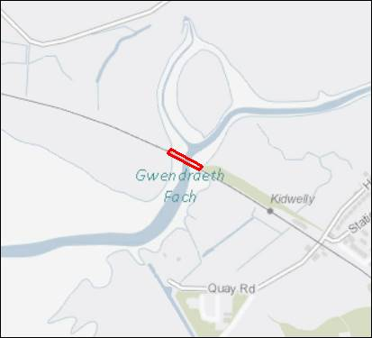
Figure 1 Site location and boundary
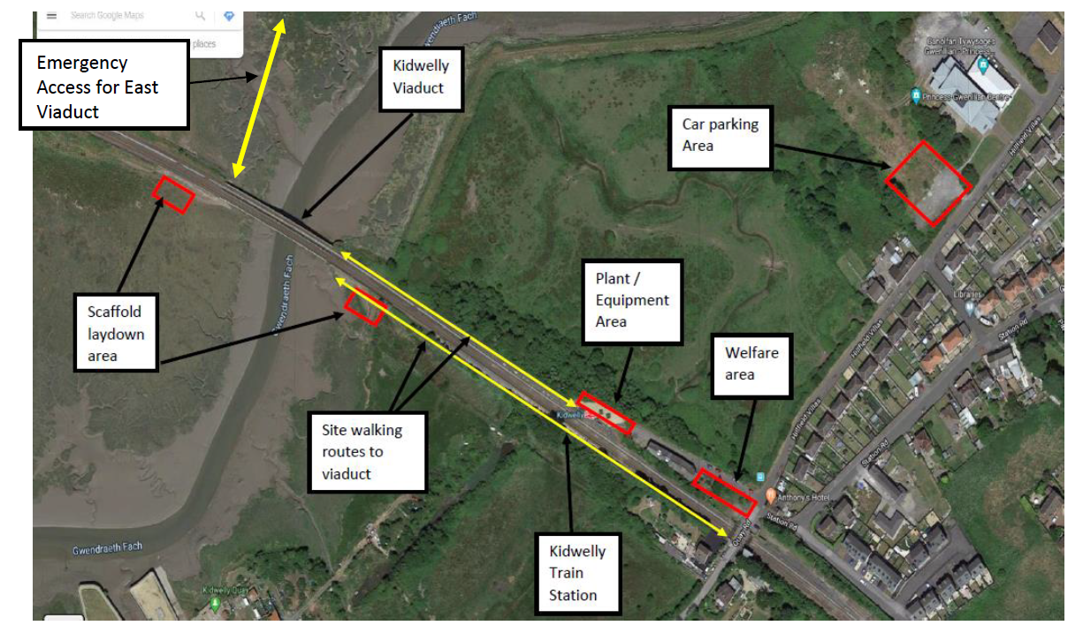
Figure 2 Site Access emergency routes, walking routes, scaffold lay down area, welfare area and Plant/ Equipment location area.
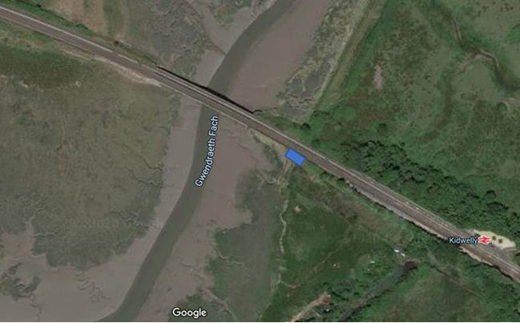
Figure 3 Elevated scaffolding laydown area location.

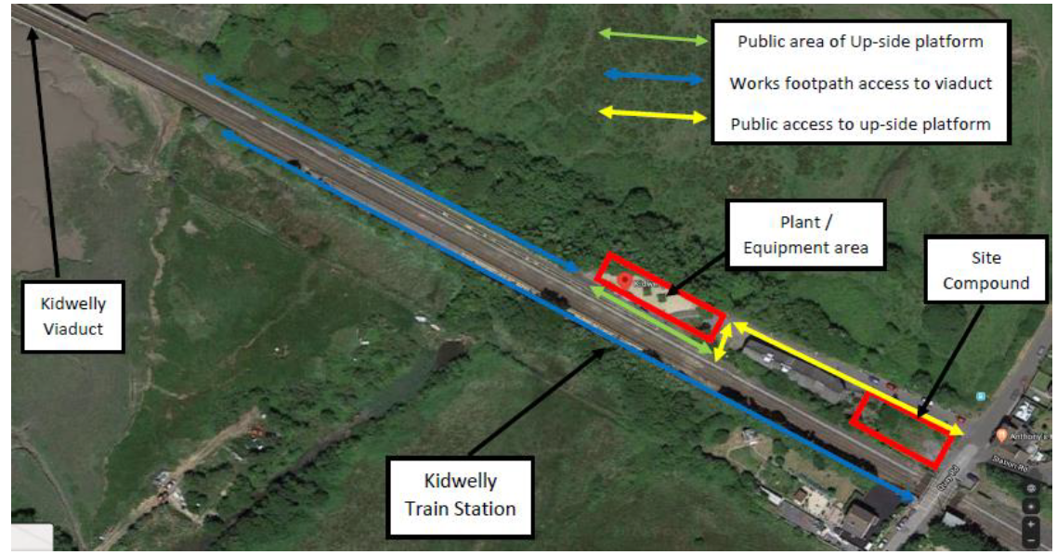
Figure 4 Map to show public access, works footpath and work areas
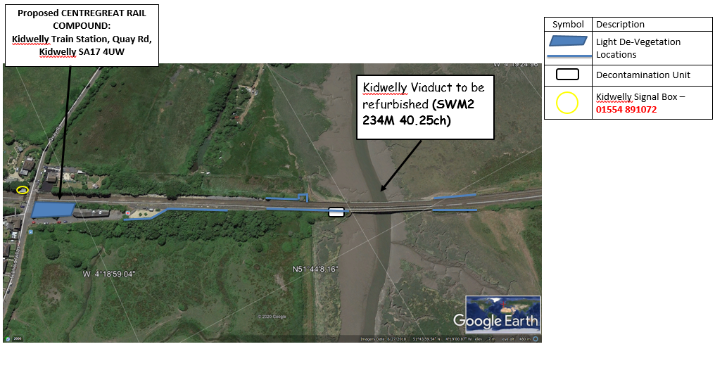
Figure 5 Areas of vegetation clearance

Scaffold encapsulation section drawings



