Details
Deployment Reference Number: | PAN-010713
Permit Reference Number: | EPR-AB3891CX
Permit Holder: | Stepside Agri
Site Address: | Hafod Farm  Ferwig  Cardigan  Ceredigion  SA43 1PU
Grid Reference: | Farm location: SN 18094 50342  Fields:  Hafod Farm  Tyriet 1 SN 18066 50822  Tyriet 2 SN 18005 50957  Tyriet 3 SN 17876 50863  Tyriet 4 SN 17898 50624  Tyriet 5 SN 17874 50710  Tyriet 6 SN 17721 50455  Tyriet 7 SN 17679 50597  Hafod 2675 SN 18257 50747  Nant Y Croi Farm  15 SN 18209 50894  Trefwtial  Land at Rhosygadair 3 SN24464 50006  Land at Rhosygadair 4 SN 24247 50153  Land at Rhosygadair 5 SN 24339 50241  Land at Rhosygadair 6 SN 24418 50292  Land at Rhosygadair 7 SN 24616 50113  Castell Malgwyn Farm  8440 SN 21858 42394  2301 SN 22246 42001  Storage:  SN 18155 50376  SN 18100 50729  SN 22136 43107  SN 22133 41942  SN 24252 50344

Administrative Checks- by permit support officer
 | Comments
Consultation | Waste reg team: South West and Mid  wasteregulation.swwales@cyfoethnaturiolcymru.gov.uk  CeredigionEnvironmentTeam@cyfoethnaturiolcymru.gov.uk  Environment team: Ceredigion and Pembrokeshire  CeredigionEnvironmentTeam@cyfoethnaturiolcymru.gov.uk  pembsdistrictteam@cyfoethnaturiolcymru.gov.uk  NLO: Malcolm Dines  Malcolm.Dines@cyfoethnaturiolcymru.gov.uk  Archaeological trust: Dyfed  a.pyper@dyfedarchaeology.org.uk
Date due: | 02/07/2020
Are fields on Anglesey? If yes, then send application. | N/A
Permit compliance rating and multiplier | Rating A- 100%

Administrative Checks- by determining permitting officer
Item | Action completed, or document provided? (Yes, No or n/a) | Comments
Is the base permit still live?  Has there been any variations we need to be aware of? | Y
Correct application form | Y
Correct fee | Y | See permit compliance multiplier above and Charging Scheme page 43
Fee on MyNRW | Y | Amount: £1018  Date cleared on MyNRW:12/06/2020  Transaction number: 2078096
Location map | Y
Waste Analysis | Y
Soil Analysis | Y
Certificate of Agricultural Benefit | Y
Site Specific Risk Assessment | Y | High risk location only

Application Form | Y N n/a | Comments
4a Multiple deployments Qu answered? | Y | Single deployment
4b1 Has the NCP name and contact information been given? | Y
4c Is the risk banding correct? | Y
4d/4e Does the operator need to provide a risk assessment? | Y
4f Has all of Table 2- waste types been completed? | Y
4f Are the wastes listed in the deployment specifically listed in the permit? | Y
4f Can you verify the waste producer (source of waste) is correct in terms of production, coding and description? | Y | Tools used: own knowledge from previous deployments
4g1 Does the farm address match the grid reference? | Y
4g2 If it is agricultural land; has the holding number been given? | Y | 55/226/0027 Not checked
4h Has all of Table 3- parcels of land been completed? | Y | Separate sheet
4h Is the total area of land to be treated less than 50 ha, or 100 hectares for a single continuously managed area of land? | Y | 50 ha
4g/4h Is the land to be treated within a 10 miles radius of the main address? | Y
4i Has consent been given to carry out the activity? | Y
4k Has all of Table 4- previous land treatment been completed? | Y | PAN-005436  Expired 12/06/2020
4l Has all of Table 5- waste storage details been completed? | Y
4l Is the storage given no more than 1250 tonnes shall be non-stackable waste, and no more than 3000 tonnes of all other wastes? | Y
6b/6c Have both Table 6 and Table 7 been completed? | Y
8 Has confidentially been claimed? | N
8 Has national security been claimed? | N
9a If signing on behalf of a relevant person, has written confirmation from a relevant person been given? | Y
9b Has the operator confirmed they will comply with the conditions of the rule set? | Y
9c Has a relevant person or approved person (Qu 9a) signed the declaration? | Y

Location | Y N n/a | Comments
Has determining officer completed MyMap screening report? | Y
Do the grid references match the site plan? | Y
If there is storage; do the grid references match the site plan? | Y
The map must include the following details in relation to both storage and spreading
(TGN 8.01, box 3.1)
surface water courses  (permit condition: no spreading within 10 meters)  (buffer zones needed) | Y | Noted as being marked in blue but are not marked on the map in blue. Visible as grey lines on maps provided.
groundwater source protection zones  (permit condition: no spreading in SPZ1)  (high risk deployment if in SPZ2) | n/a
any well, spring or borehole used for the supply of water for human consumption including from a private water supply or supplies.  (permit condition: no spreading within 50 meters) | n/a
location of all storage sites for the waste to be spread | Y
any spring, well or borehole not used to supply water for domestic or food production purposes within 50m  (shown on map) | Y
any spring, well or borehole used to supply water for domestic or food production purposes within 250m  (shown on map) | n/a
any European designated sites- Natura 2000 (SPA, pSPA, SAC or cSAC) or Ramsar- or SSSI within 500m  (shown on map) | Y | West Wales Marine / Gorllewin Cymru Forol is just outside the 500m.  Screening in:  Aberarth – Carreg Wylan SSSI  Cardigan Bay/ Bae Ceredigion SAC  Caeau Crug Bychan, Ty Gwyn A Llwyn Ysgaw SSSI
location of any public rights of way  (shown on map)  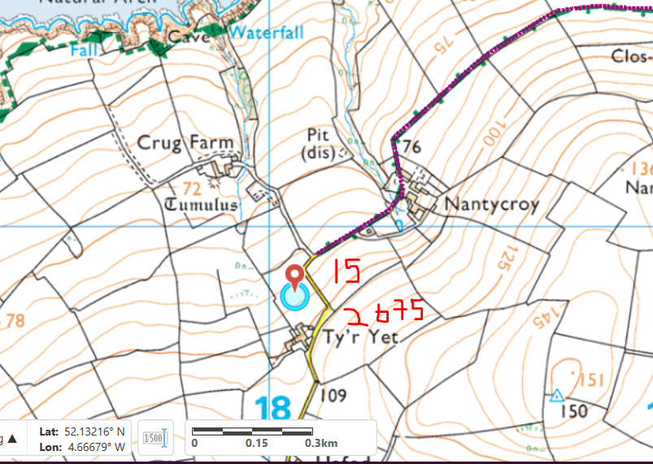  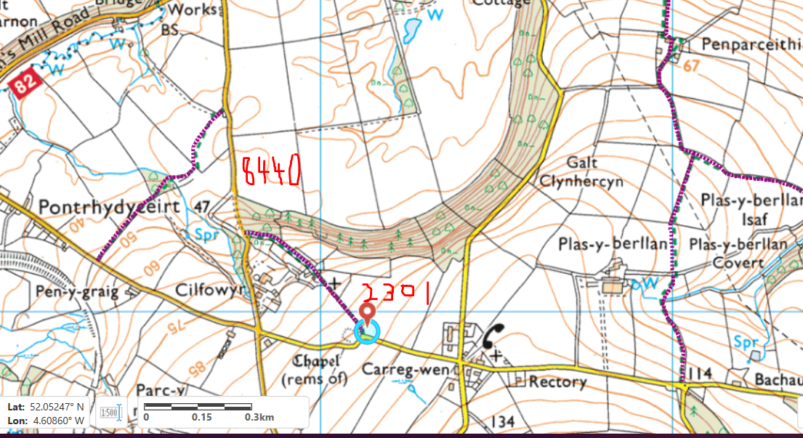  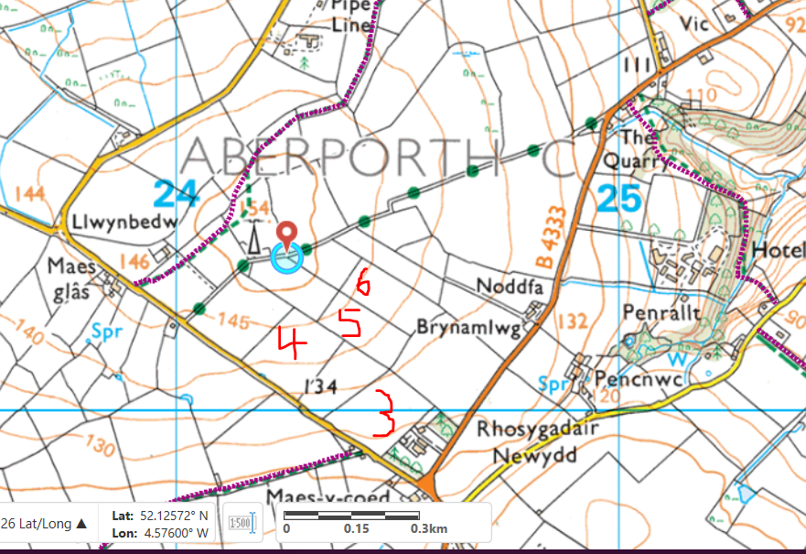 | N | Not marked - RFI
any buildings or houses within 250m  (shown on map) | Y
the location of any other designated environmentally sensitive sites within 500m. Including but not limited to:  - Protected Species  - Protected Habitats  - Scheduled Ancient Monument  - Local Nature Reserve  - National Nature Reserve  - Ancient Woodlands  - Local Wildlife Sites (SINC)  - National Park  - Nitrate Vulnerable Zone (NVZ)  - Groundwater Safeguard Zone  - Hedges  - Ditches | Y | 2301 – borders lowland dry acid grassland and lowland calcareous grassland, a plantation on ancient woodland site and a restored ancient woodland site.  2675 – borders lowland dry acid grassland and lowland calcareous grassland

Waste Analysis | Y N n/a | Comments
Is the waste analysis report less than 12 months old at time of application? | Y
Does the analysis include the following?
- pH | Y
- Nitrogen (N) | Y
- Phosphorus (P) | Y
- Potassium (K) | Y
- % dry matter | Y
Does the analysis include the following?
If it is a required parameter for the waste (see section below) and has not been tested for; has adequate justification been provided?
- Zinc | Y
- Copper | Y
- Nickel | Y
- Lead | Y
- Cadmium | Y
- Mercury | Y
- Magnesium | Y
- Sodium | Y | Not in all analyses but not required.
- Sulphur | Y
Check Appendix A of TGN 8.01 for the wastes types applied for.
- Are there any special testing requirements? | Y | Aluminium, iron
- If yes; have they been tested for? | Y
If spreading waste soil, has the analysis been carried out at an MCERTS Lab? | n/a
If the spreading is in a groundwater safeguard zone (permit condition 2.1.8); are any wastes “high readily available nitrogen wastes”? i.e. organic wastes in which more than 30% of the total nitrogen content is available to the crop at the time of spreading. | n/a
- If yes, have they stated condition 2.1.8 of the permit will be complied with? | n/a

Soil Analysis | Y N n/a | Comments
Is the soil analysis report less than 4 years old at time of application? | Y
Does the analysis include the following?
- pH | Y
- Potassium (K) | Y
- Phosphorus (P) | Y
- Magnesium (Mg) | Y
If the waste analysis shows high PTE’s; have these been tested for in the soil? | Y
Have the soil indices for P, K and Mg on each field been given? | Y
Does analysis show that the soils are deficient in the nutrients or properties required by the proposed cropping? | Y

Benefit Statement | Y N n/a | Comments
Does the writer of the benefit statement have appropriate technical expertise? (TGN 8.01 6.1) | Y
Does the activity meet the definition of recovery? (TGN 8.01 6.2)
- Is there a clear benefit from the activity? | Y
- Is the material suitable for its intended use? | Y
- Is the minimum amount of waste being used to achieve the intended benefit? | Y
- Is the waste being used as a substitute for a non-waste material? | Y
- Will the proposal be completed to an appropriate standard?  NOTE: For this activity, the standard is the deployment application that has been assessed and approved. Any deviation from this which has not been agreed is likely to be viewed as disposal. | Y
Benefit should be assessed against the following criteria. If the chosen benefit, has information been given on? (TGN 8.01 6.3)
- Plant nutrient requirements | Y
- Timing of application | Y | Not specific - RFI
- Amount of waste to be applied and application rate | Y
- Soil chemical properties (e.g. liming and pH) | n/a
- Soil physical properties (e.g. organic matter and soil structure) | Y
- Soil water content | Y
- Levelling the land | n/a
If an operator wants to apply more nutrients than is recommended in RB209 have they? (TGN 8.01 6.3)
- Justified the nutrient level with appropriate technical expertise | n/a
- Included the nutrient level in their environmental risk assessment | n/a
- Stated the source of information that they used to set the nutrient level. | n/a
Have any potential negative impacts of the activity been addressed?  (TGN 8.01 6.5) | Y
Is the application rate appropriate (i.e. not be applied in excess of crop or soil need as this may not meet the principles of waste recovery) in terms of? (TGN 8.01 6.7)
- Waste type | Y
- Waste analysis | Y
- Crop nutrient requirements | Y
If multiple wastes are being mixed: (TGN 8.01 6.8)
- Does each waste confer benefit in its own right? | n/a
- Is it only for operational purposes? | n/a
- Have individual application rates for each waste been given? | n/a
- If mixing ratios have not been given, is there a statement saying that the highest limiting parameter will be used as the maximum application rate allowed to be spread, i.e. the waste will be spread at the lowest application rate. | n/a
Application of waste (TGN 8.01 6.10)
- Is method of application appropriate for the waste type and cropping? | Y
- Is the timing of application appropriate? | Y
- Have they stated when the waste will be spread? | N | RFI – not specific
- Have they stated how often the waste will be spread? | N | RFI – not specific
Have the total nutrients supplied by the waste been given? | Y
Does the total nutrients supplied match NRW calculations? | Y
Has total nutrients supplied been given in oxide format? | Y
Has the SNS for each field been provided? Or enough information provided to calculate the SNS? | Y
If the operator has stated (or intelligence from local teams have told us) that other sources of nutrients have been applied in the last 12 months; have they stated:
- What material was spread? | Y
- How much material was spread? | Y
- At what application rate material was spread? | N | See PAN-005436
- The nutrients supplied by the material? | N | See PAN-005436

Site specific risk assessment (TGN 8.01 2.2) | Y N n/a | Comments
If the deployment is in a high-risk location as per LPD1 has a site-specific risk assessment been submitted? | Y
If there are other designated environmentally sensitive sites within 500 meters has a site-specific risk assessment been submitted? | Y
Does the site-specific risk assessment identify all potential?
- Sources of pollution or hazards. Potential hazards include but are not limited to dust, odours, run-off, leachate etc. | Y
- Pathways | Y
- Receptors that can be affected by that source of pollution. Receptors include but are not limited to environmentally sensitive sites, watercourse, local residents, public rights of way, housing, schools, workplaces and recreational facilities etc. | Y
- Measures that will minimise or mitigate the impact will be put in place | Y

Appendix 4 assessment | Y N n/a | Comments
Is the site within 500 meters of a SSSI?  - If yes, the complete an Appendix 4 CroW assessment. | Y
Has a likely significant effect been identified?  - If yes, consult with the relevant NRM team.  - If no, save the Appendix 4 to the DMS as information only | N | Saved on DMS for info

Habitat Regulation Assessment | Comments
Is the site within 500 meters of a Natura 2000 (SPA, pSPA, SAC or cSAC) or a Ramsar site? | Y
No FORM 1 completed:
HRA is not required because there is no conceivable impact pathway to any Natura 2000/Ramsar site.

The appropriate buffer zones have been put in place to allow no spreading within 10m of any ditch, pond, surface water and within 50m of any spring, well or borehole. A site-specific risk assessment has been provided by the operator to take into account any potential issues and provide any mitigation that may be required. All spillages will be reported immediately to Natural Resources Wales as required by SR2010 No4’s conditions. The operator has stated that they will not exceed applications of 50t/ha in any one application, which will help reduce the risk of excess waste on the land that may contribute to surface run off.

Comments
Consultation responses:
No comments
MyMap and location assessment:
Within screening distance for SSSIs and SACs.
Agricultural benefit calculations:
High pH for Penderyn Whisky – mentioned in potential negative impacts section of application.
Request for information:
Request for Information 1 – 03/07/2020
- Public rights of way need marking. Updated maps provided.
- Spreading times not specific. Further explanation provided.

Decision
Can the deployment application be approved? | Yes

Issue date

Effective date
Permitting Officer  Date | Rhiannon Smith  09/07/20
Team leader or Transfer of Powers (ToP) approval  Date | Huw Davies  09/07/2020

Time recording
Admin/consultations | 40
Determination | 975
Sign off | 10
Issuing
Total

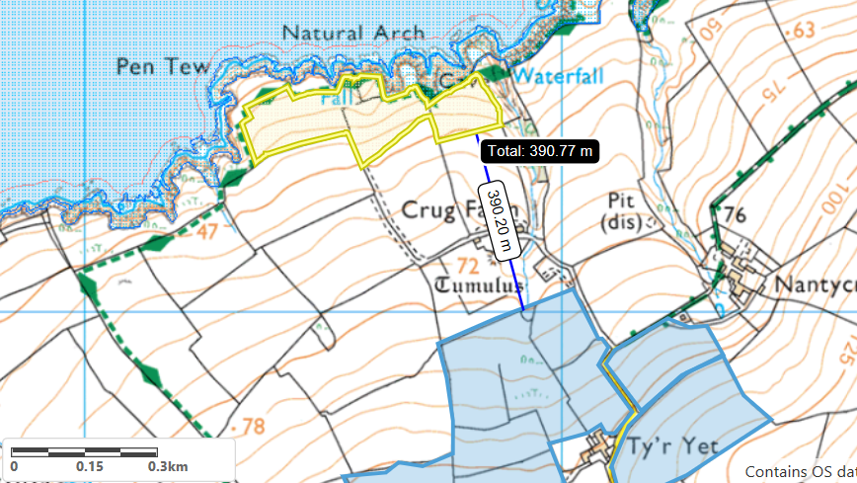
CAEAU CRUG BYCHAN, TY GWYN A LLWYN YSGAW SSSI
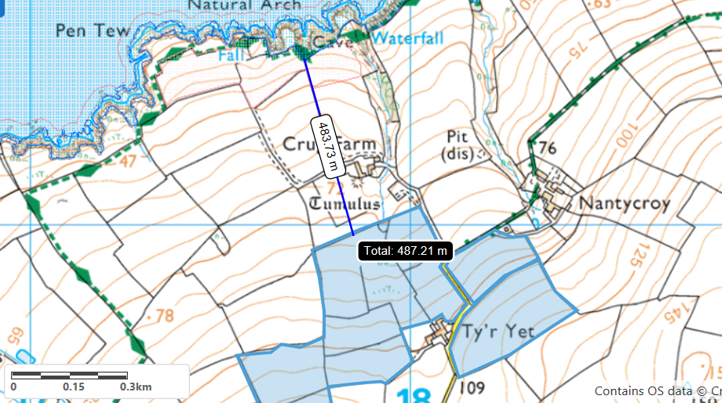
Aberarth – Carreg Wylan SSSI
Cardigan Bay/ Bae Ceredigion SAC

