CRoW Appendix 4  CRoW Act 2000: Natural Resources Wales application for permission - Formal Notice |  | 
Natural Resources Wales Formal Notice.
Requirements of Section 28I of the Wildlife & Countryside Act 1981 as amended by the Countryside and Rights of Way Act (CRoW) 2000.
Duty in relation to granting any consent, licence or permit for activities likely to damage Sites of Special Scientific Interest (SSSI).
- Natural Resources Wales area/region/NPS hub: | Powys / Mid Wales
- Name of SSSI: | Coed y Ciliau 32WYA  River Ifon 32WJN  Cae Comin Coch 32WVF  Caeau Llwyn Gwrgan 32WHZ  Tyncoed Pasture 32WO4  Cors y Llyn 32WRS  Upper Wye Tributaries 32WXT  Elenydd 32WJE  River Wye (Upper Wye) 32WUQ
- Type of permission: | New Bespoke Environmental Permit for an intensive farming broiler unit
- Date for Natural Resources Wales permit determination: | 19/11/2019
- Predicted 28 day date for response from NRW conservation/ecology (under S28 I(4)):
- Natural Resources Wales reference no: | PAN-005300
- National grid reference: | SN 96284 55331  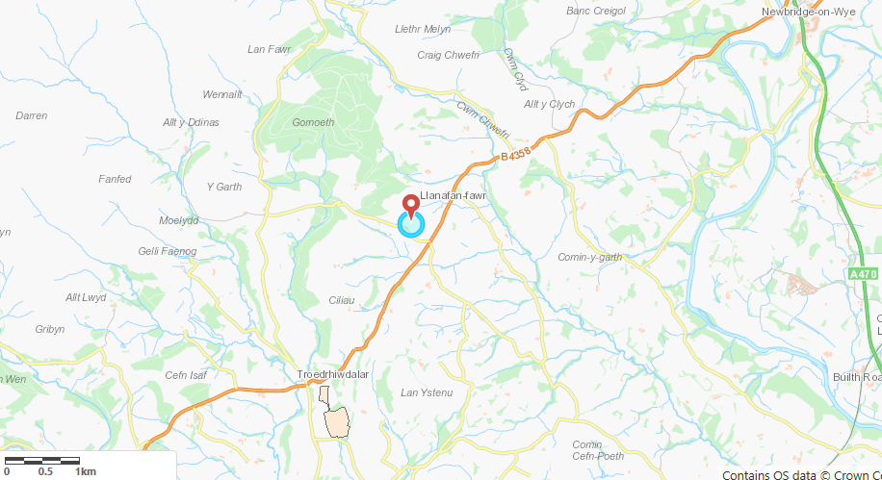
- Description of proposal: | This permit application is for the housing of 100,000 broilers at Cwmafan, Llanafan Fawr, Builth Wells, Powys, LD2 3PF, and is proposed by Mr John Rhys Morgan Jones, Mrs Heulwen Hannah Jones and Mr Lyndon Rhys Jones trading as JRM and HH Jones and Son.  The farmstead at Cwmafan is in a rural area approximately 650 m to the south-west of the small village of Llanafan-Fawr, near to Builth Wells in Powys. The farm is at an elevation of approximately 260 m, with the land rising to Lan Dwpa at a height of 378 m to the north-west, above the Nant yr Esgob, which is to the south and flows eastward into the River Chwefri.  The surrounding land is predominantly pasture and there are wooded areas nearby.  Under the proposal, two new poultry houses would be constructed on a green-field site to the north of the existing farm buildings at Cwmafan. These proposed poultry houses would provide accommodation for up to 100,000 broiler chickens and would be ventilated using uncapped high-speed ridge mounted fans, each with a short chimney.  The chickens would be reared from day old chicks to up to around 38 days old and there would be approximately 7.5 crops per year. Heat exchanger units will be installed to mitigate environmental impacts from ammonia emissions.
- Is the proposed activity within (wholly or partially) the SSSI boundary? | No  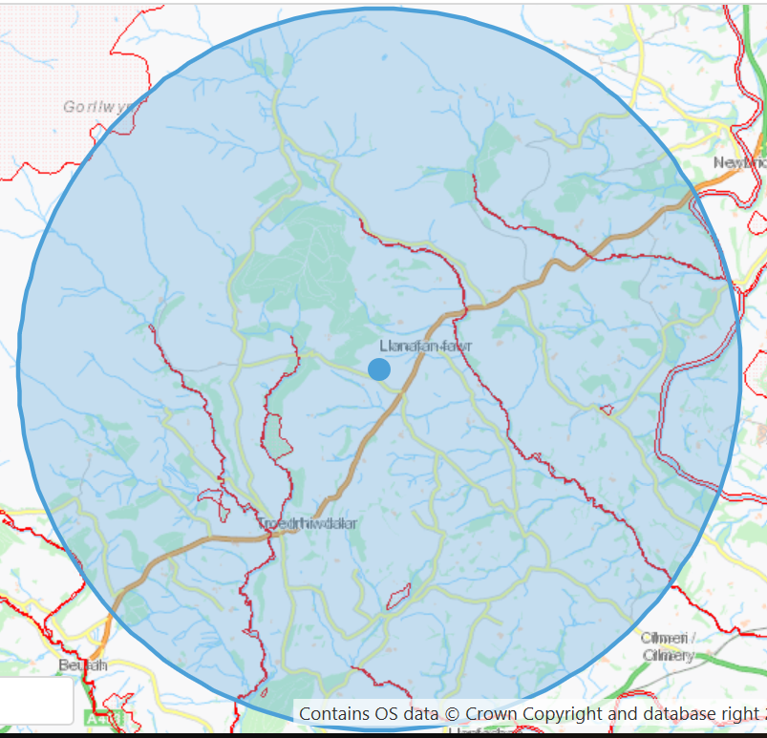
- Has there been any pre-application discussion or correspondence with NRW conservation/ecology | No
- What aspect(s) of the proposed permission may damage the features which are of special interest for the SSSI?
The following ‘Operations Requiring Consent’ (or other activities associated with the permission) that may cause damage) are relevant to the proposed permission.
- Emissions from the housing of poultry

The following SSSI features and mechanisms of impact have been considered to assess the likelihood of damage:
- Potential for increased ammonia concentration and potential increase in nitrogen deposition
- Decision
The applicant used ADMS 5.0 modelling software and meteorological data to predict the plume and ground level concentrations and deposition rates of pollutants. They then compared them to the critical levels and loads. The process contribution from the installation has been calculated and compared against the minimum and maximum critical loads for each habitat type found within the SSSI’s.

Comparison against Critical Loads:
The applicant has presented a detailed assessment of ammonia concentration and nitrogen deposition as part of the application. The process contribution from the installation has been calculated and compared against the minimum and maximum critical loads for each habitat type found within the SSSI’s. The critical levels for the SSSI’s are as follows:
Site | Critical Level (µg-NH3/m3)
Coed Y Ciliau SSSI | 1.0
River Irfon SSSI | 1.0
Caeau Llwyn Gwrgan SSSI | 1.0
Cae Comin Coch SSSI | 3.0
Tyncoed Pasture SSSI | 1.0
Cors Y Llyn SSSI | 1.0
Upper Wye Tributaries SSSI | 3.0
Elenydd SAC / SSSI | 1.0
River Wye SSSI | 1.0

Where the Process Contribution (PC) is at or below 1% of the appropriate ammonia critical level / nitrogen critical load, no further assessment is required. As in line with OGN041 and GN020, where the livestock unit’s process contribution, either alone or in combination with other sources (where they exist), is between 1 – 8 % or above 8% it needs to be considered in the context of background ammonia concentration and nitrogen deposition at the sensitive receptor. This is termed the predicted environmental concentration (PEC) and includes the addition of the PC of the unit being assessed with other sources (sumPCs) and with background levels.

Ammonia concentration:

The detailed modelling predicts that, should heat exchanger units be installed in the proposed poultry houses, impacts would be reduced at all receptors. However, there would still be an exceedance of Natural Resources Wales’ lower threshold percentage of the Critical Level and Critical Load at Coed Ciliau SSSI and the River Irfon SSSI. There are no existing poultry units since 2015 within 5km to consider in combination with this facility. Poultry units prior to 2016 will be captured in the background concentration.

- Coed y Ciliau SSSI: maximum process contribution is 0.014 µg/m³ (1.4% of Cle). Combined with the background concentration of 0.79 µg/m³ is 0.8 µg/m³, below the Cle of 1 µg/m³. Therefore, screens out.
- River Wye SAC / River Irfon SSSI: maximum process contribution is 0.053 µg/m³ (5.3% of Cle). Combined with the background concentration of 0.79 µg/m³ is 0.8 µg/m³, which is below the Cle of 1 µg/m³. Therefore, screens out.
- Caeau Llwyn Gwrgan SSSI: maximum process contribution is below 1% of the critical level so screens out
- Cae Comin Coch SSSI: maximum process contribution is below 1% of the critical level so screens out
- Tyncoed Pasture SSSI: maximum process contribution is below 1% of the critical level so screens out
- Cors Y Llyn SSSI: maximum process contribution is below 1% of the critical level so screens out
- River Wye SAC / Upper Wye Tributaries SSSI: maximum process contribution is below 1% of the critical level so screens out

- Elenydd SAC/SSSI: maximum process contribution is below 1% of the critical level so screens out

- River Wye SSSI: maximum process contribution is below 1% of the critical level so screens out

Conclusion:

ii) The permission is not likely to damage any of the flora, fauna or geological or physiological features which are of special interest because of conditions.

Figures used in this report are based on heat exchangers being operational continuously at the site (reducing emissions by 35%). This will be an enforceable requirement in table ‘S1.1 activities’ of the permit.

Natural Resources Wales is minded to:
Issue the permission with conditions to ensure no damage to SSSI’s (stated above)
- Name and job title of Natural Resources Wales officer: | Danielle Carey  Permitting Officer
- Date form sent to NRW conservation/ecology | 02/09/2019

