Permit
The Environmental Permitting (England & Wales) Regulations 2016
Europest Environmental Services Limited

Europest
Unit G
Trecenydd Business Park
Caerphilly
CF83 2RZ

Permit number

EPR/BB3998CQ

Permit
The Environmental Permitting (England and Wales) Regulations 2016
Permit number

EPR/BB3998CQ

The Natural Resources Body for Wales (“Natural Resources Wales”) authorises, under regulation 13 of the Environmental Permitting (England and Wales) Regulations 2016

Europest Environmental Services Limited (“the operator”),

whose registered office is

Unit G

Trecenydd Business Park

Caerphilly

Mid Glamorgan

CF83 2RZ

company registration number 04238468

to operate waste operations at

Europest

Unit G

Trecenydd Business Park

Caerphilly

Mid Glamorgan

CF83 2RZ

to the extent authorised by and subject to the conditions of this permit.

Under regulation 27(2) of the Regulations, standard rules SR2008 No24 are conditions of this permit.

Name | Date
Huw Davies | 19/01/2021

Authorised on behalf of Natural Resources Wales

Schedule 1 - Site plan

This is the plan referred to in the standard rules SR2008 No24.
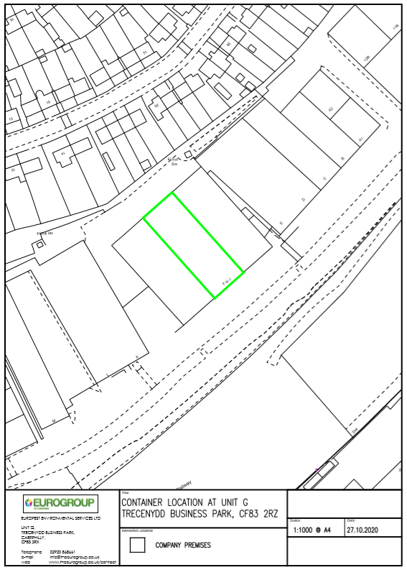

END OF PERMIT

