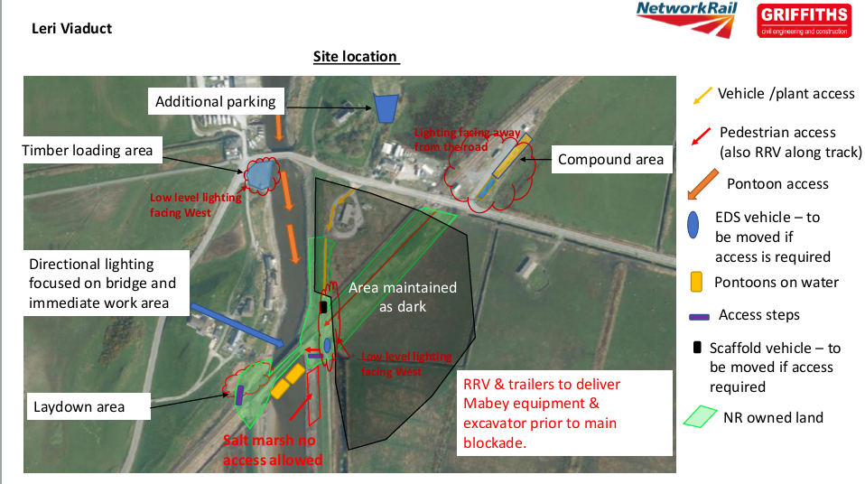
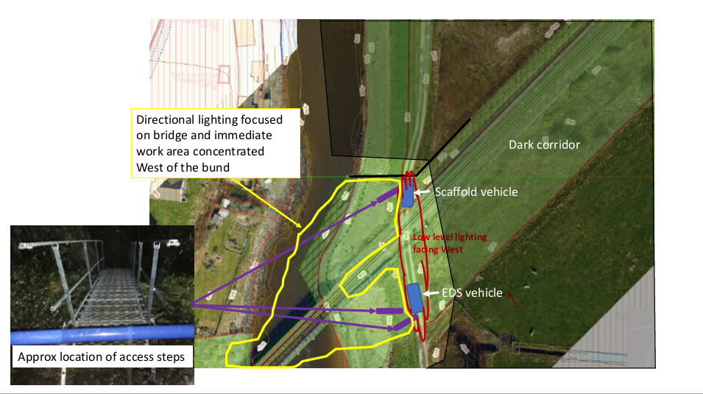
The works will be checked on a weekly basis by the Ecological Clerk of Works (Otter Licenced Ecologist or their duly accredited agent).

