Schedule 5 – Notification

These pages outline the information that the operator must provide.
Units of measurement used in information supplied under Part A and B requirements shall be appropriate to the circumstances of the emission. Where appropriate, a comparison should be made of actual emissions and authorised emission limits.
If any information is considered commercially confidential, it should be separated from non-confidential information, supplied on a separate sheet and accompanied by an application for commercial confidentiality under the provisions of the EP Regulations.

Part A

Permit Number | AP3833HZ
Name of operator | 2 Sisters Food Group
Location of Facility | Industrial Trading Estate, Llangefni, LL777UX
Time and date of the detection | 10.25 25.2.21

(a) Notification requirements for any malfunction, breakdown or failure of equipment or techniques, accident, or emission of a substance not controlled by an emission limit which has caused, is causing or may cause significant pollution
To be notified within 24 hours of detection
Date and time of the event | 10.25 25.2.21
Reference or description of the location of the event | External Yard adjacent to the Sludge Tank
Description of where any release into the environment took place | Yard Area from Weigh Bridge to Security Lodge
Substances(s) potentially released | Effluent Sludge
Best estimate of the quantity or rate of release of substances | 2,000 litres
Measures taken, or intended to be taken, to stop any emission | Surface Water Discharge Point (Pen-Stop Valve) closed from site as a precaution. Surface Water Drains were covered with Drain Mats. Natural fall of the road resulted in a sedentary collection pool. Dry Weather Conditions resulted in no spread or run off.
Description of the failure or accident. | During sludge collection the tank hatch split leading to a release.

(b) Notification requirements for the breach of a limit
To be notified within 24 hours of detection unless otherwise specified below
Emission point reference/ source
Parameter(s)
Limit
Measured value and uncertainty
Date and time of monitoring
Measures taken, or intended to be taken, to stop the emission

Time periods for notification following detection of a breach of a limit
Parameter | Notification period

(c) Notification requirements for the detection of any significant adverse environmental effect
To be notified within 24 hours of detection
Description of where the effect on the environment was detected
Substances(s) detected
Concentrations of substances detected
Date of monitoring/sampling

Part B – to be submitted as soon as practicable

Any more accurate information on the matters for notification under Part A. | Sludge was viscous and contained within a localised areas. Sludge was suctioned into a specialised vehicle. Wash water was used rinsed residual sludge from the yard surface. All rinse water used for clean-up was contained, suctioned up and removed from site for treatment.
Measures taken, or intended to be taken, to prevent a recurrence of the incident | Review with Haulier on causes of the tank hatch failure with the purpose of future preventative measures.
Measures taken, or intended to be taken, to rectify, limit or prevent any pollution of the environment which has been or may be caused by the emission | Site emergency response procedures were effectively and quickly exercised.  Site will replenish 2 x Drain Mats used to cover surface water drains.
The dates of any unauthorised emissions from the facility in the preceding 24 months. | N/A

Name* | Simon Holland
Post | Group HSE Manager
Signature
Date | 26.2.21
* authorised to sign on behalf of the operator

Schedule 6 – Interpretation

“accident” means an accident that may result in pollution.
“application” means the application for this permit, together with any additional information supplied by the operator as part of the application and any response to a notice served under Schedule 5 to the EP Regulations.
“authorised officer” means any person authorised by the Environment Agency under section 108(1) of The Environment Act 1995 to exercise, in accordance with the terms of any such authorisation, any power specified in section 108(4) of that Act.
“emissions to land” includes emissions to groundwater.
“EP Regulations” means The Environmental Permitting (England and Wales) Regulations SI 2010 No.675 and words and expressions used in this permit which are also used in the Regulations have the same meanings as in those Regulations.
“emissions of substances not controlled by emission limits” means emissions of substances to air, water or land from the activities, either from the emission points specified in schedule 3 or from other localised or diffuse sources, which are not controlled by an emission limit.
“groundwater” means all water, which is below the surface of the ground in the saturation zone and in direct contact with the ground or subsoil.
“Industrial Emissions Directive” means DIRECTIVE 2010/75/EU OF THE EUROPEAN PARLIAMENT AND OF THE COUNCIL of 24 November 2010 on industrial emissions
“MCERTS” means the Environment Agency’s Monitoring Certification Scheme. “Pests” means Birds, Vermin and Insects.
Where a minimum limit is set for any emission parameter, for example pH, reference to exceeding the limit shall mean that the parameter shall not be less than that limit.
Unless otherwise stated, any references in this permit to concentrations of substances in emissions into air means:
- in relation to emissions from combustion processes, the concentration in dry air at a temperature of 273K, at a pressure of 101.3 kPa and with an oxygen content of 3% dry for liquid and gaseous fuels, 6% dry for solid fuels; and/or
- in relation to emissions from non-combustion sources, the concentration at a temperature of 273K and at a pressure of 101.3 kPa, with no correction for water vapour content.
“year” means calendar year ending 31 December.

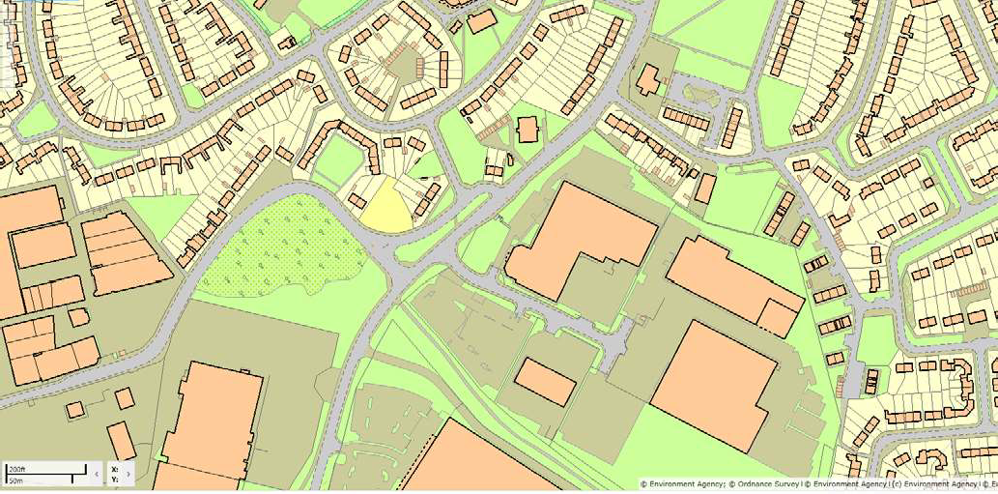
Schedule 7 – Site plan

“©Crown Copyright. All rights reserved. Environment Agency, 100024198, 2016.”

END OF PERMIT

