PAN-012552 File Note for Appendix 4 Assessment.
Whilst the Risk screening report, saved on the DMS, identified one designated SSSI (Gwernydd Penbre) within the 1000-meter screening criteria, the flow of the receiving watercourse is in the opposite direction (see map below). Therefore, the proposal is not hydrologically connected to the SSSI and there is no impact pathway. As a result, no Appendix 4 has been completed for this site.

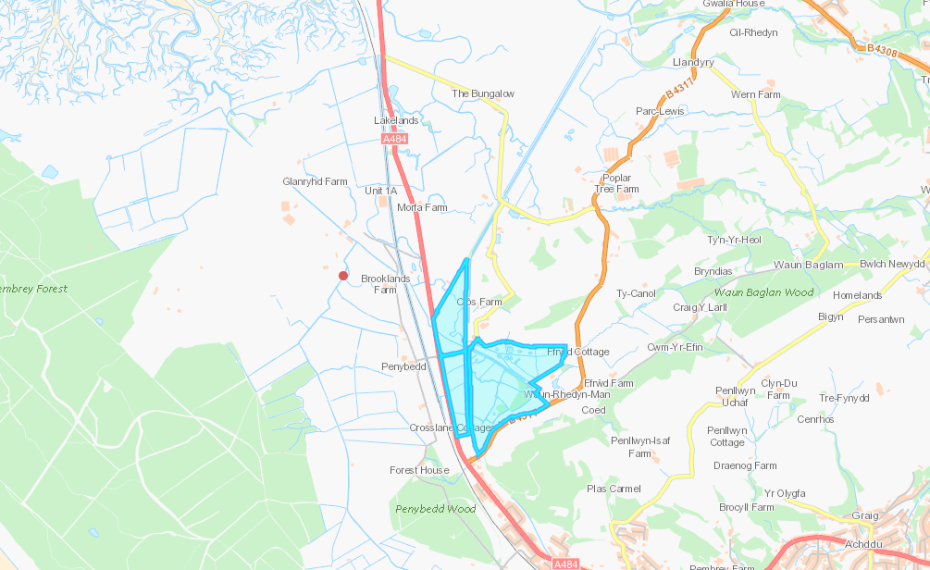
Direction of flow
Discharge Point
Gwernydd Penbre SSSI

