Notice of variation with introductory note
Environmental Permitting (England & Wales) Regulations 2016

Solway Foods Limited

RF Brookes (Solway Foods)
Rogerstone Park
Azalea Road
Newport
NP10 9SA

Variation number
EPR/UP3237CP/V006

Permit number

EPR/UP3237CP

RF Brookes (Solway Foods)

Permit number EPR/UP3237CP

Introductory note

This introductory note does not form a part of the notice

The following notice gives notice of the variation of an environmental permit.

This is a minor technical variation to replace burner ovens and therefore there is a change to the emission points list on the permit. The first part is the removal of emission point A7 as a result of the decommissioning of the five x 150 kW thermal input natural gas burner ovens (750 kW thermal input total) listed as emission point A7 and the addition of a 6 rack rotary oven (natural gas fuel) with a thermal input of 350 kW listed at emission point A11. This replacement oven is less than the 1 MW thermal input threshold and is used for direct heating, therefore is not subject to the Medium Combustion Plant (MCP) directive.

The schedules specify the changes made to the original permit.

The status log of a permit sets out the permitting history, including any changes to the permit reference number.

Status log of the permit
Description | Date | Comments
Application BP3007IM | Received 02/09/2004
Additional information requested | 13/12/2004
Additional information received | 14/12/2004
Additional information requested | 07/02/2005
Additional information received | 22/02/2005
Additional information requested | 10/03/2005
Additional information received | 15/03/2005
Permit determined | 29/04/2005
Variation application TP3030XS | Received 04/10/2007
Variation notice TP3030XS issued | 21/12/2007
Transfer application LP3035XM | Received 04/10/2007
Additional information received | 07/01/2008
Transfer determined EPR/LP3035XM | 30/01/2008
Transfer application EPR/UP3237CP/T001 (full transfer of permit EPR/LP3035XM) | Duly Made 09/08/2012 | Application to transfer the permit in full to Solway Foods Limited.
Transfer determined (EPR/UP3237CP/V002) | 07/09/2012 | Full transfer of permit complete.
Agency variation determined EPR/UP3237CP/V002 | 25/03/2013 | Agency variation to implement the changes introduced by IED.
Variation application received EPR/UP3237CP/V003 | 29/04/2013 | Application to extend permit boundary and add two point source emissions to air.
Variation application determined EPR/UP3237CP/V003 | 29/07/2013
Variation application received EPR/UP3237CP/V004 | Duly Made 07/07/2015 | Application to cover an additional production area and add two point source emissions to air.
Variation application determined EPR/UP3237CP/V004 | 07/10/2015 | Variation notice issued to Solway Foods Limited.
Variation application received EPR/UP3237CP/V005 | Duly Made 04/10/2018 | Application to add a CHP plant.
Variation determined EPR/UP3237CP/V005 | 18/01/2019 | Variation notice issued to Solway Foods Limited.
Variation application received EPR/UP3237CP/V006 | Duly Made  27/01/2021 | Application to replace gas burner ovens
Variation determined EPR/UP3237CP/V006 | 15/03/2021 | Variation notice issued to Solway Foods Limited.

End of introductory note

Notice of variation
Environmental Permitting (England and Wales) Regulations 2016

The Natural Resources Body for Wales (“Natural Resources Wales”) in exercise of its powers under regulation 20 of the Environmental Permitting (England and Wales) Regulations 2016 varies

Permit number

EPR/UP3237CP

issued to:

Solway Foods Limited (“the operator”)

whose registered office is

Trinity Park House

Fox Way

Wakefield

West Yorkshire

WF2 8EE

company registration number 02189139

to operate a regulated facility at

RF Brookes (Solway Foods)

Rogerstone Park

Azalea Road

Newport

NP10 9SA

to the extent set out in the schedules.

The notice shall take effect from 15/03/2021

Signed | Date
Holly Noble | 15/03/2021

Authorised on behalf of Natural Resources Wales

Schedule 1 – conditions to be deleted

None

Schedule 2 – conditions to be amended

The following conditions are amended as a result of the application made by the operator

Condition 2.2.1 shall be amended to:

2.2.1 Emissions to air, (including heat, but excluding odour, noise or vibration) from specified points

2.2.1.2 Emissions to air from the emissions points in Table 2.2.1 shall only arise from the sources specified in that Table. The limits given in Table 2.10.1 shall not be exceeded

Table 2.2.1 shall be amended to:

Table 2.2.1 Emission points to air
Emission point reference | Source | Location
A1 – as on revised site  plan in Schedule 4 of  Variation Notice EPR/UP3237CP/V006 | Odour abatement (1st plant) | Anguil odour stack – NE corner of main production building
A2 – as on revised site  plan in Schedule 4 of  Variation Notice EPR/UP3237CP/V006 | Raising steam 20 bar | Steam boiler No1 - Energy centre building
A3 – as on revised site  plan in Schedule 4 of  Variation Notice EPR/UP3237CP/V006 | Raising steam 10 bar | Steam boiler No2 - Energy centre building
A4 – as on revised site  plan in Schedule 4 of  Variation Notice EPR/UP3237CP/V006 | Raising steam 10 bar | Steam boiler No3 - Energy centre building
A5 – as on revised site  plan in Schedule 4 of  Variation Notice EPR/UP3237CP/V006 | Primary heating fryers | Thermal oil generator - Energy centre building
A6 – as on revised site  plan in Schedule 4 of  Variation Notice EPR/UP3237CP/V006 | Odour abatement (2nd plant) | Thermal oxidiser unit
A8 – as on revised site plan in Schedule 4 of Variation Notice EPR/UP3237CP/V006 | Thermal Oil Boiler Stack) | Oriental Plant LHS
A9 – as on revised site plan in Schedule 4 of Variation Notice EPR/UP3237CP/V006 | Thermal Oil Boiler Stack | Oriental Plant RHS
A10 – as on revised site plan in Schedule 4 of Variation Notice EPR/UP3237CP/V006 | CHP (Rogerstone Park CHP - Jenbacher (Clarke Energy – C3748)) | Rear of energy centre
A11 as on revised site plan in Schedule 4 of Variation Notice  EPR/UP3237CP/V006 | Oven discharge from 350 kW thermal input, natural gas fuelled 6-rack rotary oven | A11 -6 Rack rotary cooking oven

Table S2.10.1 shall be amended to:

Table S2.10.1 Other Monitoring Requirements
Emission point reference | Parameter | Limit | Reference period | Monitoring Frequency | Monitoring Method (Note¹) | Other  specifications
S1– as on revised site plan in  Schedule 4 of Variation Notice EPR/UP3237CP/V003 | Effluent Flow Rate | No limit set | Daily average | Continuous | As agreed in  improvement  programme number 7 | To commence on completion of improvement programme number seven.
S1– as on revised site plan in  Schedule 4 of Variation Notice EPR/UP3237CP/V003 | COD | No limit set | Quarterly | Spot sample | BS ISO 15705:2002, BS 6068-  2.80:2002
S1– as on revised site plan in  Schedule 4 of Variation Notice EPR/UP3237CP/V003 | Suspended solids | No limit set | Quarterly | Spot sample | BSEN872:1996,  BS6068 2.54:1996
S1– as on revised site plan in  Schedule 4 of Variation Notice EPR/UP3237CP/V003 | pH | No limit set | Monthly | Spot sample | BS6068-  2.50:1995, ISO 10523:1994
A1-A6 A8-A9, A11 as on revised site plan  in Schedule 4 of Variation Notice EPR/UP3237CP/V006 | Oxides of Nitrogen (NO and NO₂ expressed as NO₂) | No limit set | Annual | Spot sample | ISO 10849
A1-A6, A8-A9, A11 as on revised site plan  in Schedule 4 of Variation Notice EPR/UP3237CP/V006 | Carbon Monoxide | No limit set | Annual | Spot sample | ISO 12039
A1-A6, A8-A9, A11 as on revised site plan  in Schedule 4 of Variation Notice EPR/UP3237CP/V006 | Particulates | No limit set | Annual | Spot sample | BSISO 9096
A10 – as on revised site plan in Schedule 4 of Variation Notice EPR/UP3237CP/V006 | Oxides of Nitrogen (NO and NO₂ expressed as NO₂) | 95 mg/m³ | In line with NRW TGN M5 | Every 3 years | NRW TGN M5
 | Carbon monoxide | No limit set | In line with NRW TGN M5 | Every 3 years | NRW TGN M5
Note¹ - Or to an EN, BS, ISO or SCA blue book standard as agreed in writing with Natural Resources Wales.

Table S2 shall be amended to:

Table S2 Reporting of Monitoring Data
Parameter | Emission point | Reporting period | Period begins
Cadmium and its compounds (g/year) | S1 | Annually | 01/01/2005
Mercury and its compounds (g/year) | S1 | Annually | 01/01/2005
Cadmium and its compounds (μg/l) | S1 | Annually | 01/01/2005
Mercury and its compounds (μg/l) | S1 | Annually | 01/01/2005
Effluent Flowrate m³/hr | S1 | Every 6 months | 01/01/2005
pH | S1 | Every 6 months | 01/01/2005
Suspended solids | S1 | Annually | 01/01/2005
COD | S1 | Annually | 01/01/2005
Oxides of nitrogen as NO2 | A1-A6, A8-A9, A11 | Annually | 15/03/2021
Carbon Monoxide | A1-A6, A8-A9, A11 | Annually | 15/03/2021
Particulates | A1-A6, A8-A9, A11 | Annually | 15/03/2021
Water Usage | A1-A6 | Annually | 29/07/2013
Energy Usage | A1-A6, A8-A11 | Annually | 15/03/2021
Waste Disposal and/or recovery | A1-A6 | Annually | 29/07/2013
Oxides of Nitrogen (NO and NO₂ expressed as NO₂) | A10 | Every 3 years | 18/01/2019
Carbon Monoxide | A10 | Every 3 years | 18/01/2019

Table S3 is amended as follows:

Table S3 Reporting Forms
Media/parameter | Form number | Date of form
Air | A1 | 15/03/21
Sewer | S1 | 30/01/08
Energy | E1 | 15/03/21
Waste Return | R1 | 30/01/08
Water usage | WU1 | 30/01/08
Performance indicators | PI1 | 30/01/08

Schedule 3 – conditions to be added

None

Schedule 4 – amended plan

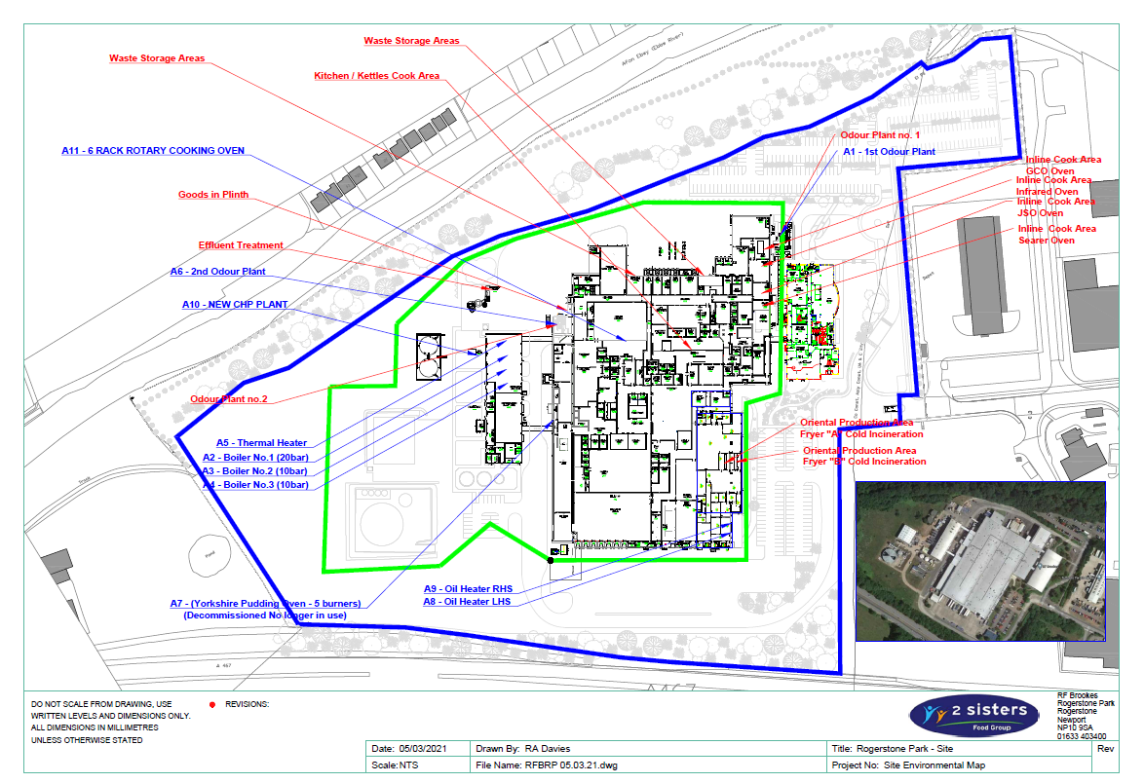
Amended plan attached showing point source emissions to air

© Crown Copyright and database right 2021. Ordnance Survey licence number 100019741.

