This template is intended to be used in conjunction with a Band 1 Marine Licence application. Please complete each section below following the guidance provided (max 500 words per section). For any queries relating to this template please contact: marinelicensing@cyfoethnaturiolcymru.gov.uk

Summary
Please provide a brief summary of the application including location of the works (coordinates - lat/long, decimal degrees). For activities that cover a large area please provide coordinates of the approximate extent of works.

Minor maintenance works required to Loughor Viaduct, that carries the SDI2 railway over Loughor Estuary.

Eastern extent of Viaduct: Latitude = 51°42'10.56"N
Longitude = 4°3'3.56"W

Western extent of Viaduct: Latitude = 51°42'10.91"N
Longitude = 4°3'8.59"W

Buddleia is growing on the structure and requires removal. Using rope access personnel, they will be tied off at an anchor point using the running rail and will remove the vegetation growing from the outside face of the structure.

Missing mortar will be identified by site operatives and all open joints will be re-pointed using like-for-like mortar; Blaenavon Dark lime mix mortar.

All works will be completed from the railway.

Scope of works
Please provide a full description of all proposed works including:
- Sequence of works (mobilisation, marine works, site remediation (if required))
- Estimated timing of works (duration, working hours, day/night, plus contingency)
- Plant, machinery or vessel required
- Estimated quantities (removals, deposits, construction materials)

• On arrival at site the entire work group are to take 10 minutes to observe the site and assess any potential hazards or forthcoming activities that may result in a close call/near miss and report/remediate via the close call system.
• COVID 19 – All operators to maintain social distance of a minimum of 2m if this is not achievable then works are to stop and site manager to be informed to seek advice.

• All works will be carried out within a railway possession.

• E/S TO SIGN IN WITH PICOP AND AGREE WORKSITE LIMITS AND TIMES AND RECORD

• The AMCO COSS is to brief all members on the safe system of work and the shifts activities at the start of each shift.

• Access to site will be at authorised access at 9m61ch

Work will consist of:

• Amco to carry out pre-start checks on the rail trolley before placing onto the down main to transport materials to site.

• Once at site Amco will identify missing mortar to deep open joints and replace mortar using like for like in this case Blaenavon Dark lime mix mortar. Re-pointing will be carried out using hand tools and secondary containment measures to be in place beneath point of work to catch any mortar/arisngs from work task. Small amounts of mortar applied at any one time to fill joint to correct level.

• Bespoke rope access team will remove the buddleia using hand tools from the outside face of the structure using the running rail as an Anchor point. All vegetation will be tied off and lifted trackside and removed from site.

- Before any plant is used all pre checks are to be completed and recorded before use.

• All debris to be removed from site and disposed of in skip back at AmcoGiffen yard.

Access and working areas
Access route to and from works location via railway track.

Track trolley used to moved equipment to and from site.
Access point to track
Loughor Viaduct (works location)
Please provide details of access to the site and working areas. This should include:
- Attached map of the access/egress route and working areas (annotated aerial image and/or OS map)
- Predicted plant/vehicle movements
- Storage areas for plant, equipment and materials (if required)
- Risks to navigation

Access to site will be via a Network Rail authorised access point on the track at 9 miles 61 chains on the SDI2 railway line, which is approximately 241 m to the east of Loughor Viaduct.

All works remain from the railway on the Viaduct.

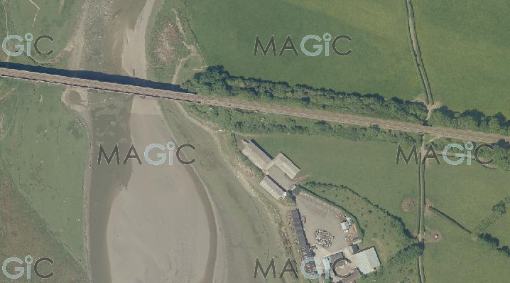

Environmental mitigation
Please list appropriate mitigation measures to minimise impacts on the marine environment these may include:
- Pollution prevention and control procedure (guidance available at: http://www.netregs.org.uk/media/1304/gpp-5-works-and-maintenance-in-or-near-water.pdf)
- Spill response kits
- Minimise plant traffic
- Designated access and egress routes
- Storage of materials (fuel, chemicals, construction waste)
- Biosecurity (guidance available at http://www.snh.gov.uk/docs/A1294630.pdf)

Note: To assist you, the following mitigation statements will be used as conditions within the licence. By signing this method statement you will be agreeing to adhere to these restrictions. If you are unable to do this, the application will not qualify as Band 1.

- All equipment, temporary structures, access tracks, waste and/or debris associated with the works will be removed on completion of the works.

- Bunding, storage facilities and spill kits will be employed to contain and prevent the release of fuel, oils and chemicals associated with the plant, refuelling and construction equipment into the marine environment.

- Plant, vehicles and machinery will not be refuelled on the foreshore.

- Coatings and treatments will be suitable for use in the marine environment and are used in accordance with best environmental practice.

- All equipment, materials, machinery and PPE used will be in a clean condition prior to their arrival on site, and upon removal from site, to minimise risk of introducing non-native species into the marine environment.

- In the event of removal of any sensitive species or habitat designated by NRW under Schedule 7 of the Environment (Wales) Act 2016, no further removals will occur at that location or within 20m of that location.

Please list your bespoke mitigations here:

• There is no direct work or interaction with the water and marine environment.
• No polluting substances will be allowed to enter the marine environment. Secondary containment used beneath re-pointing activity to catch any arisings.
• Removed vegetation will be securely tied and carefully lifted trackside to minimise risk of vegetation falling into water beneath Viaduct.
• Small quantities of mortar will be used at any one time to fill open joints and applied by hand to control amounts.
• No refuelling of equipment on the Viaduct or within immediate vicinity of Viaduct and Loughor Estuary.
• All materials, equipment and waste will be stored securely and removed from trackside on the track trolley back to access point.

Additional Information
Please list any additional information that may help with the application:
- Consents/permissions required
- List of plans or drawings attached to method statement
- Emergency procedures
- Contact details

MWC0823S – Loughor Viaduct Photos.
MWC0823S – Loughor Viaduct TBS

- Customer details
Signature: 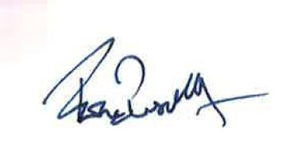

Full name: Fiona Bussell

Organisation name (where appropriate): Amalgamated Construction Ltd.

Contact e mail: Fiona.bussell@amcogiffen.co.uk

Contact phone number: 07557 540036

