Network Rail  ITT 8611 – SBA2 Timber Structures Urgent Works  2. Technical Response | 
Leri viaduct urgent works
Tender Methodology
ELR: SBA2 – 85m 30ch
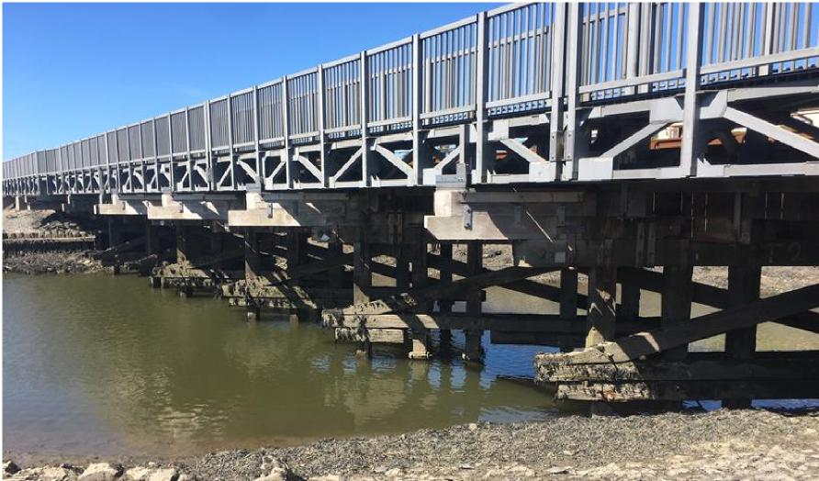
Page 1 of 17

Network Rail  ITT 8611 – SBA2 Timber Structures Urgent Works  2. Technical Response | 

Contents
1 Introduction 3
2 Overview. 5
3 Pre-Commencement 7
4 Site Compound location, access and bridge structure area. 8
5 Preparation and possession work’s 9
6 RRV WORKS 15
7 Pontoon works 15
8 Dive team works 16
9 Scaffolding requirements 16
10 Cabins, site set up arrangement 17
Page 2 of 17

Network Rail
ITT 8611 – SBA2 Timber Structures Urgent Works
2. Technical Response

2.1.1 |  | Technical Submission and Methodology

1 COVID -19 Consideration
In producing our methodology and programme, we have considered and made specific arrangements for managing the effect of the Coronavirus (COVID -19) and complying with NR/L2/MTC/CP008 - Delivering On-Site Works During COVID-19 Response and NR/L3/MTC/CP009 - Coronavirus COVID-19 Safe Working Practices.
We have assessed the cost of implementing COVID-19 measures and have included this cost in the pricing document as a provisional sum item. Griffiths will work collaboratively with Network Rail to ensure the safety of all project staff, site operatives and specialist subcontractors in delivering Leri safely and to agreed programme and cost.
We have carried out a thorough review of the scope of work and activities for Leri Viaduct Repairs and assessed that most of the works can be carried out without any additional intervention. To minimise the risk of COVID-19 we have considered social distancing controls for activities, such as, travel to site, site briefings and messing. Our Methodology and programme limits the number of operatives, subcontractors, supervision and management staff on site at any one time.
The site set up has been extended to include additional canteen and drying room facilities to maintain the COVID-19 restrictions. Additional parking will be required to allow for increased vehicle use. Briefings and breaks will be staggered to allow maintenance of 2m separation, with briefings carried out outside where possible. Where operatives have to be within 2m to carry out certain tasks this will be subject to a specific risk assessment and include appropriate RPE and PPE as required
2 Introduction
Alun Griffiths (contractors.) are committed to safety, sustainability, social responsibility and engineering excellence. During this tender submission and preparation, the team have developed a robust construction methodology that focuses on the safety of the team, not putting public and passengers at risk and ultimately putting them first.
Our plan will consider the safety and wellbeing of all working on the structure, and the people who live and work in the area.
As always rail passengers come first and because of this we will be carrying out as much preparatory work as possible while passenger trains are still running as not to cause disruption. The main blockade, consisting of a -> 53 hr possession of the line in week 24, this is where the main structural elements of the works will be completed.
Leri viaduct is a grade II* listed structure on the SBA2 line between dovey junction station and Aberystwyth,
Page 3 of 17

Network Rail
ITT 8611 – SBA2 Timber Structures Urgent Works
2. Technical Response

which runs over the tidal river AFON LERI. it is an 8-trestle bridge which has a newer GRP public footpath attached to the upside of the structure, this is attached along the extended crossheads and bolted to the top.
A significant amount of wailer removals, pile replacements and steel repairs are required along with new corbels at certain locations.
We will successfully deliver this project using our own internal plant including Road Rail Vehicles (RRVs) and a highly skilled workforce who have already proved themselves on other similar wooden structures in the area on the same line.
A dive team will be required for most of these works due to the area being in a tidal estuary.
All of the above combined will reduce any risk of an overrun to the possession and the project programme timescale.
Key dates:
Site set up 17th to 28th August, including access across field
Prep/doubler works including scaffold 31st August to 10th September
Wailing Doubler removal possessions 24th August to 10th Sept Midweek and sat nights
Main Possession Fri night 11th to Mon morning 14th Sept 24/7
Removal of scaffold/snagging 14th to 25th September
Snagging/removal of material poss Sat nights; 19th and 26th September
Site demob 28th to 2nd October
Page 4 of 17

Network Rail
ITT 8611 – SBA2 Timber Structures Urgent Works
2. Technical Response

3 Overview.
The project will be delivered using both day and night shift working, during the day without disruption to the operational railway, bolts will be changed in the upper wailer. The diagonal restraint bracings and certain metalwork components will be changed. During the nightshifts and Saturday nights on the build up to the main blockade, wailers will be removed in a specific sequence (detailed later in this document) and pile strap assemblies installed to 30No piles. There are also 3 full piles to replace, this will be carried out in the main blockade. Pile packing with Stainless Steel -shims will also be done as an when the tide suits, day or night. There will be occasions where the rising tide will render the night shift unworkable for certain operations but will have other parts of the works to complete while this occurs.
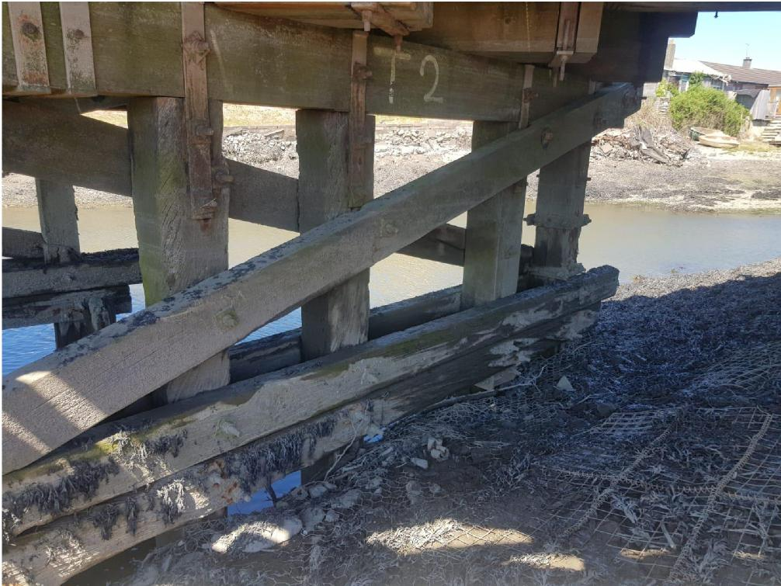
Above is a picture of trestle 2 showing the general arrangement of the trestle construction, note the double wailer methodology.
Page 5 of 17

Network Rail
ITT 8611 – SBA2 Timber Structures Urgent Works
2. Technical Response

Trestle No. | 1 | 2 | 3 | 4 | 5 | 6 | 7 | 8
No. of Piles to be replaced | 0 | 0 | 0 | 1 | 1 | 0 | 1 | 0
Temporary pile splice assemblies |  | 5 | 4 | 4 | 4 | 5 | 4
No. of lateral  restraint diagonals to be replaced | 4 | 0 | 0 | 4 | 4 | 4 | 4 | 4
No. of Wailers to be replaced | 0 | 4out 2new | 4out 2new | 4out 2new | 4out 2new | 4out 2new | 4out 2new | 0
Pile shim repairs | 1 | 4 | 1 | 0 | 0 | 3 | 2 | 3
Corbel replacement |  |  |  |  |  | B3 |  | B6
Number of TA bolts to replace | 0 | 14 | 14 | 14 | 14 | 14 | 14 | 0

Above is a table of wooden elements needing changing during the project, NB all new steel clamps and straps will be put on all new timbers and where detailed new TA assemblies will be changed out for new. The pile splice assembly for 30No existing pile splice assemblies is also detailed later in this document.
Page 6 of 17

Network Rail
ITT 8611 – SBA2 Timber Structures Urgent Works
2. Technical Response

4 Pre-Commencement
Following award of contract and prior to commencement on site, Griffiths will undertake a review and gap analysis of all supplied documentation, identify any missing information, put plans in place to undertake further surveys, if necessary, and supply the following documentation to Network Rail.
- Construction Environmental Management Plan, (CEMP)
- Quality Management Plan (QMP)
- Construction Phase plan (CPP)
- Work package Plans (WPP) for survey and construction works.
- Task Briefs (TB) for survey and construction works
- Form 002/003 for temporary works
- Form 002, Form 003 and Approved for Construction (AFC) Drawings for permanent works
Environmental Issues: - As the structure to be worked on is over the River Leri, Marine licence and FRAP must be obtained prior to site start, this is being done under a separate contract. Due to the works being in close proximity to local residents and businesses, noise generated from plant, equipment and compound activities, especially at night during the possession over a weekend, A section 61 noise application will be required.
We will adhere to Guidance for Pollution Prevention (GPP) section 5 - Works and maintenance in or near water 2017
Having worked closely with Ceredigion County Council on past projects in the area we have the benefit of being fully aware of the requirements in relation to the form and the content of the section 61 Application.
Although not seen on any visits, due to the location of the structure and the works an otter disturbance license will be needed prior to works starting, this will be applied for on award of the contract.
Page 7 of 17

Network Rail
ITT 8611 – SBA2 Timber Structures Urgent Works
2. Technical Response

5 Site Compound location, access and bridge structure area.
The proposed site compound is the Ynys-las rail yard.
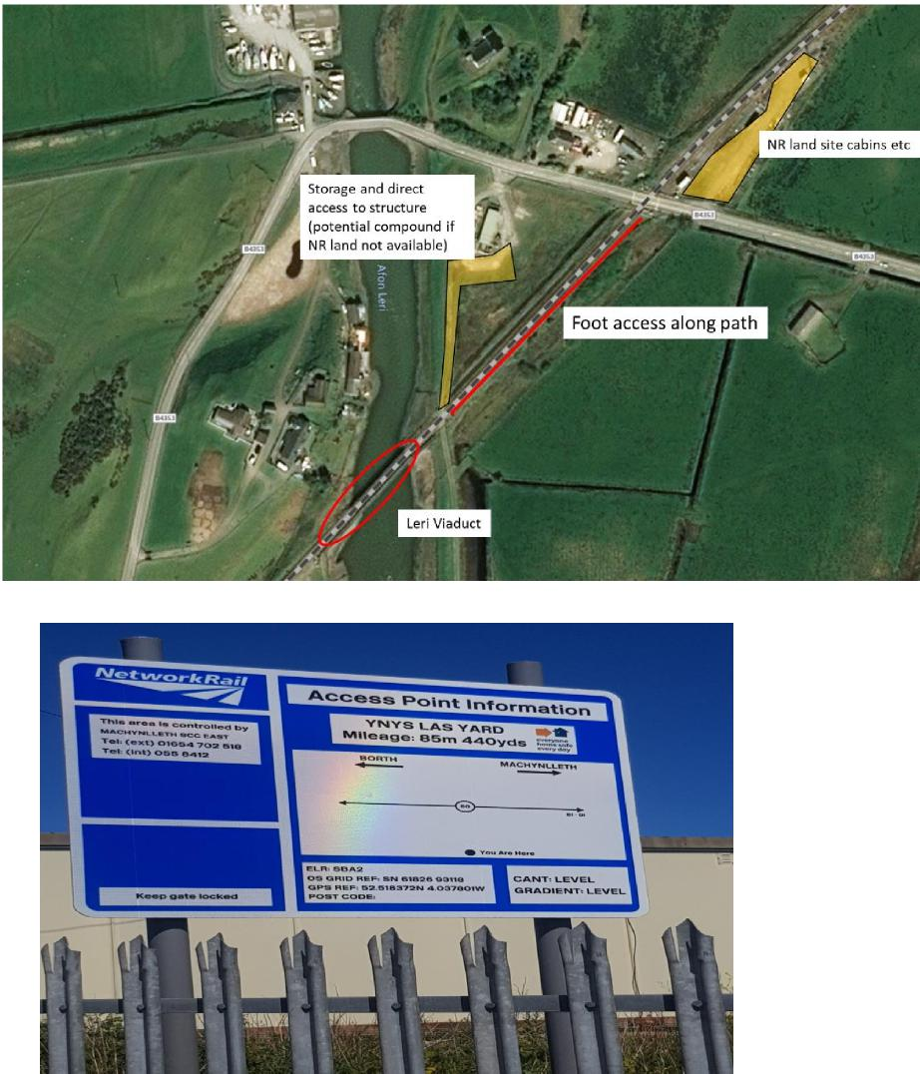
Above picture contains details of ELR, grid refences of proposed yard.
Page 8 of 17

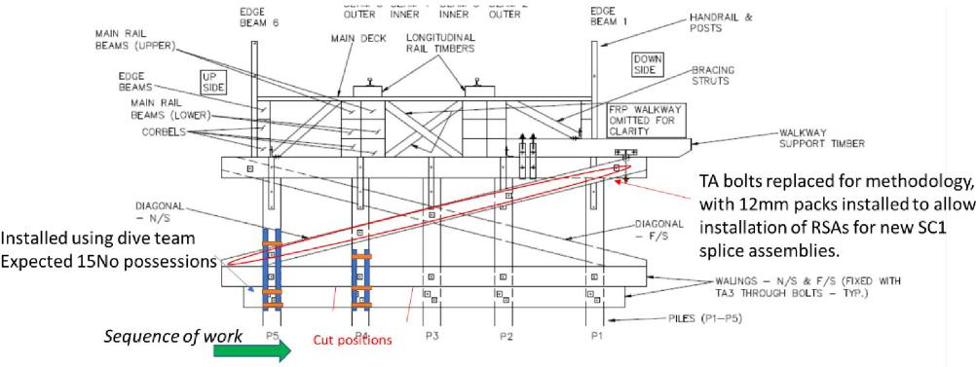
7
Network Rail
ITT 8611 – SBA2 Timber Structures Urgent Works
2. Technical Response

6 Preparation and possession work’s
Site establishment: - Site compound set up will begin on the 17th august which will consist of various units including storage containers for tools and steel components.
Construction of the Mabey lifting system will also be built there, due to its close location the Viaduct itself. This will include use of 3rd party land for access and storage.
Structural survey :- On confirmation of contract award, Griffiths will assign an engineer to conduct a full dimensional survey of the structure including baseline track levels, cross-head dimensions to ensure we have the right levels when pile removal/pile splice holding repairs. On completion of the works a programme of track monitoring will be carried out by our team on a 5,2,2,1 monitoring for the following month
Delivery of timber elements to compound. On confirmation of contract award the wooden elements will be procured and delivery will be to the main compound. A lay down area will be set up close enough to the running rail at the Ynys-las compound so the RRV can safely pick up the timbers prior to the shift. (details of this operation will be detailed later in this document)
Possession strategy. The 55.5hr possession will be ran with 3 shifts per 24hr, each shift will have 8hours working with an hour handover, this will allow fatigue management and will also limit those requiring overnight accommodation as this is extremely limited due to Covid 19.
Wailing replacement.
A total of 12no new wailers are to be installed during the project, the existing system of a double wailer is being replaced with a single wailer and holding repair steel detail. The sequence for this is as follows
The upper wailer and diagonals will have there through bolt assemblies replaced 1 at a time on day shifts. The new upper wailer and diagonal bolts will be loosened off and 12mm packers will be placed between the pile and the wailer and corresponding diagonal temporarily, then torqued up and ready for the nightshifts work.
During possessions working on one pile at a time, starting from an outer pile the bottom wailers will be cut off. The bolt in the corresponding new wailer above will be slackened off and the 12mm packers taken out, the Pile Splice Assembly can then be placed into position and SC1 clamps tightened around the pile splice cut. Any packing in the splice will be done at this time. This sequence continues along the trestle until the last pile has only a short length bottom wailer left; these now need removing completely for the last clamp assembly can be installed. There are 30No of these repairs to be done.

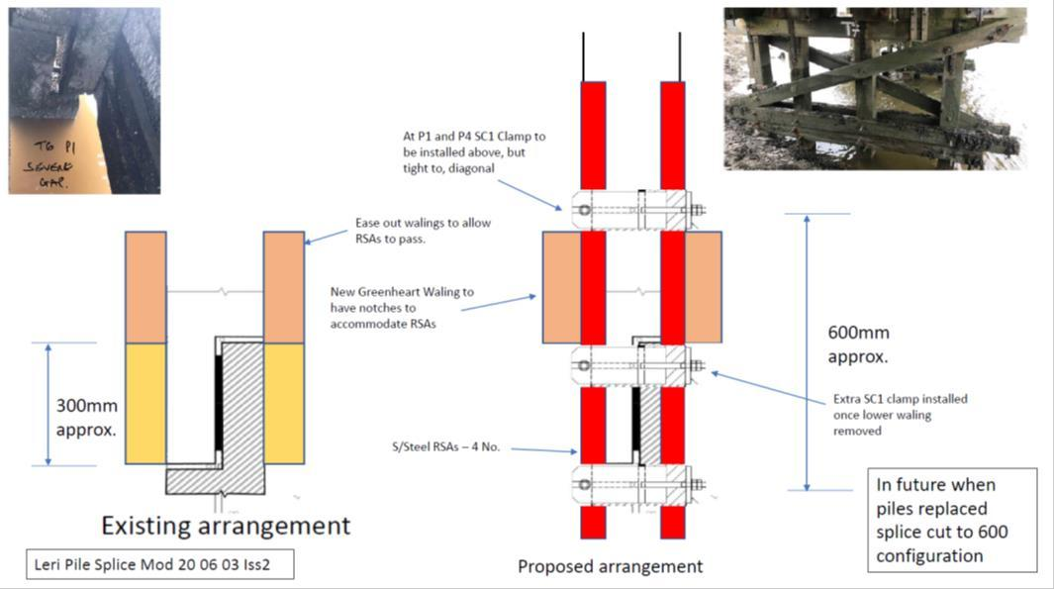
Network Rail
ITT 8611 – SBA2 Timber Structures Urgent Works
2. Technical Response

Suggested splice arrangement.
Diagonal TA bolt replacements
As detailed in the DRRD, a number of bolts will be changed in the diagonals throughout the structure, this will be on a one out, one in system, the original bolt will be removed, the hole reamed out to 32 mm if required with MAG drills sat on pre-fabricated holding plates which are fixed to the pile prior to drilling the SA1 strap, then a wooden 32mm bit will be used to re-bore the hole through the pile, new bolt installed, torqued and tested with double nut to lock off.
Corbal replacement:-  The methodology of replacing these is as follows, temporary works will be installed to take the weight off the corbel, this will be supported from ground level in front of the trestle existing SA8 will be removed and corbel removed, the new corbel will be installed using block and tackle from above the new SA8 straps will then be installed. | 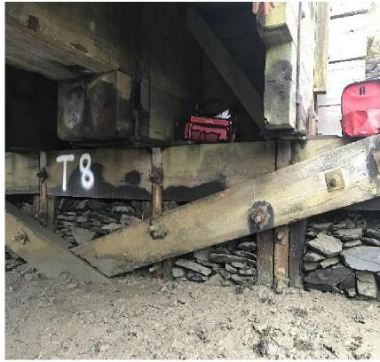

Page 10 of 17

Network Rail
ITT 8611 – SBA2 Timber Structures Urgent Works
2. Technical Response

Lateral restrain diagonals throughout structure: -
On inspection of the structure it was determined that numerous Lateral Restraint diagonal timbers were missing, lose or not up to standard, these will be replaced under live load at any time during the project.
A competent team of joiners will be deployed to re-install these timbers; measurements will be taken so that a template made for each individual timber prior to cutting. All end to timbers must be 45-degree angles and no cut to a point. Fitting must be tight, and any packing is to be at the bottom cut not the top. Timber will be fixed with Stainless Steel fixings throughout. The 4ft timbers will be fixed through the centres with a M30-300mm bolt and double nuts installed, all torqued and tested prior to being signed off.
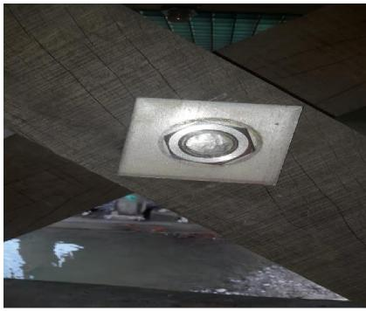
. New diagonal restraint timber photo with centre bolting installed at Artro. Pile replacement works during possession: -
All piles needing changing will be carried out during the 55.5 hr blockade. Methodology for this operation is the tried and tested pile lifting system used successfully used at Artro Ph 2.
As with the temporary pile splice arrangement a propping system will be utilised during the main possession, this will be installed prior to the possession to save time, however it will be installed such that it doesn’t take any load as it is only designed for dead weight not live loading. Within the possession the final packs or tightening of screw jacks will ensure it taking dead load as designed. Below is example of prop as detailed on Barmouth structure. This will be subject to a Form 002/003 produced by Cass hayward.
Page 11 of 17

Network Rail
ITT 8611 – SBA2 Timber Structures Urgent Works
2. Technical Response

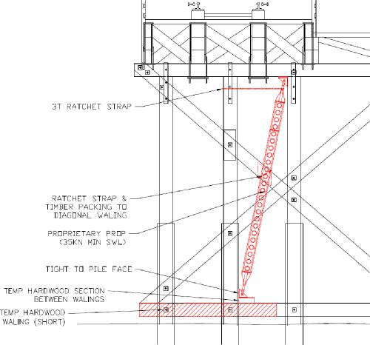
The Mabey system will be placed over the top of the trestle that need piles removing. Initially the lower section will be installed prior to the possession in dayshift utilising line blocks. Holes will be drilled through deck planks to allow for the Macalloy bar to be dropped through and fastened to the lifting beam underneath the deck of the bridge, at this stage the system will be supported from plates and couplers
During the maim possession phase 2 will be installed, once agreed the system will be jacked up taking the weight of the crosshead. The diagonal and wailer will be removed from one side, and set aside for re-use or replaced. The straps will be secured to pile holding it in position. Both SC1 clamp assemblies will be cut off and set aside for removal. The pile is now free to be lifted out using block and tackle off the Maybe lifting system, the pile stub will be recut at a level determined by the engineer and the template used off this will be used to cut the new pile. The pile will then be lifted back into position and checked for correct level.
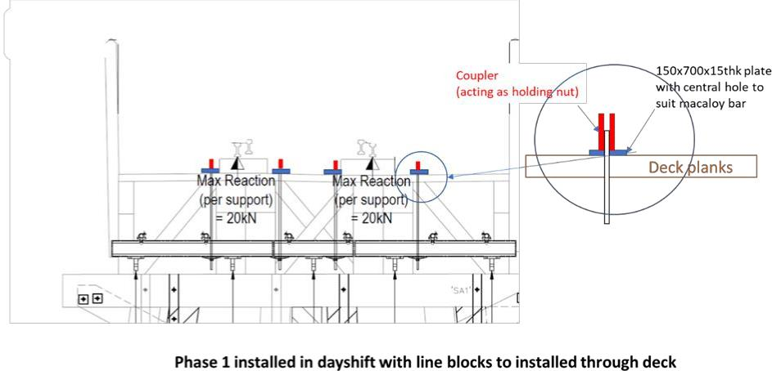
Page 12 of 17

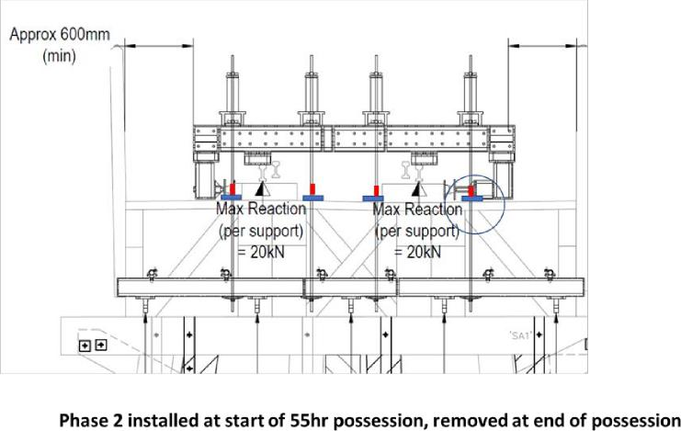
Network Rail
ITT 8611 – SBA2 Timber Structures Urgent Works
2. Technical Response

New SC1 clamp assemblies will be strapped back on the pile splice joint and torqued to required load. New SA1 strap will be placed over the crosshead and bolted up again being torqued and tested. Repeat the operation to all piles.
Steel work to be replaced during the urgent works: -
Any old bolts or straps needing replacing will be new for old. They will be replaced with stainless steel throughout. New SA1 clamps will be supplied without pre drilled holes for the pile holes, the methodology for this is to drill the new pile and insert the TA1bolt assembly at both locations, with the bars inserted, we will offer the blank SA1 strap to the bolts and mark off where the holes are to be drilled, we have had a successful trial run of this system at Dovey, each hole taking approx. 1.5 minutes to drill.
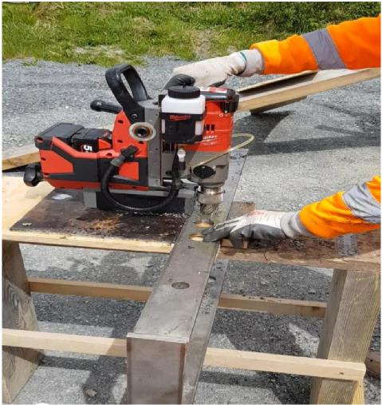
Page 13 of 17

Network Rail
ITT 8611 – SBA2 Timber Structures Urgent Works
2. Technical Response

Above, is a photo of the trial mentioned. This is a battery-operated magnetic drill; We have had plates fabricated which fasten to the pile allowing easy and very precise drilling of the SA1 strap. The older method of pre-drilled steel straps needed very accurate drilling through the strap, pile and strap again in situ, and was never easy!
SA8 and SA9 strap assemblies are required for the corbels and also the main beams at some locations, these will be done during the possession, on a 1 in 1 out basis. We will be using the adjustable straps as these are easier to install and fundamentally easier to remove for wood maintenance in the future, once the straps are replaced, they will be torqued, tested and double nuts installed as standard. Any packing requirements will be dealt with at the time of installation cutting down on revisit times.
Below are drawings of the strap assemblies to be used on this project. SA8 CORBAL STRAP AND SA9 MAIN BEAM STRAP DETAILS
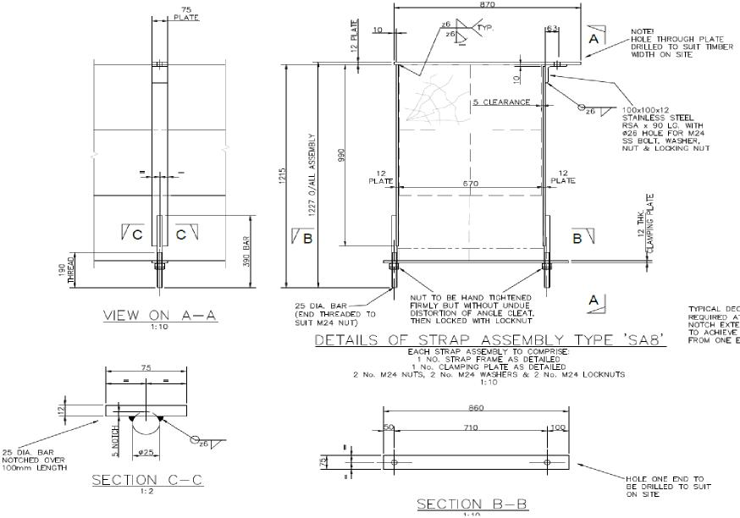
Page 14 of 17

Network Rail
ITT 8611 – SBA2 Timber Structures Urgent Works
2. Technical Response

7 RRV WORKS
An RRV will be required early on in the programme to take the wailers to site and lower onto a holding pontoon, the RRV will use the crossing at Ynys-las to access the track and reverse back to the compound for trailers and the timber elements to be collected and distributed as necessary. The RRV will also be required for 1 shift at the end to remove all old wailers and straps etc. traffic management with stop and go boards for on tracking.
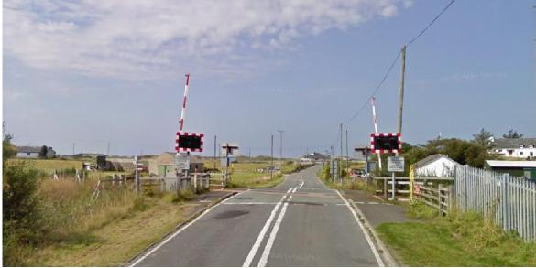
8 Pontoon works
Most of the works on Leri viaduct will require the use of pontoons. Changing straps and diagonal restraint timbers will require a scaffold tower erected on them to reach these works. the pontoons will be launched at a pre-arranged location and tied off while not in use, the pontoons will be managed by a water rescue team who will be on site at all times for emergency procedures and moving pontoons around the bridge safely.
Please see below picture taken at ARTRO, showing pontoon in position, after having a crosshead installed.
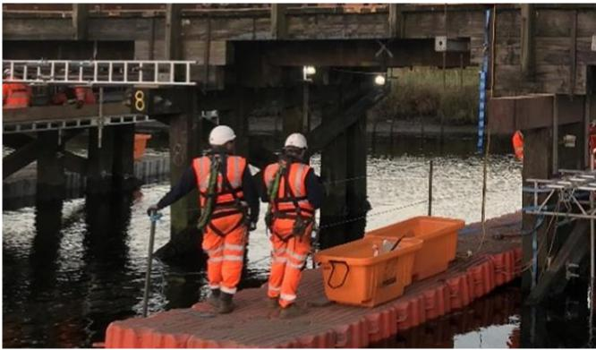
Page 15 of 17

Network Rail
ITT 8611 – SBA2 Timber Structures Urgent Works
2. Technical Response

9 Dive team works
Dive team requirements
Main 53hr possession:
Replace pile 2 T4
Replace pile 4 to T5
Replace pile 3 to T7
Standard days
Underwater survey to clear debris and check proposed pile splice locations. Standard mid-week and weekend possessions (nights) 6hrs working
Removal of wailings and installation of straps one pile at a time (based on completing 2No piles per night) trestles 2, 3, 4, 5, 6 & 7 5No piles per trestle therefore 30No pile splices i.e. 15 nights
10 Scaffolding requirements
Temporary tower scaffold off pontoons to be utilised for general access. Trestle scaffold access for spans 2, 4, 5, 6, 7, and 8
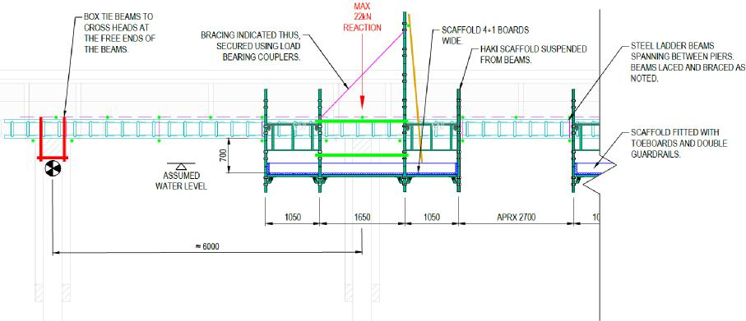
Typical trestle access scaffold (extract Artro scheme)
Page 16 of 17

Network Rail
ITT 8611 – SBA2 Timber Structures Urgent Works
2. Technical Response

11 Cabins, site set up arrangement
Typical site set up within NR land, note car parking, additional storage and access to bridge will need to be arranged in 3rd party land.
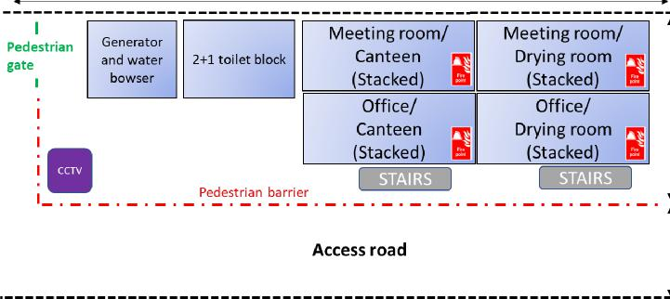
Page 17 of 17

