CRoW Appendix 4 (140_10_SD02)  CRoW Act 2000: Natural Resources Wales application for permission - Formal Notice |  | 
Natural Resources Wales Formal Notice.
Requirements of Section 28I of the Wildlife & Countryside Act 1981 as amended by the Countryside and Rights of Way Act (CRoW) 2000.
Duty in relation to granting any consent, licence or permit for activities likely to damage Sites of Special Scientific Interest (SSSI).
Guide to filling in this form for Natural Resources Wales staff:
To be completed by Permitting Officers for any applications for a permission which the Natural Resources Wales has considered under S28G duties to protect and enhance SSSIs. This applies to all proposed permissions within a SSSI, and to operations outside the SSSI boundary which are likely to damage its special features.
Refer to OI 140_10 ‘Applying the Countryside and Rights of Way (CRoW) Act 2000 to applications for permits with potential for impact on Sites of Special Scientific Interest (SSSI)’, including the flowchart in Appendix 2.
Pink italic text – drafting notes, to be deleted before completion/consultation.
Blue text – examples, to be replaced with permission-specific information.
Ensure you have completed all sections.
- Natural Resources Wales area/region/NPS hub: | South West
- Name of SSSI: | Broad Oak and Thornhill Meadows  Cae Gwynfryn SSSI  Caeau Blaneu-Mawr SSSI  Caeau Capel Hendre SSSI  Caeau Ffos Fach SSSI  Caeau Lotwen SSSI  Felin Fach Meadows, Cwmgwili SSSI
- Type of permission: | Environmental Permit
- Date for Natural Resources Wales permit determination: | 12/04/21
- Predicted 28 day date for response from NRW conservation/ecology (under S28 I(4)): | -
- Natural Resources Wales reference no: | PAN 011338
- National grid reference: | SN 57736 11573
- Description of proposal: | The application is for a Tier 3 Bespoke Application for a Inert and Non Hazardous Waste Transfer Station without treatment. The site is located Land Adjacent to Ty-Newydd, Thornhill Road, Cwmgwili, Llanelli, Carmarthenshire, SA14 6PT.  The site will process 32,500 Tonnes per Annum and all waste will be stored in skips (covered) an impermeable sealed surface that drains to a waste storage tank. Areas of the site that do not interact with waste will drain via interceptor to soakaway (with shut of valve for accidents).  The location of the site in relation to the multiple locations of the above listed SSSI is shown by the two figures below:  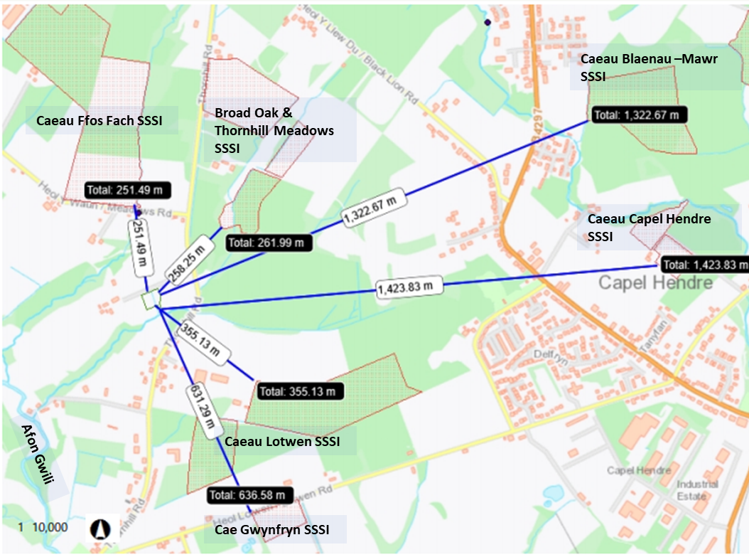  Figure 1 – The location of the proposed waste facility in relation to Caeau Ffos Fach SSSI, Broad Oak & Thornhill Meadows SSSI, Caeau Blanau – Mawr SSSI Caeau Capel Hendre SSSI, Caeau Lotwen SSSI, and Cae GwynFryn SSSI.  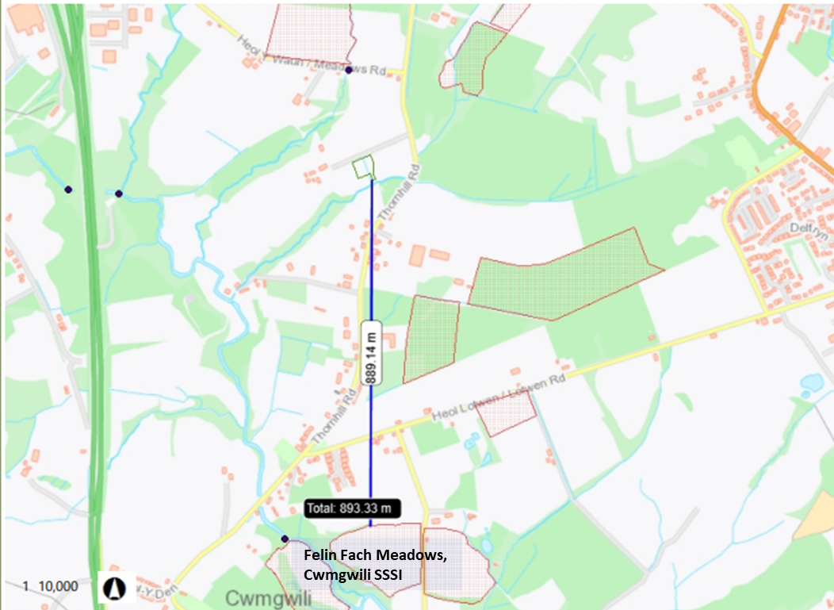  Figure 2 – The location of the proposed waste facility in relation to Felin Fach Meadows, Cwmgwili SSSI
- Is the proposed activity within (wholly or partially) the SSSI boundary? | NO
- Has there been any pre-application discussion or correspondence with NRW conservation/ecology | NO
- What aspect(s) of the proposed permission may damage the features which are of special interest for the SSSI?
Caeau Ffos Fach SSSI, Broad Oak & Thornhill Meadows SSSI, Caeau Blanau – Mawr SSSI, Caeau Capel Hendre SSSI, Caeau Lotwen SSSI, and Cae GwynFryn SSSI, Felin Fach Meadows, Cwmgwili SSSI

The following ‘Operations Requiring Consent’ (or other activities associated with the permission) that may cause damage) are relevant to the proposed permission.

- 7. Dumping, spreading or discharging of any materials.
- 22. Storage of Materials

The following SSSI features and mechanisms of impact have been considered to assess the likelihood of damage:

- Protected habitats (eg. Pastures and Meadows) and their supported invertebrate biology affected by suspended solids, and nutrients in run-off water from the proposed site.
- Protected habitats (eg. Pastures and Meadows) and their supported invertebrate biology affected by deposition of fugitive dust emissions from the proposed site.
- Decision
The proposed permission is not likely to damage any of the flora, fauna or geological or physiological features which are of special interest.

Caeau Ffos Fach SSSI, Broad Oak & Thornhill Meadows SSSI, Caeau Blanau – Mawr SSSI, Caeau Capel Hendre SSSI, Caeau Lotwen SSSI, and Cae Gwyn Fryn SSSI - Discharge of site run-off

The site has an impermeable surface with sealed drainage areas of the site that come into contact with waste, or where waste containers are stored has separate drainage whereby any water (eg.rainfall) is directed to a underground storage tank and therefore not connected to the above listed SSSI’s. It is worth noting also that the waste types accepted by the site are inert and non-hazardous and all waste is stored in containers. Waste is only tipped onto the impermeable surface for sorting into individual containers (skips) All skips are covered when not in use.

All remaining areas of the site are deemed clean and are drained via interceptor (with isolator valve) and are discharged by Soakaway. The operator has confirmed that the small drainage ditch south of the site runs east to waste in the opposite direct to the multiple SSSIs. It is therefore not deemed that any water discharged by the soakaway on site would drain into any of the SSSis but instead in an easterly direction towards the Afon Gwili.

Due to this the above SSSI are not considered any further as the proposed permission is not likely to damage any of the flora, fauna or geological or physiological features which are of special interest..g. No mechanism (hazard), no pathway for features to be affected, features are not sensitive to this activity.

Felin Fach Meadows, Cwmgwili SSSI - Discharge of site run-off

The site has an impermeable surface with sealed drainage areas of the site that come into contact with waste (‘dirty area on plan below), or where waste containers are stored has separate drainage whereby any water (eg.rain fall) is directed to a underground storage tank and therefore not connected to the above listed SSSI’s. It is worth noting also that the waste types accepted by the site are inert and non-hazardous and all waste is stored in containers. Waste is only tipped onto the impermeable surface for sorting into individual containers (skips) All skips are covered when not in use.

All remaining areas of the site are deemed clean and are drained via interceptor (with isolator valve) and are discharged by Soakaway. The operator has confirmed that the small drainage ditch south of the site runs east to towards the Afon Gwili. It is therefore recognised there is a conceivable pathway between the site and the Felin Fach Meadow, Cwmgwilli SSSI for any water discharged by the soakaway. However due to the following reasons we do not consider it is likely that any discharges would damage any flora, fauna or geological or physiological features which are of special interest:

- The soakaway only discharges from ‘clean’ areas of the site. The areas of the site that waste is not tipped on to or stored on. As a result there should be no waste material in the run off from site.
- All run off from the clean area of the site is discharged via an interceptor to prevent any discharge of hydrocarbons (as a result of vehicles entering the site) this is deemed suitable (this is confirmed in Section 3.1 of the operators EMS). As a result there should be no hydrocarbons in the run off from site.
- Accidents (no return valve)
- Spill kits (and bunds) confirmed in the FPMP to ensure fire water doesn’t enter the soakaway
- Although the above should prevent run-off from waste being discharged to the environment it is worth pointing out that the operator has only proposed to accept non-hazardous and inert waste types only and has outlined Waste Acceptance Criteria in their EMS to ensure that they do not accept non-conforming wastes. This is a further level of protection that makes it unlikely the any discharges from site would damage any flora, fauna or geological or physiological features which are of special interest:

The standard control measures outlined above form the operator’s EMS was considered alongside the ‘How to comply with your environmental permit’ guidance and deemed acceptable considering the type and scale of the waste activities and the nature of the waste codes accepted on site.
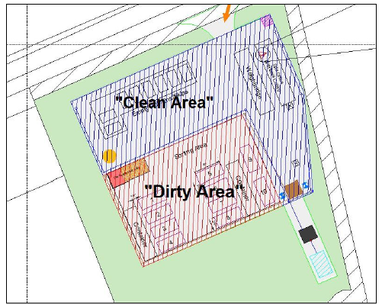

All SSSIs - Emissions to Air and Land

Due to the type of site activities there should be minimal emissions to air and no emissions to land. In regards fugitive emissions of dust from site activities we have assessed the operators standard control measures outlined in their EMS and the ‘How to comply with your environmental permit’ guidance. Which outlined the following:

Speed limit of 10 mph shall be implemented within the site;
- Any existing vegetation and bund screening around the site will be maintained to reduce wind speeds;
- New vegetation to be planted and maintained in accordance with planning permission for the site;
- The drop distance when tipping shall be reduced to the minimum the equipment can safely achieve;
- All staff members will be required to notify the site manager of any excessive fugitive emissions observed;
- An adequate water supply for dust suppression will be available for use at the site;
- All skips on site will be sheeted/covered;
- All lorries delivering or removing materials from site to be sheeted or suitably covered.
- No treatment (eg. shredding, crushing or compacting) of waste.

Natural Resources Wales is minded to:
Issue the permission

- Name and job title of Natural Resources Wales officer: | Permitting Officer
- Date form sent to NRW conservation/ecology | 12/04/2021

