CRoW Appendix 4 (140_10_SD02)  CRoW Act 2000: Natural Resources Wales application for permission - Formal Notice |  | 
Natural Resources Wales Formal Notice.
Requirements of Section 28I of the Wildlife & Countryside Act 1981 as amended by the Countryside and Rights of Way Act (CRoW) 2000.
Duty in relation to granting any consent, licence or permit for activities likely to damage Sites of Special Scientific Interest (SSSI).
- Natural Resources Wales area/region/NPS hub: | Installation: SW EPR Regulated Industry.  Environment team: Neath Port Talbot.
- Name of SSSI: | The project has been screened for SSSIs sites within 2Km of the installation boundary, and the following have been identified:  Eglwys Nunydd Reservoir SSSI  Margam Moors SSSI  Note: While Cefn Cribwr and Kenfig SAC are subject to HRA assessment for this permit determination, they do not require consideration on the App4 for their SSSI designation, as they lie beyond the 2km screening distance for SSSI assessment (although within the 10km SAC screening distance)
- Type of permission: | Environmental Permit
- Date for Natural Resources Wales permit determination: | 26/04/2021. Note area EPR team request rapid turnaround if possible, owing to pressure from the applicant to make our determination.
- Predicted 28 day date for response from NRW conservation/ecology (under S28 I(4)): | 07/05/21
- Natural Resources Wales reference no: | PAN-011056; EPR/ZP39339GL
- National grid reference: | Main stack NGR: X: 279072, Y: 186189
- Description of proposal: | Western Wood Energy Facility – Margam is a biomass combustion unit for the generation of electricity. It is already permitted by Natural Resources Wales, and combusts approx. 140,000 – 160,000 tonnes per annum of various biomass, in order to generate electricity. The plant has a thermal rating of 47.5 MW_{th} and generates 14 MW_{e} of electrical power for export. The main emissions to air, following bag filtration to remove particulate, are oxides of nitrogen (NO_{X}), carbon monoxide and residual particulate, released via a 55 m high stack. The fuel characteristics and composition means that air pollution control techniques for acid gases (such as SO₂ and HCl) are not required.  Until now, optimisation of primary combustion (such as combustion system and secondary air optimisation) was sufficient to control emission of other pollutants, including NO_{X,} therefore secondary measures for NO_{X} reduction were unnecessary. However, the plant has previously operated close to the daily NO_{X} emission limit of 250 mg/m³ (@6% O₂), and the operator now considers it necessary to implement secondary NO_{X} control. The operator has submitted a normal variation in order to install secondary pollution abatement to the air emissions control system, for the further control of NO_{X}. This is to ensure compliance with the current emission limit value for NO_{X}, while allowing a more diverse range of biomass fuels to be combusted, as also proposed in the variation.  The proposed secondary NO_{X} abatement is Selective non-catalytic reduction (SNCR). The SNCR system will inject aqueous urea (CO(NH₂)₂) into the combustion chamber at around 950˚ - 1000˚ C, controlling NO_{X} according to the chemical reaction below, whereby NO is reduced to N₂ (nitrogen):  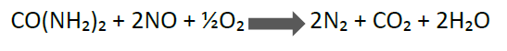  The proposed SNCR system is supplied by the company that provided the boiler, therefore ensuring compatibility of the equipment and technique. While SNCR reduces NO_{X}, unwanted additional emissions of ammonia can result from the breakdown of urea, if it is not all used in the reduction of NO according to the reaction above; so-called “ammonia slip”. Therefore optimisation of the SNCR system involves obtaining maximum NO reduction, while minimising excess urea.  As ammonia is a potentially significant ecological pollutant directly, and also as a potential contributor to nutrient nitrogen and acid deposition. The potential impact from the aerial emissions of these pollutants are the main focus of this assessment. Other potential pollutant pathways / impacts are briefly considered, but as the plant is already built, permitted, and operating, most other impacts are unchanged and do not require re-assessment.
General location map:
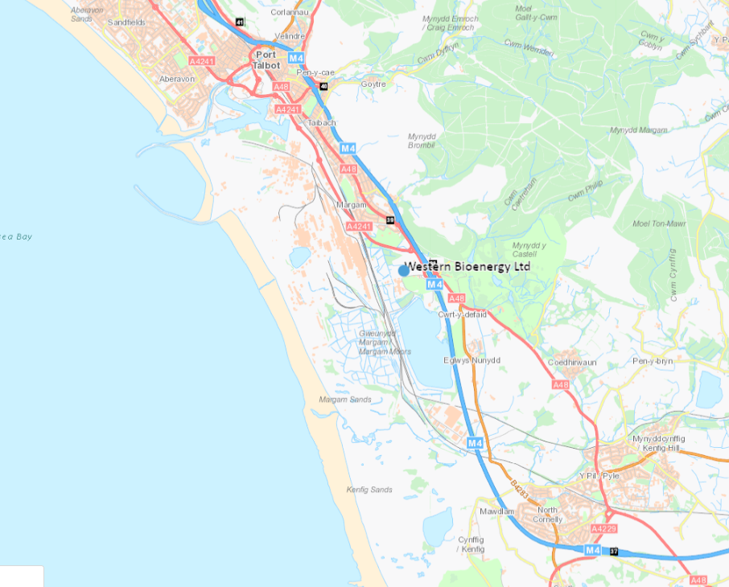
© Crown Copyright and database right 2021. Ordnance Survey licence number 100019741.

SSSI within 2km screening distance:
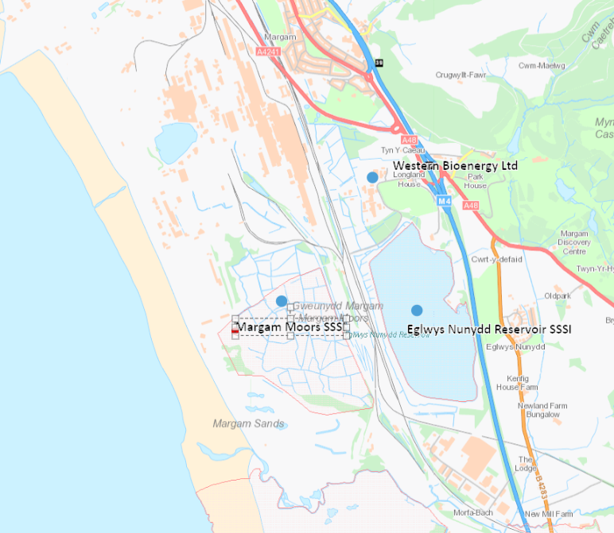
© Crown Copyright and database right 2021. Ordnance Survey licence number 100019741.
- Is the proposed activity within (wholly or partially) the SSSI boundary? | No  As shown above, Eglwys Nunydd is to the south of the installation (minimum approx. 470m away), and Margam Moors to the south west (minimum approx. 880m away). No part of the installation falls within any SSSI area,
- Has there been any pre-application discussion or correspondence with NRW conservation/ecology | No There has been correspondence between NRW Installations Permitting and the NRW air quality/ecology specialist advisor Khalid Aazem, before agreeing the content of this assessment during determination.
- What aspect(s) of the proposed permission may damage the features which are of special interest for the SSSI?
The following ‘Operations Requiring Consent’ (or other activities associated with the permission) that may cause damage) are relevant to the proposed permission.

In broad interpretation the activity may be considered to include forms of:
7. Dumping, spreading or discharging of any materials (aerial pollutants from stack outside the SSSIs but potentially impacting within);

The potential effects of these proposed activities are considered below.

The following SSSI features and mechanisms of impact have been considered to assess the likelihood of damage:

- Source: Combustion of biomass fuels for electricity generation resulting in emissions of gaseous pollutants – additional impact of and from ammonia as a result of SNCR addition:

SSSI Features considered: All habitats, as sensitive to aerial pollution. General air quality Environmental Standards (ES) for ecological sites are applied, and in addition, specific site-specific limits are applied for habitats which have specific sensitivity to nutrient nitrogen deposition or acid deposition. Indirectly, all other SSSI features are protected by protection of supporting habitats. Relevant site-specific environmental standards for nutrient nitrogen, acid deposition, and ammonia have been confirmed with the NRW specialist for aerial pollutant impacts on protected sites (Khalid Aazem), and communicated to the applicant, who has updated their air quality assessment as appropriate.

Mechanisms of impact: Emission and dispersion of aerial pollutants from chimney stack of the proposed facility, leading to potential increase in the Ambient concentration of pollutants. Possible impact on SSSIs is considered for pollutants for which an environmental standard is set to limit harm to SSSIs, including site specific limits as noted above, and which installation of SNCR causes an expected change in emissions.

Assessment of potential impact: For pollutants which would be emitted by the proposed variation to add SNCR, that have an environmental standard for either or both of the SSSIs within screening distance there is an impact pathway in principle. The key additional pollutant to be emitted is ammonia, which also contributes to nutrient nitrogen and acid deposition.

The applicant has completed a detailed air quality assessment (AQA) using dispersion modelling for emissions from the main stack, which has been checked by NRW. Emissions are assumed to be at a performance level guaranteed by the technology provider, of 10 µg/Nm³ of ammonia (at 6% O₂), which we consider to be Best Available Technique (BAT). All other pollutant maximum emission concentrations are unaltered by the variation . Maximum process contributions (PCs) from the proposed addition of SNCR have been calculated for the potentially affected SSSIs, as detailed in the table below, and provided by the applicant in the following reports:

- Original application email containing AQA document “atmospheric dispersion modelling” dated April 2020
- Schedule 5 response – “Air Quality Response to the Schedule 5 Notification” dated March 2021
- Email clarification of discrepancy in Schedule 5 response, 07/04/21

The AQA contains a number of conservative assumptions. The impacts stated below are from the whole facility, including contribution from existing emissions of sulphur dioxide and nitrogen oxides, which although unaltered by the proposal, are (relatively minor) co-contributors to nutrient nitrogen and acidification. These will already form part of the background, so there is an element of protective “double accounting”.

Pollutant | ES / EAL  ⁽¹⁾ | Back-ground  ⁽¹⁾ | Process  Contribution  (PC) ⁽¹⁾ | PC as % of ES | Predicted  Environmental Concentration (PEC) ⁽¹⁾ | PEC as % ES
Eglwys Nunydd Reservoir SSSI (ER1)
Ammonia (µg/m³) | Not sensitive
N Deposition (kg N/ha/yr) | Not sensitive ⁽²⁾
Acidification (Keq/ha/yr) | Not sensitive ⁽²⁾
Margam Moors SSSI (ER2)
Ammonia (µg/m³) | 3 | - | <0.01 | 0.1 | - | -
N Deposition (kg N/ha/yr) | 20-30 | - | 0.02 | 0.12 | - | -
Acidification (Keq/ha/yr) ⁽³⁾ |  | - | 0.01 | 0.49 | - | -
  Min_{Cl} MaxN 2.8
(1) Units as given per table row.
(2) The SSSI is listed for wintering wildfowl and is not considered directly sensitive to aerial pollutants. In a broader sense, the site is protected by application of BAT to permitted installations of this type. Were the general limit for ammonia of 3 µg/m³ applied, the PC would be insignificant.
(3) The critical load figures for acid deposition are quoted as a range – from Min_{Cl} to Max_{Cl}, for each of three parameters (Max S, Min N and Max N). For screening purposes, the Min_{Cl}MaxN is used. For further explanation of the acid deposition parameters, see (apis.ac.uk – guide and apis.ac.uk – critical load tool). Figures in italics are therefore recalculated by NRW from applicant data, as they made initial assessment against Max_{Cl}MaxN.

Conclusion – impact of aerial emissions: In all cases, from the data provided, the PC is <1% of the long-term environmental standard (ES), meaning that all pollutant potential impacts can be considered insignificant. Therefore we are satisfied that the proposed variation is not likely to damage either of the SSSIs within screening distance. It is therefore not necessary to consider background pollutant concentrations and predicted environmental concentrations (PECs)

- Source: Other potential impacts of the proposed installation, such as physical damage to flora / fauna, disturbance, smothering, entrapment, changes to water abstraction or emission.

SSSI Features considered: All

Mechanisms of impact: All (other than air quality as detailed above)

Assessment of potential impact: Other potential impacts have been screened, and determined not to have a significant credible effect on the SSSIs. The site is an existing installation, currently permitted to burn biomass. The effects on the SSSIs of the proposed variation will be negligible, other than the air quality factors assessed above.

For example, there is no transport activity proposed within the SSSIs, therefore no anticipated impact of such activity. There will be no abstraction or changes to discharge to water, which in any case are of uncontaminated rainwater only. Discharges to sewer are consented, and will be unaltered. New waste biomass types permitted have similar characteristics to those already permitted, and have no additional environmental impacts.

Activities on site will be subject to standard permitting requirements and environmental management system controls, such as secondary containment of harmful liquids, and management techniques for handling permitted potentially dusty biomass, meaning that the risk of off-site impacts in normal, abnormal, and emergency situations is minimised.
Conclusion – all other ongoing impacts of the facility are unaltered, and are not likely to damage either of the SSSIs within screening distance.
- Decision
ii) The permission is not likely to damage any of the flora, fauna or geological or physiological features which are of special interest because of conditions.

Potential impacts have been described and assessed in detail above. The whole of the installation will be subject to BAT and permitting conditions, which will limit the magnitude of impacts in normal operation, and will minimise any risks from abnormal or emergency conditions.

The applicant has undertaken to meet an air Emission limit value for ammonia (10 mg/Nm³ at 6% oxygen), which limits impacts of associated aerial pollutants. Application of an ELV in the permit at this level is considered to be a condition of proposed permit decision, in order to limit the possible effect of the installation on the environment in general, including specifically the SSSIs.

Natural Resources Wales is minded to: Issue the permission with conditions to ensure no damage to SSSI

There will be the standard permitting conditions, applicable to any similar installation. In addition, a site-specific ammonia emission limit value will be set at 10mg/Nm³, the performance level that the operator has indicated is achievable, and is considered BAT for the installation.
- Name and job title of Natural Resources Wales officer: | David Poole  Senior Permitting Officer
- Date form sent to NRW conservation/ecology | 09/04/21
For Natural Resources Wales use only, once NRW conservation/ecology response received
- NRW conservation/ecology comment on assessment: | Please delete as appropriate:  i) NRW conservation/ecology advise the operation can go ahead  ii) NRW conservation/ecology advise the operation can go ahead with conditions  iii) NRW conservation/ecology advise against permitting the operation  Please ensure that the NRW conservation/ecology response is attached to this Formal Notice.
- Name and job title of NRW conservation/ecology officer:
- Date of receipt of NRW conservation/ecology response:

