

Permit with introductory note
The Environmental Permitting (England & Wales) Regulations 2016

Vale Europe Limited

Clydach Nickel Refinery
Clydach
Swansea
SA6 5QR

Permit number

EPR/BL4567IZ

Clydach Nickel Refinery

Permit number EPR/BL4567IZ

Introductory note

This introductory note does not form a part of the permit

The main features of the permit are as follows.

Vale Europe Ltd operates a nickel refinery producing approximately 40,000 tonnes per annum of nickel pellets, powders and coated products using the ‘nickel carbonyl’ process. The nickel refinery plant operates continuously and has the following elements:

Process gas plant – The carbon monoxide (CO) and hydrogen (H₂) needed for nickel refining are produced by the steam reforming of natural gas. The natural gas is de-sulphurised, mixed with steam and then decomposed over a catalyst at 800°C to give hydrogen, carbon monoxide, carbon dioxide (CO₂) and methane (CH₄). The yield can be up to 2800m³/hr hydrogen and 400m³/hr carbon monoxide. There is a small storage capacity for purified hydrogen and carbon monoxide but most goes directly to the process. Carbon dioxide is also recovered for use as an inert purge gas.

Kiln Plant – Impure nickel oxide imported from Canada as fine granules is stored in silos prior to transfer to the kiln plant which has two lines of rotary kilns. The oxide is reduced by counter current flow of hydrogen at temperatures between 300°C and 500°C producing impure nickel. This passes by gravity to an activation kiln where a sulphur containing gas and hydrogen are passed over the impure nickel. The activated material is passed to volatilisation kilns, where it is reacted with carbon monoxide. In the volatiliser the nickel is converted to gaseous nickel carbonyl Ni(CO)₄ this gas is passed through a cyclone and filtered before entering a ring main. Unreacted metallic process intermediates are transferred to a stabilisation kiln where partial oxidation makes the residues non-pyrophoric, before their return to Canada for reprocessing. The off gas from the reduction kiln is passed through cyclones and scrubbers. The remaining hydrogen is heated and returned to the reduction process. Gas from the activation kiln is cycloned and scrubbed before being returned to the reduction plant. Gas from the stabilisation kiln is cleaned by ceramic filters and then passed to the gaseous effluent plant. The carbon monoxide and nickel carbonyl gas are circulated around a ring main feeding the pellet and powder plant area:

Pellet and powder plant – This plant consists of 19 pellet units, 8 powder decomposers and a fluid bed decomposer. In the pellet units nickel carbonyl gas decomposes onto pre-heated pellets increasing their size. Pellets of the required size are removed, screened and packed. The powder decomposers operate at higher temperatures, the nickel carbonyl decomposes in the vessel head space and powder falls under gravity into a consolidator before being removed, sieved, blended and packed. The fluid bed decomposer is used to produce speciality coated powders such as nickel-coated graphite.

Aqueous effluent plant – This plant is designed to treat all process effluent streams including surface and storm water.

The treatment involves dosing with caustic soda, thickening and sand filtration, with the treated water being discharged to the River Tawe and the thickener sludge being dewatered followed by thermal drying. The sand filter backwash is returned to the raw effluent sump from where it is fed forward into the plant.

As of the variation V007 modification to the treatment process involves the effluent from the Kiln 1&2 primary scrubber (K1&2PS) diverted to a K1&2PS sump tank (a hire tank until date of improvement condition IC11). The effluent is pumped to directed to emergency caustic dosing tank (ECDT) during where the coagulant Nalco 77135 is added. Caustic solution is added to the effluent in the ECDT which overflows to the thickner.

Gaseous effluent plant – Gas from the volatilisation kilns and the pellet and powder plants is incinerated to destroy residual nickel carbonyl. The waste gases then pass through a bag filtration plant, which remove solids before exhausting to the main stack.

The status log of the permit sets out the permitting history, including any changes to the permit reference number.

Status log of the permit
Description | Date | Comments
Application received | 20/12/2001 | Application duly made 20/12/01
Operator requests Commercial  Confidentiality for diagrams of the foam & fibre coating process | 28/12/2001 | Request agreed to.  Notice of Determination sent to  Operator 31/12/01
1st Schedule 4 Notice Issued | 24/01/2002 | 1st Schedule 4 Notice Response received 23/04/2002
2nd Schedule 4 Notice Issued | 07/06/2002 | 2nd Schedule 4 Notice Response received 18/07/2002
Request from Agency (1) to extend determination date to 29/11/2002. | 18/07/2002 | Operator agrees to the extension to determination period. 23/07/2002
Request from Agency (2) to extend determination date to 28/03/2003. | 19/11/2002 | Operator agrees to the extension to determination period. 27/11/2002
3rd Schedule 4 Notice Issued | 17/03/2003 | 3rd Schedule 4 Notice Response received 25/07/2003
Operator informs the Agency of change of company registered office. | 22/09/2003 | Information added to application.
Request from Operator (1) to extend determination date to 22/09/2003. | 27/07/2003 | Agency agrees to extension to determination period. 27/07/2003
Request from Operator (2) to extend determination date to 22/10/2003. | 15/09/2003 | Agency agrees to extension to determination period. 15/09/2003
Additional information received on flood defence pumps | 19/09/2003 | Information added to application.
Request from Agency (3) to extend determination date to 31/10/2003. | 14/10/2003 | Operator agrees to the extension to determination period. 15/10/2003
Request from Operator (3) to extend determination date to 14/11/2003 | 15/10/2003 | Agency agrees to extension to determination period. 15/10/2003
Permit Issued | 14/11/2003 | ----

Status log of the permit
Description | Date | Comments
Application EPR/BL4567IZ/V002 | Application received 27/01/2005 | Application returned. Dealt with instead as a Regulation 16 notification of change.
Application EPR/BL4567IZ/V003 | 08/12/2008 | Application duly made 29/01/2009
Variation Issued | 30/01/2009
Application EPR/BL4567IZ/V004 | Application received 30/07/2010 | Application duly made 30/07/2010
Additional Information Received | 19/08/2010
Variation issued | 28/09/2010
Application EPR/BL4567IZ/V005 | Application received 02/04/2012 | Application duly made 23/05/2012
Additional information received | 19/06/2012 | Document entitled ‘Clarification:  “Atmospheric Dispersion  Modelling Study of Releases from  Proposed Advanced Energy Project”, P1028/R015 Rev 1, page 19’ received.
Additional information received | 28/06/2012 | Appendix H to the application document ‘Supporting document in respect of application to vary environmental permit reference BL4567IZ under the Pollution Prevention and Control (England and Wales) Regulations 2010’ [sic], reference P1028/R007-Rev  1.
Request for further information issued | 06/07/2012 | Further information requested relating to the operation of the RTO and potential impacts associated with abnormal operation.
Additional information received | 26/07/2012 | Information relating to existing soil acidity in the locality and background metals concentrations at a range of monitoring stations.
Additional information received | 27/07/2012 | Document entitled ‘Assessment of the impact of releases from the Vale AEP on the North and South bank of the River Tawe’, document reference P1028/R020, issue date 26/07/12.
Response to request for further information dated 06/07/12 received | 09/08/2012
Additional information received | 10/08/2012 | Revised version of document entitled ‘Atmospheric dispersion
 |  | modelling study of releases from proposed advanced energy project’, reference P1028/R015 Rev 2, dated July 2012. This replaces the original version of this document that was included as Appendix 14 of the document ‘Supporting document in respect of application to vary environmental permit reference BL4567IZ under the Pollution Prevention and Control (England and Wales) Regulations 2010’ [sic], reference P1028/R007-Rev 1 when the application was received.
Variation and consolidation issued  EPR/BL4567IZ/V005 | 14/12/2012 | Notice of variation and consolidation issued  (incorporating a new, consolidated permit).
Regulation 60(1) Notice of request for information | 27/07/2016
Regulation 60(1) response received | 30/11/2016 | Implementation of BAT conclusions under IED
Variation application received | 21/12/2016 | Application to vary the process for removing and drying solids from the waste water
Variation application received. | 23/06/2017 | Variation application to remove Pyrolysis plant received.
Natural Resources Wales Non-Ferrous Metals Sector Review 2016 Permit EPR/BL4567IZ  Variation issued EPR/BL4567/V006 | 16/10/2017 | Varied and consolidated permit issued in modern IED condition format.
Variation application received  EPR/BL4567IZ/V007 | Duly made  08/02/2021 | Application for the use of coagulating in the effluent treatment process
Variation Issued | 07/05/2021 | Variation Issued to Vale Euro Limited

End of introductory note

Permit
The Environmental Permitting (England and Wales) Regulations 2016

Permit number
EPR/BL4567IZ

This is the consolidated permit referred to in the variation and consolidation notice for application EPR/BL4567IZ/V007 authorising,

Vale Europe Limited (“the operator”)
whose registered office is

Suite 1
3rd Floor
11-12 St James’s Square
London
SW1Y 4LB

company registration number 00137114

to operate a regulated facility at

Clydach Nickel Refinery

Clydach

Swansea

SA6 5QR

to the extent authorised by and subject to the conditions of this permit.

Signed | Date
Holly Noble | 07/05/2021

Authorised on behalf of Natural Resources Wales

Conditions

Management

General management

The operator shall manage and operate the activities:

in accordance with a written management system that identifies and minimises risks of pollution, including those arising from operations, maintenance, accidents, incidents, non-conformance, closure and those drawn to the attention of the operator as a result of complaints; and

using sufficient competent persons and resources.

Records demonstrating compliance with condition 1.1.1 shall be maintained.

Any person having duties that are or may be affected by the matters set out in this permit shall have convenient access to a copy of it kept at or near the place where those duties are carried out.

1.2 Energy efficiency
1.2.1 The operator shall:
- take appropriate measures to ensure that energy is used efficiently in the activities;
- review and record at least every four years whether there are suitable opportunities to improve the energy efficiency of the activities; and
(c) take any further appropriate measures identified by a review.

1.3 Efficient use of raw materials
1.3.1 The operator shall:
- take appropriate measures to ensure that raw materials and water are used efficiently in the activities;
- maintain records of raw materials and water used in the activities;
- review and record at least every four years whether there are suitable alternative materials that could reduce environmental impact or opportunities to improve the efficiency of raw material and water use; and
- take any further appropriate measures identified by a review.

1.4 Avoidance, recovery and disposal of wastes produced by the activities
1.4.1 The operator shall take appropriate measures to ensure that:
- the waste hierarchy referred to in Article 4 of the Waste Framework Directive is applied to the generation of waste by the activities;
- any waste generated by the activities is treated in accordance with the waste hierarchy referred to in Article 4 of the Waste Framework Directive; and
- where disposal is necessary, this is undertaken in a manner which minimises its impact on the environment.
1.4.2 The operator shall review and record at least every four years whether changes to those measures should be made and take any further appropriate measures identified by a review.

2 Operations
2.1 Permitted activities

2.1.1 The operator is only authorised to carry out the activities specified in schedule 1 table S1.1 (the “activities”).

2.2 The site
2.2.1 The activities shall not extend beyond the site, being the land shown edged in green on the site plan at schedule 7 to this permit.

2.3 Operating techniques

2.3.1 (a) The activities shall, subject to the conditions of this permit, be operated using the

techniques and in the manner described in the documentation specified in schedule 1, table S1.2, unless otherwise agreed in writing by Natural Resources Wales.

(b) If notified by Natural Resources Wales that the activities are giving rise to pollution, the operator shall submit to Natural Resources Wales for approval within the period specified, a revision of any plan or other documentation (“plan”) specified in schedule 1, table S1.2 or otherwise required under this permit which identifies and minimises the risks of pollution relevant to that plan , and shall implement the approved revised plan in place of the original from the date of approval, unless otherwise agreed in writing by Natural Resources Wales.

2.3.2 The operator shall ensure that where waste produced by the activities is sent to a relevant waste operation, that operation is provided with the following information, prior to the receipt of the waste:
- the nature of the process producing the waste;
- the composition of the waste;
- the handling requirements of the waste;
- the hazardous property associated with the waste, if applicable; and
- the waste code of the waste.
2.3.3 The operator shall ensure that where waste produced by the activities is sent to a landfill site, it meets the waste acceptance criteria for that landfill.

2.4 Improvement programme

2.4.1 The operator shall complete the improvements specified in schedule 1 table S1.3 by the date specified in that table unless otherwise agreed in writing by Natural Resources Wales.

2.4.2 Except in the case of an improvement which consists only of a submission to Natural Resources Wales, the operator shall notify Natural Resources Wales within 14 days of completion of each improvement.

3 Emissions and monitoring

3.1 Emissions to water, air or land

3.1.1 There shall be no point source emissions to water, air or land except from the sources and emission points listed in schedule 3 tables S3.1(a), S3.2(a) and S3.4.

3.1.2 The limits given in schedule 3 shall not be exceeded.

3.1.3 Total annual emissions from the emission points set out in schedule 3 shall not exceed the relevant limit in table S3.3.
3.1.4 Periodic monitoring shall be carried out at least once every 5 years for groundwater and 10 years for soil, unless such monitoring is based on a systematic appraisal of the risk of contamination

Emissions of substances not controlled by emission limits

Emissions of substances not controlled by emission limits (excluding odour) shall not cause pollution. The operator shall not be taken to have breached this condition if appropriate measures, including, but not limited to, those specified in any approved emissions management plan, have been taken to prevent or where that is not practicable, to minimise, those emissions.

3.2.2 The operator shall:

(a) if notified by Natural Resources Wales that the activities are giving rise to pollution, submit to Natural Resources Wales for approval within the period specified, an emissions management plan which identifies and minimises the risks of pollution from emissions of substances not controlled by emission limits;

(b) implement the approved emissions management plan, from the date of approval, unless otherwise agreed in writing by Natural Resources Wales.

3.2.3 All liquids in containers, whose emission to water or land could cause pollution, shall be provided with secondary containment, unless the operator has used other appropriate measures to prevent or where that is not practicable, to minimise, leakage and spillage from the primary container.

3.3 Odour
3.3.1 Emissions from the activities shall be free from odour at levels likely to cause pollution outside the site, as perceived by an authorised officer of Natural Resources Wales, unless the operator has used appropriate measures, including, but not limited to, those specified in any approved odour management plan, to prevent or where that is not practicable to minimise the odour.
3.3.2 The operator shall:
- if notified by Natural Resources Wales that the activities are giving rise to pollution outside the site due to odour, submit to Natural Resources Wales for approval within the period specified, an odour management plan which identifies and minimises the risks of pollution from odour; and
- implement the approved odour management plan, from the date of approval, unless otherwise agreed in writing by Natural Resources Wales.

3.4 Noise and vibration
3.4.1 Emissions from the activities shall be free from noise and vibration at levels likely to cause pollution outside the site, as perceived by an authorised officer of Natural Resources Wales, unless the operator has used appropriate measures, including, but not limited to, those specified in any approved noise and vibration management plan to prevent or where that is not practicable to minimise the noise and vibration.
3.4.2 The operator shall:
- if notified by Natural Resources Wales that the activities are giving rise to pollution outside the site due to noise and vibration, submit to Natural Resources Wales for approval within the period specified, a noise and vibration management plan which identifies and minimises the risks of pollution from noise and vibration;
- implement the approved noise and vibration management plan, from the date of approval, unless otherwise agreed in writing by Natural Resources Wales.

3.5 Monitoring

3.5.1 The operator shall, unless otherwise agreed in writing by Natural Resources Wales, undertake the monitoring specified in the following tables in schedule 3 to this permit:

point source emissions specified in tables S3.1(b) and S3.2(b);

process monitoring specified in table S3.5

3.5.2 The operator shall maintain records of all monitoring required by this permit including records of the taking and analysis of samples, instrument measurements (periodic and continual), calibrations, examinations, tests and surveys and any assessment or evaluation made on the basis of such data.

3.5.3 Permanent means of access shall be provided to enable sampling/monitoring to be
carried out in relation to the emission points specified in schedule 3 tables S3.1(a), S3.1(b), S3.1(c), S3.1(d), S3.2(a) and S3.2(b) unless otherwise agreed in writing by Natural Resources Wales.

3.5.4 Monitoring equipment, techniques, personnel and organisations employed for the emissions monitoring programme and the environmental or other monitoring specified in condition 3.5.1 shall have either MCERTS certification or MCERTS accreditation (as appropriate), where available, unless otherwise agreed in writing by Natural Resources Wales. For activity A3 referenced in schedule 1, table S1.1, newly installed CEMs, or CEMs replacing existing CEMs, shall have MCERTS certification and have an MCERTS certified range which is not greater than 1.5 times the daily emission limit value (ELV) specified in schedule 3 table S3.1(c). The CEM shall also be able to measure instantaneous values over the ranges which are to be expected during all operating conditions. If it is necessary to use more than one range setting of the CEM to achieve this requirement, the CEM shall be verified for monitoring supplementary, higher ranges.

3.5.5 The Operator shall monitor daily the water temperature of the canal abstraction at NGR SN 6955 0145.

4 Information

4.1 Records

All records required to be made by this permit shall:

be legible;

be made as soon as reasonably practicable;

if amended, be amended in such a way that the original and any subsequent amendments remain legible, or are capable of retrieval; and

be retained, unless otherwise agreed in writing by Natural Resources Wales, for at least 6 years from the date when the records were made, or in the case of the following records until permit surrender:
- off-site environmental effects; and
- matters which affect the condition of the land and groundwater.
4.1.2 The operator shall keep on site all records, plans and the management system required to be maintained by this permit, unless otherwise agreed in writing by Natural Resources Wales.

4.2 Reporting

4.2.1 The operator shall send all reports and notifications required by the permit to Natural Resources Wales using the contact details supplied in writing by Natural Resources Wales.

4.2.2 A report or reports on the performance of the activities over the previous year shall be submitted to Natural Resources Wales by 31 January (or other date agreed in writing by Natural Resources Wales) each year. The report(s) shall include as a minimum:

(a) a review of the results of the monitoring and assessment carried out in accordance with the permit including an interpretive review of that data;

4.2.3 Within 28 days of the end of the reporting period the operator shall, unless otherwise agreed in writing by Natural Resources Wales, submit reports of the monitoring and assessment carried out in accordance with the conditions of this permit, as follows:

(a) in respect of the parameters and emission points specified in schedule 4 table S4.1;

(b) for the reporting periods specified in schedule 4 table S4.1 and using the forms specified in schedule 4 table S4.2 ; and

(c) giving the information from such results and assessments as may be required by the forms specified in those tables.

4.2.4 The operator shall, unless notice under this condition has been served within the preceding four years, submit to Natural Resources Wales, within six months of receipt of a written notice, a report assessing whether there are other appropriate measures that could be taken to prevent, or where that is not practicable, to minimise pollution.

4.3 Notifications
4.3.1 (a) In the event that the operation of the activities gives rise to an incident or accident which significantly affects or may significantly affect the environment, the operator must immediately—
(i) inform Natural Resources Wales,
(ii) take the measures necessary to limit the environmental consequences of such an incident or accident, and
(iii) take the measures necessary to prevent further possible incidents or accidents;
(b) in the event of a breach of any permit condition the operator must immediately—
(i) inform Natural Resources Wales, and
(ii) take the measures necessary to ensure that compliance is restored within the shortest possible time;
(c) in the event of a breach of permit condition which poses an immediate danger to human health or threatens to cause an immediate significant adverse effect on the environment, the operator must immediately suspend the operation of the activities or the relevant part of it until compliance with the permit conditions has been restored.

4.3.2 Any information provided under condition 4.3.1 (a)(i), or 4.3.1 (b)(i) where the information relates to the breach of a limit specified in the permit, shall be confirmed by sending the information listed in schedule 5 to this permit within the time period specified in that schedule.

4.3.3 Where Natural Resources Wales has requested in writing that it shall be notified when the operator is to undertake monitoring and/or spot sampling, the operator shall inform Natural Resources Wales when the relevant monitoring and/or spot sampling is to take place. The operator shall provide this information to Natural Resources Wales at least 14 days before the date the monitoring is to be undertaken.

4.3.4 Natural Resources Wales shall be notified within 14 days of the occurrence of the following matters, except where such disclosure is prohibited by Stock Exchange rules:

Where the operator is a registered company:
- any change in the operator’s trading name, registered name or registered office address; and

(b) any steps taken with a view to the operator going into administration, entering into a company voluntary arrangement or being wound up.

Where the operator is a corporate body other than a registered company:
- any change in the operator’s name or address; and
- any steps taken with a view to the dissolution of the operator.

In any other case:
- the death of any of the named operators (where the operator consists of more than one named individual);
- any change in the operator’s name(s) or address(es); and
- any steps taken with a view to the operator, or any one of them, going into bankruptcy, entering into a composition or arrangement with creditors, or, in the case of them being in a partnership, dissolving the partnership.

4.3.5 Where the operator proposes to make a change in the nature or functioning, or an extension of the activities, which may have consequences for the environment and the change is not otherwise the subject of an application for approval under the Regulations or this permit:

Natural Resources Wales shall be notified at least 14 days before making the change; and

the notification shall contain a description of the proposed change in operation.

4.3.6 Natural Resources Wales shall be given at least 14 days notice before implementation of any part of the site closure plan.

4.3.7 Where the operator has entered into a climate change agreement with the Government, Natural Resources Wales shall be notified within one month of:
(a) a decision by the Secretary of State not to re-certify the agreement;
(b) a decision by either the operator or the Secretary of State to terminate the agreement; and
(c) any subsequent decision by the Secretary of State to re-certify such an agreement.

4.4 Interpretation

4.4.1 In this permit the expressions listed in schedule 6 shall have the meaning given in that schedule.

4.4.2 In this permit references to reports and notifications mean written reports and notifications, except where reference is made to notification being made “without delay”, in which case it may be provided by telephone.

Schedule 1 - Operations

Table S1.1 activities
Activity reference | Activity listed in Schedule 1 of the EP Regulations | Description of specified activity | Limits of specified activity
A1 | S2.2 A(1)(a) | Producing nickel pellets and powder by the nickel carbonyl process. | Receipt of raw materials to nickel powder and pellets being transported off-site.
A2 | S4.2 A(1)(a)(v) | Producing nickel carbonyl gas for directly associated processes | Receipt of raw materials to material being transferred to nickel coating process.
A5 | S4.2 A(1)(a)(i) | Producing of gasses including hydrogen and oxides of carbon | Gases for use within boundaries of site

Directly Associated Activity
A6 | Gaseous effluent plant | Burning and filtering waste gases | Gaseous waste as generated within boundaries of site
A7 | Water discharges to foul sewers | Discharge of ammonia from the installation. | From interceptors to point of entry to sewer
A8 | Main effluent plant | Discharge of process water | Use of coagulant in effluent treatment limited to Nalco 77135 and subject to conditions in table s1.2 and s1.3  Unless otherwise agreed in writing by NRW
A9 | site drainage from the installation. | From interceptors to point of entry to controlled waters

Table S1.2 Operating techniques
Description | Parts | Date Received
Permit application | The following parts of the application:  - The response to question 2.1 given in section 2.1  - The response given to question 2.2 given in section  2.2  - The response to question 2.3 given in section 2.3  - The responses to question 2.4 given in sections 1.3,  2.4 and 2.10  - The response to question 2.5 given in section 2.5 • The response to question 2.6 given in section 2.6 • The response to question 2.7 given in section 2.7 • The response to question 2.8 given in section 2.8  - The response to question 2.9 given in section 2.9  - The response to question 2.10 given in section 2.10  The response to question 2.11 given in section 2.11 | 20/12/2001
Response to 1st  Schedule 4 Part 1  Notice | Response to question 1 | 23/04/2002
Response to 2nd  Schedule 4 Part 1  Notice | Responses to questions 3, 4, 5, 6, 7, 8, 9, 10, 11, 12,  13, 14, 15, 16, 17, 18, 19, 22, 23, 24, 25, 26, 27, 28, 29, 30, 31, 32, 33 | 18/07/2002
EPR/BL4567IZ/V004 Response to further queries | Plan referenced: 301-146-X-01 Refinery Works Plan | 19/08/2010
Responses to improvement conditions | The proposals approved in writing by the  Environment Agency under improvement condition  IC8(c). | As set out in table S1.3 of schedule 1.
Variation application | Introduction and process description document received with variation application | 21/12/2016
Variation application EPR/BL4567IZ V007 | - 301_1-2-1 Trial description v1.0 description of effluent treatment process and coagulant Nalco 77135  - HAZOP risk assessment | 12/11/2020

Table S1.3 Improvement programme requirements
Reference | Requirement | Date
IC1 | Removed | N/A
IC2 | Removed | N/A
IC3 | Removed | N/A
IC4 | Removed | N/A
IC5 | Removed | N/A
IC6 | Removed | N/A
IC7 | Removed | N/A
IC8 | The Operator shall:  - Review all point-source emissions to air at the installation with a view to reducing their total number;  - Submit to the Environment Agency at the Reporting Address for approval written proposals for the reduction in number of point-source emissions to air, incorporating any existing such programmes at the installation. The proposals shall include a proposed timetable for their implementation; and  - Implement the proposals in accordance with the written approval of Natural Resources Wales. | Completed  Completed  In respect of item (b), in accordance with the written approval of Natural Resources Wales.
IC9 | The Operator shall:  (a) Review and quantify (where possible) annually all point-source and fugitive emissions for nickel to air.  (b) Detail improvements made on the installation to minimise nickel releases from point sources and fugitive releases.  (c) Submit to Natural Resources Wales at the Reporting Address for approval.  Submission Annually each August. | Annually until 31 August 2022
IC10 | The Operator shall:  Inform NRW in writing when the opperator are to use the coagulant in the main effluent treatment process. | Minimum of 10 days prior to the start of process
IC11 | The Operator shall:  - Review the trial to use the coagulant in the effluent treatment process and submit a report highlighting the outcomes of the trial.  - An agreement in writing between Operator and Natural Resources Wales to continue the use of coagulant on a permanent basis. If agreed the operator must submit to Natural Resources Wales an updated operating technique, highlight if any changes are made (with the agreement of Natural Resources Wales). | 3 Months after completion of IC10

Schedule 2 - Waste types, raw materials and fuels

Table S2.1 Raw materials and fuels
Raw materials and fuel description | Specification
- | -

Schedule 3 – Emissions and monitoring

Table S3.1(a) Point-source emissions to air – nickel refinery plant
Emission  point ref. & location [as shown in Schedule 7] | Height (m) | Source | Location of emission point
A1 | 36 | Kiln Plant ‘Born’ Heater | Point 1 on site plan
A2 | 36 | Kiln Plant ‘Born’ Heater | Point 2 on site plan
A3 | 23 | Pellet Decomposer 1 | Point 3 on site plan
A4 | 23 | Pellet Decomposer 3 | Point 4 on site plan
A5 | 23 | Pellet Decomposer 5 | Point 5 on site plan
A6 | 23 | Pellet Decomposer 7 | Point 6 on site plan
A7 | 23 | Pellet Decomposer 9 | Point 7 on site plan
A8 | 23 | Pellet Decomposer 11 | Point 8 on site plan
A9 | 23 | Pellet Decomposer 13 | Point 9 on site plan
A10 | 23 | Pellet Decomposer 15 | Point 10 on site plan
A11 | 23 | Pellet Decomposer 17 | Point 11 on site plan
A12 | 23 | Pellet Decomposer 21 | Point 12 on site plan
A13 | 23 | Pellet Decomposer 2 | Point 13 on site plan
A14 | 23 | Pellet Decomposer 4 | Point 14 on site plan
A15 | 23 | Pellet Decomposer 6 | Point 15 on site plan
A16 | 23 | Pellet Decomposer 8 | Point 16 on site plan
A17 | 23 | Pellet Decomposer 10 | Point 17 on site plan
A18 | 23 | Pellet Decomposer 12 | Point 18 on site plan
A19 | 23 | Pellet Decomposer 14 | Point 19 on site plan
A20 | 23 | Pellet Decomposer 16 | Point 20 on site plan
A21 | 23 | Pellet Decomposer 18 | Point 21 on site plan
A25 | 25 | Hydrogen Plant Vaporiser | Point 25 on site plan
A26 | 25 | Hydrogen Plant Vaporiser | Point 26 on site plan
A27 | 40 | Hydrogen Plant Reformer Furnace and Flue Gas Heaters | Point 27 on site plan
A28 | 40 | Hydrogen Plant Reformer Furnace and Flue Gas Heaters | Point 28 on site plan
A30 | 20 | Hydrogen Plant Ruston Boiler | Point 30 on site plan
A31 | 20 | Hydrogen Plant Ruston Boiler | Point 31 on site plan
A34 | 2 | Filtered extract from FMW container cleaner | Point 34 on site plan
A36 | 2 | Filtered extract from Pellet and Powder Plant vacuum cleaning system | Point 36 on site plan
A37 | 2 | Filtered extract from Pellet and Powder Plant vacuum cleaning system | Point 37 on site plan
A39a | 2 | Filtered extract from Kiln Plant central vacuum cleaning system | Point 39a on site plan
A40 | 7 | Filtered extract from FMW off-loading area – lower belt extraction | Point 40 on site plan
A41 | 7 | Filtered extract from FMW off-loading area – container common extraction | Point 41 on site plan
A42 | 12 | Filtered extract from FMW off-loading area – tower belt extraction | Point 42 on site plan
A43 | 24 | Filtered extract from FMW off-loading area – transfer lower oxide silo and recovery conveyor system | Point 43 on site plan
A44 | 24 | Filtered extract from FMW off-loading area – oxide silo extraction | Point 44 on site plan
A45 | 24 | Filtered extract from FMW off-loading area – transfer lower oxide silo and recovery conveyor system | Point 45 on site plan
A46 | 3 | Filtered extract from FMW off-loading area – recovery conveyor system | Point 46 on site plan
A47 | 3 | Filtered extract from FMW off-loading area – recovery conveyor system | Point 47 on site plan
A48 | 10 | Filtered extract from Kiln Plant concentrate bagging vent | Point 48 on site plan
A54a | 100 | Main stack – electrostatic precipitators, sulphur dioxide plant, kiln line 1 head seal extract, kiln line 2 head seal extract | Point 54a on site plan
A54b | 100 | Main stack – electrostatic precipitators, sulphur dioxide plant, kiln line 1 head seal extract, kiln line 2 head seal extract | Point 54b on site plan
A55 | 30 | Hydrogen lute pot relief vent | Point 55 on site plan
A56 | 25 | Kiln head seal area extract, Reduction Kilns and Volatiser Kiln line 2 roof vent | Point 56 on site plan
A57 | 25 | Kiln head seal area extract, Reduction Kilns and Volatiser Kiln line 2 roof vent | Point 57 on site plan
A58 | 25 | Kiln head seal area extract, Reduction Kilns and Volatiser Kiln line 2 roof vent | Point 58 on site plan
A59 | 25 | Kiln head seal area extract, Reduction Kilns and Volatiser Kiln line 2 roof vent | Point 59 on site plan
A60 | 25 | Kiln head seal area extract, Reduction Kilns and Volatiser Kiln line 2 roof vent | Point 60 on site plan
A61 | 25 | Kiln head seal area extract, Reduction Kilns and Volatiser Kiln line 2 roof vent | Point 61 on site plan
A62 | 17 | Powder Plant Air Mixers | Point 62 on site plan
A78 | 23.5 | T123 Powder Plant dust extraction | Point 78 on site plan
A79 | 12 | Nitrogen purge vent | Point 79 on site plan
A80 | 12 | Nitrogen purge vent | Point 80 on site plan
A81 | 17 | 400 Unit mid-stream vent | Point 81 on site plan
A82 | 17 | 500 Unit mid-stream vent | Point 82 on site plan

Table S3.2(a) Point-source emissions to water (other than sewer) and land
Emission point ref. & location | Source | Receiving water
W1 [as shown in Schedule 7] | Main Effluent Treatment Plant Outfall | River Tawe
W2 [as shown in Schedule 7] | Uncontaminated storm water overflow | River Tawe
W3 [as shown in Schedule 7] | Overflow from river water tanks | River Tawe
W4 [as shown in Schedule 7] | Discharge from river water tanks | River Tawe
W5 [as shown in Schedule 7] | River water rotary screen backwash | River Tawe
W6 [as shown in Schedule 7] | Backwash from river water cartridge filters | River Tawe
W7 [as shown in Schedule 7] | 30” emergency untreated trade discharge | River Tawe
W8 [as shown in Schedule 7] | Warehouse drain and weighbridge toilet and old research laboratory | River Tawe
W9 [as shown in Schedule 7] | Canal Water Overflow | Swansea Canal
W10 [as shown in Schedule 7] | Flood defence pump system | River Tawe

Schedule 3b – Emissions and monitoring from 30 June 2020

Table S3.1(b) Point source emissions to air – emission limits and monitoring requirements
Emission point ref. & location | Source | Parameter | Limit (including unit) | Reference Period | Monitoring frequency | Monitoring standard or method
A1 and A2 | See table S3.1(a) | Sulphur dioxide | 80 mg/m³ | Periodic over minimum 30 minutes, maximum 8 hour period | Annually (minimum 16 weeks interval between monitoring ) | BS 6069-4.4:1993
A1 and A2 | See table S3.1(a) | Oxides of Nitrogen (as NO₂) | 100 mg/m³ | Periodic over minimum 30 minutes, maximum 8 hour period | Annually (minimum 16 weeks interval between monitoring ) | BS EN 14792
A1 and A2 | See table S3.1(a) | Carbon monoxide (as CO) | 15 mg/m³ | Periodic over minimum 30 minutes, maximum 8 hour period | Annually (minimum 16 weeks interval between monitoring ) | BS EN 15058
A3 to A21 | See table S3.1(a) | Sulphur dioxide | 80 mg/m³ | Periodic over minimum 30 minutes, maximum 8 hour period | Annually (minimum 16 weeks interval between monitoring ) | BS 6069-4.4:1993
A3 to A21 | See table S3.1(a) | Oxides of Nitrogen (as NO₂) | 100 mg/m³ | Periodic over minimum 30 minutes, maximum 8 hour period | Annually (minimum 16 weeks interval between monitoring ) | BS EN 14792
A3 to A21 | See table S3.1(a) | Carbon monoxide (as CO) | 15 mg/m³ | Periodic over minimum 30 minutes, maximum 8 hour period | Annually (minimum 16 weeks interval between monitoring ) | BS EN 15058
A25 and A26 | See table S3.1(a) | Sulphur dioxide | 80 mg/m³ | Periodic over minimum 30 minutes, maximum 8 hour period | Annually (minimum 16 weeks interval between monitoring ) | BS 6069-4.4:1993
A25 and A26 | See table S3.1(a) | Oxides of Nitrogen (as NO₂) | 100 mg/m³ | Periodic over minimum 30 minutes, maximum 8 hour period | Annually (minimum 16 weeks interval between monitoring ) | BS EN 14792
A25 and A26 | See table S3.1(a) | Carbon monoxide (as CO) | 15 mg/m³ | Periodic over minimum 30 minutes, maximum 8 hour period | Annually (minimum 16 weeks interval between monitoring ) | BS EN 15058
A27 and A28 | See table S3.1(a) | Sulphur dioxide | 80 mg/m³ | Periodic over minimum 30 minutes, maximum 8 hour period | Annually (minimum 16 weeks interval between monitoring ) | BS 6069-4.4:1993
A27 and A28 | See table S3.1(a) | Oxides of Nitrogen (as NO₂) | 100 mg/m³ | Periodic over minimum 30 minutes, maximum 8 hour period | Annually (minimum 16 weeks interval between monitoring ) | BS EN 14181
A27 and A28 | See table S3.1(a) | Carbon monoxide (as CO) | 15 mg/m³ | Periodic over minimum 30 minutes, maximum 8 hour period | Annually (minimum 16 weeks interval between monitoring ) | BS EN 15058
A30 and A31 | See table S3.1(a) | Sulphur dioxide | 80 mg/m³ | Periodic over minimum 30 minutes, maximum 8 hour period | Annually (minimum 16 weeks interval between monitoring ) | BS 6069-4.4:1993
A30 and A31 | See table S3.1(a) | Oxides of Nitrogen (as NO₂) | 100 mg/m³ | Periodic over minimum 30 minutes, maximum 8 hour period | Annually (minimum 16 weeks interval between monitoring ) | BS EN 14792
A30 and A31 | See table S3.1(a) | Carbon monoxide (as CO) | 15 mg/m³ | Periodic over minimum 30 minutes, maximum 8 hour period | Annually (minimum 16 weeks interval between monitoring ) | BS EN 15058
A34 to A47 | See table S3.1(a) | Dust | 5 mg/m³ | Periodic over minimum 30 minutes, maximum 8 hour period | Annually (minimum 16 weeks interval between monitoring ) | BS EN 14181
A48 | See table S3.1(a) | Dust | 5 mg/m³ | Periodic over minimum 30 minutes, maximum 8 hour period | 6-monthly (minimum 16 weeks interval between monitoring ) | BS EN 14181
A48 | See table S3.1(a) | Nickel compounds (as Ni) | 3 mg/m³ | Periodic over minimum 30 minutes, maximum 8 hour period | 6-monthly (minimum 16 weeks interval between monitoring ) | BS EN 14385
A48 | See table S3.1(a) | Gas flow rate m³/hour | None set |  | 6-monthly (minimum 16 weeks interval between monitoring )
A54a | See table S3.1(a) | Sulphur dioxide | 150 mg/m³ | Periodic over minimum 30 minutes, maximum 8 hour period | 6-monthly (minimum 16 weeks interval between monitoring ) | BS 6069-4.4:1993
A54a | See table S3.1(a) | Oxides of Nitrogen (as NO₂) | 100 mg/m³ | Periodic over minimum 30 minutes, maximum 8 hour period | 6-monthly (minimum 16 weeks interval between monitoring ) | BS EN 14792
A54a | See table S3.1(a) | Carbon monoxide (as CO) | 450 mg/m³ | Periodic over minimum 30 minutes, maximum 8 hour period | 6-monthly (minimum 16 weeks interval between monitoring ) | BS EN 15058
A54a | See table S3.1(a) | Dust | 5 mg/m³ | Daily average | Continuous | BS EN 14181
A54a | See table S3.1(a) | Dust | 5 mg/m³ | Periodic over a minimum of 30 minutes and maximum of 8 hours. | Annually | BS EN 13284-1
A54a | See table S3.1(a) | Nickel compounds (as Ni) | 1 mg/m³ | Periodic over minimum 30 minutes, maximum 8 hour period | 6-monthly (minimum 16 weeks interval between monitoring ) | BS EN 14385
A54b | See table S3.1(a) | Sulphur dioxide | 150 mg/m³ | Periodic over minimum 30 minutes, maximum 8 hour period | 6-monthly (minimum 16 weeks interval between monitoring ) | BS 6069-4.4:1993
A54b | See table S3.1(a) | Oxides of Nitrogen (as NO₂) | 100 mg/m³ | Periodic over minimum 30 minutes, maximum 8 hour period | 6-monthly (minimum 16 weeks interval between monitoring ) | BS EN 14792
A54b | See table S3.1(a) | Carbon monoxide (as CO) | 450 mg/m³ | Periodic over minimum 30 minutes, maximum 8 hour period | 6-monthly (minimum 16 weeks interval between monitoring ) | BS EN 15058
A54b | See table S3.1(a) | Dust | 5 mg/m³ | Daily average | Continuous | BS EN 14181
A54b | See table S3.1(a) | Dust | 5 mg/m³ | Periodic over a minimum of 30 minutes and maximum of 8 hours. | Annually | BS EN 13284-1
A54b | See table S3.1(a) | Nickel compounds (as Ni) | 1 mg/m³ | Periodic over minimum 30 minutes, maximum 8 hour period | 6-monthly (minimum 16 weeks interval between monitoring ) | BS EN 14385
A62 | See table S3.1(a) | Dust | 5 mg/m³ | Periodic over minimum 30 minutes, maximum 8 hour period | Annually (minimum 16 weeks interval between monitoring ) | BS EN 14181
A78 | See table S3.1(a) | Dust | 5 mg/m³ | Periodic over minimum 30 minutes, maximum 8 hour period | Annually (minimum 16 weeks interval between monitoring ) | BS EN 14181

Table S3.2(b) Point source emissions to water (other than sewer) and land – emission limits and monitoring requirements
Emission point ref. & location | Source | Parameter | Limit (incl. Unit) | Reference period | Monitoring frequency | Monitoring standard or method
W1 as shown on emissions plan in Schedule 7 | See table S3.2(a) | Flow rate | 15000 m³/day | Daily | Continuous | MCERTS
W1 as shown on emissions plan in Schedule 7 | See table S3.2(a) | Flow rate | 625 m³/hour | hourly | Continuous | MCERTS
W1 as shown on emissions plan in Schedule 7 | See table S3.2(a) | pH maximum | 9 | Continuous | Continuous | ISO 10523
W1 as shown on emissions plan in Schedule 7 | See table S3.2(a) | pH minimum | 6 | Continuous | Continuous | ISO 10523
W1 as shown on emissions plan in Schedule 7 | See table S3.2(a) | Temperature | 20(ºC) above canal extraction temperature | Continuous | Continuous
W1 as shown on emissions plan in Schedule 7 | See table S3.2(a) | Suspended Solids | 10 mg/l | Continuous | Continuous | BS EN 13284-2
W1 as shown on emissions plan in Schedule 7 | See table S3.2(a) | Total Copper | 0.5 mg/l | Daily Average | Daily | ISO 17294-2  ISO 11885  ISO 15586
W1 as shown on emissions plan in Schedule 7 | See table S3.2(a) | Soluble Copper | 0.5 mg/l | As above | Daily | ISO 17294-2  ISO 11885  ISO 15586
W1 as shown on emissions plan in Schedule 7 | See table S3.2(a) | Total Nickel | 2.0 mg/l | As above | Daily | ISO 17294-2  ISO 11885  ISO 15586
W1 as shown on emissions plan in Schedule 7 | See table S3.2(a) | Soluble Nickel | 2 mg/l | As above | Daily | ISO 17294-2  ISO 11885  ISO 15586
W1 as shown on emissions plan in Schedule 7 | See table S3.2(a) | Total Cobalt | 0.5 mg/l | As above | Daily | ISO 17294-2  ISO 11885  ISO 15586
W1 as shown on emissions plan in Schedule 7 | See table S3.2(a) | Soluble Cobalt | 0.5 mg/l | As above | Daily | ISO 17294-2  ISO 11885  ISO 15586
W1 as shown on emissions plan in Schedule 7 | See table S3.2(a) | Arsenic (AS) | 0.3 mg/l | As above | Daily | ISO 17294-2  ISO 11885  ISO 15586
W1 as shown on emissions plan in Schedule 7 | See table S3.2(a) | Cadmium (Cd) | 0.1 mg/l | As above | Daily | ISO 17294-2  ISO 11885  ISO 15586
W1 as shown on emissions plan in Schedule 7 | See table S3.2(a) | Lead (Pb) | 0.5 mg/l | As above | Daily | ISO 17294-2  ISO 11885  ISO 15586
W1 as shown on emissions plan in Schedule 7 | See table S3.2(a) | Zinc (Zn) | 1.0 mg/l | As above | Daily | ISO 17294-2  ISO 11885  ISO 15586
W1 as shown on emissions plan in Schedule 7 | See table S3.2(a) | Mercury (Hg) | 0.05 mg/l | As above | Daily | ISO 17294-2  ISO 11885  ISO 15586
W1 as shown on emissions plan in Schedule 7 | See table S3.2(a) | Fixed & Free Ammonia as N | 5 mg/l |  | Weekly | ISO 5664
W1 as shown on emissions plan in Schedule 7 | See table S3.2(a) | Oxygen demand (PV4) | 3 mg/l |  | Weekly

Table S3.3 Annual mass limits for emissions to air from nickel refinery plant
Substance | Limit (kg)
Nickel compounds expressed as Ni | 2500
Sulphur dioxide | 15000
Oxides of nitrogen | 130000

Table S3.4 Point-source emissions to sewer
Emission point ref. & location | Source | Sewer
S1 [as shown in Schedule  7] | Purge liquor from carbon dioxide wash tower | Dwr Cymru Welsh Water
S2 [as shown in Schedule  7] | Foul water | Dwr Cymru Welsh Water

Table S3.5 Process monitoring requirements
Emission point reference or source or description of point of measurement | Parameter | Monitoring frequency | Monitoring standard or method | Other specifications
W1 Use of coagulant in the effluent treatment | Fixed & Free Ammonia as N | Daily | ISO 5664
W1 Use of coagulant in the effluent treatment | Phosphorus | Daily | Not applicable
W1 Use of coagulant in the effluent treatment | Oxygen demand (PV4) | Daily

Schedule 4 – Reporting from 30 June 2020

Parameters for which reports shall be made, in accordance with conditions of this permit, are listed below.

Table S4.1 Reporting of monitoring data – nickel refinery plant
Parameter | Emission or monitoring point/reference | Reporting period | Period begins
Sulphur dioxide mg m⁻³ | A1 to A21 inclusive, A25 to A28 inclusive, A30, A31, A67 | Annually | 01/01
Sulphur dioxide mg m⁻³ | A54a, A54b | 6-monthly | 01/01, 01/07
Oxides of nitrogen mg m⁻³ | A1 to A21 inclusive, A25 to A28 inclusive, A30, A31, A67, A77 | Annually | 01/01
Oxides of nitrogen mg m⁻³ | A54a, A54b | 6-monthly | 01/01, 01/07
Carbon Monoxide mg m⁻³ | A1 to A21 inclusive, A25 to A28 inclusive, A30, A31, A67 | Annually | 01/01
Carbon Monoxide mg m⁻³ | A54a, A54b | 6-monthly | 01/01, 01/07
Particulates mg m⁻³ | A34 to A47 inclusive | Annually | 01/01
Particulates mg m⁻³ | A62 and A78 | Annually | 01/01
Particulates mg m⁻³ | A48, A67, A77 | 6-monthly | 01/01, 01/07
Particulates mg m⁻³ | A54a, A54b | 3-monthly | 01/01, 01/04, 01/07, 01/10
Nickel compounds expressed as Ni kg/month | A54a, A54b | 3-monthly | 01/01, 01/04, 01/07, 01/10
Nickel compounds expressed as Ni kg/month | A48 | 6-monthly | 01/01, 01/07
Nickel compounds expressed as Ni mg m⁻³ | A48, A67, A77, A54a, A54b | 6-monthly | 01/01, 01/07
Gas flow rate m³/hr | A67, A77 | Annually | 01/01
Gas flow rate m³/hr | A48 | 6-monthly | 01/01, 01/07
Bypass of abatement time hh:mm | A54a, A54b | 3-monthly | 01/01, 01/04, 01/07 01/10
CEM availability % | A54a, A54b | 3-monthly | 01/01, 01/04, 01/07, 01/10
Flue switching | A54a, A54b | 3-monthly | 01/01, 01/04, 01/07, 01/10
Maximum flow m³/hr | W1, W3, W4, W5, W6, W7, W8, W9 | 3-monthly | 01/01, 01/04, 01/07, 01/10

 | Table S4.1 Reporting of monitoring data – nickel refinery plant
 | Parameter | Emission or monitoring point/reference |  | Reporting period |  | Period begins
 | Maximum flow m³/day | W1, W3, W4, W5, W6, W7, W8, W9 |  | 3-monthly |  | 01/01, 01/04, 01/07, 01/10
 | Mean flow m³/hr | W1 |  | 3-monthly |  | 01/01, 01/04, 01/07, 01/10
 | Mean flow m³/day | W1 |  | 3-monthly |  | 01/01, 01/04, 01/07, 01/10
 | pH maximum | W1 |  | 3-monthly |  | 01/01, 01/04, 01/07, 01/10
 | pH minimum | W1 |  | 3-monthly |  | 01/01, 01/04, 01/07, 01/10
 | Mean pH | W1 |  | 3-monthly |  | 01/01, 01/04, 01/07, 01/10
 | Temperature (ºC) | W1 |  | 3-monthly |  | 01/01, 01/04, 01/07, 01/10
 | Suspended solids mg l⁻¹ | W1, W5, W6 |  | 3-monthly |  | 01/01, 01/04, 01/07, 01/10
 | Total copper mg/l | W1 |  | 3-monthly |  | 01/01, 01/04, 01/07, 01/10
 | Soluble copper mg/l | W1 |  | 3-monthly |  | 01/01, 01/04, 01/07, 01/10
 | Total nickel mg/l | W1, W7 |  | 3-monthly |  | 01/01, 01/04, 01/07, 01/10
 | Soluble nickel mg/l | W1, W7 |  | 3-monthly |  | 01/01, 01/04, 01/07, 01/10
 | Total cobalt mg/l | W1 |  | 3-monthly |  | 01/01, 01/04, 01/07, 01/10
 | Soluble cobalt mg/l | W1 |  | 3-monthly |  | 01/01, 01/04, 01/07, 01/10
 | Arsenic | W1 |  | 3-monthly |  | 01/01, 01/04, 01/07, 01/10
 | Cadmium | W1 |  | 3-monthly |  | 01/01, 01/04, 01/07, 01/10
 | Lead | W1 |  | 3-monthly |  | 01/01, 01/04, 01/07, 01/10
 | Zinc | W1 |  | 3-monthly |  | 01/01, 01/04, 01/07, 01/10
 | Mercury | W1 |  | 3-monthly |  | 01/01, 01/04, 01/07, 01/10
 | Total ammonia (free and fixed ammonia as nitrogen) mg/l | W1 |  | 3-monthly |  | 01/01, 01/04, 01/07, 01/10
 | Oxygen demand (PV4) mg/l | W1 |  | 3-monthly |  | 01/01, 01/04, 01/07, 01/10
 | Temperature (ºC) | Canal Abstraction at NGR SN 6955 0145 |  | 3-monthly |  | 01/01, 01/04, 01/07, 01/10
 | Maximum flow m³/hr | S1 |  | 3-monthly |  | 01/01, 01/04, 01/07, 01/10
 | Maximum flow m³/day | S1 |  | 3-monthly |  | 01/01, 01/04, 01/07, 01/10
 | Suspended solids mg l⁻¹ | S1 |  | 3-monthly |  | 01/01, 01/04, 01/07, 01/10
 | Fixed ammonia (as N) mg/l | S1 |  | 3-monthly |  | 01/01, 01/04, 01/07, 01/10
 | Free ammonia (as N) mg/l | S1 |  | 3-monthly |  | 01/01, 01/04, 01/07, 01/10
 | pH maximum | S1 |  | 3-monthly |  | 01/01, 01/04, 01/07, 01/10
 | pH minimum | S1 |  | 3-monthly |  | 01/01, 01/04, 01/07, 01/10
 | Temperature (ºC) | S1 |  | 3-monthly |  | 01/01, 01/04, 01/07, 01/10
 | Table S4.1 Reporting of monitoring data – nickel refinery plant
 | Parameter | Emission or monitoring point/reference |  | Reporting period |  | Period begins
 | Sludges and solid wastes containing metals sent for landfill and/or treatment and/or recovery | N/A |  | Annually |  | 01/01
 | Other process wastes sent for landfill | N/A |  | Annually |  | 01/01
 | Mass release to air of Nickel compounds expressed as Ni | N/A |  | Annually |  | 01/01
 | Mass release to air of Sulphur dioxide | N/A |  | Annually |  | 01/01
 | Mass release to air of oxides of nitrogen | N/A |  | Annually |  | 01/01
 | Mass release to water of total nickel | N/A |  | Annually |  | 01/01
 | Mass release to water of soluble nickel | N/A |  | Annually |  | 01/01
 | Mass release to water of total copper | N/A |  | Annually |  | 01/01
 | Mass release to water of soluble copper | N/A |  | Annually |  | 01/01
 | Mass release to water of total cobalt | N/A |  | Annually |  | 01/01
 | Mass release to water of soluble cobalt | N/A |  | Annually |  | 01/01
Table S4.2 Reporting forms – nickel refinery plant
Parameter |  |  | Reporting format
Air quarterly |  |  | As agreed in writing by Natural Resources Wales
Air 6-monthly |  |  | As agreed in writing by Natural Resources Wales
Air annual releases SO₂ |  |  | As agreed in writing by Natural Resources Wales
Air annual releases NO₂ |  |  | As agreed in writing by Natural Resources Wales
Air annual releases CO |  |  | As agreed in writing by Natural Resources Wales
Air annual releases particulates |  |  | As agreed in writing by Natural Resources Wales
Water |  |  | As agreed in writing by Natural Resources Wales
Sewer |  |  | As agreed in writing by Natural Resources Wales
All media/annual releases |  |  | As agreed in writing by Natural Resources Wales

Schedule 5 - Notification

These pages outline the information that the operator must provide.

Units of measurement used in information supplied under Part A and B requirements shall be appropriate to the circumstances of the emission. Where appropriate, a comparison should be made of actual emissions and authorised emission limits.

If any information is considered commercially confidential, it should be separated from non-confidential information, supplied on a separate sheet and accompanied by an application for commercial confidentiality under the provisions of the EP Regulations.

Part A

Permit Number

Name of operator

Location of Facility

Time and date of the detection

(a) Notification requirements for any activity that gives rise to an incident or accident which significantly affects or may significantly affect the environment

To be notified Immediately

Date and time of the event

Reference or description of the location of the event

Description of where any release into the environment took place

Substances(s) potentially released

Best estimate of the quantity or rate of release of substances

Measures taken, or intended to be taken, to stop any emission

Description of the failure or accident.

(b) Notification requirements for the breach of a permit condition

To be notified immediately

Emission point reference/ source

Parameter(s)

Limit

Measured value and uncertainty

Date and time of monitoring

Measures taken, or intended to be taken, to stop the emission

Time periods for notification following detection of a breach of a limit
Parameter | Notification period

(c) In the event of a breach of permit condition which poses an immediate danger to human health or threatens to cause an immediate significant adverse effect on the environment:

To be notified immediately

Description of where the effect on the environment was detected

Substances(s) detected

Concentrations of substances detected

Date of monitoring/sampling

Part B - to be submitted as soon as practicable

Any more accurate information on the matters for notification under Part A.

Measures taken, or intended to be taken, to prevent a recurrence of the incident

Measures taken, or intended to be taken, to rectify, limit or prevent any pollution of the environment which has been or may be caused by the emission

The dates of any unauthorised emissions from the facility in the preceding 24 months.

Name*

Post

Signature

Date

* authorised to sign on behalf of the operator

Schedule 6 - Interpretation
“accident” means an accident that may result in pollution.
“application” means the application for this permit, together with any additional information supplied by the operator as part of the application and any response to a notice served under Schedule 5 to the EP Regulations.

“authorised officer” means any person authorised by Natural Resources Wales under section 108(1) of The Environment Act 1995 to exercise, in accordance with the terms of any such authorisation, any power specified in section 108(4) of that Act.

“emissions to land” includes emissions to groundwater.
“emissions of substances not controlled by emission limits” means emissions of substances to air, water or land from the activities, either from the emission points specified in schedule 3 or from other localised or diffuse sources, which are not controlled by an emission or background concentration limit.

“EP Regulations” means The Environmental Permitting (England and Wales) Regulations SI 2010 No.675 and words and expressions used in this permit which are also used in the Regulations have the same meanings as in those Regulations.

“groundwater” means all water, which is below the surface of the ground in the saturation zone and in direct contact with the ground or subsoil.

“MCERTS” means the Environment Agency’s Monitoring Certification Scheme.
“year” means calendar year ending 31 December.
“background concentration” means such concentration of that substance as is present in:
- for emissions to surface water, the surface water quality up-gradient of the site; or
- for emissions to sewer, the surface water quality up-gradient of the sewage treatment works discharge.
“hazardous property” has the meaning given in Schedule 3 of the Hazardous Waste (England and Wales) Regulations 2005 No.894 and the Hazardous Waste (Wales) Regulations 2005 No. 1806 (W.138).

“Industrial Emissions Directive” means Directive 2010/75/EU Of The European Parliament and of the Council of 24 November 2010 on industrial emissions

“quarter” means a calendar year quarter commencing on 1 January, 1 April, 1 July or 1 October.
“recovery” means any of the operations provided for in Annex II to Directive 2008/98/EC of the European Parliament and of the Council on waste.

“Waste code” means the six digit code referable to a type of waste in accordance with the List of Wastes (Wales) Regulations 2005 and in relation to hazardous waste, includes the asterisk.

Where a minimum limit is set for any emission parameter, for example pH, reference to exceeding the limit shall mean that the parameter shall not be less than that limit.

Unless otherwise stated, any references in this permit to concentrations of substances in emissions into air means:
- in relation to emissions from combustion processes, the concentration in dry air at a temperature of 273K, at a pressure of 101.3 kPa and with an oxygen content of 3% dry for liquid and gaseous fuels, 6% dry for solid fuels; and/or
- in relation to emissions from non-combustion sources, the concentration at a temperature of 273K and at a pressure of 101.3 kPa, with no correction for water vapour content.
Where a minimum limit is set for any emission parameter, for example pH, reference to exceeding the limit shall mean that the parameter shall not be less than that limit.

Schedule 7 - Site plan

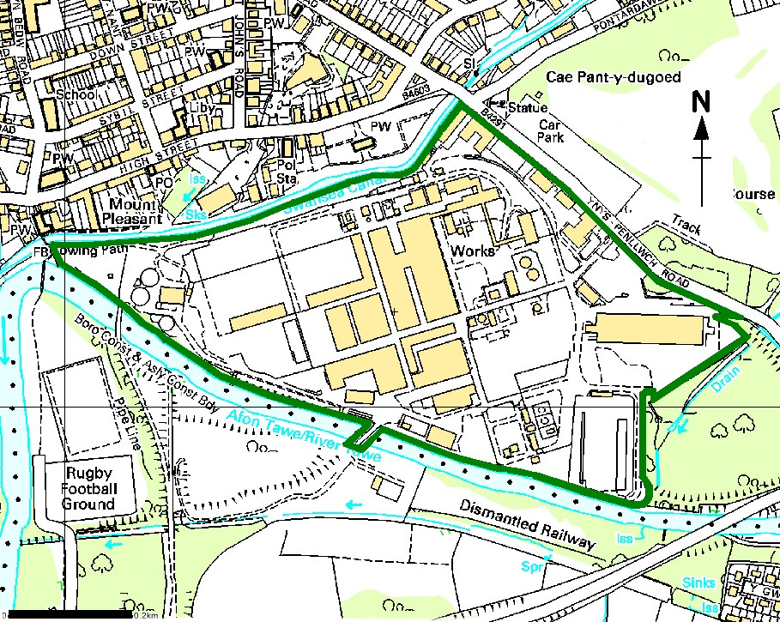
Installation boundary plan

© Crown Copyright and database right 2017. Ordnance Survey licence number 10001974.

Site layout plan

Points of emission to air, water and sewer from the installation
Western part of the site
Location of installation boundary relative to emission points is shown in green. Coloured, numbered symbols indicate emission points.
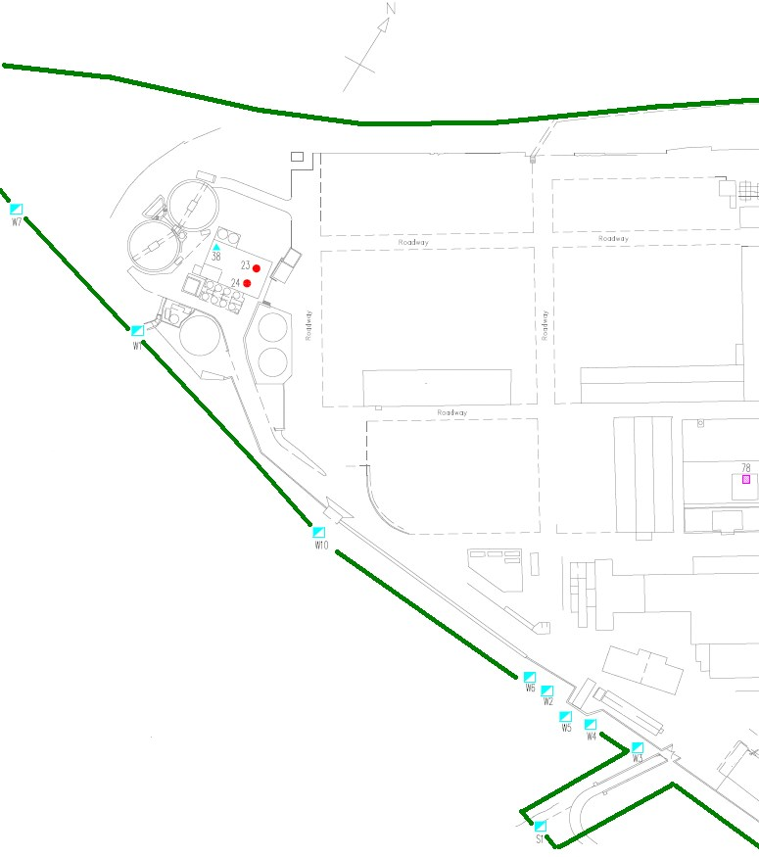

Eastern part of the site

Location of installation boundary relative to emission points is shown in green. Coloured, numbered symbols indicate emission points.
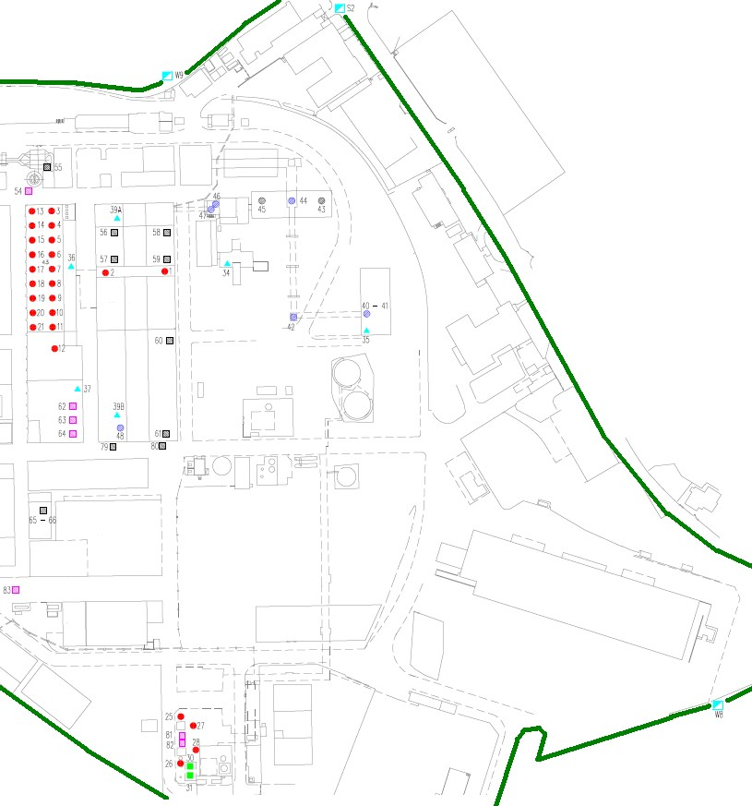

END OF PERMIT

